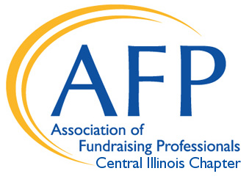
Scholarship for International Conference

International Conference Scholarships
Up to three (3) scholarships will be awarded each calendar year for the following spring’s AFP International Conference on Fundraising.

Deadline: Ongoing
Applications are reviewed on an ongoing basis.

Benefits of Scholarship
Each recipient will receive up to $2,000 toward their registration, travel, or lodging expenses for the International Conference on Fundraising.

Eligibility
Recipients must be a current member of AFP. Recipients must be employed as a fundraising professional or, if candidate is an executive director, a substantial amount of time must be devoted to fundraising. This scholarship is open to any Central Illinois Chapter member; however, preference will be given to a candidate who has never attended the AFP International Conference on Fundraising as a registered participant. Candidate must agree to complete and return an evaluation or summary about his or her experience.

Criteria for Selection
Once eligibility is met, priority will be given to applicants with demonstrated financial need. Priority also will be given to applicants who have demonstrated their participation in the local chapter through monthly meeting attendance or committee involvement.
Only one application for a conference scholarship from the same organization will be considered each year.

Scholarship Application
Applicants must submit a completed application form along with a narrative. Please return application by mail to:
Central Illinois AFP
Attention: Scholarship for International Conference
PO Box 5323
Peoria, IL 61601
Or by email to: Veronica Stalter, Chapter Scholarship Chair
at vstalt@gmail.com

Further information: For more information, contact Veronica Stalter at vstalt@gmail.com

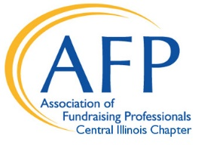
Scholarship for International Conference Application Form

Applicant Name:
Title:
Organization:
Preferred Address:
City, State, Zip:
Preferred Telephone and Fax:
Email:
Number of years in fundraising:
Annual Agency Operating Budget:
Is your organization paying your expenses? Yes No
Member of AFP since: ____________ (list year, or the number of years of membership)
Have you previously attended an International Conference on Fundraising?
Yes - if yes, when? ___________ No

Scholarship recipients are encouraged to volunteer for one of AFP-Central Illinois Chapter’s activities. Please indicate which you would be interested in working with:
Education/Professional Advancement
National Philanthropy Day Awards Luncheon AFP Chapter Board

Along with this completed Application Form, candidate must submit a narrative (limit to two pages, letter form) explaining why candidate is applying for scholarship. In narrative, describe:
• Financial need
• How scholarship will benefit you and your organization
• Previous/current involvement or participation with AFP
• Previous training in fundraising
• Any prior scholarships received from AFP (with dates)
• Other volunteer experience in the community
Candidate will also be required to submit a growth experience summary within a month following the International Conference for publicity usage.

Submit application and narrative to:
Central Illinois AFP
Attention: Scholarship for International Conference
PO Box 5323
Peoria, IL 61601

Or via email to Veronica Stalter at vstalt@gmail.com.

