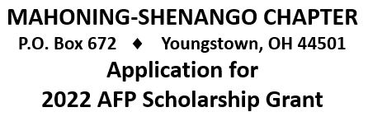
Name ____________________________________________ AFP Member since ___________________
Address ______________________________________________________________________________
City ______________________________________________ State ____________ Zip ______________
Phone __________________________ E-Mail _______________________________________________
Organization __________________________________________ Position _________________________
Address ______________________________________________________________________________
City ______________________________________________ State ____________ Zip ______________
Phone __________________________ E-Mail _______________________________________________
Continuing Education Event: _____________________________________________________________
Date(s): _______________________ Location: ______________________________________________
Describe the event and your purpose in attending:
_____________________________________________________________________________________________
_____________________________________________________________________________________________
_____________________________________________________________________________________________
Itemized Costs: _______________________________________________________________________________
_____________________________________________________________________________________________
_____________________________________________________________________________________________
_____________________________________________________________________________________________
Amount for which you are making application: $ ___________________________
Check to be issued to: ______________________________________________________ (specifiy organization or self)
Signature ____________________________________________ Date _____________________________

Please complete & email to Nicholas Bush at: nbush@jewishyoungstown.org
Or Mail a hard copy to: Nicholas Bush
Development & Community Relations Manager
Youngstown Area Jewish Federation
505 Gypsy Lane
Youngstown, OH 44504

