
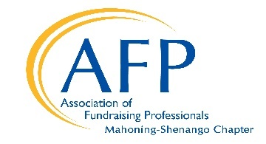

2026 Annual National Philanthropy Day
Tuesday, November 10, 2026
Awards Nomination Application

Completed applications should be sent via email or mail and
must be received by Friday, July 17, 2026, by 5:00 p.m.
Email: Scan form and documentation; send to afpmash@gmail.com
Or
Mail to: Association of Fundraising Professionals Mahoning-Shenango Chapter
P.O. Box 672
Youngstown, OH 44501-0672

Have Questions? Please contact the NPD Chair
Paige Fortner: 330-501-9062, paigefortner1@gmail.com

Nominee Name and Title _________________________________________________________________
Home/Business Address __________________________________________________________________
Phone ____________________ Fax _____________________ E-mail ______________________________
in the following category (check one):
_____ Outstanding Philanthropist _____ Outstanding Volunteer Fundraising Group
_____ Outstanding Corporate Philanthropist _____ Outstanding Young Philanthropist
_____ Outstanding Small Business Philanthropist _____ Outstanding Volunteer Fundraiser
_____ Foundation Leadership Award _____ Legacy Award (posthumous)

Nominator(s) and Organization _____________________________________________________________
Address ________________________________________________________________________________
Phone ____________________ Fax ______________________ E-mail ______________________________
Nominator Signature: ________________________________________________________________
The above signature verifies that I have notified the Nominee and they have approved this submission.
_________________________

Nominator(s) and Organization _____________________________________________________________
Address ________________________________________________________________________________
Phone ____________________ Fax ______________________ E-mail ______________________________
Nominator Signature: ________________________________________________________________
The above signature verifies that I have notified the Nominee, and they have approved this submission.
__________________________________________________

Describe on additional pages the accomplishments of the nominee. Specify how these accomplishments satisfy the criteria outlined in the nomination brochure. Please attach supporting documentation but note that only the first SIX pages will be reviewed. Thank you for your nomination! This form may be copied for additional nominations. To find additional forms go to www.afpmash.org.

