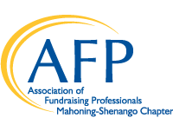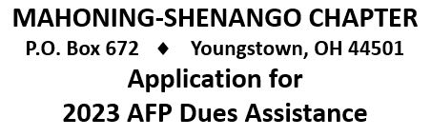
Name _______________________________________________ Date ___________________________
Organization __________________________________________ Position _________________________
Address ______________________________________________________________________________
City ______________________________________________ State ____________ Zip ______________
Phone __________________________ E-Mail _______________________________________________
AFP Membership Status: New ______ Renewal ________ Amount Requested $____________________
Amount Requested should be no more than 50% of the prevailing National Dues – Chapter Dues are not included
Balance of dues paid by: Self __________ Employer __________ Other ________________________________
Check to be issued to*: Self __________ Employer __________ Other ________________________________
Membership Expiration Date _____________________________
Type of AFP Membership: Professional _______ Young Professional ______ Associate ______ Retired _______
Reason for Applying:
_____________________________________________________________________________________________
_____________________________________________________________________________________________
_____________________________________________________________________________________________
_____________________________________________________________________________________________
____________________________________
Signature
*All dues assistance checks will be made Payable to AFP unless proof of payment is included in this request.
Please complete & email to Kathleen Austrino at: austrinoka@hotmail.com
Or Mail a hard copy to: AFP Mahoning-Shenango
Attn: Kathleen Austrino
PO Box 672
Youngstown, OH 44501

It is the tradition of the AFP Mahoning-Shenango Chapter to assist in payment of membership dues. The purpose of this assistance is to enalbe persons to participate in the benefits of AFP membership who are volunteer fund raisers, in part-time positions, or employed as fundraisers by small agencies. Priority consideration is giving to self-employed members of members whose agencies cannot or do not assist with payment of AFP dues. New members qualify for this assistance as well as members who are currently serving on a committee or the Board. New members are expected to serve on a committee.

