Project Name: Showing the Invisible
- You will pick an abstract word and express it with photos. Do not share your word with any classmate.
- You can shoot as many photos as you like, but you will submit 8 of them.
- Put your photos in a PPT. Each photo shall take one slide.
- Your photos will take 8 slides. On the ninth slide, put a big “?” in it.
- In the tenth slide, you will put the word there.
Below is an example from earlier students. Each cell is for a PPT slide
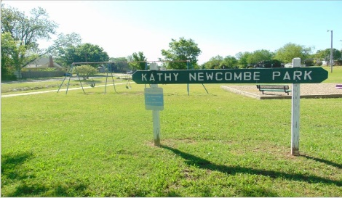 | 
 | 
 | 
 | 
? | Quarantine

