You’re speaking at Virtual ICED 2021! Now what? Help spread the word!

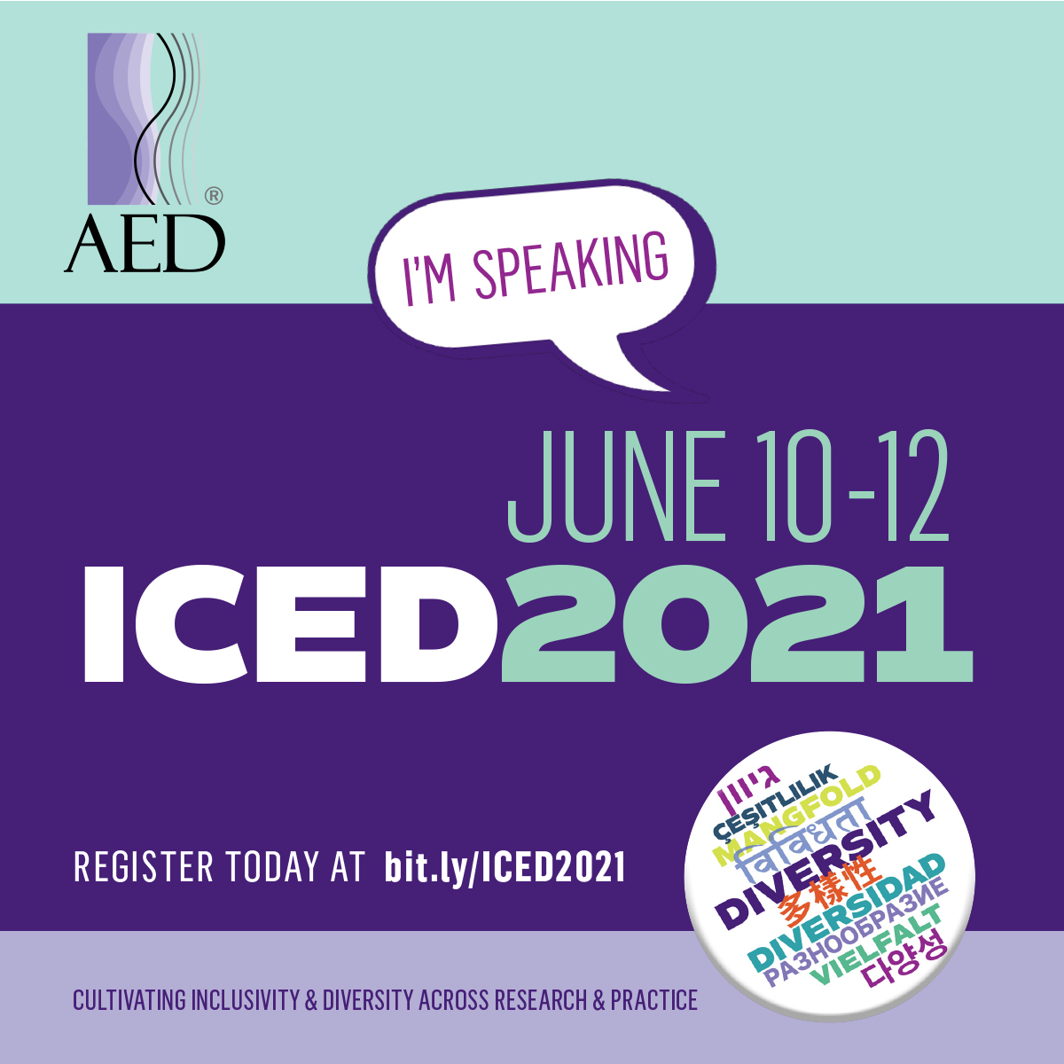
Conference – Social Media Examples
Thank you for being a speaker at Virtual ICED 2021! Here are some suggested messages to help spread the word about our annual conference and your participation as a speaker or presenter. You can also use these examples in your blogs or other social media platforms.
Sample Messages:
- What's next in eating disorder research? Find out at #ICED2021, where I'll be presenting on [fill in your topic here]. Join me virtually: http://bit.ly/ICED2021
- Looking forward to exploring [your topic here] at #ICED2021. Hope to see you online with me! http://bit.ly/ICED2021
- Inspiration, ideas, and connections: it doesn't get better than #ICED2021. Hope you'll be joining me online! http://bit.ly/ICED2021
- The future of eating disorder treatment and prevention starts at #ICED2021. I'll be discussing [your topic here]. http://bit.ly/ICED2021
- Counting down the days until #ICED2021. Looking forward to connecting with everyone virtually! http://bit.ly/ICED2021
- #ICED2021 is the premier annual meeting for professionals and advocates engaged in research, treatment, and prevention of eating disorders – hope to see you virtually! http://bit.ly/ICED2021

- This year’s #ICED2021 is coming directly to you from the convenience of your laptop! Register today and tune in as I present on [fill in your topic here]. http://bit.ly/ICED2021
- I’m speaking at #ICED2021, @aedweb’s annual conference! Will you be attending? I look forward to connecting virtually with other champions in the field! http://bit.ly/ICED2021

- Collaborate and engage with your peers and I at the #ICED2021 virtual conference. I'll be presenting on [your topic here]. http://bit.ly/ICED2021

- #ICED2021 is around the corner! Get ready to connect with others passionate about research, treatment, and prevention of eating disorders. See you online! http://bit.ly/ICED2021

- What are new methods to end the stigma of eating disorders? Register for #ICED2021 to find out about [your topic here]. http://bit.ly/ICED2021

- Connect with me and other advocates for [your topic here] at #ICED2021! http://bit.ly/ICED2021
Conference banner image (horizontal):
Can be used for blog headers, email headers:
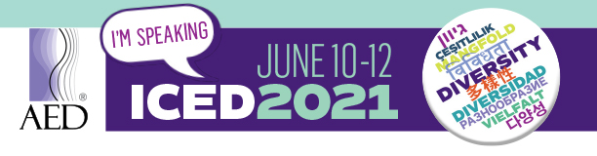
Conference 1080x1080 image option:
Can be used for Instagram:
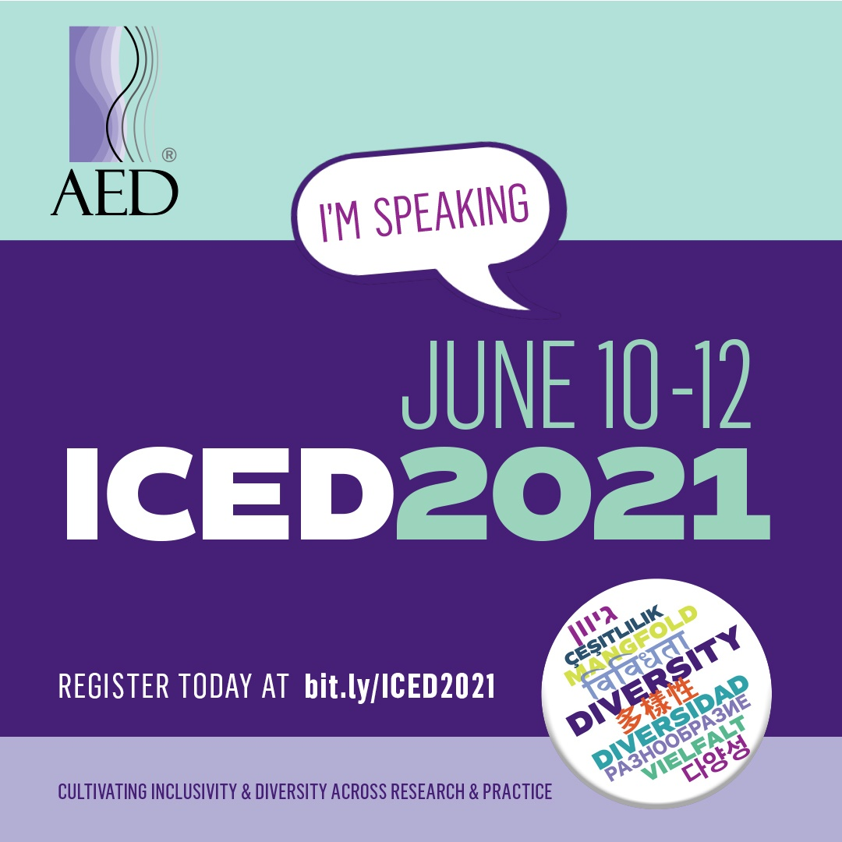
Conference 940x788 image option:
Can be used for Facebook:
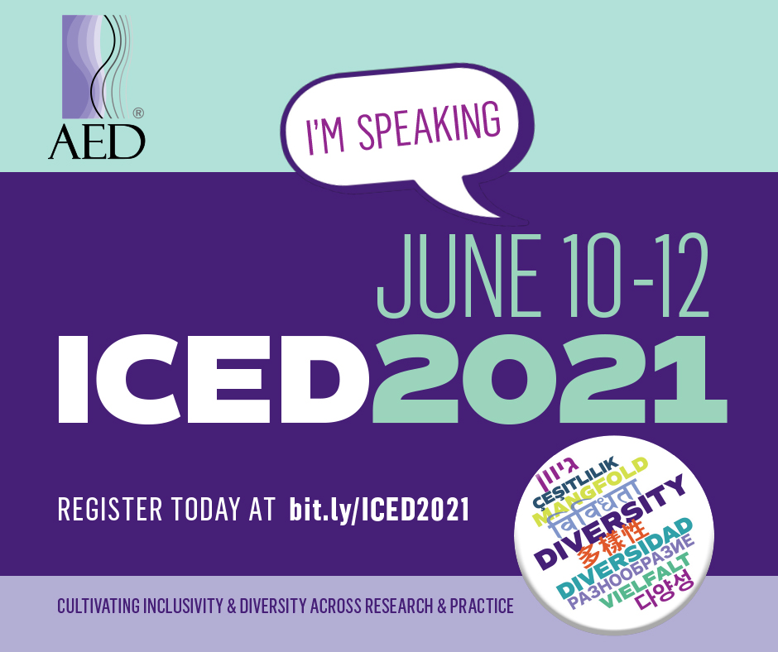
Conference 1600x900 image option:
Can be used for Twitter:
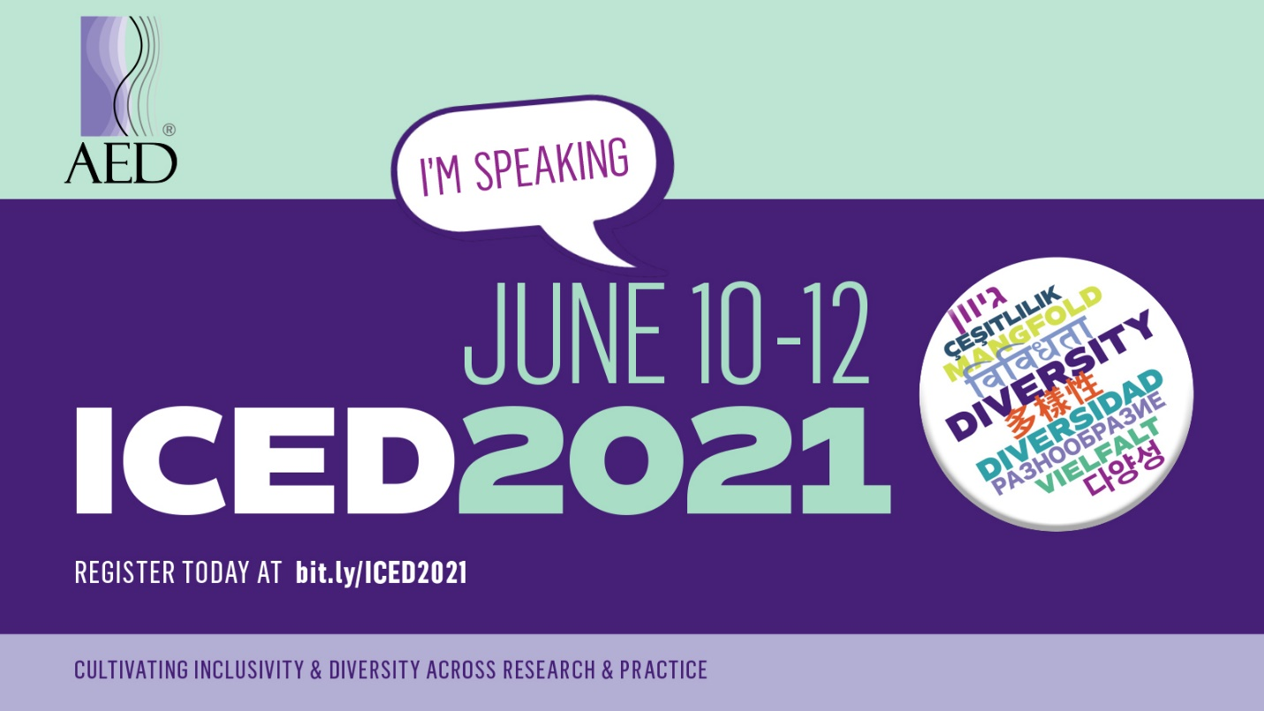
Conference 1200x1200 image option:
Can be used for LinkedIn:
