Title: Style “Title,” Arial, 14-pt., Bold, Centered

Author Name, Institution, Email
Author Name 2, Institution 2, Email 2
(if same institution, you may put all authors separated by commas,
then put on new line “email_1, email_2, email_3” in order of authorship,
then put institution on the bottom line)

Abstract: Place one 12-pt. blank line before the abstract. Use “Abstract,” Times or Times New Roman, 10-pt., for your abstract. Indent the abstract 1.27 cm (0.5 inches) from the right and left margins of the paper. All text should be single-spaced. “Full justify” all text (straight margins on both left and right sides). Paper abstracts are 150 words; poster abstracts are 75 words.

General notes (Style “Heading 1” — Arial, 12-pt., bold, 12-pt. space before, only first word capitalized except after a colon)
This year we are publishing the AECT proceedings through the Journal of Applied Instructional Design (JAID). This document provides formatting requirements for papers that will be published in the proceedings of the AECT Annual Convention. Your paper must conform to these guidelines so that each paper in the proceedings is uniform. Submitting your paper following these guidelines is necessary to make sure that your paper is included in the proceedings. It is recommended to use the MS Word styles in this document as a template for your document.

Body text formatting (Style “Heading 2” — Arial, 12-pt., regular, 10-pt. space before, only first word capitalized except after a colon)
The initial paragraph following a heading should be in style “Body Text.” Use Times or Times New Roman 10 pt. “Full justify” paragraph text (straight margins on both left and right sides). Do not indent or leave a blank line following the heading. The margins for your entire paper should be 2.54 cm (1 inch) on the right and left and 3.175 cm (1.25 inches) on the top and bottom, using A4 paper (not Letter!).
Subsequent paragraphs are in style “Body Text First Indent.” Do not leave blank lines between paragraphs. Indent the first line of each paragraph 1.27 cm (0.5 inches) from the left margin.
DO NOT use page numbers, running heads, or footnotes. If you must use notes, please use endnotes, and place them immediately before the reference list. Refer to endnotes in text using a standard full-sized numeral inside parentheses without superscripting (1). For emphasis in your text, use italics.
Leave one line before each section heading. This will be accomplished automatically if you use the MS Word styles in this document. Do not use more than three levels of headings.

Page length (Style Heading 3 — Arial, 10-pt., regular, underlined, 10-pt. space before, only first word capitalized except after a colon)
All proposals that have been accepted to the AECT25 convention are eligible to submit paper to the proceeding. All papers should be a minimum of 1000 words and should not exceed the maximum of 2000 words. Please note that the word count also includes references. Publication of a paper in the proceedings will be contingent upon the following:
- Preparing a paper based on this provided template.
- Ensuring that the submitted paper does not go above 2000 words and the file is less than 5MB in size.
- Submitting the paper on or before 17 November 2025 at 11:59pm EST
- Responding to editor feedback disseminated on or before 14 January 2025 at 11:59pm EST
- Submitting the final camera-ready paper on or before 14 February 2026 at 11:59pm EST, that incorporates reviewer feedback
- Responding to copyediting inquiries within 10 days of notice

The AECT proceedings are expected to be available April/May 2026.

Reviews for proceeding submissions
Since the proceeding submissions are based on already peer reviewed submissions, there will be no need for a double blind review at this stage. We will use an editorial review process at this stage.

Extended quotations
For extended quotes from source material, use style “Block Text,” Times or Times New Roman 10-pt., and indent the quote 1.27 cm (0.5 inches) from both the left and right margins. “Full justify” the text for the extended quote. The extended quote should be preceded and followed by one 10-pt. blank line.

Education thus becomes an act of depositing, in which the students are the depositories and the teacher is the depositor. Instead of communicating, the teacher issues communiques and makes deposits which the students patiently receive, memorize, and repeat. This is the “banking” concept of education, in which the scope of action allowed to the students extends only as far as receiving, filing, and storing the deposits. (Freire, 1970, p. 49)

Figures and tables
All figures and tables must be referred to in your text (see Table 1). Color figures may be included (see Figure 1). All figures and tables should be centered. The number and title should be left-justified aligned with the table or figure themselves as shown below.

Table 1
An Example of a Table for the AECT Proceedings
 | Heading 1 | Heading 2 | Heading 3
Row 1 | Cell 1 | Cell 2 | Cell 3
Row 2 | Cell 4 | Cell 5 | Cell 6

Figure 1

The AECT Convention Timeline
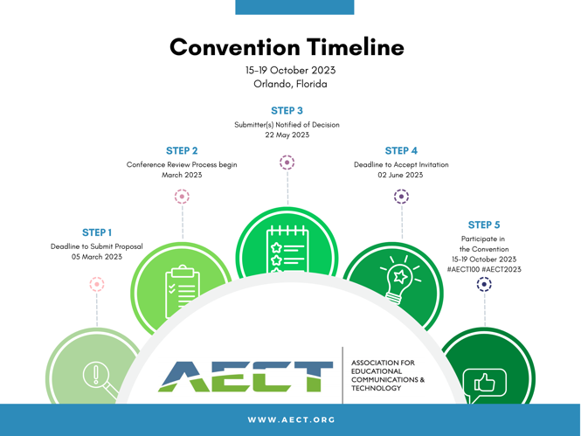

Citation and reference style
Please refer to the Seventh Edition of the APA Publication Manual for full details and more extensive examples. Regardless of the medium of the source, all sources with three authors or more are now attributed using the name of the first author followed by “et al.” The only exception to this occurs when doing so would create ambiguity (e.g., if two papers have first-listed authors with the same name). In these cases, list as many names as needed to differentiate the papers, followed by “et al.” See examples of APA 7th edition below:

… environment where learning takes place remain the same year after year (Asino & Pulay, 2019)
…to engage in ethical work in educational technology, a level of criticality in our approaches is necessary (e.g., Bradshaw, 2017)…
... Freire (1970) called for attention on issues of power and justice in teaching practice…

Endnotes (use Heading 1)
(1) Place any endnotes after the main text of your paper, but before your reference list. Use Times or Times New Roman 9-pt. text for your endnotes, and "full justify" the margins. Place the endnote number reference in parentheses in the left margin, using the same number as in the text of the paper.
(2) Use style “Endnotes”, with a 0.635 cm (0.25 inches) "hanging" indent and a 0.635 cm (0.25 inches) tab setting, as in this example.

References (use Heading 1)
Asino, T. I., & Pulay, A. (2019). Student perceptions on the role of the classroom environment on computer supported collaborative learning. TechTrends, 63, 179-187.
Bradshaw, A. C. (2017). Critical pedagogy and educational technology. Culture, learning and technology: Research and practice, 8-27.
Freire, P. (1970). Pedagogy of the oppressed. New York: Seabury Press.
Hannafin, M., Land, S., & Oliver, K. (2013). Open learning environments: Foundations, methods, and models. In Instructional-design theories and models (pp. 115-140). Routledge.
Lockee, B. B. (2021). Online education in the post-COVID era. Nature Electronics, 4(1), 5-6.
Moore, J. L., Dickson-Deane, C., & Galyen, K. (2011). e-Learning, online learning, and distance learning environments: Are they the same?. The Internet and higher education, 14(2), 129-135.

(Note that references are in style “References,” Times or Times New Roman 10-pt. text, “full justified” and use a 1.27 cm (0.5 inches) "hanging" indent, with no spaces left between entries. Follow APA style (7th edition). The MOST important thing about the reference style you use is that readers are able to locate the sources you cite! Please be especially clear in the case of references to online materials!)

Acknowledgments (use Heading 1)
If you would like to make acknowledgments in your paper, please do so after the reference section, use Times or Times New Roman 10-pt. font, “full justify” your text, and do not indent the first line of the acknowledgments.

