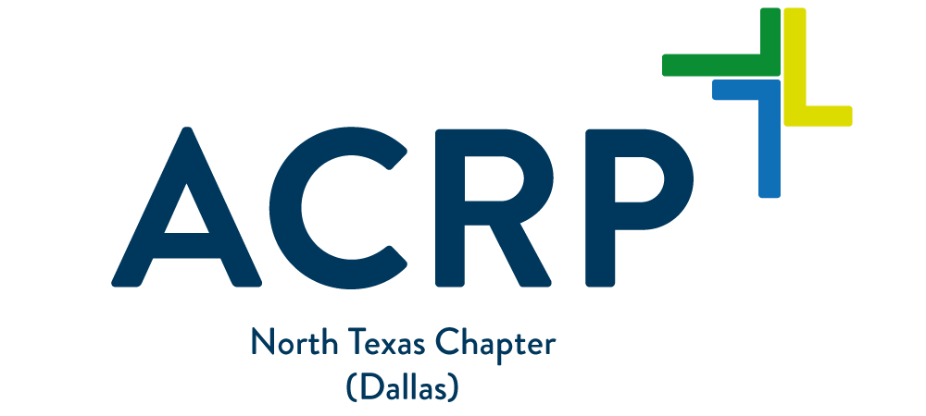

SAVE THE DATE!

June 27, 2018

North Texas Chapter
presents an ACRP Webinar Replay:

“Responding to an FDA Inspection”

Also… Bridget Gonzalez will share
“Highlights of 2018 ACRP Global”
Bridget Gonzales, CCRC, Director, Training and Professional Development, Association of Clinical Research Professionals
Bridget states that she has no financial interest/arrangement or affiliation with one or more organizations that could be perceived as a real or apparent relationship in the context of the subject of this presentation or in the planning of this educational activity.

Date: June 27, 2018 Time: 5:30 to 8:00 PM

Agenda: 5:30-6:00 PM Registration, Sign in, Snacks and Networking

6:00-7:00 PM Webinar (1.0 contact hour available)

7:00 – 8:00 PM Highlights of 2018 ACRP Global (no contact hours provided)

Location: Cook Children’s Hospital
801 7th Street
Fort Worth, Texas 76104
Room: Pavilion Class 5 - Basement

Free Parking, see attached map and directions

This program will be offered in Tyler, TX in the near future
Date and venue TBD

Program Description (webinar): This webinar is intended to expose the attendee to the basics of an FDA response. It will begin by identifying the core findings in an FDA response and explore considerations in responding to an FDA inspection. The goal of the presentation is for the attendee to recognize, evaluate and respond to the FDA’s inspection without causing an escalation – or understand when it is important to bring in additional assistance.
The “Highlights of ACRP Global” presentation is intended to expose the attendee to topics presented at the 2018 ACRP Global Meeting, April 27-30, 2018, Gaylord National Resort & Convention Center, National Harbor, Maryland

Program Objectives: Upon Completion of the webinar, participants should be able to:

1. Identify the main causes of an FDA inspection
2. Identify the primary types of enforcement actions
3. Identify the core team responsible for dealing with an FDA inspection
4. Identify the appropriate and reviewing mechanisms for an FDA inspection

Target Audience: Anyone working in or pursuing a degree in clinical research, including: Clinical Research Coordinators, Clinical Research Associates, Clinical Site Managers, Project Managers and Investigators.

Costs: No fee for attendees who do not want to receive contact hours; however, if you want to obtain contact hours, you must purchase them individually. The fee is $15 per contact hour for each national ACRP member and $75 for each non-member. Contact hours are free for National and Chapter members.

To receive contact hours: Purchase the contact hours, sign in at the registration desk, and attend the program. Log on to the ACRP website then click “ACRP Learning Portal” to complete the evaluation between 1-30 days following the event and receive the online certificate. CE contact hours are Free for NTX Chapter members or other ACRP Chapter members who are also ACRP members. Contact hours will be available for purchase on your chapter’s website from now until 7/11/18 (2 weeks post meeting). The evaluation will be available on your ACRP records from 6/27/18 – 7/27/18.

Contact hours: 1.0 ACRP contact hour has been approved through ACRP for the webinar only.

The Association of Clinical Research Professionals (ACRP) provides 1.0 continuing education credits for the completion of this educational activity. These credits can be used to meet the certification maintenance requirement.

Online Registration: Membership is not required for online registration at

http://www.acrpnet.org/GetInfoFor/USChapters/NorthTexas.aspx

If you do not have a username and password, please use New Visitor Registration to register.

ACRP Members, Login with your email address and password (required) to register online.

Please register by Tuesday, July 27 and check our website for updates.

Sponsors: Cook Childern’s Hospital has provided the room for this event.
Medix Clinical Research will be providing light appetizers. Medix partners with research sites, Sponsors and CROs across the United States to be a resource in workforce solutions. The Medix team can help to provide strategic solutions to recruit and retain top talent in order to drive your quality trials on time and under budget.

The sponsors named above do not have any influence on the content of the presentation.

Contact NorthTexas@acrpnet.org with questions or concerns

