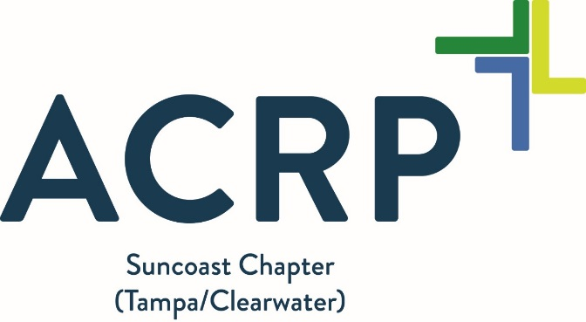
ACRP Journal Club –November 2018 | Suncoast Chapter ACRP

Program Description:  The Association of Clinical Research Professionals (ACRP) Suncoast Chapter relies on great local professionals who are committed to growth and mentorship.  The Journal Club will plan to meet on-line on the 4th Tuesday every month. A Go-To-Meeting invitation will be sent to those who want to attend remotely. RSVP using the link below.  The main goal of our meetings will be to discuss the most recent topics on the minds of research professionals on the ACRP “Online Community” forum. This month’s topic is:  “What do I do about the 1572?”  RSVP  Target Audience:  ACRP members and prospective members.  To provide feedback on how to make this better for you and others, please email the ACRP Suncoast Chapter Board at SuncoastChapterACRP@gmail.com or enter feedback in our survey.  Further Information:  GoToMeeting Web-conference:  https://global.gotomeeting.com/join/959690709  You can also dial in using your phone. United States: +1 (786) 535-3211  Access Code: 959-690-709 | Date: Tuesday, November 27, 2018  Time: 12:30pm – 1:30pm  Location: GoToMeeting  Contact hours: Contact hours can be obtained by signing on to the ACRP chapter website: http://community.acrpnet.org/communities/community-home?CommunityKey=ca565f8d-621b-43ed-a9f9-c40a0841e8fd .  To receive contact hours: The local chapter will not be responsible for issuing contact hours.  Cost: There is no cost to attend the meeting. Contact hour pricing is posted on the website. There will be no charge if you are a Suncoast Chapter member.  Refund Policy:  The ACRP Suncoast Chapter does not provide contact hour refunds.  Level: Basic to Intermediate

