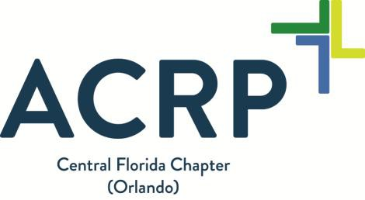

Exploring the Transformation of Registries in the 21st Century

Program Agenda:  - 6:00 – 6:30 pm – Registration & Dinner  - 6:30 – 7:30 pm – Presentation (including Q&A and Closing)  - 7:30 – 7:45 pm – Networking  Program Description:  Registries are data collection tools typically used to better understand long-term trends in some certain specific population. When designed appropriately, registries can be used as a data source within which clinical trials can be performed. In recent years, the changes we have seen regarding comparative effectiveness research, the medical device industry, and now the push of utilizing “Big Data” are increasing the volume and complexity of registries we encounter in healthcare. This program will help to differentiate clinical registries and research registries and review the impact it may have in clinical trial billing.  Upon completion of this Webinar, attendees should be able to:  - Identify different types of registries.  - Apply applicable regulations to registries.  - Understand how changes within the medical device industry affected registries.  - Identify which type of registries have clinical trial billing concerns associated with them.  Webinar presenter Christina Jackson is a Research Compliance and Education Specialist in the Office of Research Integrity at Florida Hospital. In that role, her responsibilities included conducting onsite reviews of selected research protocols for the purposes of compliance with federal regulations related to the conduct of research, protection of human subjects participating in research, IRB policies, and adherence to the protocol. Ms. Jackson also taught classes and served as a resource on those topics, as well as informed consent, protocol development and data collection.  Target Audience: Executives, Risk Management /Quality /Safety Professionals, Principal Investigators, site managers or others engaged in clinical research  Registration: Registration will be available beginning Friday, November 2nd on the Central Florida Chapter website. Please check occasionally for potential updates.  Please contact Carole Coyne or Jessica Hyacinthe with any questions, comments, or concerns at: CFLACRP@gmail.com | Date: Thursday, December 6, 2018  Time: 6:00 pm – 7:45 pm  Location:  FRi Diagnostic Imaging  Strategic Alliance Conference Room  2nd floor  235 E. Princeton Street  Orlando, Florida 32804  Speaker: Christina Jackson, MJ, BSN, RN, CHRC, CCRC  Registration Fee: Event Registration:  $5 Chapter Members  $10 All Others  Contact hours: 1.0 Contact Hour has been approved through ACRP. Membership is not required for online registration of contact hours.  To receive contact hours: Purchase the contact hours, sign in at the registration desk, and attend the program. Log onto the ACRP website then “ACRP Learning Portal” to complete the evaluation no later than 30 days following the event and obtain the online certificate.  Contact Hour Costs:  - $0 Chapter Members  - $15 ACRP Members  - $30 Non-Members  Refund Policy: There are no refunds unless the program is cancelled by the chapter before the start of the program.  Level: Intermediate

