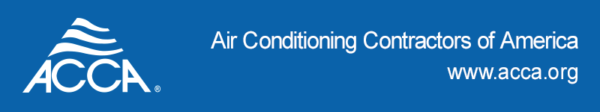

Position Title: Podcast Producer Intern
Reports to: Manager of Communications and Strategic Partnerships
Location: Remote

Summary Description ACCA is seeking a bright, self-motivated individual interested in learning about podcast production and marketing. You’ll be part of the internal ACCA team working with an outside podcast partner to organize, record, produce and publish podcasts.

Duties and Responsibilities:

- Help produce several podcast episodes under the guidance of a more experienced producer.
- Provide social media marketing support.
- Research sources for ongoing series, send booking requests, prepare background research for hosts, search for archival materials, etc.
- Assist with various coordination and administrative duties, including but not limited to; calendar booking, answering guest questions, etc.
- Synopsize each podcast episode for website search engine optimization.
- Participate in team meetings and creative collaboration.

Ideal Candidate will Possess:

- Resilience and willingness to perform less glamorous tasks as well as the fun ones.
- Excellent communication and time management skills, especially in a remote environment. You must be able to work independently, meet deadlines, and communicate effectively with your supervisor.
- Attention to detail and strict adherence to the highest podcast standards and ethics.
- Well-organized, energetic, independent, and responsive to feedback and direction.
- Strong spelling, grammar, proofreading, and editing skills.
- Availability for 10-15 hours per week.

Preferred Qualifications:

- Knowledge of Microsoft programs (required) and Adobe Creative Suite (preferred).
- Thorough knowledge of MS Office Suite (Word, Excel, PowerPoint, Access), G Suite (Gmail, Google Docs, Google Sheets), and Zoom conferencing software.
- Familiarity with online design tools, such as Canva.
- Experience with audio recording software such as Audacity, Pro Tools, and Garage Band is a plus but not required.
- Video editing software such as iMovie is a plus but not required.
- An understanding and passion for digital and social media channels and trends.

About ACCA The Air Conditioning Contractors of America (ACCA) is a non-profit national association whose membership includes more than 60,000 professionals in the indoor environment and energy services community. Members install, maintain, and replace air conditioning and refrigeration systems in homes and businesses across the United States. Our roots stretch back to the early part of the 20th century, with the organization incorporated in its present form over 40 years ago. We are the industry’s voice advancing the HVACR contracting sector and promoting professional contracting, energy efficiency, and healthy, comfortable indoor environments. The HVACR industry employs over two million heating, ventilation, air conditioning, and refrigeration professionals, including contractors, distributors, engineers, and manufacturers. In addition, HVACR is responsible for manufacturing, distributing, and installing the products that consume nearly half of the energy produced in the United States.

Contact: Send your resume and a brief cover letter detailing your qualifications and availability to deb.weiner@acca.org with the subject line of Podcast Producer Intern and your last name.

Program schedule: ACCA runs a year-round internship program. If you are unable to join us for the sessions below, we welcome you to propose another period:

- Spring internship runs from January to May
- Summer internship runs from June to August
- Fall internship runs from September to December

ACCA is an equal opportunity employer and will not discriminate because of race, creed, color, national origin, sex, sexual orientation, age, disability, or marital status.

