For Immediate Release
October 16, 2017
Contact: Todd Washam
703-824-8864

ACCA Board of Directors Hosts HVAC 101 for Congress
Visits with Congressional Delegations
Arlington, VA October 16, 2017 – Last week, the Air Conditioning Contractors of America (ACCA) Board of Directors hosted HVAC 101 for Congress, a Capitol Hill briefing. The briefing was followed by dozens of meetings with Members of Congress and their staff, as well as senior officials from the Trump Administration.
The purpose of the briefing was to underscore for congressional leaders that most consumers are receiving 60 to 70 percent of the labeled efficiency of their heating, ventilation and air conditioning (HVAC) because half of the installations in the country are not done properly. ACCA's briefing panel was led by Congressman Markwayne Mullin (OK-2), ACCA Board Members and former ENERGY STAR National Manager Chandler von Schrader. The panel recommended policy changes to the ENERGY STAR Program and the Environmental Policy and Conservation Act that can help address the efficiency gaps. Attendees were encouraged to use legislative tools to force regulatory agencies to undertake robust consumer awareness campaigns promoting quality contracting practices.
While meeting with their elected officials and staff, ACCA’s Board of Directors discussed other issues affecting the HVAC industry including tax reform, career and technical education funding and healthcare legislation.
“The ACCA briefing and our subsequent meetings with Members of Congress was certainly worth the time and energy that we put in,” said ACCA Chairman of the Board Don Langston, President of Aire Rite Air Conditioning and Refrigeration in Huntington Beach, CA. “Every Member of Congress I met with recognized that, if U.S. energy policy continues to focus on a piece of high-efficiency equipment, then homes and businesses will continue to suffer. They understood that the federal government must do a better job of promoting the role of a professional contractor if we want our homes and businesses to be energy efficient."
Paul Stalknecht, ACCA President and CEO said, “Contractors across the country should be proud of ACCA’s Board of Directors for the work they did on behalf of the industry on Capitol Hill. I want to especially thank Congressman Markwayne Mullin (OK-2) for his commitment to pro-business tax policies and other issues that are important to contractors. He is a true champion for HVACR contractors.”
“As the Chairman of ACCA’s Government Relations Committee, I was proud to help lead these efforts on behalf of professional contractors,” said Dan Weis, ACCA Board Member and Vice-President of Weis Comfort Systems in Fenton, MO. “What makes contractors powerful advocates with Congress is that we are small business owners and job creators, and every Member of Congress needs us. Every one of them wants their homes and offices comfortable and safe, so they listen when we discuss what goes into delivering the promised efficiency of consumers’ air conditioning systems by following quality installation (QI) standards. Every HVAC contractor should be meeting with their local, state and national representatives and educating them about delivered efficiency through QI practices.”
ACCA’s Capitol Hill Briefing and congressional meetings were the first step in strengthening contractors’ partnerships with elected officials and ACCA's work to ensure consumers get the efficiency they paid for. ACCA’s Board of Directors will be conducting follow-up discussions with their Members of Congress in their district offices and continuing to advocate on behalf of HVACR contractors. ACCA strongly encourages all its members to meet with, call and e-mail their elected officials to advocate for better energy policy, fully funded career and technical education programs and tax reform legislation that helps America’s small businesses.

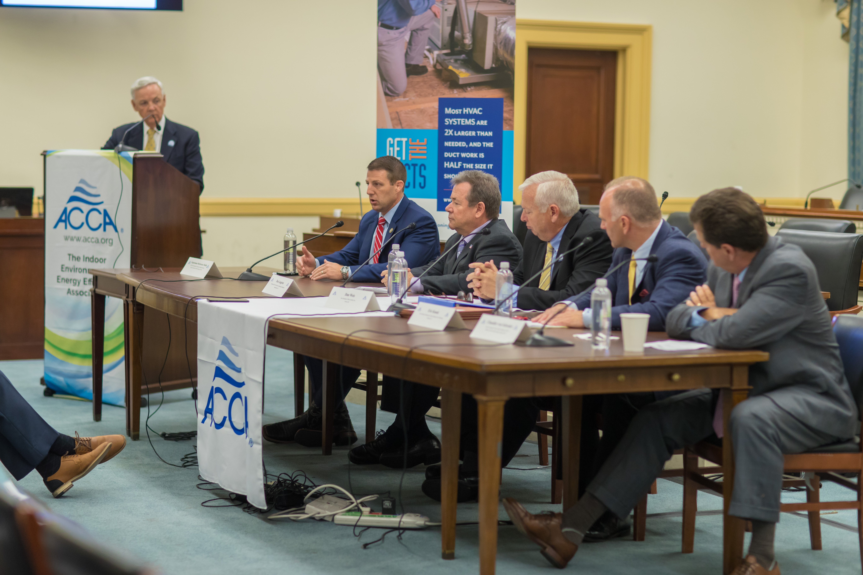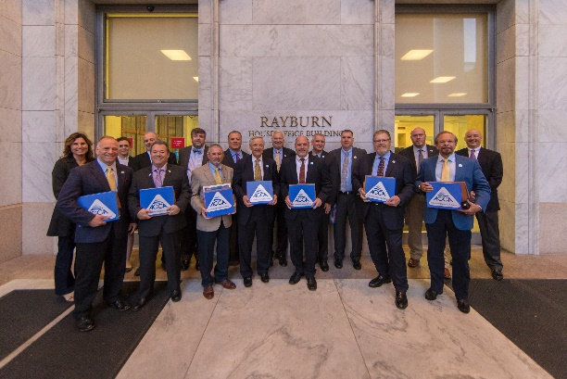

To view more photos visit ACCA’s flickr account.

For more information, please contact ACCA’s Director of Industry and External Relations, Todd Washam, at todd.washam@acca.org or 703-824-8864.

###
About ACCA
The Air Conditioning Contractors of America, is the nation’s premier trade association for heating, ventilation, air conditioning, and refrigeration contractors. ACCA’s member companies provide quality service in heating, air conditioning, refrigeration, building and home performance, solar, hydronics, and plumbing. ACCA has created the nationally-recognized and industry-endorsed standards needed to ensure HVACR systems are properly installed and maintained. Learn more at www.acca.org.

