Modifications to Proposed Addendum c to the

Normative Sections of ANSI/ACCA Manual S – 2023, Addendum a – 2024, and Addendum b – 2024, Residential Equipment Selection

Note: The proposed modifications are based on comments received on the first public review dated June 6, 2025.

Additions are shown as underline text and deletions are shown as strikethrough.

N1.3 Definitions
Terminology directly relevant to equipment sizing procedures is defined below.

Sizing Condition:
The applicable set of parameters used to find size limits based on the load calculation and the type of cooling or heat pump equipment selected.

- Two-Speed Heat Pump Heating Sizing Condition: The parameters used for sizing a two-speed capacity heat pump that is the primary source of heat and is installed in climates in which the JSHR is 0.95 or greater, or that uses active dehumidification.

Rationale: The definition is no longer needed, this aligns with the deletion of Section N2.3.3.

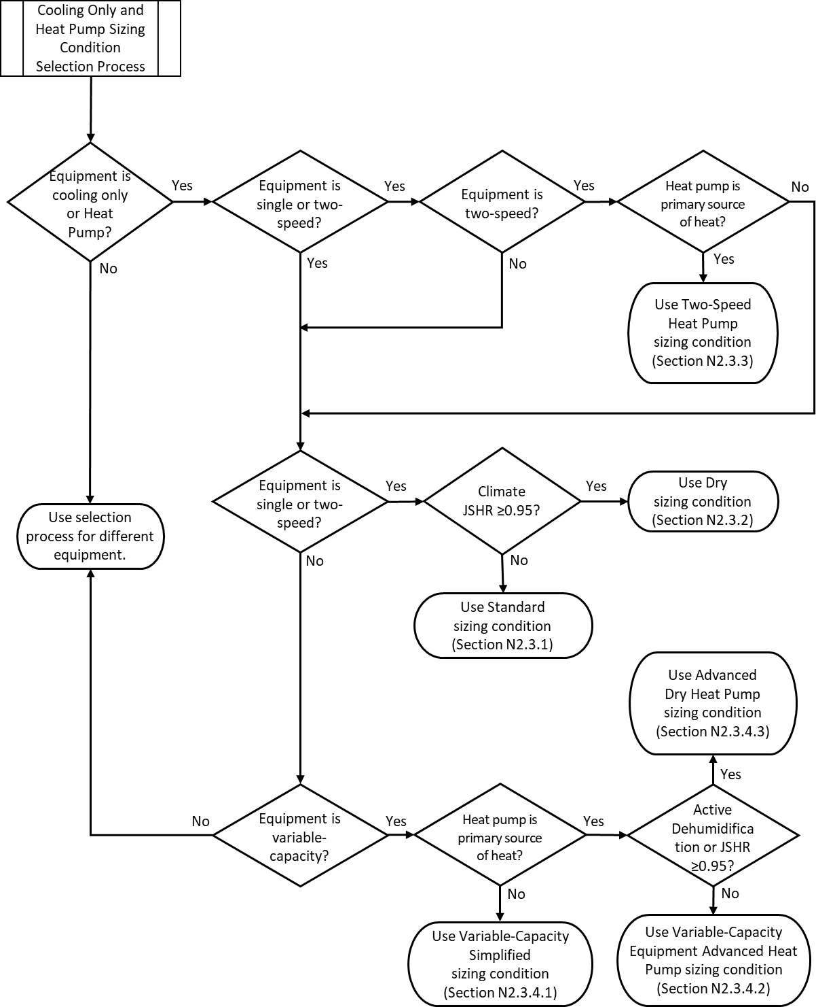
Figure 2: Sizing Condition Procedure Flowchart
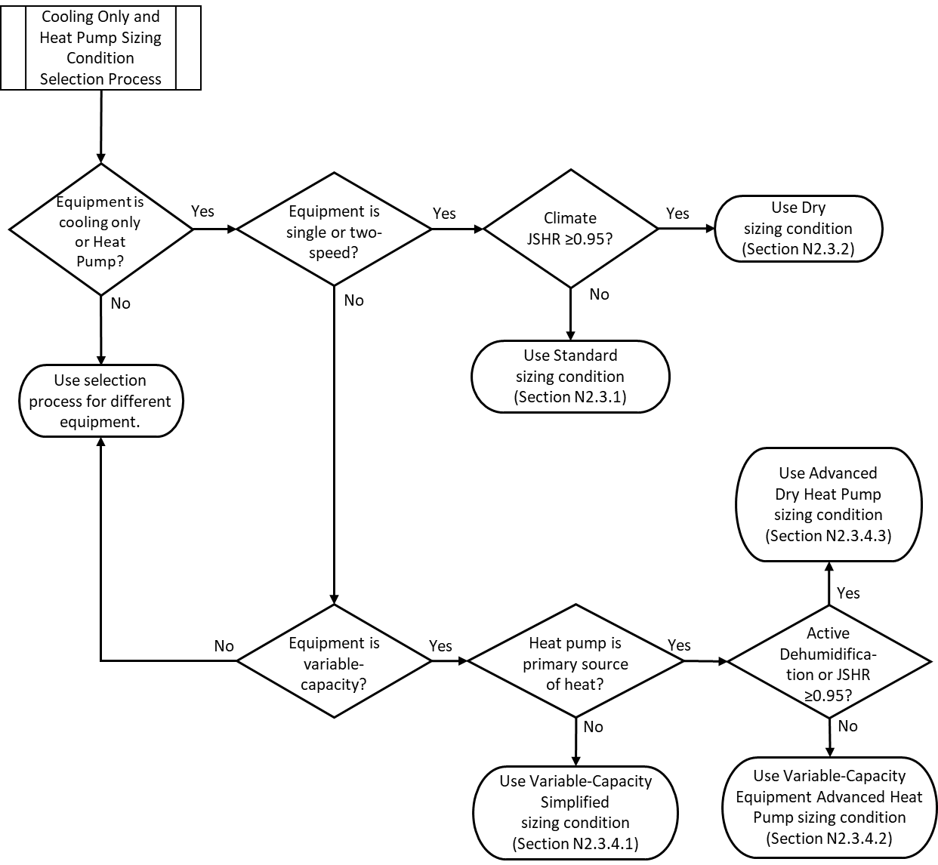
(Revised) Figure 2: Sizing Condition Procedure Flowchart
Rationale: Figure 2 is replaced by the modified version to better reflect the requirements and to correct some of the flow indicators. This revision also reflects changes resulting from deletion of Section N2.3.3, please see that section for the associated rationale.

Documentation: Cooling or Heat Pump Equipment -
Standard Sizing Condition
Type | AC / HP | Compressor |  | Single- Two-Speed
Medium |  |  |  | Air-Air Water-Air
Size Condition: |  |  |  | Standard
Outdoor Unit Model Number
Indoor Unit Model Number
Single-Speed Equipment
Total Cooling Load Less Than or Equal to 24,000 BTU/h
Size Factor |  |  | Size Limit
Total Cooling: |  |  | Maximum: |  | 1.20
 |  |  | Minimum |  | 0.90
Sensible Cooling: |  |  | Minimum: |  | 0.90
Latent Cooling: |  |  | Minimum: |  | 1.00
Total Cooling Load More Than 24,001 BTU/h
Size Factor |  |  | Size Limit
Total Cooling: |  |  | Maximum: |  | 1.15
 |  |  | Minimum: |  | 0.90
Sensible Cooling: |  |  | Minimum |  | 0.90
Latent Cooling: |  |  | Minimum: |  | 1.00
Two-Speed Equipment
Size Factor |  |  | Size Limit
Total Cooling: |  |  | Total Cooling Maximum: |  | 1.25 – 0.90
 |  |  | Minimum |  | 0.90
Sensible Cooling: |  |  | Sensible Cooling Minimum |  | 0.90
Latent Cooling: |  |  | Latent Cooling Minimum: |  | 1.00
Table N1.16.2.1
Rationale: The proposed changes are to correct the size limit format for two-speed equipment to reflect the correction of the term minimum compressor cooling size factor.

Cooling and Heat Pump Equipment: Dry Sizing Condition Documentation.
For the dry sizing condition, provide the total cooling capacity / total cooling load plus 6,000 BTU/h, size factor, sensible cooling size factor, and latent cooling size factor., and for t Two-speed heat pumps shall provide, the maximum minimum compressor cooling size factor.

Documentation: Cooling or Heat Pump Equipment –
Dry Sizing Condition
Type | AC / HP | Compressor |  | Single- Two-Speed
Medium |  |  |  | Air-Air Water-Air
Size Condition: |  |  |  | Dry
Outdoor Unit Model Number
Indoor Unit Model Number
Single-Speed Equipment
Size Factor |  |  |  | Size Limit
Total Cooling / Total Cooling Load + 6,000 BTU/h: |  |  | Maximum: |  | ≤ 1.00
 |  |  | Minimum: |  | 0.90
Total Cooling |  |  | Minimum |  | 0.90
Sensible Cooling: |  |  | Minimum: |  | 0.90
Latent Cooling: |  |  | Minimum: |  | 1.00
Two-Speed Equipment
Size Factor |  |  |  | Size Limit
Min. Compressor Cooling: |  |  | Minimum Maximum |  | 0.87 1.15
Sensible Cooling: |  |  | Minimum: |  | 0.90
Latent Cooling: |  |  | Minimum: |  | 1.00
Table N1.16.2.2
Rationale: The proposed changes are to correct the name of the minimum compressor size factor in the text and the Total Cooling Load plus 6,000 BTU/h. In addition this corrects the two-speed size limit from minimum to maximum, and deletes the “≤” symbol, it is unnecessary as the value is specified as a maximum.

Two-Speed Heat Pump Heating Sizing Condition Documentation.
For the two-speed heat pump sizing condition, provide the total cooling size factor, sensible cooling size factor, and latent cooling size factor, minimum compressor cooling size factor, heating size factor, minimum compressor heating size factor, and the heating size factor (47°F).

Documentation: Two-Speed Heat Pump Equipment
Type | AC / HP | Compressor | Two-Speed
Medium |  |  | Air-Air Water-Air
Size Condition: |  |  | Two-Speed
Outdoor Unit Model Number
Indoor Unit Model Number
Two-Speed Equipment
Size Factor |  |  |  |  | Size Limit
Min. Compressor Cooling: |  |  |  |  | Maximum: | 0.80
Heating: |  |  |  |  | Maximum: | 1.20
Min. Compressor Heating: |  |  |  |  | Maximum: | 0.80
Heating at 47°F Heating (47° F) |  |  |  |  | Maximum | 1.50
Table N1.16.2.3

Rationale: See the rationale for the deletion of Section N2.3.3, which results in the corresponding deletion of this section.

- Variable-Capacity: Advanced Sizing Condition Documentation.
For the variable-capacity heat pump equipment advanced heat pump sizing condition, provide the minimum compressor cooling size factor, , and minimum compressor latent cooling size factor, heating size factor, and the minimum compressor heating size factor.
For the variable-capacity heat pump equipment advanced heat pump dry sizing condition, provide the minimum compressor cooling size factor, heating size factor, and the minimum compressor heating size factor, and the heating size factor (47°F).

Rationale: The proposed changes correct grammar and align the text with the requirements listed in the table.

Documentation: Variable-Capacity Heat Pump Equipment – Advanced Sizing Conditions
Type | HP | Compressor | Variable Capacity
Medium |  |  | Air-Air Water-Air
Size Condition: |  |  | Advanced Advanced Dry
Outdoor Unit Model Number
Indoor Unit Model Number
Advanced Sizing Condition
Size Factor |  |  | Size Limit
Min. Compressor Cooling |  |  |  | Maximum: | 0.80
Min. Compressor Latent Cooling |  |  |  | Minimum: | 1.00
Heating Size Factor |  |  |  | Minimum: | 1.00
Min. Compressor Heating |  |  |  | Maximum: | 0.80
Advanced Dry Sizing Condition
JSHR > 0.95 or with Dehumidification
Size Factor |  |  | Size Limit
Min. Compressor Cooling |  |  |  | Maximum: | 0.80
Heating Size Factor |  |  |  | Minimum: | 1.00
Min. Compressor Heating |  |  |  | Maximum: | 0.80
Heat Pump Heating Size Factor Capacity at (47°F) |  |  |  | Maximum | 1.50
Table 1.16.2.5

Rationale: The proposed changes correct Table 1.16.2.5 to reflect the requirements in Section 1.16.2.5.

- Dry Sizing Condition – Size Limits
- For two-speed equipment:
- The minimum compressor cooling size factor shall not exceed 1.15, and
- The sensible cooling size factor shall be equal to or greater than 0.90, and
- The latent cooling size factor shall be equal to or greater than 1.00.
- For heat pump equipment with insufficient heat pump heating capacity to meet the heating load, see the procedure in Section N2.4.1 for electric supplemental heat or Section N2.5 for fuel-fired equipment.

Dry Sizing Condition

Air Conditioners and Heat Pumps
Air-Air or Water-Air
JSHR ≥ 0.95
Single-Speed Equipment
Total Cooling Capacity / (Total Cooling Load + 6,000 BTU/h) ≤ 1.00
Total Cooling Size Factor ≥ 0.90
Sensible Cooling Size Factor ≥ 0.90
Latent Cooling Size Factor ≥ 1.00
Two-Speed Equipment
Minimum Compressor Cooling Size Factor ≤ 1.15
Sensible Cooling Size Factor ≥ 0.90
Latent Cooling Size Factor ≥ 1.00
- The dry sizing condition requires a Manual J sensible heat ratio (JSHR) of 0.95 or greater. The Manual J sensible heat ratio is the sensible cooling load divided by the total cooling load.
- For single-speed equipment, the size limits are based on cooling capacities:
- The total cooling capacity divided by the cooling load plus 6,000 BTU/h must be 1.00 or less, and
- The total cooling size factor shall be equal to or greater than 0.90, and
- The sensible cooling capacity divided by the sensible cooling must be at least 0.90, and
- The latent capacity divided by the latent load must be 1.00 or greater.
- For two-speed equipment, the size limits are based on cooling capacities:
- The minimum speed total cooling capacity divided by the cooling load must be 1.15 or less, and
- The sensible cooling capacity divided by the sensible cooling load must be at least 0.90, and
- The latent capacity divided by the latent load must be 1.00 or greater.
- For heat pump equipment with insufficient heat pump heating capacity to meet the heating load, see the procedure in Section N2.4.1 for electric supplemental heat or Section N2.5 for fuel-fired equipment.
Table N2.3.2

Rationale: Section 2.3.2.2.D revises the requirement to ensure that heat pumps with insufficient heat and 3 were removed to reduce complexity.

2.3.3 Two-Speed Heat Pump
For two-speed heat pump equipment only, Table N2.3.3 provides the heating size limits for heat pump heating capacity, and minimum compressor capacity.

- The minimum compressor cooling capacity size factor shall be less than or equal to 0.80, and
- The heat pump heating size factor shall not exceed 1.20, and
- The minimum compressor heating size factor shall be less than or equal to 0.80, and
- The heat pump heating capacity at 47°F divided by the heating load at the winter design condition shall be less than or equal to 1.50.
- For heat pump equipment with insufficient heat pump heating capacity to meet the heating load, see the procedure in Section N2.3.1.4 for supplemental heat.

Two-Speed Heat Pump - Heating Size Limit
Two-Speed Heat Pumps Only Air-Air or Water-Air
Two-Speed Equipment
Dry Sizing Condition - Two-Speed Equipment Heat Pump Standard Cooling Requirements Apply
Heating Size Factor ≤ 1.20
Minimum Compressor Heating Size Factor ≤ 0.80
Heating Size Factor (47°F) ≤ 1.50
- The two-speed heat pump sizing condition requires a Manual J sensible heat ratio of 0.95 or greater, or active dehumidification. The Manual J sensible heat ratio is the cooling sensible load divided by the total cooling load.
- Size limits:
  - The ratio of the minimum compressor speed cooling capacity to the total cooling load shall be less than or equal to 0.80, and
  - The ratio of the heat pump heating capacity to the heating load must not exceed 1.20, and
  - Heat pump heating capacity at 47°F divided by the heating load shall be less than or equal to 1.50.
- For heat pump equipment when heat pump heating capacity is insufficient to meet the heating load, then supplemental heat shall be required. The size limit shall be in compliance with
Section N2.3.1.4.
Table N2.3.3

Rationale: Section 2.3.3 was removed to reduce complexity. This section was originally intended to provide a path to size a two-speed heat pump when it would be the only heat source. The term “only” was eventually modified to “primary” to allow supplemental heat to be added. This change provided a smoother path for adoption of heat pumps by providing an additional heat source to be available if needed. However, the change from “only” to “primary” removed the need for the above alternate path under 2.3.3. Designers who choose heat pumps in “humid” climates with a JSHR <.0.95 have a pathway to size a two-speed heat pump as do designers in dry climates, JSHR >0.95. Therefore, retaining this section would have been redundant and would add unnecessary complexity in markets that already have suitable paths for their use. Removing this section also simplifies the standard which will aid in its adoption and implementation.

