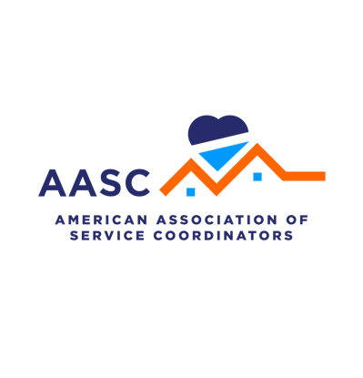
AASC Business Case & Impact Planner
Pre-, during -, & post – event worksheets for attendees, plus templates to help you build your case to attend #AASC26!

JUSTIFICATION DASHBOARD FOR YOUR SUPERVISOR
What is the cost of you attending the event? (Registration, Hotel, Travel, etc.)
Early Bird Registration - $875 (member) $1,125 (nonmember)
Hotel - $249 / night
Per Diem - $80 / day
Travel -

Who is going to be there? (What relationships will you gain?)

How many contact training hours can you earn?
Conference attendees can earn up to 16 contact training hours. Service Coordinators are required to earn 12 continuing contact training hours each year. New Service Coordinators are required to earn up to 36 contact training hours in their first year. Attending conference for four days brings you near half the amount you would need to earn in your first year as a Service Coordinator.
I intend to earn

What answers can I find here for problems our organization is trying to solve? (Session topics, speakers, exhibitors, etc.)

Are there any testimonials from people who have attended in the past? (Ask fellow Service Coordinators or check social media to see what people have said)

How will you value the experience of this event? (The cost of the problems you are trying to solve, the answers you are looking for, the people you will meet, etc.)

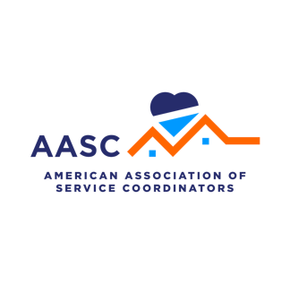
TEMPLATE EMAIL TO YOUR SUPERVISOR
To use if you prefer to send you supervisor an email, we’ve formatted one for you.

Subject: Business Case for Attending the 2026 National Service Coordinator Conference
Dear (Supervisor’s Name),
I’d like to request approval to attend the 2026 National Service Coordinator Conference from August 23 – 26 in Austin, Texas, as I am certain it will deliver measurable value to our organization. This conference has been hosted by the American Association of Service Coordinators for 26 years and has provided countless Service Coordinators with career development opportunities as well as insights to help affordable housing properties and their residents.
This conference is a national hub for trending research, best practices, innovative models, and essential resources in affordable housing. It will provide me with new perspectives on my programs and the needs of my residents and provide up to 16 contact training hours toward my HUD requirements.
At the national conference, I would have the chance to:

- Take part in educational topics that reflect today’s affordable housing landscape
- Receive training contact hours that go toward my annual HUD training requirements
- Network with other Service Coordinators who might share similar experiences, challenges and real-world solutions
- Learn about untapped resources and potential partnerships we could use at our property
- Gain insights into current resident programs and resident engagement opportunities

The early bird registration for members to attend is $875 and is an allowable program expense in HUD Service Coordinator budgets and grants. The conference will be held at the JW Marriott Austin, where I can stay for an added expense that would give me ease of access and simplify my travel and lodging. Travel and lodging for Service Coordinator trainings are also eligible HUD expenses.

The national conference is a win-win for myself and our residents, who would benefit from new ideas I come back with. Previous attendees of this conference have gained takeaways they can immediately use at their properties, and three out of four said the conference is valuable to their work! I’m working on a business case document that will outline my pre-event goals and my post-event learning that I can share when I return.

Since seats are limited and filling up fast, I’d like the opportunity to register on May 5th, when early bird registration opens. Please let me know if you have any questions. I appreciate you taking the time to consider my request.

Thank you!

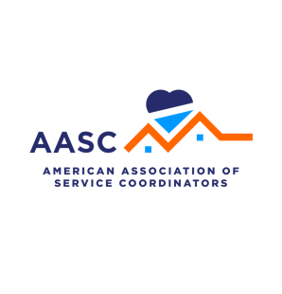
FOR THE REGISTERED ATTENDEE: PRE-EVENT
You’ve invested time and resources to join AASC26 – make it count! Use this worksheet to set clear intentions and design the experience you want. Spend a few minutes mapping your goals and a create a story uniquely yours.

What problems am I trying to solve?

What three learning opportunities can I find or create (a topic, a speaker, a person to meet, and exhibitor, etc.)?

Who can I partner with to find solutions (attendees / exhibitors)?

Here are three topics I want to ask other Service Coordinators how they are handling:
1.
2.
3.

What new experiences will I seek out at this event?

What are the biggest challenges that my residents face that I hope to find solutions for?

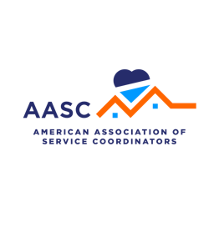
FOR THE REGISTERED ATTENDEE: DURING THE EVENT
You’ve invested time and resources to join AASC26 – make it count! Use this worksheet to set clear intentions and design the experience you want. Spend a few minutes mapping your goals and a create a story uniquely yours.

What are the top three resources I’ve discovered at this event?

What are my key discoveries, solutions, and surprises?

What training has been the most helpful for me?

Who have I met at conference that has provided me some great insight?

If I’m not where I need to be, how do I plan to get there? (More education, more resources, more career opportunities, etc.)

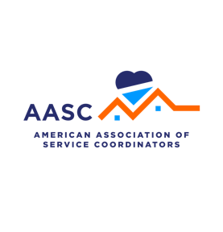
FOR THE REGISTERED ATTENDEE: POST EVENT
Complete the following form to give to your direct supervisor.

What are the tangible things that I am bringing back from this event? (Notes, best practices, resources, advice, etc.)

What relationships did I create?

Who will I follow-up with after the conference?

What was my lightbulb moment – my one key takeaway?

What solutions did I find and how will I implement them?

What resources did I acquire that will help me work better with my residents?

Which presentation impacted me the most and why?

Was the value of attending conference worth the cost? (Training contact hours, networking, new resources, best practices)

