Goal Setting Tips

Keep them few in number | Focus on a handful of goals so that you can repeat almost from memory.
Make “SMART” goals  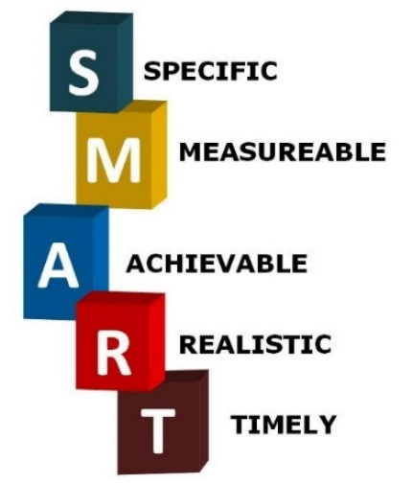 | Goals must meet five criteria:  Specific—identify exactly what you want to accomplish as specifically as possible  Poor: Hold a webinar.  Good: Hold a webinar about FDA recommendations in the new Generic Drug Development Guidance.  Measurable—quantify the result so you know if the goal has been met  Poor: Conduct student outreach.  Good: Visit 5 student chapters.  Actionable—every goal should start with an action verb (e.g., submit, develop, conduct, enhance)  Poor: Be more consistent in posting discussions.  Good: Write 2 posts per month.  Realistic—good goals should advance the group, but must be obtainable  Poor: Hold a successful workshop.  Good: Hold a workshop that has a 95% satisfaction rate from the attendees.  Time-bound—every goal needs a date when you plan to deliver on it  Poor: Submit a white paper.  Good: Submit a white paper by April 2020.
Build SMART goals collaboratively | The community’s goals should:  - Support the AAPS strategic plan  - Relate to the community’s prior goals  - Be SMART goals  - Be developed in collaboration with your volunteers and other communities with similar interest areas
Review them frequently | Reviewing goals on a regular basis is what turns them into reality. Ask yourself, what is the next step needed to move towards achieving this goal.

