Engaging Your Community Members

Inspiring community participation takes a thoughtful process. How do you empower and encourage community members to participate?

First, it helps to understand that community engagement is both a process and an outcome. It’s a process in which your community’s leadership team and the community members build ongoing relationships to elevate and apply their collective vision for community. It’s an outcome in that people are willing, ready, and able to advocate effectively for that vision.

This guide outlines best practice strategies that drive long-term member engagement in your online community. The goal is to show your members what they can do in your community so that you are leading by example.

Remember, your community’s members value peer to peer connections and your expertise.

Log in at community.aaps.org to get started!

Contents

Tip 1: Ensure all community leaders update their profiles and upload photos. 2
Tip 2: Engage members with discussion posts. 3
Tip 3: Add “Postings” as discussion topic on the monthly leadership team meeting agendas. 4
Tip 4: Respond to all discussion posts published by community members to encourage and continue ongoing, useful scientific conversations. 5
Tip 5: Share meeting minutes as a discussion post with a high-level meeting summary. 6
Tip 6: Supplement virtual or in-person experiences with online discussions. Let these activities inform the other in a connective cycle. 7

Tip 1: Ensure all community leaders update their profiles and upload photos.
How To  Leadership with completed profiles and photos creates a more personal approach to interactions with your members.  Select the dropdown menu in the upper right-hand corner and go to PROFILE. | 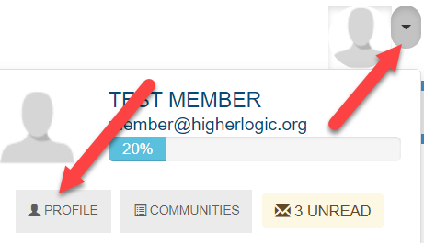
Example  View Hristo Svilenov’s Profile for a great example of a completed profile. | 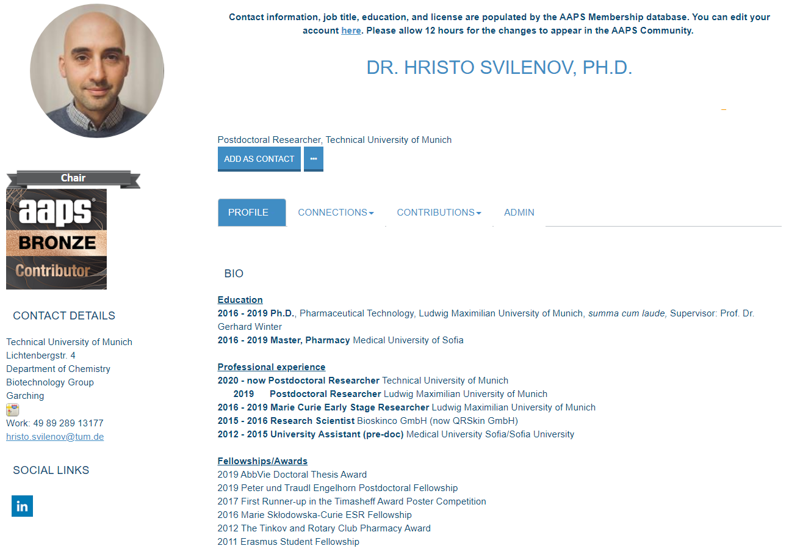

Tip 2: Engage members with discussion posts.
Start the conversations!  The most important task of each community is to engage AAPS’ members through the online community platform. | - Ask questions: What do you want to know more about? Have a question about advancing in your field, or common challenges in your research? There's someone out there with the answer.  - Share ideas: Is there a hot topic you want to discuss? How about a best practice you've learned that might help others in your field? Start a discussion thread to give others a peek inside your world or to demonstrate your expertise on a topic.  - Spread knowledge: Upload useful resources to the community library and see what others have uploaded.  - Give feedback: Use your knowledge and experience to answer other members' questions. Simply click on the "Reply to Discussion" button to the right of any discussion post, to post your response. You may also add comments to library entries.  - Tag experts: Encourage certain individuals to contribute based on their unique knowledge or perspective (i.e., single out subject-matter experts using the tagging feature and invite them to share their experiences. Inviting members to weigh in produces far more powerful results.  A successful community is fostered by these best practices:  - Membership aims to create a sense of belonging and make people feel like insiders  - Fulfillment means that community members find immediate value in participating  - Gratitude to show appreciation for community members  - Influence is gained by showing how members’ input influences decisions  - Connection is established when the community supports shared experiences

Tip 3: Add “Postings” as discussion topic on the monthly leadership team meeting agendas.
How To  Discuss community posts during your monthly leadership team calls.  This is a sample layout to organize and schedule discussion posts.  Ensure community leaders maintain discussion posts and aim to publish at least one new post per month. | Subject Line for Post Question (Body of Post) Leader Assigned to Post Question Posting Date Response to Post (Body of Post) Leader Assigned to Post Response Response Posting Date  Discussion posts build engagement and knowledge-sharing in your community and these tips will help you get started:  - Keep adding questions. When the community launches, and throughout periods of inactivity in the community, you will want to post questions to boost engagement and encourage participation.  - Have authors post their own questions. It’s important that the user who submitted the question is also the one who posts it. We want other members to see their peers engaging with the community.  - The more members we have posting, the better! Members are more likely to respond to their peers’ questions! They are also motivated to create discussions of their own and to reply to existing discussions after seeing their peers engage in the same behavior.  - Work as a team to encourage respondents. You can ask someone in the Community Leadership Team to respond to a question that hasn’t picked up momentum yet. The first response, even if it comes from a member of the community’s leadership, can inspire others to weigh in.
Example  View this great example from the Therapeutic Product Immunogenicity Community. The team talks about discussion posts during their monthly leadership team calls. | 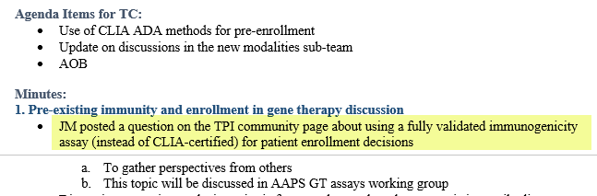

Tip 4: Respond to all discussion posts published by community members to encourage and continue ongoing, useful scientific conversations.
How To  Task Member Engagement Managers with monitoring posts in the DISCUSSION tab and alerting the leadership team when a new question has been posted. | 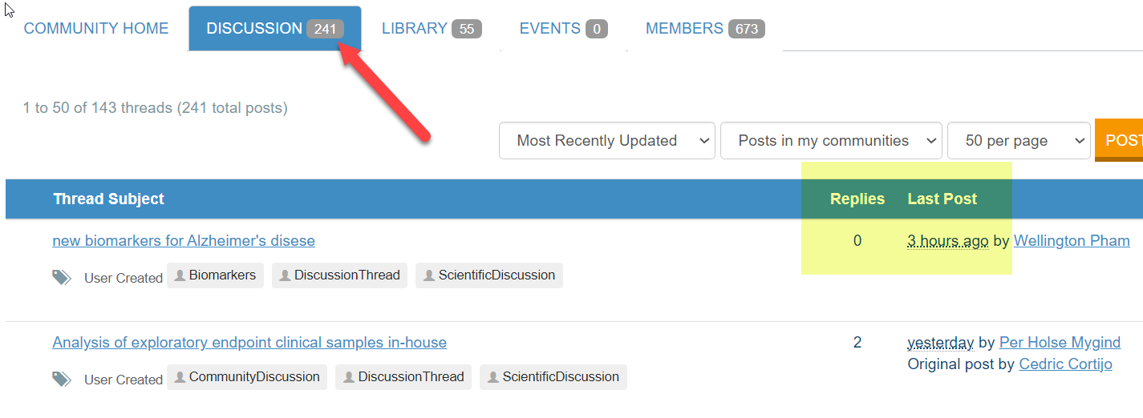
Example  Task a member of the community leadership team to respond to the post. Every question should have at least one response.  This is a great example from the Bioanalytical Community where the person asking the question received a prompt response. | 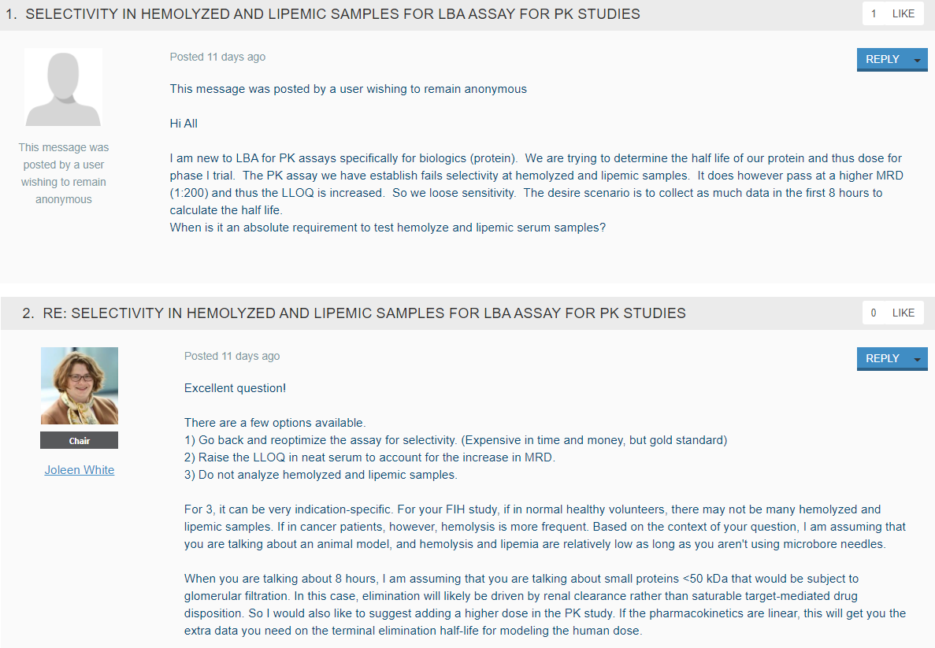

Tip 5: Share meeting minutes as a discussion post with a high-level meeting summary.
How To

Adding the monthly leadership team meeting minutes to the community library is a great practice.

We encourage you to take this a step further and create a post about your discussions.
Example  This is a perfect example from the Ocular Drug Delivery and Biopharmaceutics Community. | 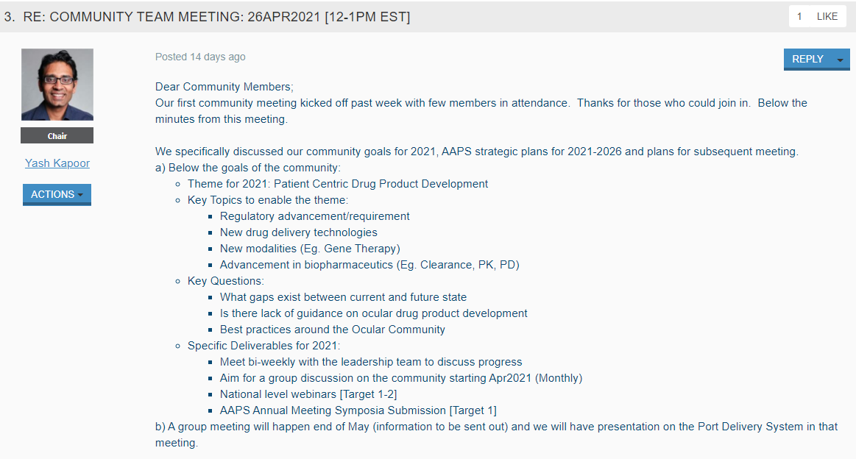

Tip 6: Supplement virtual or in-person experiences with online discussions. Let these activities inform the other in a connective cycle.
How To

Inviting community members to your events is a must. It is also a best practice to add a link to a virtual event recording in your community.

We encourage you to take this a step further and create a post about the questions and answers that were addressed during the event. This will allow your members who could not attend the event to also benefit from the exchanges.
Example  This is a great example from a virtual Novartis event and attendees engaged with the speakers through online discussions. | 