JOIN OUR TEAM

ASSOCIATE DEAN FOR RESEARCH

The University of North Carolina at Chapel Hill School of Nursing (SON), a research-intensive, top-ranked school of nursing, seeks outstanding candidates for a tenured position at the rank of Professor to serve as Associate Dean for Research. Both the SON and the university foster a highly collaborative research environment. The SON has significant dedicated research space including a state-of-the-art Biobehavioral Laboratory. The SON is located within walking distance to the university’s top-ranked schools of medicine, public health, pharmacy, dentistry and social work located within steps of each other and is adjacent to UNC Hospitals. SON faculty lead and collaborate on a diverse portfolio of multidisciplinary studies. The school ranks 12th for NIH funding, with SON faculty receiving over $12 million in external funding in 2021.

We invite candidates with a strong record of externally- funded research as a principal investigator who will provide strategic direction for SON research and mentor faculty on the development of their research programs. An ideal candidate:
(a) will have experiences in leading team efforts toward the development of center grant proposals, and (b) can both harness and focus faculty areas of research in ways that facilitate multiple principal investigator and co-investigator levels of collaboration among faculty in the SON. We are seeking a doctorally-prepared, tenurable individual who demonstrates a commitment to equity and to ensuring a climate that supports inclusion among faculty, staff, and students. Further, we are seeking an individual who acts as a role model and champion for service excellence and continuous improvement, encourages innovation and risk- taking, speaks candidly about negative trends and encourages appropriate action, listens to feedback, and is willing to make timely decisions.
The Associate Dean for Research guides the direction of the school's research programs and advocates for the school and nursing research mission and the development and support needs of faculty. The Associate Dean also provides oversight for the Office of Research Support and Consultation (RSC) and chairs the Research Division, the administrative home for faculty whose primary function is research related. As chair of the Research Division, the Associate Dean oversees faculty recruitment, appointment and promotion, and performance evaluations for research- division faculty, advocates for these faculty as needed in various school forums and holds regular meetings of the Division faculty.

The Associate Dean for Research reports to the Dean. S/he works closely with other Associate and Assistant Deans to facilitate the research endeavors of the school and faculty and to facilitate extramural grant submissions by doctoral and postdoctoral students. The Associate Dean also works closely with and maintains liaison relationships with various University research offices and committees. The Associate Dean for Research supervises the RSC’s faculty statisticians and the Director of the RSC, who supervises the RSC editors, proposal specialists, and budget personnel. The Associate Dean is supported by an RSC Advisory Board and RSC consultants - a group of four to six faculty who receive workload credit to mentor and support their colleagues as they develop proposals for external funding.

The School of Nursing recognizes the importance of an educational and work environment in which all individuals are respected and valued. To that end, we are strongly committed to hiring and retaining a diverse workforce.

REQUIRED QUALIFICATIONS
Doctorate (nursing and/or related field)

PREFERRED QUALIFICATIONS
Substantial experience working with nurse scientists
Extensive history of funded research from various external sources.
Experience mentoring faculty and students in developing research competence
Experience that demonstrates the ability to lead teams toward the development of center grant proposals. Experience that demonstrates the ability to promote multiple principal investigator and co-investigator levels of collaboration among faculty.

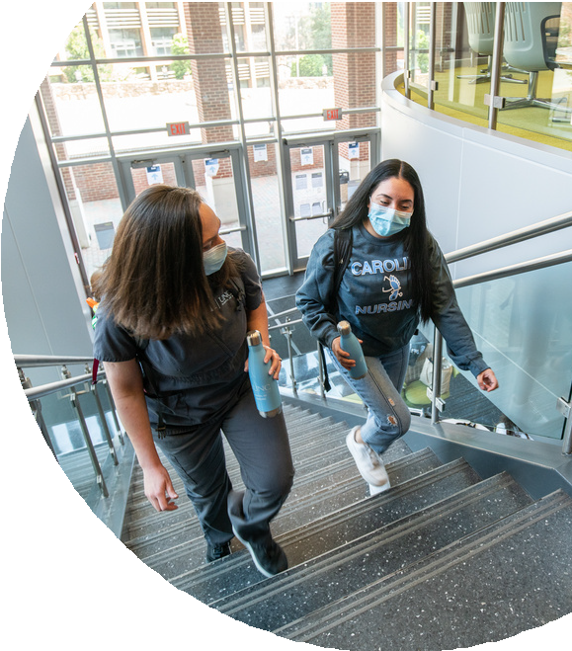
TO APPLY
ASSOCIATE DEAN FOR RESEARCH

Please visit the online position posting and application at
UNC.PEOPLEADMIN.COM/POSTINGS/242091
A review of applications will begin immediately, and the position will
remain open until filled. For questions, please contact search committee co-chairs Dr. Saif Khairat (saif@unc.edu) or Dr. Peggy Wilmoth (wilmothp@email.unc.edu).

THE UNIVERSITY of NORTH CAROLINA
at CHAPEL HILL SCHOOL of NURSING

The first public university in the United States, the University of North Carolina at Chapel Hill ranks among the nation’s great institutions of higher education, set on a historic and beautiful campus that celebrates all four seasons.

Carolina’s students, faculty and staff come to Chapel Hill from around the world, bringing varied cultural, racial, socio-economic and ethnic heritages that help make UNC-Chapel Hill a thriving and diverse global intellectual center.

At Carolina Nursing, we develop exceptional nurse leaders who advance health
care to improve lives. We drive the state of nursing science and translate our discoveries
into better practice and systems of care. We serve the needs of our neighbors and export our
expertise to nurse educators, scientists, and practitioners around the globe. In all these ways, Carolina Nursing leads and promotes the profession for the greater good.

Established in 1950, the UNC School of Nursing is part of a cutting-edge, research-intensive university. The school offers top-ranked BSN, MSN, DNP and PhD degree programs, as well as post-graduate certificate programs.

We know from experience that where Carolina Nursing and its graduates lead, improvement follows. And it is this improvement — in systems, in practice, in education, in health, in the lives of people near and far — that informs and inspires our work.

To that end, the UNC School of Nursing is actively engaged in seeking to recruit and retain brilliant, collaborative and diverse faculty and staff to help us fulfill our mission to advance health for all. If you are interested in joining our community, we want to hear from you.

The University of North Carolina at Chapel Hill is an equal opportunity and affirmative action employer. All qualified applicants will receive consideration for employment without regard to age, color, disability, gender, gender expression, gender identity, genetic information, national origin, race, religion, sex, sexual orientation, or status as a protected veteran. Males and minorities are encouraged to apply.

