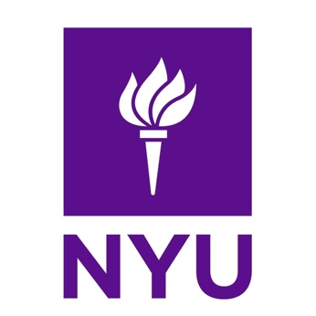

Dean, Rory Meyers College of Nursing
New York University
New York, NY

The Rory Meyers College of Nursing at New York University (NYU) invites applications and nominations for Dean. NYU, founded in 1831, is the largest private university in the United States, with 19 schools and colleges and a thriving global network of campuses, over 5,000 full-time faculty, and more than 53,000 students. NYU is recognized as one of the most prominent and respected research universities in the world and is a member of the distinguished Association of American Universities.

The NYU Rory Meyers College of Nursing (Meyers) is the second-largest private university college of nursing in the United States and reflects the intellectual curiosity, dynamism, and quality characteristic of NYU. NYU Meyers has grown its research portfolio substantially, jumping from 50th in the annual ranking of research funding received from the National Institutes of Health (NIH) in 2008 to ranking in the top 15 among all nursing schools every year for the past 12 years. In 2022, NYU Meyers ranked ninth in the US News and World Report for best undergraduate nursing programs. In addition, NYU Meyers received the Health Professions Higher Education Excellence in Diversity (HEED) Award from INSIGHT Into Diversity magazine for the past two years for demonstrating an outstanding commitment to diversity and inclusion. In recent years Meyers has sustained major growth in research funding, received a transformative $30 million naming gift, moved into a new building, developed the nation’s first design thinking-led undergraduate curriculum, and expanded its global presence and partnerships, among many other milestones.

Building upon the excellent reputation and dynamism of NYU Meyers, the next Dean will set and execute an ambitious, creative, and distinctive vision that extends Meyers’ global reach and impact. The Dean will embrace interprofessional activities and seek partnerships, support, and resources to advance research, scholarship, service, and clinical opportunities. The Dean will be a forerunner in a new era of nursing and harness opportunities to further elevate Meyers as a pioneering leader. The Dean will shape the future of Meyers and have a significant impact on nursing locally, nationally, and internationally.

To fulfill accreditation requirements, the Dean must be a registered nurse (RN) with a graduate degree in nursing and hold an earned doctorate. The Dean must also have a current or eligible RN license to practice nursing in the state of New York. Significant experience in nursing leadership, education, practice, and/or research is expected.

NYU has engaged Isaacson, Miller, a national executive search firm, to assist in the search. Applications, nominations, and inquiries can be submitted at www.imsearch.com/8610.

New York University is committed to equity, diversity, and inclusion and is an equal-opportunity employer. It encourages inquiries from candidates who will enrich and contribute to the cultural and ethnic diversity of the University. New York University does not discriminate on the basis of age, race, creed, color, religion, marital status, gender identity and/or expression, sexual orientation, veteran status, national origin, or disability status in employment, or in its education programs.

Salary range: $458,000 - $528,000/yearly

