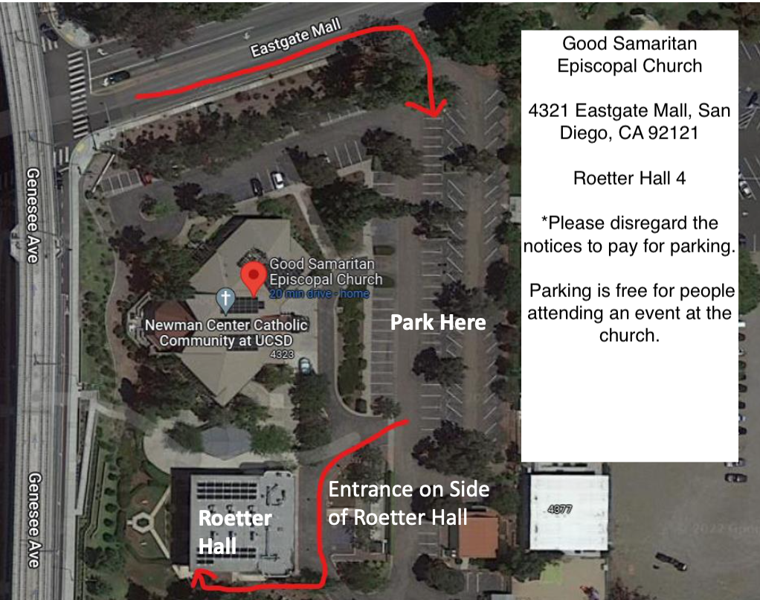
GOOGLE MAP LINK FOR DIRECTIONS: CLICK HERE

APPLE MAP LINK FOR DIRECTIONS: CLICK HERE

WAZE MAP LINK FOR DIRECTIONS: CLICK HERE
