FOR IMMEDIATE RELEASE

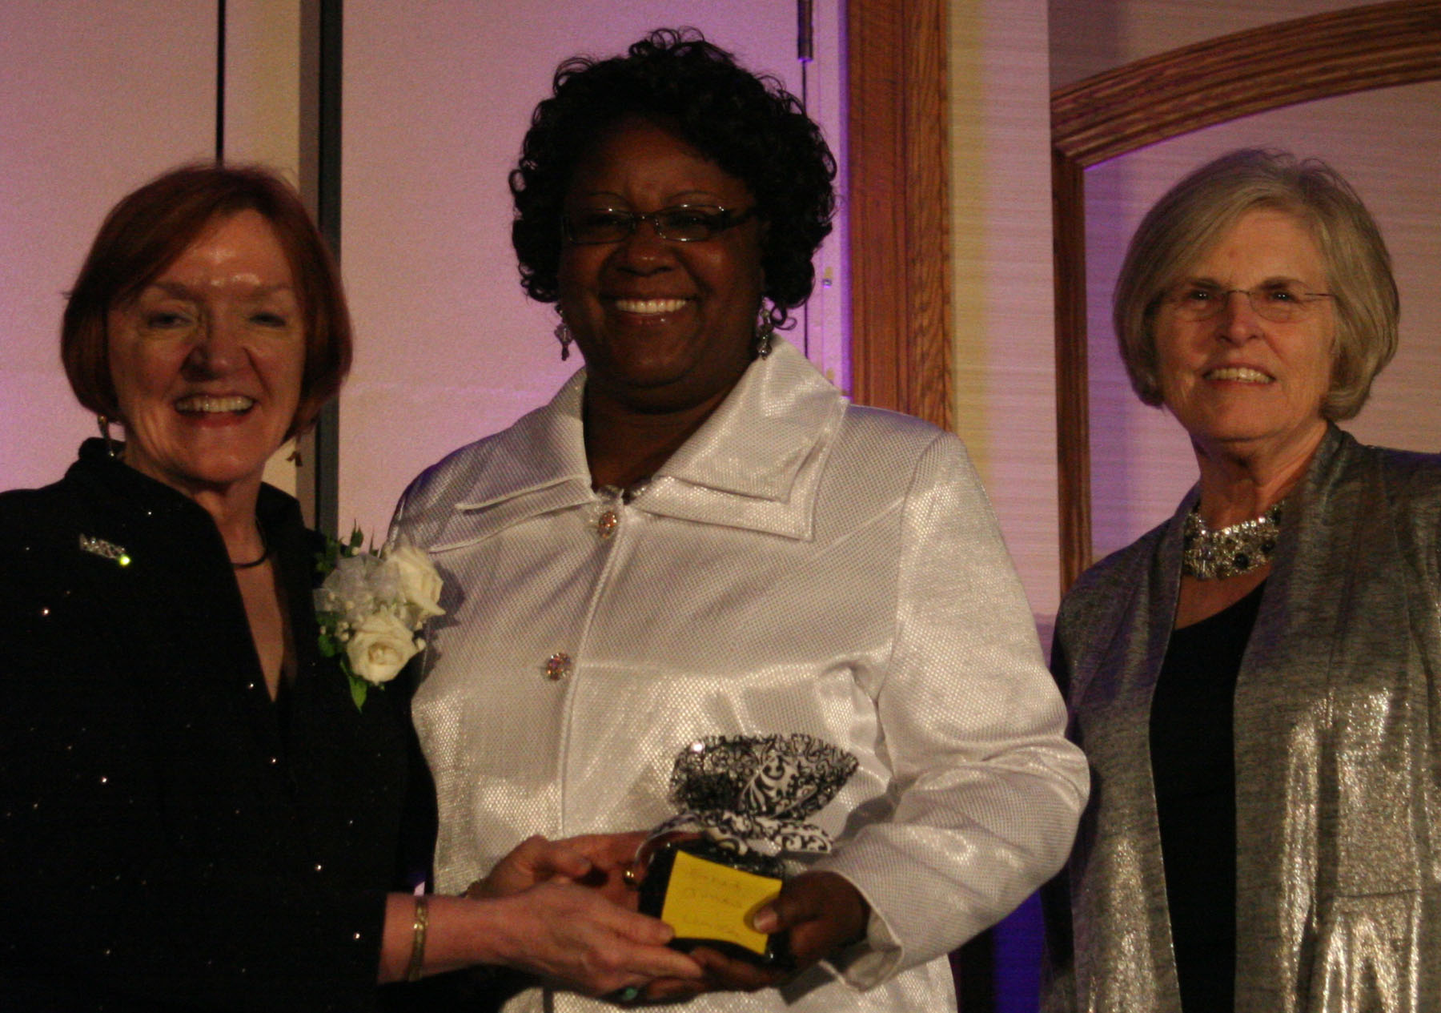

Jones Receives National “Leaders” Award

Alexandria, Va. – July 28, 2014 – The American Association of Family & Consumer Sciences (AAFCS) honored its Leaders Award recipients at a ceremony during the 105th Annual Conference & Expo in St. Louis, Missouri, on June 28th. Among those selected for the prestigious award is Ethel G. Jones, department chairperson, South Carolina State University, Orangeburg, South Carolina.
Established at the association’s 75th anniversary observance in 1984, the AAFCS Leaders Award honors family and consumer sciences professionals who have made significant contributions to the profession through their national leadership in AAFCS.
Jones has influenced the direction and attention given to family and consumer sciences in a multitude of roles, from Cooperative Extension, high school teacher, event coordinator for FHA (aka FCCLA), graduate teaching and research assistantships at Iowa State University to her current position as department chair at South Carolina State University. Her most recent initiative was the Orangeburg County Initiative to address the issue of obesity. Jones has also served on numerous committees, councils, and boards, including serving as past president and current treasurer of the South Carolina Affiliate of AAFCS.
-more-

About the American Association of Family & Consumer Sciences (AAFCS)
Based in the Washington, D.C., area, AAFCS is the only association for family and consumer sciences students and professionals across multiple practice settings and content areas. For more than 100 years, AAFCS has focused its mission on providing leadership and support for professionals whose work assists individuals, families, and communities in making more informed decisions about their well-being, relationships, and resources to achieve optimal quality of life. AAFCS members provide research-based knowledge about the topics of everyday life to help create healthy and sustainable families. These topics include human development, personal and family finance, housing and interior design, food science, nutrition and wellness, textiles and apparel, and consumer issues. AAFCS members are located nationwide, and include educators, administrators and managers, human service and business professionals, researchers, community volunteers, and consultants who develop research-based information and deliver programs on essential skills to help individuals and families be better prepared to live, work, and succeed in today’s complex and diverse world.

Field of Family & Consumer Sciences
Family and consumer sciences (FCS) draws from broad and diverse disciplines to develop and provide content and programs that help individuals become more effective critical thinkers and problem solvers. Through discovery and delivery of research-based knowledge, FCS professionals help individuals and families develop essential skills to successfully live and work in a complex world. Professionals in the field are uniquely qualified to speak on many critical issues affecting individuals and families, such as maintaining a healthy lifestyle, wisely managing personal and family finances, and creating supportive relationships with family members, friends, and co-workers. They are located nationwide in a variety of practice settings, including secondary schools, universities, government agencies, and businesses.

For more information, please contact:
Gwynn Mason
Director of Communications, AAFCS
703-706-4613
gmason@aafcs.org

# # #

