Colorado/Wyoming
Affiliate News
Spring 2026

Published by the Colorado Association of Family & Consumer Sciences

Colorado and Wyoming are Affiliates of the American Association of Family & Consumer Sciences

Dedicated to improving quality of life for individuals and families since 1908

What’s In This Issue?
2026 CO/WY Fall Conference
WY & CO President’s Messages
Highlights 2025 CO/WY Conference
Advocacy Update: Would You Consider

SAVE THESE DATES!!
2026 CO/WY Fall Conference
November 13-14, Cheyenne, WY
Put this Date and Place on the calendar NOW and join your fellow Family and Consumer Science professionals as we focus on how FCS can be a collaborative force which addresses issues impacting individuals and families.
Details are coming together and you will receive more information as details are finalized. For those who will travel from a distance to Cheyenne and come on Friday, that afternoon will include examples of community resource organizations with can collaborate with FCS professionals.
Included on Friday is Healthwork, a health services center originally opened for low-

income families in Cheyenne, but now open to all individuals; Cheyenne Bookmobile, and The Children’s Museum. Presenters will share how they work with community members to expand available resources. Friday will conclude with a no-host networking dinner.

WAFCS President Message
Virginia Vincenti
Wyoming AFCS President
FCS is a profession designed to prevent the onset or future incidence of specific problems. Too often we use tertiary prevention to address quality of life symptoms or consequences which we name as problems after they have developed. But this approach does not reduce incidence or prevalence. Secondary prevention focuses on early intervention that decreases the prevalence of specific problems. However, primary prevention saves time, money, suffering, lost productivity, and more.
As a primary preventive force FCS addresses complex problems which have ethical consequences. Therefore FCS needs to focus

on choosing the best course of action individuals and groups collaboratively could take to critique present actions and social structures for the purpose of preventing problems for the benefit of all individuals, families, and society.
It empowers constituents to assume agency for their own lives, families, communities, state, country, and to function as global citizens. It encourages them to be proactive, take initiative and responsibility, influence and take leadership. Whereas, other people and circumstances influence reactive people, and do not take responsibility or initiative.
Societal problems FCS can help to prevent are heart disease, type 2 diabetes, some cancers, and obesity. It can also help to prevent food and nutrition insecurity, financial insecurity and housing problems, mental illness and suicide, and food and clothing waste.
If you think this is hyperbole, think about what FCS encompasses, nutrition and food science, human development and family relationships, consumer issues and personal finance, housing and interior design, and textiles and apparel. All these specializations are interrelated in people’s lives and interfaced with societal systems that support
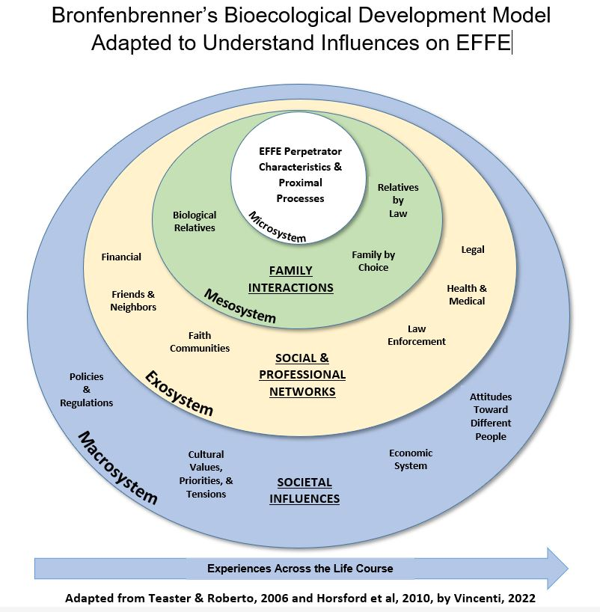

and influence them. Bronfenbrenner’s is helpful in understanding these intersections.
However, in today’s world, deep and narrow perspectives and professional practice seems to be rewarded more than being about critically examining the connections and consequences of focusing on consequences and symptoms instead of preventing the underlying problems. We need to support FCS as an interdisciplinary profession that is greater than the sum of its separate specializations.
Without support and practicing in this manner, there is no argument for keeping our specializations together. We cannot resist having them dispersed into other root disciplines across higher education campuses and as in the current Career Cluster.
Regardless of whether you work in a specialization, you can professionally practice with this comprehensive approach using critical thinking and ethical reasoning and collaboration with other FCS professionals. With this vision and purpose, we need to promote FCS education because we have many current teachers and Extension educators who are nearing retirement age. We already have too many teachers who do not hold Professional Licenses, more so than all other K-12 teachers in WY.
Over half of all states struggle to hire qualified FCS teachers and retain them. Many school administrators face a difficult decision when an FCS teacher retires: do they hire an underqualified teacher or close a program? There are not enough colleges and universities providing a robust FCS teacher preparation program. Texas Tech University is the only one offering a doctoral degree.
We need to tell our stories and share our strengths, not only with our students (youth

and adults) in our communities, but also school boards and school administrators, state education administrators, higher education and Extension administrators, community groups/influencers, legislators, and the general public and media.
The AAFCS Past President’s Unit has developed a template and a process for telling stories of the impact of our work. Please consider submitting a story. For more information, contact Ginny Vincenti, PhD, vincenti@uwyo.edu, 307-399-9753.
Ginny

CAFCS President’s Message
Jeanine Pope
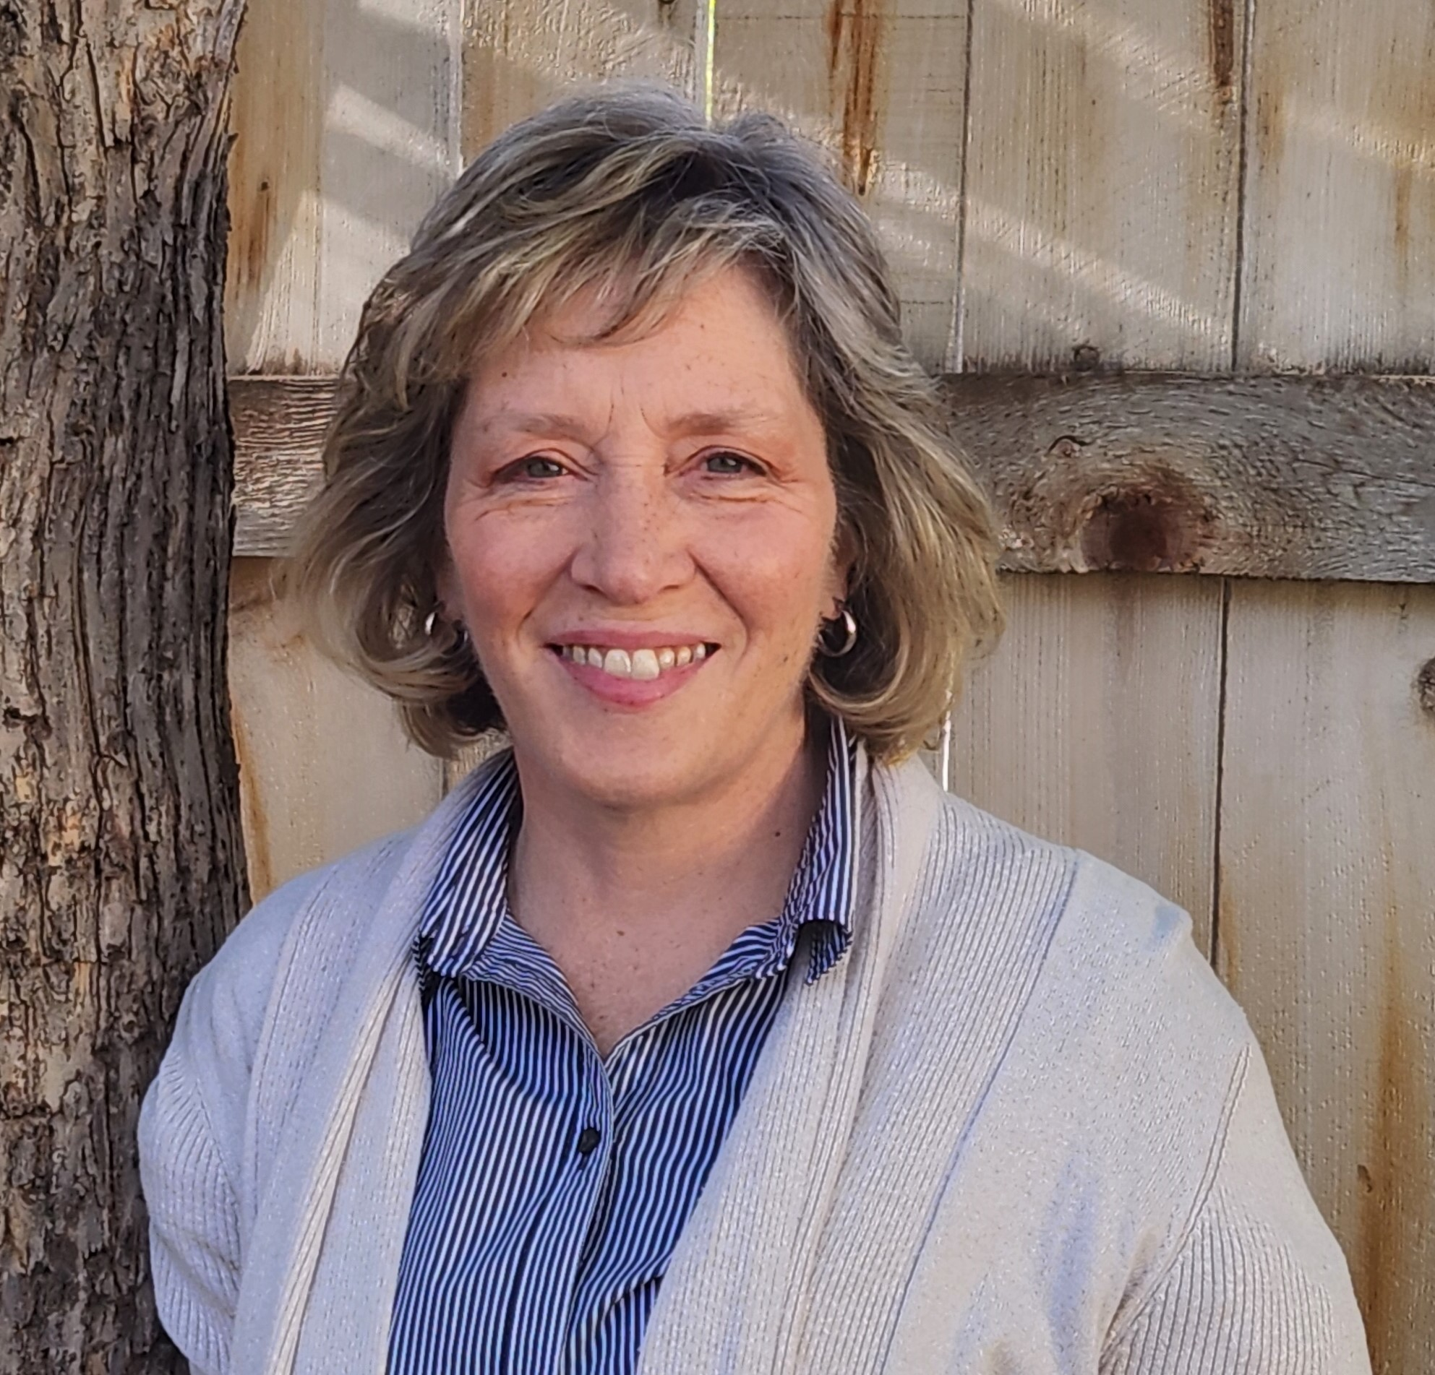
CAFCS President
Hello everyone! I am happy to update you on some of the latest news from the Colorado affiliate!
In November we held a Mini Conference hosted by Jessica Teal at Windsor High School. The day focused on Financial Literacy topics, and brought together members and guests from both Colorado and Wyoming.
Virginia Vincenti, President of the Wyoming affiliate, started the day discussing information from her session “ FCS as a Preventive Force.” She spoke of ways FCS professionals can play a role in addressing many of today’s societal problems with the groups we work with.
Manuela Ortiz from the Wyoming Housing Network, Christy Biedron from Junior Achievement, and Stephanie Hartman from

the Colorado Department of Education presented sessions. They introduced us to resources which can be used in Extension programs and in our classrooms. Lunch provided a time for attendees to visit and network with one another using some “prompting” questions for discussion.
Luann Boyer, our Executive Director, and I attended the CATFACS conference in Colorado Springs January 30th and 31st. We had a CAFCS exhibitor table and I presented a session titled, “Your FCS Story: Its Impact and Sharing with Others.”
Participants wrote and discussed times they made an impact on students. A couple of the stories have been posted in the “FCS in Action” section on the Colorado CAFCS microsite. In addition, the ways FCS can be promoted were also presented. At the end of the session, attendees were encouraged to join AAFCS and were shown the benefits of membership.
The AAFCS Annual Conference will be in Louisville, Kentucky, June 18 - 21. This is a good opportunity to gain professional development, network with others, and explore emerging trends in Family and Consumer Sciences!
Please let me know if you have any comments or questions about CAFCS. My email is jeaninepope4@gmail.com
Jeanine
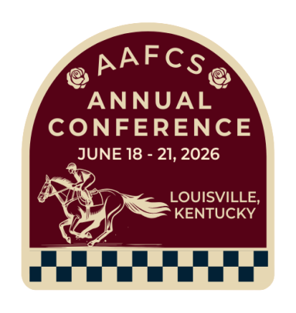
See you in Louisville !!!

Congratulations Jessica Teal
Congratulations to Jessica Teal for being awarded the Colorado affiliate Teacher of the Year award! We were proud to have her represent Colorado for the National Teacher of the Year award.
This recognition highlights her dedication and outstanding contributions to the field of Family and Consumer Sciences education. Jessica's passion for teaching and the positive influence she has on her students set her apart. She is truly deserving of this honor!
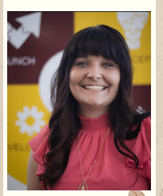

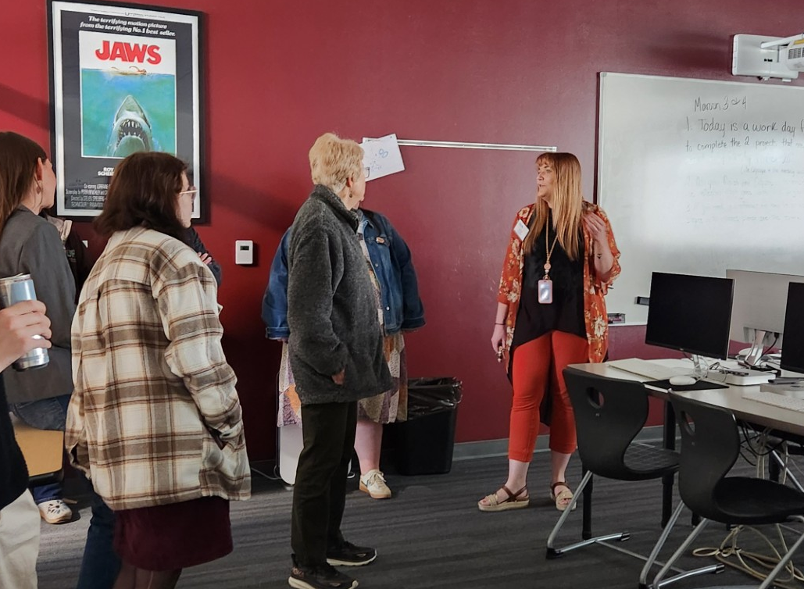

Jessica giving a tour of the FCS Department at Windsor High School .

2026 Colorado Legislature Update
Submitted by Carole Makela
(Editor Note: Due to this Newsletter being delayed, the Colorado Legislative Session is over, but Governor Polis is still making decisions regarding legislation to sign or not. Currently, there is quite a bit of information in the news regarding legislation which passed and also that which did not.
Carol has included lots of good information about these bills which relate to youth, families, education, health care, etc. )

The Colorado Legislators began their 2026 session January 14. As of March 9th, the House had introduced 325 bills and the Senate 135. More will likely be coming before the session ends on May 13th. The bills can be found and followed at https://leg.colorado.gov/bills
Live and repeat coverage of the Session and the committee hearings are at https://coloradochannel.net You can sign up to testify at committee hearings on this site.
Share your views with your representatives in the Senate and the House. Their contact information is at the link in the first paragraph above.
As examples, 3 bills in the Senate and House related to FCS are listed here.
SENATE
SB26-020—Child Care Provider Licensing and Quality
SB26-032—Promoting Immunization Access
SB26-125—Disability Right Protections in Public Schools
HOUSE
HB--1028—Second Language Educational Program for High School Students
HB-1058—Protection for Minors Featured in Digital Content
HB-1090—Teacher Licensing Requirements
To show scope of the bills introduced, here are some areas/topics and the number introduced as of mid-March.
Gun Safety 5
Health Care 11 (includes reproductive rights/behavior health)
Housing 31
Justice, Equality, Diversity 38
Natural Resources/energy 26
In the bills on page 4, some bills fit into more than one area.
Some of Carole’s observations on bills introduced for your thinking:
- Bills to provide protections for Coloradoans threatened by actions at the national level (e.g., voting rights; human rights; natural resources protections)
- Bills in response to issues/problems experienced in Colorado recently (e.g., declining immunizations rates; professional misbehaviors/crimes; deaths)
- Bills in response to special interest groups, some groups from out-of-state have bill writing groups and share them with states and may fund lobbyists (parental rights; children’s rights, safety)
- Bills with a price tag for the state (tax dollars) are likely not to pass with CO’s current budget challenges and shortfalls. Fiscal notes appended to the bills show the costs to the state (and in some cases non-state costs, which may be local governments’ dollars and/or non-government dollars).
- As in the past, legislators may send some issues to the November 2026 ballot as Referendums for citizens’ votes. Tax issues are prime for this action.
Financial Literacy: Implementing with FCS Education
Stephanie Hartman
Colorado Department of Education
Legislation passed in May 2025 requires that all Colorado high schools will be required to incorporate all the financial literacy standards into a course which is required for high school graduation. Although some schools already
have this requirement, in the 27-28 school year, each student’s Individual Career and
Academic Plan (ICAP) must include exposure to federal financial and eligibility tools for those applying for state and federal financial aid for college.
All high school financial literacy standards must be taught within a single course but it does not have to be called Financial Literacy. The legislation gives broad discretion to schools and/or districts on how each will implement the new requirement.
This legislation has the potential to set the stage for Family and Consumer Sciences to take the lead for including Financial Literacy throughout their curriculum. FCS Programs which have this already in their curriculum, it provides the opportunity for more students to be exposed to the FCS Departments and the value of their programs for providing skills for a lifetime.

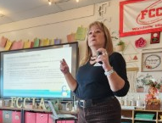

Presentation on Financial Literacy

Wyoming Housing Network
Manuela Ortiz, Housing Counselor Manager
Manuela discussed how the Wyoming Housing Network provides guidance to empower individuals to make informed decisions about accessing safe, affordable, and sustainable homes.

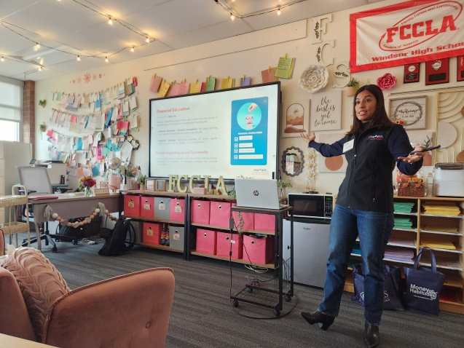
Manuela Ortiz giving updates about the Wyoming Housing Network.

One of the programs which the Wyoming Housing Network provides is Foreclosure Counseling. By completing the class, they know the steps to take when they are having problems covering their mortgage payment. Funding for the course is provided by the Wyoming Attorney General’s Office.
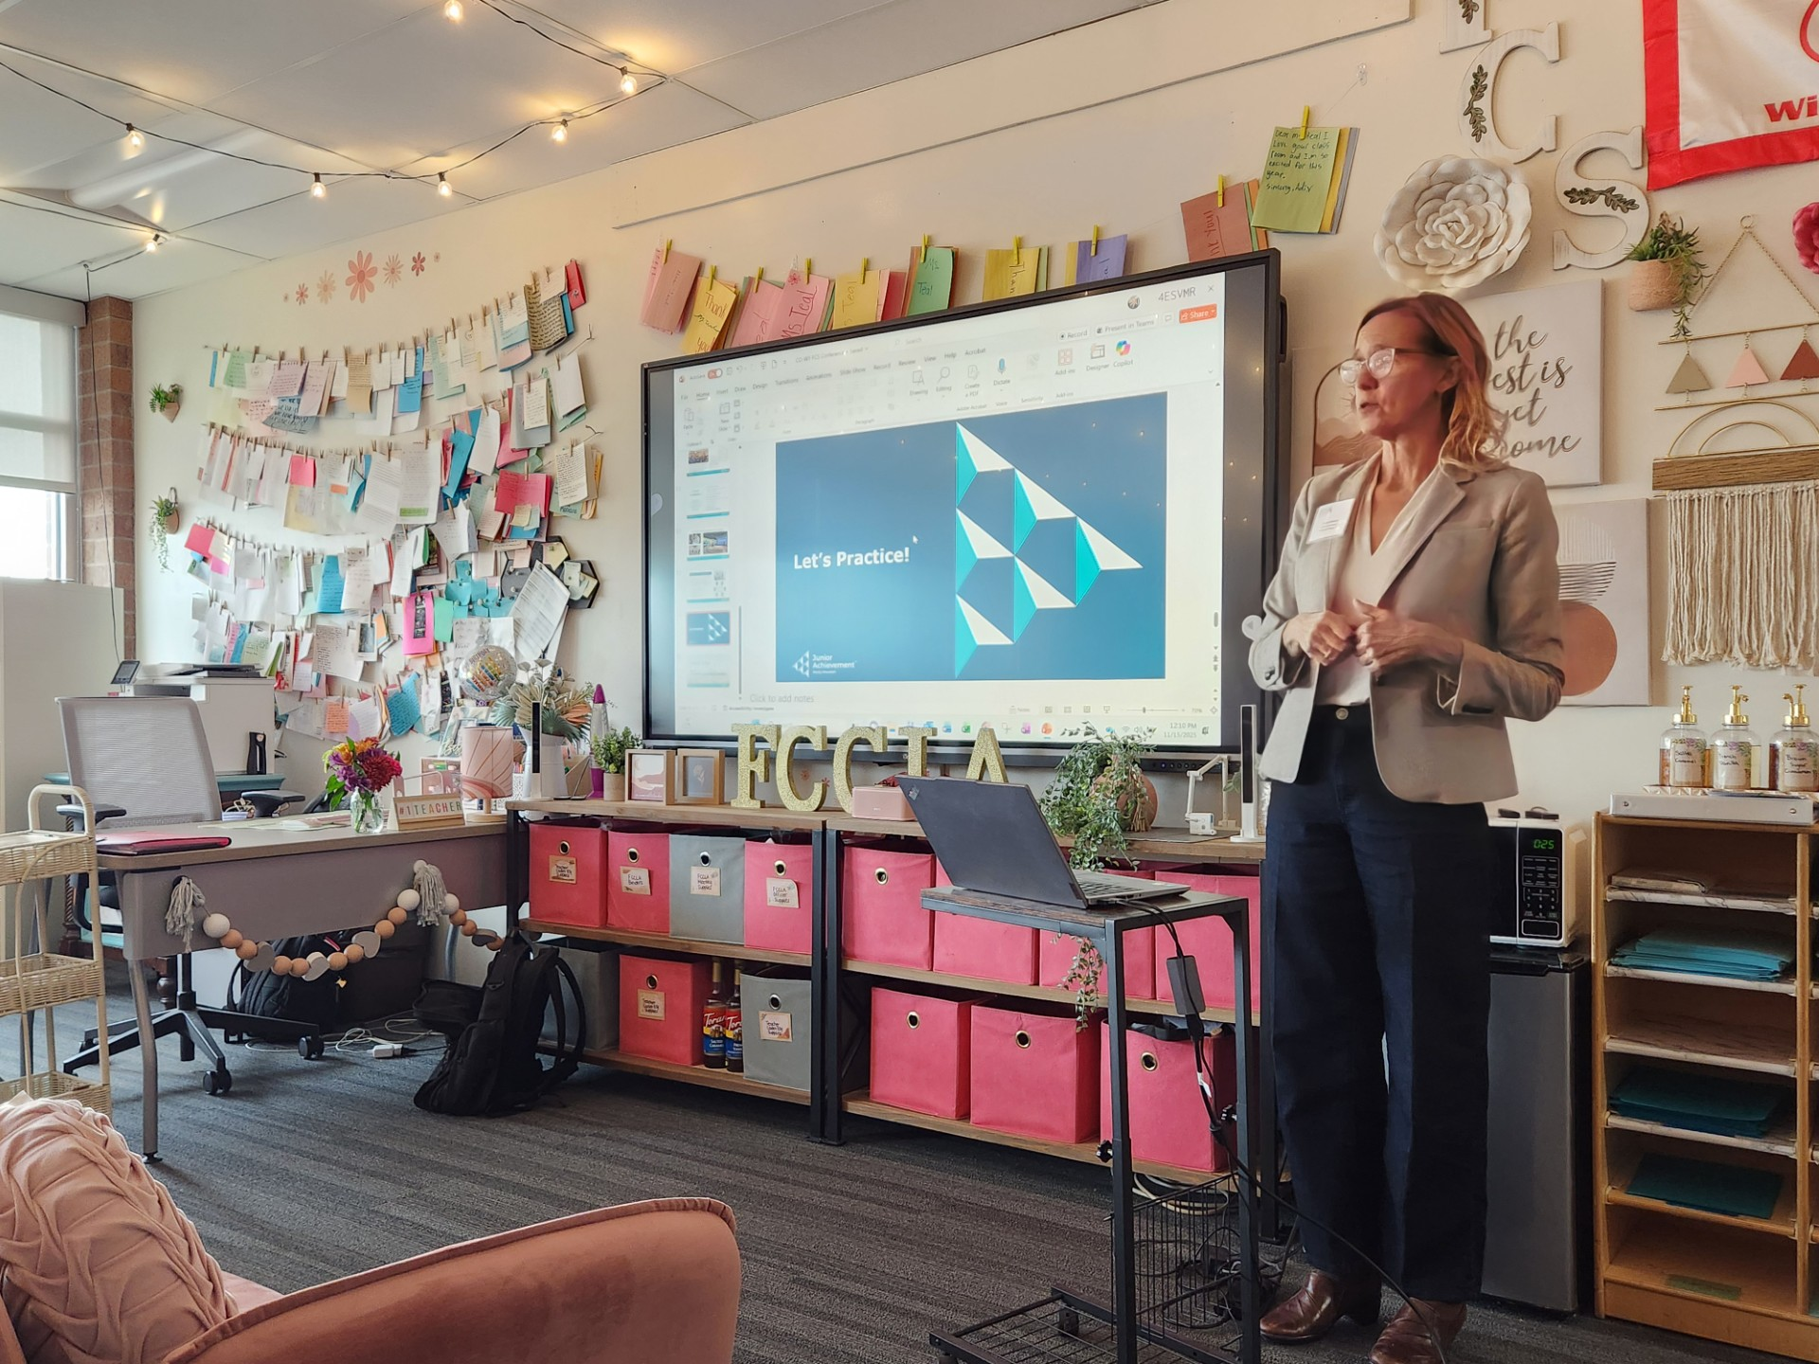

Motivating Youth for Success
Christy Biedron
Senior Director of Education
Junior Achievement- Rocky Mountain
Junior Achievement provides a variety of programs dedicated to motivating youth for future career success, self-sufficiency, and to make good financial judgements. The Curriculums are available for both middle and high school students.
Christy Biedron, Junior Achievement

Middle school students learn how they could start a new business by considering market structures, community events, and the global economy – all which are done by virtual simulation. These students learn business concepts which empower them to navigate our modern economy. Evaluation of students who complete the Business Quest activity show 75% of the students agree they understand how global events impact businesses.
The Junior Achievement Finance Park Curriculum is designed for Grades 9-12.
The 7 lessons each have a specific theme and involve simulation activities. Themes are: Employment and Income
Employment and Education
Financial Responsibility and Decision
Making
Planning and Money Management
Risk Management and Insurance
Investing
Finance Park Simulation
The Junior Achievement Business Quest Simulation prepares students for life and work in the real world. Students select their career and then “receive a job, salary, credit score and family situation” they use to calculate their income and to plan a budget.

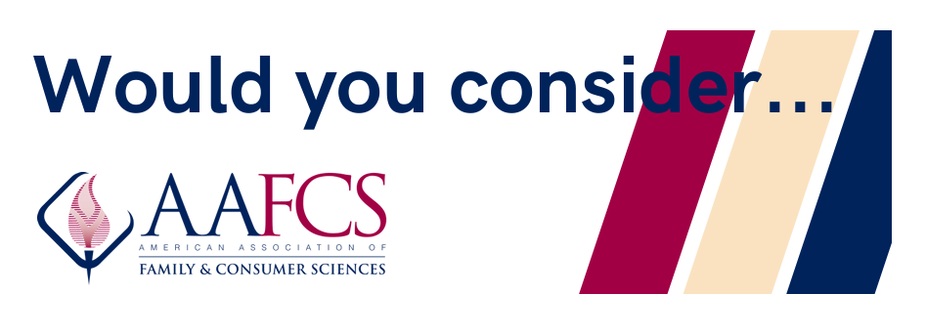
Social Media/Website
- Taking pictures of FCS classes and other FCS related presentations which can later be posted to the CAFCS website or FCS Facebook page. Include the title and purpose of the lesson or presentation. Be sure a photo release permission slip has been signed for each student or participant.
- Asking for student or client/ participant comments to be used anonymously for content to post on our website and Facebook page.
- Using one of the resources on the AAFCS.org website. Report how you used the resource so it can be posted on our website and Facebook page.

Next Year’s Conference/Membership
- Providing names of speakers for the conference in a FCS area which would be of interest to the members. It might be you, a colleague or a teacher.
- Bringing one new person to the conference. Ask individuals to attend the Annual Conference such as those in business or occupations related to FCS.
- Identifying or bringing door prizes for participants.
- Paying for a membership for a student in a FCS program.

Advocacy
- Locating the state representative for your district and calling him/her to set up an appointment to discuss Legislation which may be relevant to FCS. An email could also be sent.
- Connecting with an industry partner to find out if resources are available such as curriculum resources or opportunities to have a guest speaker or field trips. You could send us information on a person or business you currently partner with. Ask permission to link the company’s logo/information to the CAFCS website. Then send the information to us so it can be posted on our website and Facebook page.
- Providing FCS flyers of FCS related presentations or FCS programs to us so they can be posted or emailed for additional exposure of FCS events.

Email Jeanine (Jeaninepope4@gmail.com) to indicate which of these you can help with.
2026 Colorado Association of Family and Consumer Sciences (CAFCS)

MARK YOUR CALENDAR!!

COLORADO/WYOMING NEWS
is a newsletter for members of the Colorado and Wyoming Affiliates of American Association of Family & Consumer Sciences.
Photos and articles from and about members are welcome.
Members are asked to keep email addresses updated with CAFCS so newsletters can be emailed. Send any contact updates, including address and email to the Editor listed below.

Editor
Luann Boyer, CFCS
CAFCS Executive Director
22500 Road 21
Fort Morgan, CO 80701
970-768-0322
Luann.boyer@colostate.edu

Website
www.AAFCS.org/coafcs
CAFCS Facebook
www.facebook.com/aafcs.CO
Twitter
AAFCS Colorado@aafcsCO

The American Association of Family
& Consumer Sciences (AAFCS) is a
not-for-profit 501 (c) (3) organization with 3,000 members, dedicated to improving quality of life for individuals and families. The AAFCS and its affiliates may accept charitable contributions, which are tax-deductible to the fullest extent of the law.

2026

June 18 -21: 2026 AAFCS Conference
Louisville, Kentucky

July 6-10: National FCCLA Conference

Sept 18-20: AAFCS Leadership Summit
Pittsburg, PA

Nov. 13-14: CO/WY Fall Conference
Cheyenne, Wyoming

December 3: Ellen Swallow Richards
Dine In Day Recognition

2027

June 10-13: 2027 AAFCS Conference
Pittsburg, PA

Newsletter Submissions
This newsletter is your newsletter. Members are encouraged to submit information about programs, conferences, member awards (include website links) as well as information on current FCS topics.
Written submissions should be in a WORD document attached to the email. Photos need to be saved as jpeg and attached to the email (don’t put into the body of the email).
Email all submissions to CAFCS Executive Director at luann.boyer@colostate.edu

