

As reported in the Dallas News, nearly 12% of Texas’ roughly 18 million voters are on the suspense list, according to the Texas Secretary of State’s Office. The Texas’ voter suspense list now tops 2.1 million. Voters have until October to correct their status. Suspense means your county does not know your address or thinks you moved, often because a voter registration card or jury summons sent through the mail is returned as undeliverable.

How do I check my voter status? Check your registration on the state’s portal or your county’s voter website.

What should you do if you’re suspended? Update your address online by Oct. 7 — which is the deadline to register to vote — and be removed from the suspense list. To do so, you will need your current driver’s license or ID, Social Security number, and Voter Unique Identifier Number, or VUID, on your registration card. You can also find your VUID number with your county registrar. And after that? If you arrive at your polling place and find that you are on the suspense list, don’t worry. You can still vote, but it will require an extra step or two.

How long can you stay on the suspense list? You will be removed from Texas’ voter rolls following two general elections on the suspense list, or roughly four years.

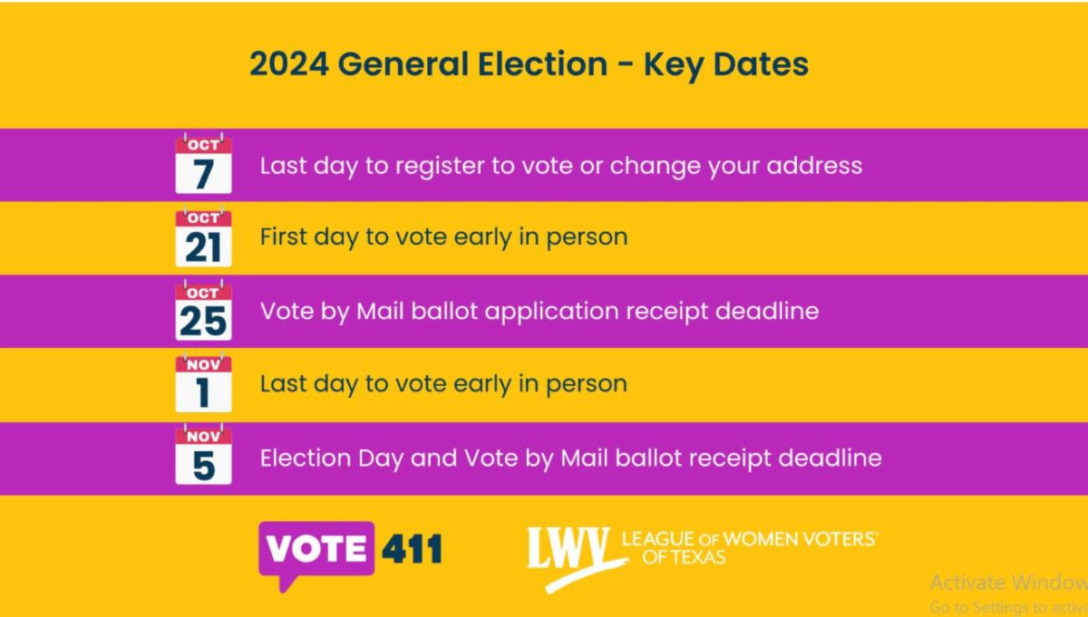
With 2.1 million Texas voters on this suspense list, you might mention this issue to friends and family. Your Texas voter registration status on the state’s portal should say “Active”.

