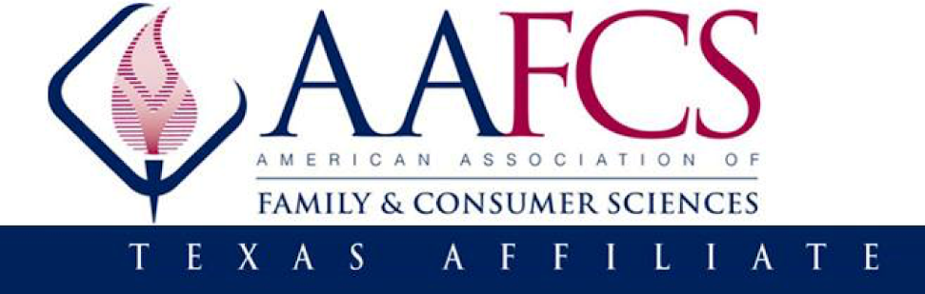

Call to Inform!
Governor Greg Abbott recently stated publicly in April that he will get the Education Savings Account section of the House Bill 1 legislation passed during the upcoming 89th State Legislative Session beginning in January 2025. The regular 88th Legislative Session ended in a stalemate between the House and Senate over education savings accounts, a voucher-like program that would allow parents access to a state-managed account to pay for private school tuition and other educational expenses. Newly released figures from the Legislative Budget Board indicate that education spending is down nearly $10 billion when adjusted for inflation and population growth since 2020. This alarming reduction has placed unprecedented pressure on schools, which are now grappling with skyrocketing expenses for essential services like utilities, fuel, and insurance. Many school districts have been forced to make drastic cuts to staff and programs, a trend that has dominated headlines throughout the summer. Additionally, private schools will not be held accountable for state and federal mandates that public education has endured many times with no additional funding from the state and federal government. Furthermore, there are currently no constraints on how this money will be spent by parents.

Raise Your Hand Texas is a non-partisan nonprofit organization supporting public policy solutions that invest in Texas’ 5.4 million public school students. They provide numerous research to show why school vouchers will hurt public education at https://www.raiseyourhandtexas.org/policy/vouchers/. We have seen no evidence from Governor Abbott or his office on how school vouchers will support and enhance public education. AAFCS-Texas supports public education because secondary Family & Consumer Sciences (FCS) courses equip students with critical life management skills and offer nationally recognized industry certifications that local employers depend on to fill positions in FCS-related industries. Without adequate funding, these programs are at risk, and so too are the industries that rely on the workforce pipeline they produce. CTE programs, as a whole, are a vital part of Texas's education landscape. They prepare students for real-world employment in industries ranging from agriculture to healthcare, and many graduates go on to fill essential roles in our communities. A reduction in funding jeopardizes not only the educational futures of these students but also the stability of our local economies, which depend on a skilled and well-trained workforce. CTE courses, which include FCS, are not provided in private schools.
The following House Representatives are members of the Public Education Committee and need to be contacted by all CTE educators:
Position | Member
Chair: | Rep. Brad Buckley
Vice Chair: | Rep. Alma Allen
Members: | Rep. Steve Allison
 | Rep. Charles Cunningham
 | Rep. Harold V. Dutton, Jr.
 | Rep. Cody Harris
 | Rep. Brian Harrison
 | Rep. Cole Hefner
 | Rep. Gina Hinojosa
 | Rep. Ken King
 | Rep. Oscar Longoria
 | Rep. Matt Schaefer
 | Rep. James Talarico
Please remember the following:

- If you can call them, this is better than emailing them. They need to hear from all concerned public educators and advocates. If you decide to email them, please do not use your school or organization email address. You will use only your personal email address because you need to represent yourself as a concerned Texas citizen and as a public education advocate.

- Be sure to let these House Representatives or their legislative staff know why you do not support the Education Savings Account legislation. Share any personal stories here that will help them see why FCS is essential in public education. Be sure to spell out any acronyms because they are not aware of our professional jargon. Remember, if we do not advocate for public education and FCS, why should anyone else care?

- Furthermore, FCCLA provides a “Stand Up” peer education program that guides students to develop, plan, carry out, and evaluate advocacy activities. This would be the perfect opportunity to get them involved in support of public education.

Please act now to advocate for public education. If you have further questions, please contact Cindy Miller, President-Elect at clamiller1991@gmail.com or at 806-790-0681.

Who Represents Me in Texas:
If you are not sure who your House Representative is, please click on this link https://wrm.capitol.texas.gov/home to find out so you can contact the appropriate state legislator. They need to hear from their constituents.

