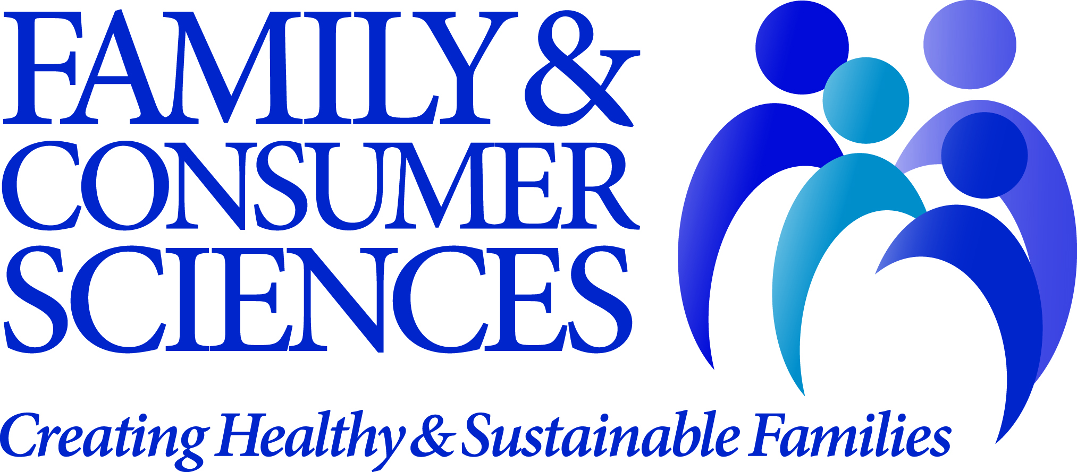

FOR IMMEDIATE RELEASE

Nacogdoches Residents Present at National Family & Consumer Sciences
Conference in St. Louis

Alexandria, Va. – July 28, 2014 — Nancy M. Shepherd and Sally Ann Swearingen of Nacogdoches, Texas, presented, “Creating a Mindset of Sustainability Through Life Skill Development in Design,” on June 27th at the 105th American Association of Family & Consumer Sciences (AAFCS) Annual Conference, Family and Consumer Sciences: Global Gateway to Healthy and Sustainable Families, June 25-28th.
Shepherd and Swearingen’s interactive session fostered critical thinking skills and a problem solving mindset of promoting sustainability. Examples of recycled projects as well as guidelines for teaching sustainability were shared with those in attendance.
More than 750 professionals and students in family and consumer sciences (FCS) and allied fields from across the U.S. convened at the Hyatt Regency at the Arch for the AAFCS Annual Conference. Experts in personal finance, health and nutrition, resource management, apparel and textiles, housing, and other areas of FCS presented research and strategies to address critical issues facing individuals, families, and communities. The meeting featured two prominent keynote speakers, including Dr. Geraldene B. Hodelin, professor at the University of Technology Jamaica, and a range of educational sessions on theme-related topics, from supporting military families to overcoming 21st century economic challenges.

About the American Association of Family & Consumer Sciences (AAFCS)
Based in the Washington, D.C., area, AAFCS is the only association for family and consumer sciences students and professionals across multiple practice settings and content areas. For more than 100 years, AAFCS has focused its mission on providing leadership and support for professionals whose work assists individuals, families, and communities in making more informed decisions about their well-being, relationships, and resources to achieve optimal quality of life. AAFCS members provide research-based knowledge about the topics of everyday life to help create healthy and sustainable families. These topics include human development, personal and family finance, housing and interior design, food science, nutrition and wellness, textiles and apparel, and consumer issues. AAFCS members are located nationwide, and include educators, administrators and managers, human service and business professionals, researchers, community volunteers, and consultants who develop research-based information and deliver programs on essential skills to help individuals and families be better prepared to live, work, and succeed in today’s complex and diverse world.

Field of Family & Consumer Sciences
Family and consumer sciences (FCS) draws from broad and diverse disciplines to develop and provide content and programs that help individuals become more effective critical thinkers and problem solvers. Through discovery and delivery of research-based knowledge, FCS professionals help individuals and families develop essential skills to successfully live and work in a complex world. Professionals in the field are uniquely qualified to speak on many critical issues affecting individuals and families, such as maintaining a healthy lifestyle, wisely managing personal and family finances, and creating supportive relationships with family members, friends, and co-workers. They are located nationwide in a variety of practice settings, including secondary schools, universities, government agencies, and businesses.

-more-

For more information, please contact:
Gwynn Mason
Director of Communications, AAFCS
703-706-4613
gmason@aafcs.org

# # #

