According to the CDC ~ 70% of US BMI > 25 (~ 1% of obesity is muscular individuals).

Below is the Obesity systems map, from Foresight showing research supported links of the multiple causes of obesity.¹ As we all know, diabetes tends to follow obesity. I show this to highlight the multiple factors impacting our nation’s weight, not any one single individual.

Obese individuals suffer greatly and are often more likely to not attend college, are less likely to get hired, earn lower salaries and be passed over for promotions. The individual outcomes are poor health, a negative self-worth or self-esteem, avoidance of medical appointments and check-ups, suffer more from suicide, depression, anxiety and are more likely to engage in illicit substance abuse.²

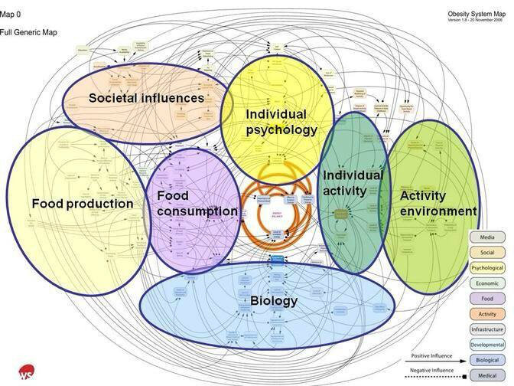

There are not any federal laws against obesity discrimination. A 2008 ADA Amendments Act allowed for discrimination protection for individuals suffering from a disability and severe obesity, but there are not any legal protections for weight discrimination for an individual without a disability. In Michigan Elliott-Larsen Civil Rights Act, or Public Act 453 of 1976 prohibits discrimination in housing, employment and access to public accommodations based on religion, race, color, national origin, age, sex, height, weight, familial status, or marital status.
A little over a year ago the state of Washington Supreme Court ruled that obesity is covered under the state’s disability laws.³
According to the Rudd Center, municipalities with weight protection laws or statutes include San Francisco, Santa Cruz, California, Washington DC, Urbana, Illinois, Binghampton, New York and Madison, Wisconsin.
A Rudd Center Survey done in 2015, of over 2,000 people the majority of the American public supports body weight as a protected class in Civil Rights statutes. Almost 80 percent support laws and legislative measures to prohibit weight-based employment discrimination.
Rudd Center policy recommendations are for legislation for weight protection be developed, and anti-discrimination laws at federal, state and local levels to include weight protection.

