April 16, 2026, 3:00 PM
Monthly Board Meetings in 2026 will be held on the third Thursday of each month from 3-4 pm virtually.
Executive Board: Dani Ronk (President), Ashleigh Brown (President Elect), DeeDee Leinen (Treasurer), Angie Swantek (Secretary) & Heather Valasek (Member at Large)
Committees
Marketing & Development Committee: Holly Leach (Chair), Camie Bremer, Austin Eldredge and Rachel Gentzler
Membership Communication Committee: Dani Ronk (Chair), Ashleigh Brown, Kimberly Derr, Cody Kamphaus and Jamie Andrews
Program Committee: Kathy Lierman (Chair), Patty Henry, Joanie Manning, Monica Vandegriend, Holly Leach, Camie Bremer and Dee Dee Leinen

In Attendance: Dani Ronk, Austin Eldredge, Angie Swantek and later Kathy Lierman.

TIME | TOPIC | PRESENTER
3:05 | Call meeting to order: By Dani at 3:05  Minutes completed by: Angie Swantek | Dani
3:06 | Mission Statement: To provide support, education and awareness of cardiovascular and pulmonary health to healthcare professionals, patients and community.  “Vision without action is merely daydreaming…” - Nelson Mandela | Dani
3:10 | Secretary Report  - Review 3/19/26 meeting minutes  - Motion to approve meeting minutes as read  - 1st Dani  - 2nd Austin | Angie
3:15 | Treasurer Report  - Review 3/19/26 treasurer report  - Review current checking account balance. Expenses for DOTH and strategic planning were presented.  - Motion to approve treasurer report  - 1st Angie  - 2nd Austin  - Dee Dee’s family member will do the taxes. We do not have a name or the amount they will charge  - Motion to approve amount to pay for taxes to be completed by Dee Dee’s family member. This was tabled until the next meeting. | Dani
3:18 | Committee Reports  Program Committee–Kathy  - Update of 4/14/26 meeting.  - They have a good mix of cardiac and pulmonary speakers this year. The keynote will be motivational  - Program next meeting is in June.  Membership/Communication Committee - Dani  - Current NCVPRN membership is 107. This time last year there were 112 members.  - Update to “Find the N” information from all hospitals across the state.  - 66 hospitals responded to calls  - RN’s - 6 do not have one on staff  - EP’s - 21 facilities  - RD’s - 43 facilities  - CCRP - 14 people in 10 facilities  - PR Certification - 14 people in 10 facilities  - Virtual - only 1 hospital is working on this Lincoln St. E’s  - Hospital vs Free Standing - 3 are free standing  - ICR – 1 Lincoln St. E’s  - Reminder, there is still time to renew your membership! Please encourage your co-workers to join and share the benefits of being a member of AACVPR!  Marketing & Development Committee- Holly  - No update currently. | Dani
3:20 | Open Agenda Items  - Committee Description Update  - Program Committee  - Membership/Communication Committee - Committee voted to leave it as is.  - Marketing & Development Committee  - Succession Planning  - Any suggestions on how to get new members? Continue to advocate for NCVPRN in your hospitals.  - Upcoming AACVPR Webinars:  - Live Webinar: Improve Your ITP for Certification Success – April 30, 2026, 12:00 – 1:00 pm CT  - Exercise Prescription Masterclass – May 12, 2026, 9 am – 2 pm  - "Implementing Virtual or Hybrid CR/PR: From Requirements to Real-World Readiness." - June 1, 2026, 10 am - 3 pm $200 for Members  - A.L.F. is June 13-14th.  - President Elect - Ashleigh Brown will attend  - AACVPR National Conference will be Sept 30 - Oct 2 in San Antonio, TX  - NCVPRN will not send a representative this year  Other items:  - AACVPR Affiliate Leader Update: Nothing received prior to today’s meeting.  - Other Affiliation Attendance:  - Dee Dee is attending the IA conference today.  - Open Board Positions for 2027 - do we have anyone in mind to fill the positions? We are all challenged to think of someone to help.  - President-Elect  - Treasurer-Elect  - Dani continues work on the Job Descriptions | Dani
3:23 | - New Business  - Goals for 2026-27  - Will update Bylaws at the Strategic Planning Meeting in 2027. | Team
3:25 | Adjournment: by Dani at 3:25 | Dani
 | Next Meeting: Thursday, May 21, 2026, 3:00-4:00 pm via Google Meet
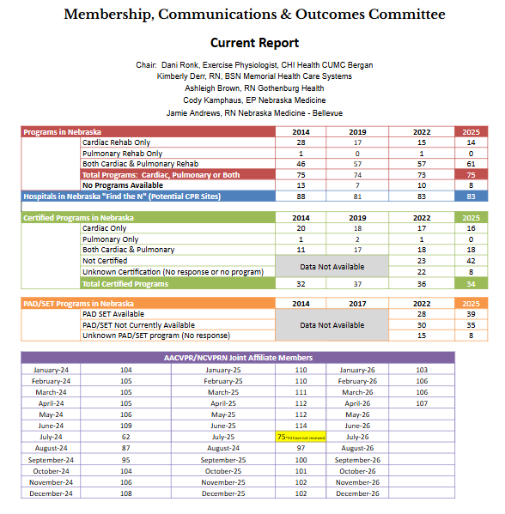
2026 Affiliate Conferences
- SACPR (Southern): April 9-10, 2026
- ACVPRA (Arkansas): April 11, 2026
- MNACVPR (Minnesota): April 16-17, 2026
- NCCRA (North Carolina): April 17, 2026
- TACVPR (Texas): April 17-18, 2026
- TACVPR (Tennessee): April 17-18, 2026
- WISCPHR (Wisconsin): April 17-18, 2026
- ISCVPR (Indiana): April 23, 2026
- SCACVPR (South Carolina): April 24-25, 2026
- VACVPR (Virginia): April 24-26, 2026
- MACVPR (Montana): April 30-May 1, 2026
- CSPR (California Pulmonary): May 1, 2026

