Sister Programs within the Application System
Most programs that have sister programs that actively applied during this window will have that noted within the application. It will likely be easy to determine sister programs based on the name of the program, but you can also check within the application to confirm. To do so, click on the “Review Status” button at the top of the page.
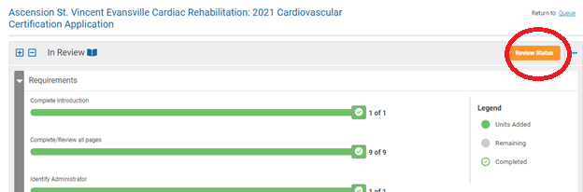

On the next screen, you’ll see a pop-up. If they designated sister programs, they will be listed below the Sister Programs question.
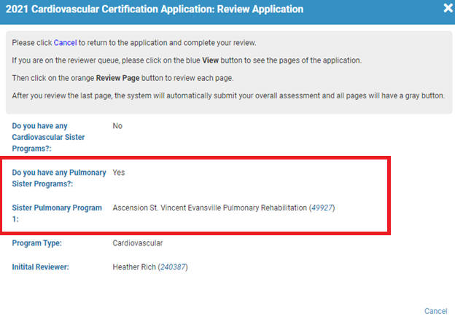
As part of the initial review assignment process, we have done our best to assign all sister programs to one reviewer to ensure consistency when reviewing policies and procedures. If you have any questions or concerns about reviewing sister programs, please let us know at certification@aacvpr.org.

