ISCHR NEWS
2026 Summer/Fall

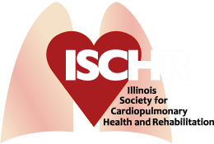
www.ischr.org

Our Mission ~ The Illinois Society for Cardiopulmonary Health and Rehabilitation is dedicated to the improvement of clinical practices, enhancement of communications between professionals, promotion of scientific inquiry and the advancement of education for the benefit of healthcare professionals and the public.



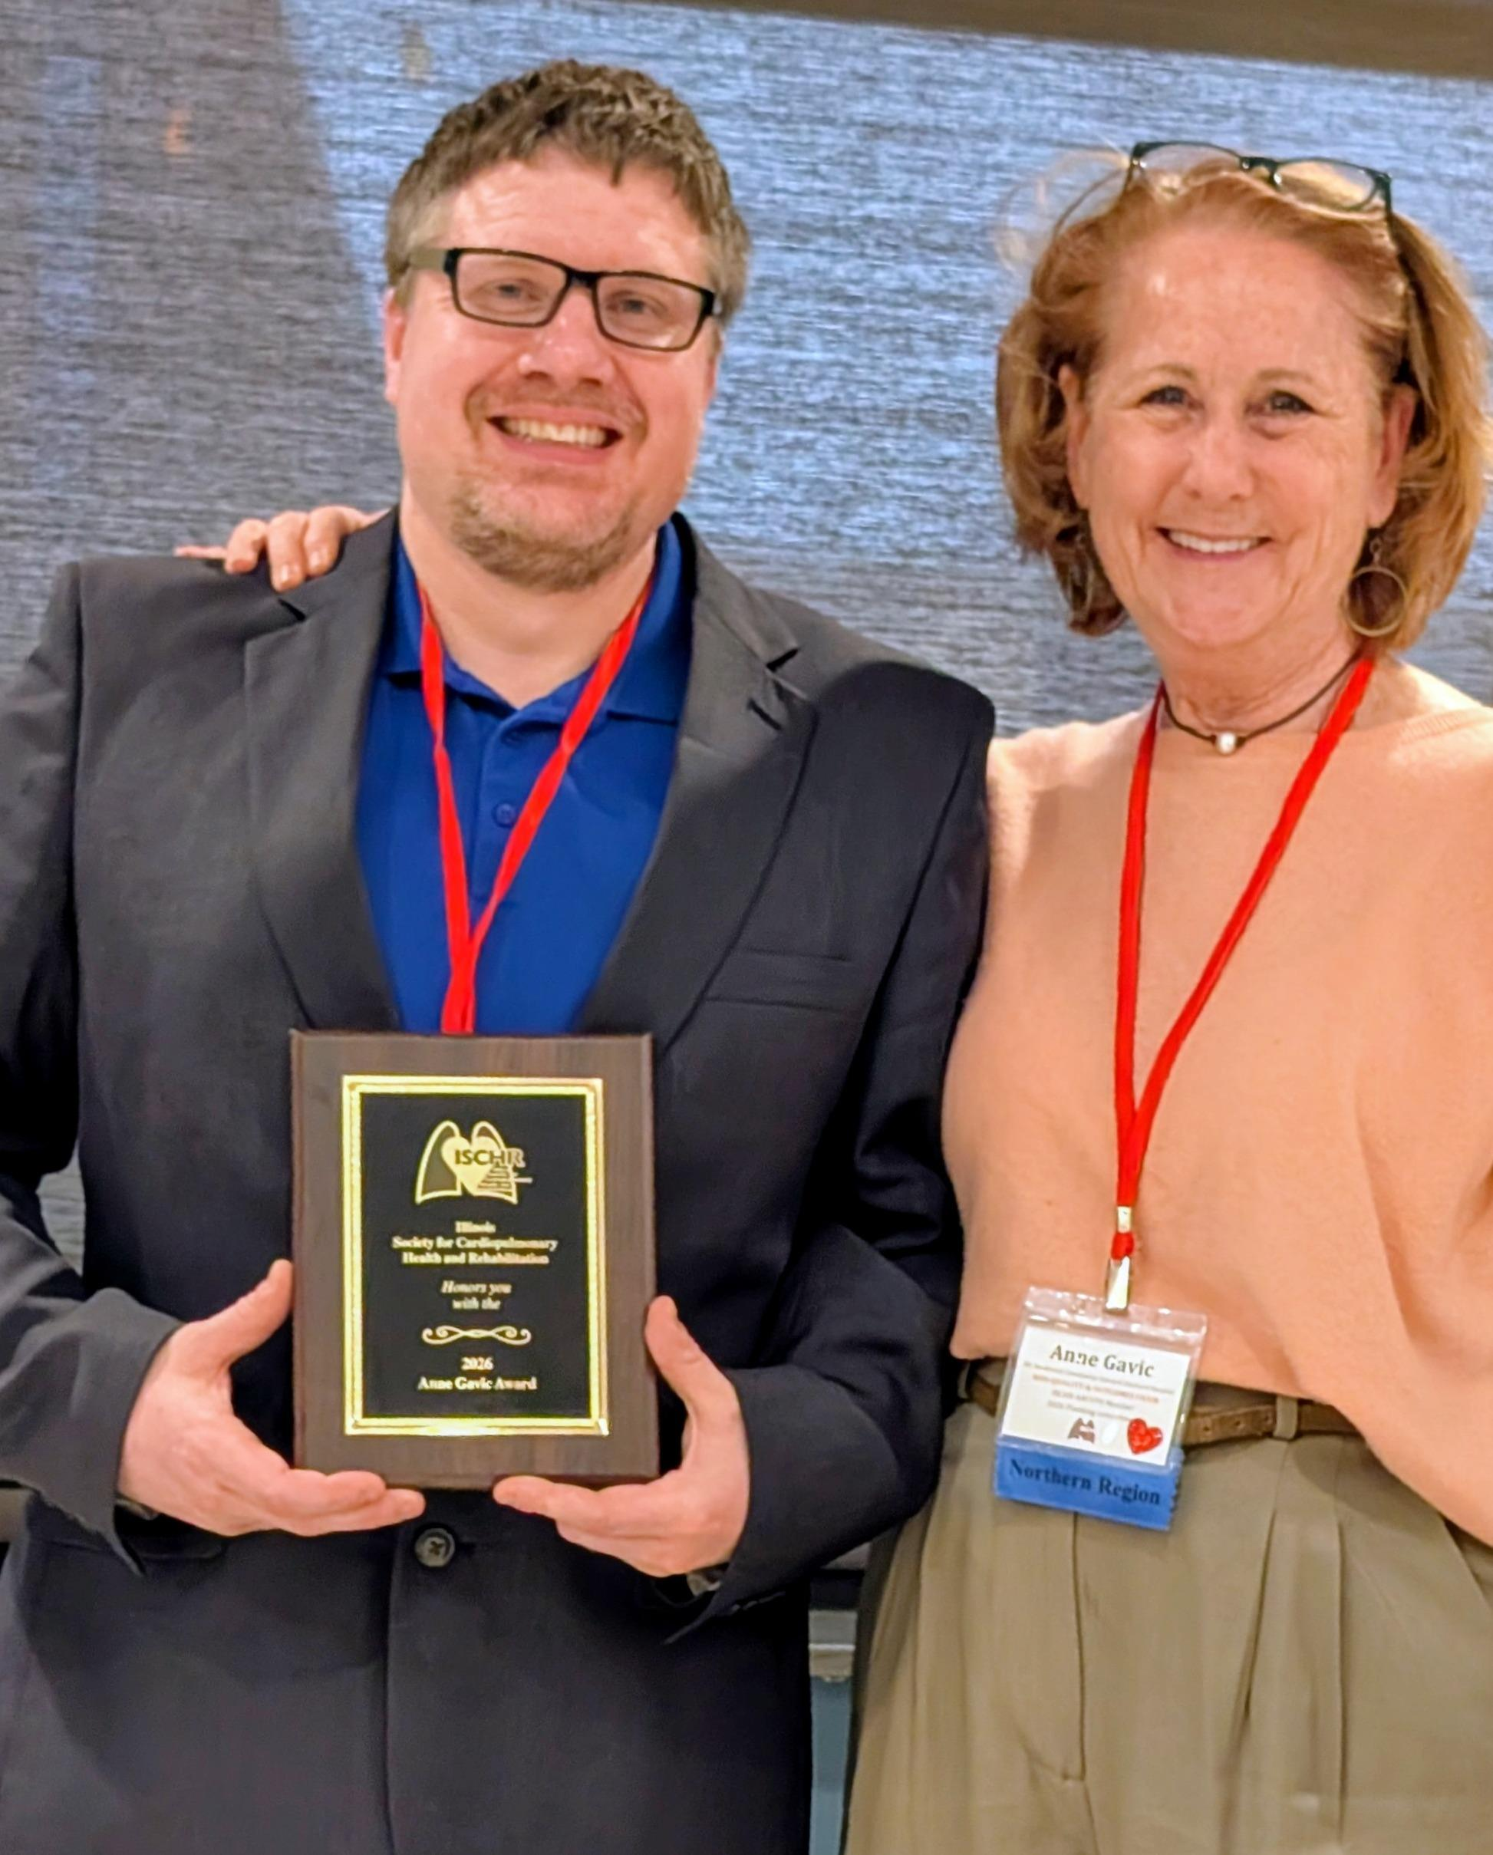

Congratulations to the 2026 Anne Gavic Award Winner—
Jeff LaPorte!
ISCHR Annual Conference
ISCHR hosted its annual conference on March 13-14, 2026. Many attended and took advantage of the wealth of information presented. They visited the vendors who supported the conference and enjoyed networking with other professionals. A record number of students presented their research work in posters for review and discussion. Make your plans to join us in 2027!

Thank You to Our Sponsors!
GOLD LEVEL SPONSOR: 
BRONZE LEVEL SPONORS: 




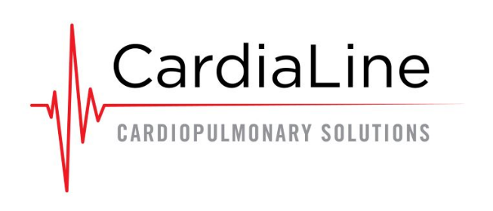

SUPPORTING SPONSORS:

SPONSOR AND HOST:



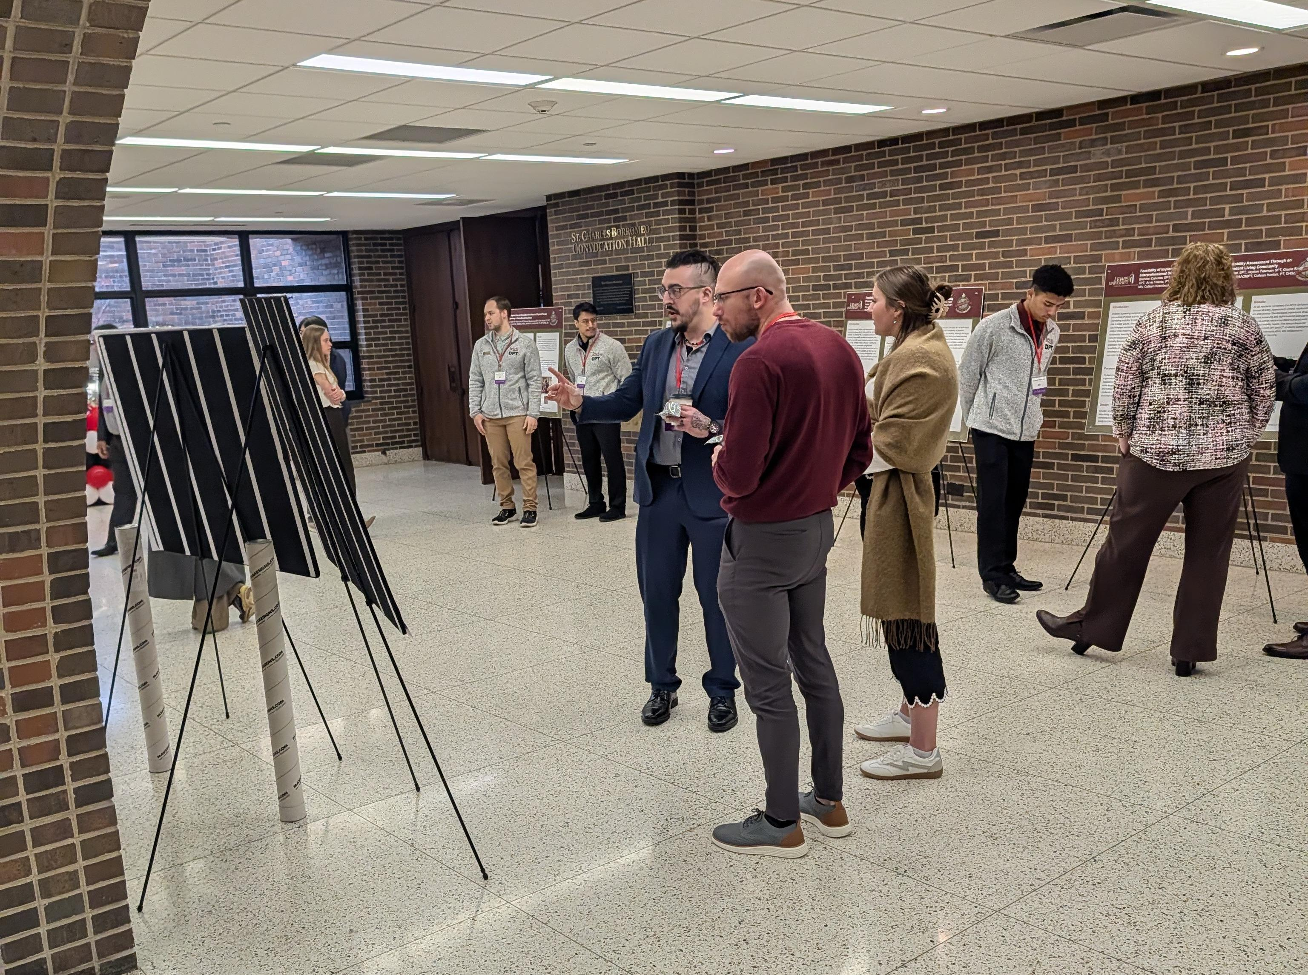

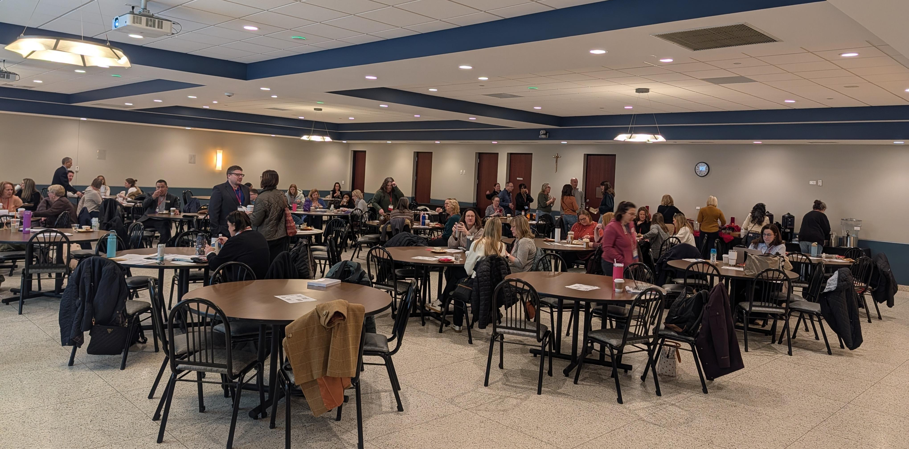

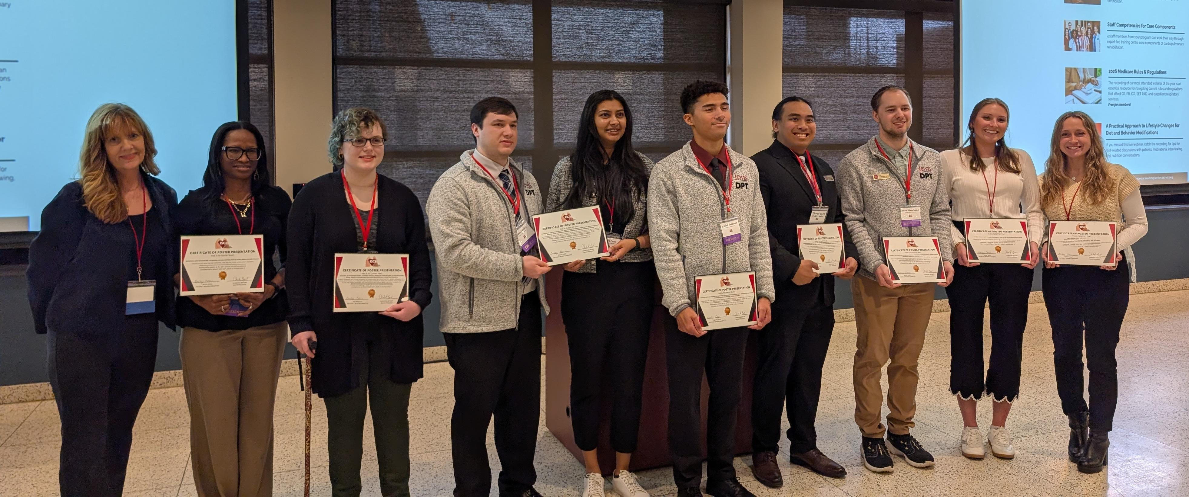


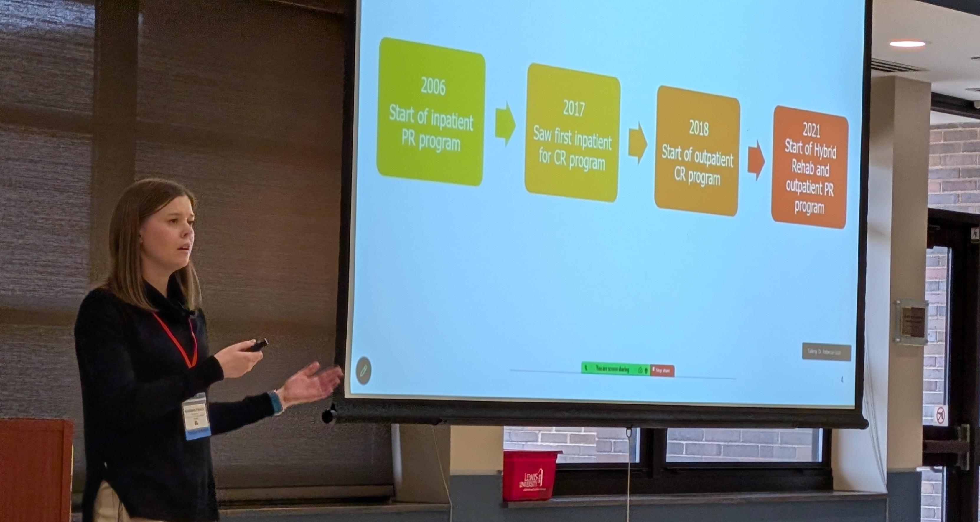

:
Legislative Updates
from Day on the Hill (DOTH):
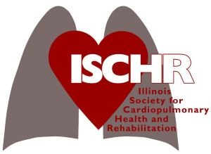

IL GENERAL ASSEMBLY-AUGUST, 2025
S.B. 1418 REQUIRES NEW AND RENEWING HEALTH COVERAGE PLANS IN THE STATE OF IL COVER ANNUAL PAD SCREENINGS FOR AT-RISK INDIVIDUALS.
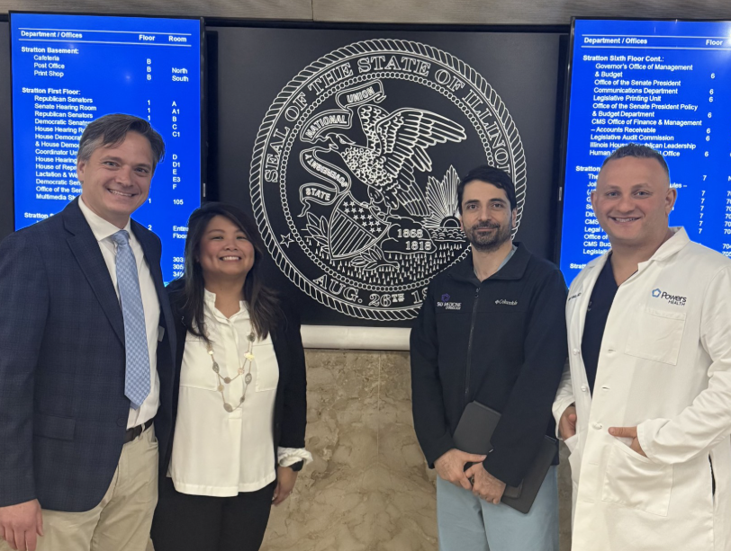

MAJOR ADVOCACY WIN!!
U.S. CONGRESS- JANUARY, 2026
CONSOLIDATED APPROPRIATIONS ACT (H.R. 71468)-PASSED IN JANUARY. ALLOWS REIMBURSEMENT FOR HOME-BASED, VIRTUAL CR/ICR/PR TILL 12/31/27
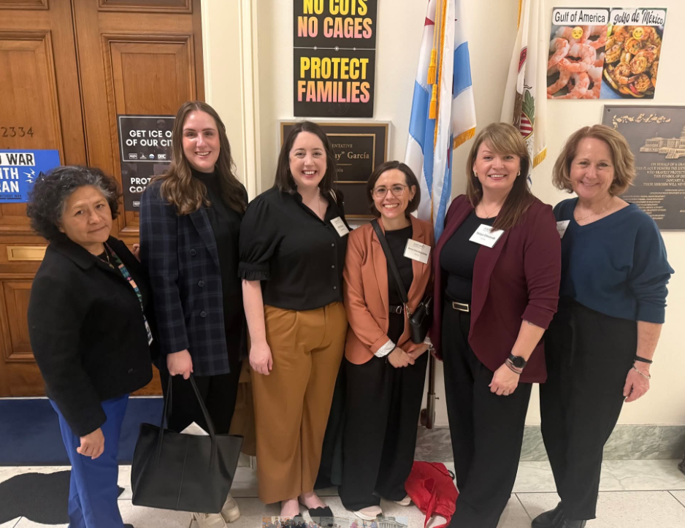

BUT THERE’S STILL MORE WORK TO BE DONE…
H.R. 783/S.248
WOULD EXTEND COVERAGE OF VIRTUAL DELIVERY OF CR/ICR/PR PERMANENTLY.
H.R. 7666/S.B. 3908 CORRECTING PAYMENT DISPARITY FOR OFF-CAMPUS HOSPITAL OUTPATIENT CR/PR PROGRAMS
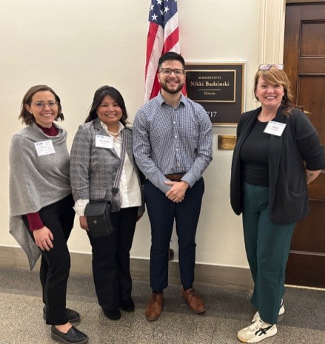

We welcome you to join us in advocating at DOTH (Day on the Hill) usually the first part of March, stay tuned for updates and join your fellow colleagues and Board Members!
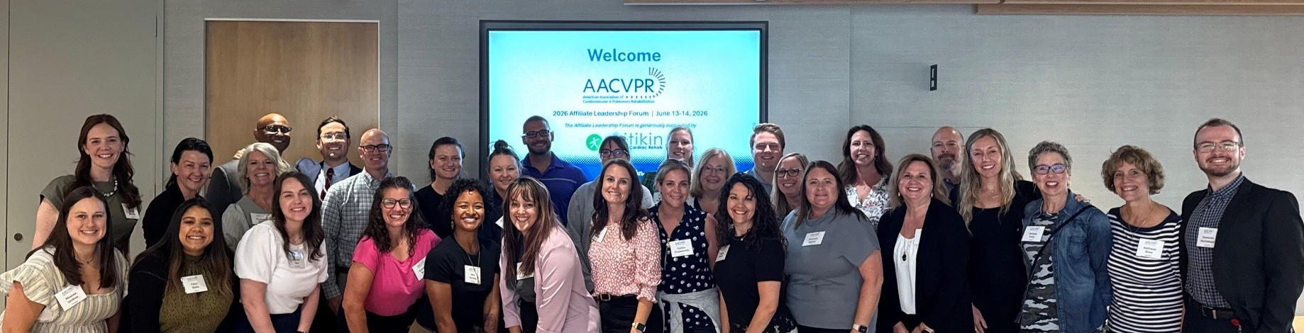

AFFILIATE LEADERSHIP FORUM JUNE 21-22, 2025 CHICAGO, IL
On June 13th and 14th, Dr. Melissa Tracy- ISCHR Reimbursement and Advocacy Co-chair and Joey Leduc, EP-ISCHR Pulmonary Coordinator Chair
proudly represented ISCHR at AACVPR's annual Affiliate Leadership Forum that was held at AACVPR headquarters in Chicago, IL.
They spent valuable time in a highly interactive & collaborative environment networking and learning new leadership skills.

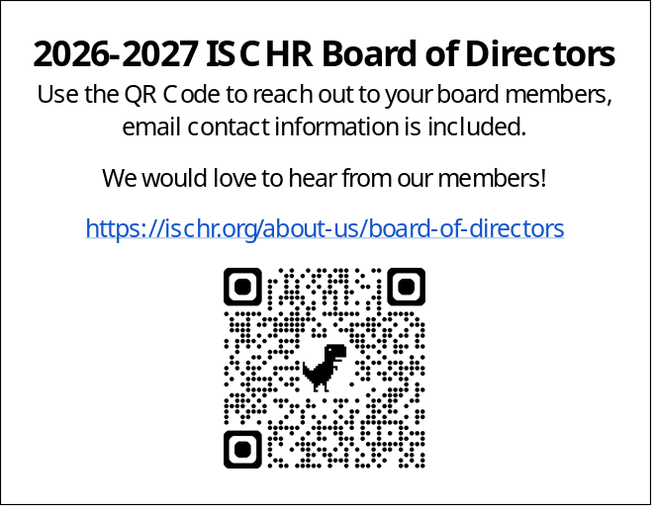

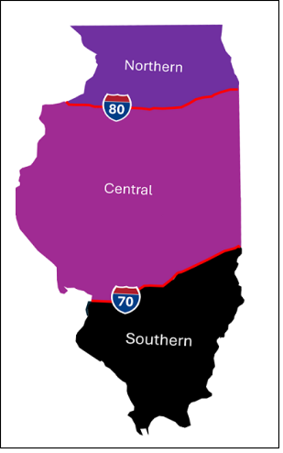

AACVPR Annual Conference
September 30 – October 2, 2026 in San Antonio, Texas!
More information to come on the ISCHR meet and greet for all ISCHR members attending the Conference! It’s a great way to meet members and network!

- ISCHR was Founded in 1987 & became a Joint affiliate in 2015
- ISCHR is the 2nd largest affiliate in terms of our membership numbers
- ISCHR is THE largest affiliate in terms of membership numbers that covers just one state!
- Our membership consists of:
- ES’s, EP’s, RT’s, RN’s, MD’s, RD’s
  - Academic Faculty and Students

- ISCHR Leadership Retreat: November 13-14, 2026 Urbana, IL
- AACVPR National Conference:
September 30-October 2, 2026, in San Antonio, TX
Another great networking and learning opportunity, get all your CEUs and collaborate with others in the field while having some fun!
- Cardiac Rehab Week: February 8-14, 2027
- Pulmonary Rehab Week: March 14-20, 2027
- Day On The Hill (DOTH): TBD March 2027
Join us in Washington DC to meet with
members of Congress to advocate for Cardiac
and Pulmonary Rehab policy changes. Training and mentoring opportunities are available.
- ISCHR Annual Conference:
TBD March 2027

Mark your Calendars:
If you are not a member of ISCHR/AACVPR, join us for up-to-date information, CEU offerings, and a great way to network with other colleagues in your profession!
www.ischr.org

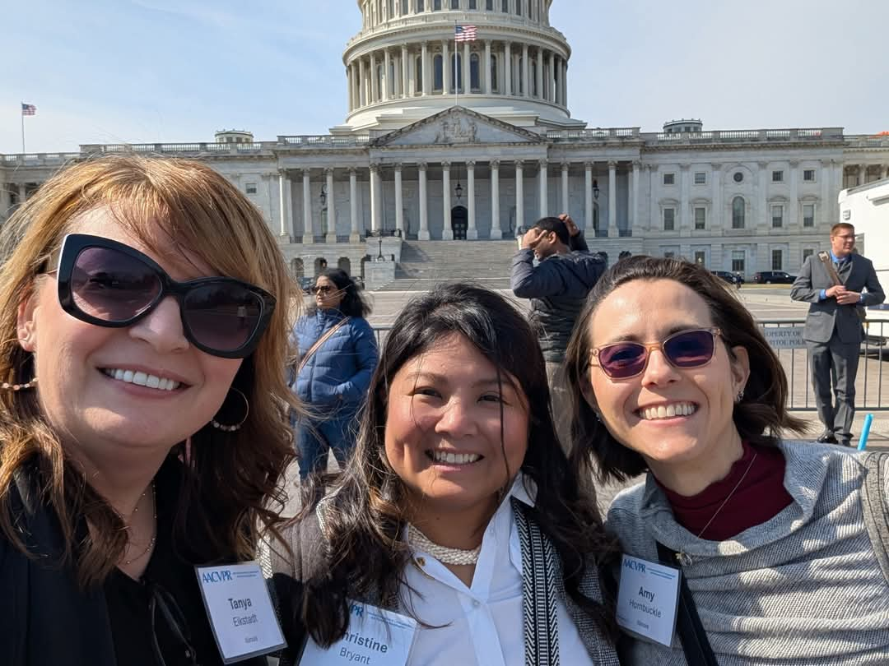

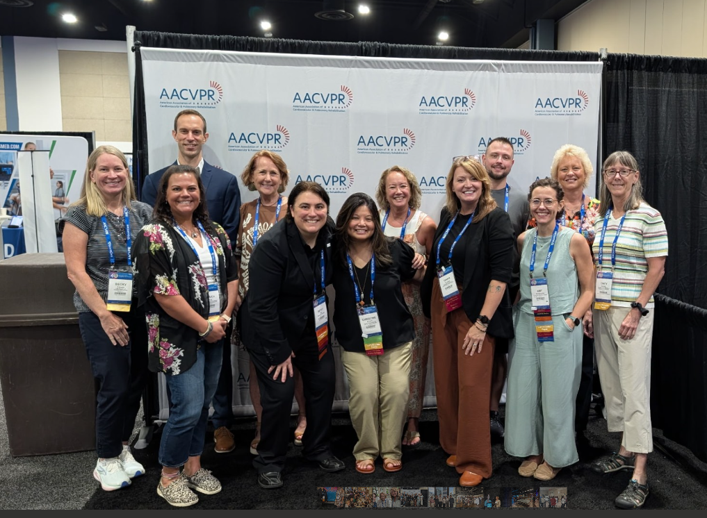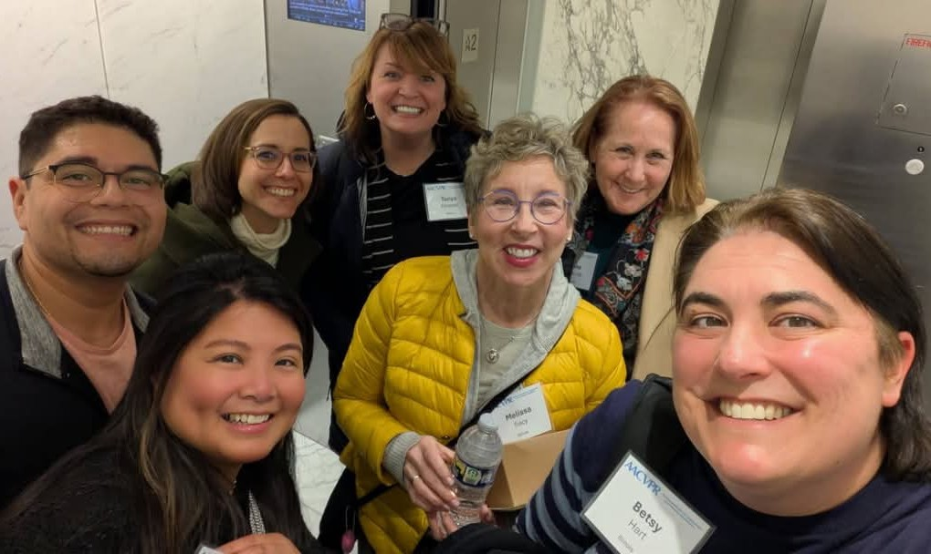
Interested in getting more involved by joining an ISCHR committee?
please email: ISCHRORG+PRESIDENT@GMAIL.COM
Calling all PR professionals!
We are looking to grow the pulmonary presence on our board. Interested?
please email: ISCHRORG+PULMONARY@GMAIL.COM

