

Short Communications

Wednesday, October 20, 2021
Drugs/Alcohol/Occupant Factors: 09:50 AM - 11:00 AM EST

Wednesday, 10/20/21, 10:50 AM - 11:00 AM EST
Are You Willing to Drink and Drive? An Investigation in Indian Scenario Using an Extended Prototype Willingness Model
Author: Ankit Kumar Yadav, ankit.yadav@iitb.ac.in
Co-Authors: Sajid Shabir Choudhary, sajidshabirch@gmail.com, Nishant Mukund Pawar, pawarnishant@iitb.ac.in, Nagendra R. Velaga, n.r.velaga@iitb.ac.in

ABSTRACT
Objective: Driving While Intoxicated (DWI) is a significant threat to traffic safety worldwide, but little is known about the motivational factors behind the willingness to drink and drive especially in low- and middle-income countries (LMICs) such as India. The present study applied an extended version of prototype willingness model (PWM) to investigate the factors predicting the willingness to drink and drive.
Methods: One hundred and forty-three participants (77% males) responded to an online survey in India. The survey included the standard PWM constructs such as attitudes, subjective norms, prototype similarity and prototype favourability. Additionally, the measures of traffic fatalism and risk-perceptions were also incorporated to examine their effects on the willingness to drink and drive.
Results: The hierarchical regression model showed that the PWM constructs explained 84% of the variance in willingness to drink and drive. When the additional measures (traffic fatalism and risk perception) were included along with the PWM variables, it resulted in an increase of additional 2% of the variance in explaining the willingness, thereby leading to a total of 86%. In both the steps, the variable ‘attitudes’ was found to be the strongest predictor of willingness to drink and drive.
Conclusions: This study is first of its kind to evaluate the effectiveness of PWM model in Indian scenario for understanding the willingness to engage in the act of drunk driving. The study findings may prove useful to the stakeholders of educational and awareness programs, where the focus is required to be aimed at attitudes, subjective norms, prototype similarity and fatalistic beliefs of the drivers.
Keywords: Alcohol; Prototype willingness model; Risk perception; Road safety; Traffic fatalism.

INTRODUCTION
The detrimental effects of alcohol on driving performance are well-established in the previous literature (Irwin et al. 2017; Yadav and Velaga 2020). Driving While Intoxicated (DWI) is a multidimensional phenomenon which depends on the complexity of the drivers’ behaviour. Understanding the drivers’ psychology behind their willingness to engage in the act of drunk-driving is important, especially in case of low- and middle-income countries (LMICs) such as India where the drivers are at significantly higher crash risk compared to the developed world. In the recent years, the prototype willingness model (PWM) has been widely used in traffic psychology research, for instance, to investigate the drivers’ willingness to engage in speeding and texting while driving (Preece et al. 2018), drowsy driving (Lee et al. 2016), and pedestrian violations (Demir et al. 2019). Here, prototype represents the social image of a typical person engaging in a particular act (Gibbons et al. 2009). The PWM aims to explain the psychological predictors involved in a decision-making process representing the willingness to engage in a particular act (Gibbons et al. 2009). It consists of four key constructs: attitudes (i.e., individual beliefs towards a particular act), subjective norms (i.e., beliefs about how other people perceive their act), prototype favourability (i.e., how favourable is the act of the prototype) and prototype similarity (i.e., how similar is the act of the prototype to oneself).
As shown in Figure 1, PWM consists of two pathways leading to the drunk-driving behaviour i.e., the reasoned action path and the social reaction path (Gibbons et al. 2009). The intention to drink and drive is explored using the reasoned action path, whereas the reactive/unplanned behaviour is examined using the social reaction path. Previous psychological studies have widely investigated the drivers’ intention to drink and drive by adopting the reasoned action path or the theory of planned behaviour (TPB) model (Vankov and Schroeter 2021; Gonzalez-Iglesias et al. 2015; Potard et al. 2018). Whereas there is limited research on the willingness to drink and drive using the social reaction path (Rivis et al. 2011) and particularly no research in Indian scenario. Therefore, the present study aims to examine the efficacy of PWM in understanding the willingness to drink and drive among Indian road users. Further, the influence of traffic fatalism (belief that an act is out of one’s control) and risk perception on willingness is also explored.

METHOD
Participants
An online survey was administered to capture the components of PWM along with the two additional variables (traffic fatalism and risk perception). One hundred and forty-three participants provided their informed consent and participated in the survey. The sample included 77% males and 23% females. The average age of participants was 26.6 years with a standard deviation of 7.4 years.
Measures
All the PWM variables were measured on a 5-point scale. Attitudes were captured using 4-items e.g., “I think it is wise to drive my car to home after drinking alcohol (1: strongly disagree, 5: strongly agree)” with reliability score (Cronbach’s α) of 0.868. Subjective norms were measured using 3-items e.g., “My family members don’t expect me to drive after drinking (1: strongly disagree, 5: strongly agree)” with α as 0.749. To measure prototype similarity, 2-items were asked e.g., “Do the characteristics that describe the type of a driver who engages in drunk driving also describe you? (1: definitely no, 5: definitely yes)” with α equal to 0.799. For prototype favourability, the participants were requested to visualize a person representative of their age and gender and based on that image, they were asked to rate their perception using adjectives such as “attractive”, “careless”, “popular”, “smart” and “cool” on a scale of 1 to 5 (Preece et al. 2018). The reliability score of prototype favourability was found to be 0.725. To capture willingness, the participants were asked two questions e.g., “How willing are you to engage in the act of drunk driving the next time you drink at a friend’s place? (1: not at all willing, 5: very willing)” with α as 0.926. Additional variables such as traffic fatalism and risk perceptions were measured using a 5-item (α = 0.809) and a 3-item scale (α = 0.881) respectively. An example of a traffic fatalism item was “Life is very unpredictable, and there is little one can do to prevent road accidents (1: strongly disagree, 5: strongly agree)”, whereas in case of risk perception, one of the questions was “What is the chance that you will meet with an accident during drunk driving? (1: very low; 5: very high).”

RESULTS
All the measures obtained from the survey satisfied the normality criteria checked using Kolmogorov–Smirnov tests. To examine the relationships among the measured variables, Pearson’s correlations were analysed (Table 1). The willingness to drink and drive was found to be significantly and positively correlated with attitudes (r = 0.58, p < 0.001), prototype similarity (r = 0.62, p < 0.001), prototype favourability (r = 0.33, p < 0.001) and traffic fatalism (r = 0.54, p < 0.001). No significant correlation was observed for the willingness with subjective norms and risk perception. Moreover, traffic fatalism showed significant positive correlations with attitudes (r = 0.36, p < 0.001), prototype similarity (r = 0.50, p < 0.001) and prototype favourability (r = 0.32, p < 0.001), and negative correlation with risk perception (r = -0.21, p < 0.05).
To investigate further, a hierarchical multiple regression model was developed to analyse the efficacy of PWM and additional variables in predicting the willingness to drink and drive. The model results are shown in Table 2. The goodness of fit of the developed model was assessed using the adjusted R². In the first step, only PWM variables (attitudes, subjective norms, prototype similarity and favourability) were considered. The PWM model explained 84% of the variance in willingness to drink and drive. In the second step, additional variables (traffic fatalism and risk perception) were also included along with the PWM variables, resulting in an increase of additional 2% of the variance in explaining the willingness, thereby leading to a total of 86%. In both the steps, the variable ‘attitudes’ was found to be the strongest predictor of willingness, which indicates that the participants with positive attitudes towards drunk-driving were more willing to engage in the act of drunk-driving. Moreover, all the PWM variables were found to be significant in the first step, whereas in the second step, prototype favourability and risk perception did not significantly influence the willingness to drink and drive.

DISCUSSION
The present study examined the effectiveness of PWM model in explaining the willingness to drink and drive. Previous research investigating the utility of TPB-PWM model in understanding the willingness to drink and drive found that the combined TPB-PWM model explained 47% to 65% of the variance in willingness to drink and drive among Britishers (Rivis et al. 2011). Another study reported that PWM model was successful in explaining 31% to 43% of the variance in the willingness to engage in speeding and texting while driving in Australia (Preece et al. 2018). On the other hand, the extended PWM model performed much better in predicting the willingness to drink and drive in the present study, where it contributed to 86% of the variance. This study is first of its kind to evaluate the utility of PWM model in Indian scenario for understanding the willingness to engage in the act of drunk driving. The study findings may prove useful to the stakeholders of educational and awareness programs, where the focus is required to be aimed at attitudes, subjective norms, prototype similarity and fatalistic beliefs of the drivers.
The present study faced certain limitations. As the study was survey-based, the responses from people who were not well-versed with the use of technology could not be collected. Further, since the present study is a work in progress, the sample size may not be sufficient to generalize the findings. A larger sample size representative of the population may provide better insights into the behavioural psychology related to drunk driving. Lastly, investigating the age and gender differences in the willingness to drink and drive will help in understanding the psychological predictors specific to a particular age group and gender category.

REFERENCES
Demir B, Özkan T, Demir S. Pedestrian violations: reasoned or social reactive? Comparing theory of planned behavior and prototype willingness model. Transp Res Part F Traffic Psychol. Behav. 2019; 60: 560-572.
Gibbons FX, Houlihan AE, Gerrard M. Reason and reaction: The utility of a dual‐focus, dual‐processing perspective on promotion and prevention of adolescent health risk behaviour. British Jour. Health Psyc. 2009; 14(2): 231-248.
González-Iglesias B, Gómez-Fraguela JA, Sobral J. Potential determinants of drink driving in young adults. Traffic Inj. Prev. 2015; 16(4): 345-352.
Irwin C, Iudakhina E, Desbrow B, McCartney D. Effects of acute alcohol consumption on measures of simulated driving: a systematic review and meta-analysis. Accid. Anal. Prev. 2017; 102: 248-266.
Lee CJ, Geiger-Brown J, Beck KH. Intentions and willingness to drive while drowsy among university students: An application of an extended theory of planned behavior model. Accid. Anal. Prev. 2016; 93: 113-123.
Potard C, Kubiszewski V, Camus G, Courtois R, Gaymard S. Driving under the influence of alcohol and perceived invulnerability among young adults: An extension of the theory of planned behavior. Transp Res Part F Traffic Psychol. Behav. 2018; 55: 38-46.
Preece C, Watson A, Kaye SA, Fleiter J. Understanding the psychological precursors of young drivers’ willingness to speed and text while driving. Accid. Anal. Prev. 2018; 117: 196-204.
Rivis A, Abraham C, Snook S. Understanding young and older male drivers' willingness to drive while intoxicated: The predictive utility of constructs specified by the theory of planned behaviour and the prototype willingness model. British Jour. Health Psyc. 2011; 16(2): 445-456.
Vankov D, Schroeter R. Driving under the influence of drugs or alcohol: Predicting the intentions of young drivers. Traffic Inj. Prev. 2021; 22(2): 97-101.
Yadav AK, Velaga NR. An investigation on the risk factors associated with driving errors under the influence of alcohol using structural equation modeling. Traffic Inj. Prev. 2020; 21(4): 288-294.

TABLES AND FIGURES
Reasoned action path
Social reaction path
Subjective norms
Prototype favourability
Intention to drink and drive
Prototype similarity
Drunk-driving behaviour
Willingness to drink and drive
Attitudes

Figure 1. Prototype willingness model (adapted from Gibbons et al. 2009)

Table 1. Bivariate Pearson’s correlations among the measured variables
Variable | 2 | 3 | 4 | 5 | 6 | 7 | Mean | SD
- Willingness | 0.58** | -0.12 | 0.62** | 0.33** | 0.54** | -0.02 | 1.71 | 1.14
- Attitudes | 1.00 | 0.05 | 0.52** | 0.27* | 0.36** | 0.12 | 1.44 | 0.84
- Subjective norms |  | 1.00 | 0.11 | -0.08 | -0.03 | 0.11 | 3.25 | 1.03
- Prototype similarity |  |  | 1.00 | 0.38** | 0.50** | 0.01 | 1.75 | 1.09
- Prototype favourability |  |  |  | 1.00 | 0.32** | 0.06 | 2.66 | 0.91
- Traffic fatalism |  |  |  |  | 1.00 | -0.21* | 2.32 | 1.05
- Risk perception |  |  |  |  |  | 1.00 | 2.31 | 1.46
**p < 0.001; *p < 0.05

Table 2. Results of hierarchical regression models for willingness to drink and drive
Step | Variable | Coefficient | SE | t-stat | 95% CI | R² | ΔR²
1. | Attitudes | 0.49 | 0.09 | 5.31** | [0.31, 0.68] | 0.84 | 0.84**
 | Subjective norms | -0.10 | 0.04 | -2.08* | [-0.19, -0.01]
 | Prototype similarity | 0.46 | 0.08 | 5.89** | [0.30, 0.61]
 | Prototype favourability | 0.18 | 0.06 | 2.74* | [0.05, 0.31]
2. | Attitudes | 0.43 | 0.09 | 4.63** | [0.25, 0.61] | 0.86 | 0.02*
 | Subjective norms | -0.14 | 0.05 | -2.83* | [-0.24, -0.04]
 | Prototype similarity | 0.35 | 0.08 | 4.54** | [0.20, 0.51]
 | Prototype favourability | 0.07 | 0.06 | 1.03 | [-0.06, 0.21]
 | Traffic fatalism | 0.29 | 0.07 | 4.04** | [0.15, 0.43]
 | Risk perception | 0.02 | 0.04 | 0.35 | [-0.07, 0.11]
**p < 0.001; *p < 0.05; SE = Standard Error; CI = Confidence Interval

Wednesday, October 20, 2021
Biomechanics: 02:00 PM - 03:20 PM EST

Wednesday, 10/20/21, 02:20 PM - 02:30 PM EST
Normalized Vertebral-Level Specific Range of Motion Corridors for Female Spines in Rear Impact
Author: Narayan Yoganandan, yoga@mcw.edu
Co-Authors: Yuvaraj Purushothaman, yuvapuru@mcw.edu, John Humm, jhumm@mcw.edu

ABSTRACT
Objective: It is well known that the biomechanical responses of female and male spines are different in rear impacts. Female-specific finite element models are being developed as improvements over generic models. Such advancements need female-specific segmental responses for validation. The objectives of the study were to develop vertebral level-specific range of motion corridors from female human cadaver head-neck complexes exposed to rear impact loading.
Methods: Previously conducted experiments from five human cadaver head-neck complexes were used in this analysis-based study. Briefly, the female head-neck complexes were isolated at the second thoracic vertebral level from the whole body such that the skin and the surrounding tissues of the osteoligamentous complex were intact. They the distal end was fixed to the platform of a min-sled testing device. The anterior angulation of T1 was at 25 degrees with respect to the horizontal axis to simulate the normal driver posture. The occipital condyles were directly superior to the T1 body, and the Frankfort plane was horizontal. Rear impact loading were applied at a velocity of 2.6 m/s. The range of motion was defined as the inter-segmental angle at each level of the subaxial spinal column, and it was obtained by tracking the motion of the retroreflective targets that were secured on vertebral bodies and lateral masses of C2 through C7 vertebrae. Data were normalized with respect to the fifth percentile female total body mass, and corridors were developed using the equal stress equal velocity approach and expressed as mean ± 1 standard deviation corridors for each segment.
Results: The segmental motions of the subaxial cervical spinal column were such that the upper regions responded with flexion while the lower regions responded with extension during the initial accelerative loading phase of the impact, resulting in a non-physiological curvature. During the later phase, all segments were in extension. individual corridors are presented as temporal responses in the body of the manuscript. A comparison of the mean temporal responses at each segment are presented to depict the angulation motion differences within the spinal column.
Conclusions: The present corridors are unique to the female spines. Because female spines have significantly (p<0.05) different biomechanical responses when compared to male spines, local anatomical differences exist between male and female spines, and field data and clinical studies show female bias to whiplash associated disorders under this mode of loading, the present set of corridors, serve as a fundamental dataset for the validation of female-specific finite element models. Current computational models can also use these corridors for improved validation to add confidence in their outputs.

INTRODUCTION
It is well known that men and women respond differently to low velocity rear impacts. Field data and clinical investigations show that women are more susceptible than men to whiplash associated disorders (Cassidy et al., 2000; Guez et al., 2002; Juul-Kristensen et al., 2013). Laboratory data show that female cervical spines are significantly (p<0.05) more flexible than male cervical spines under the same rear impact (G_{x}) acceleration input (Stemper et al., 2003). Computational models are increasingly used in impact biomechanics to better understand the intrinsic biomechanical responses of male and female spines with varying anthropometry, and this includes the GHBMC, THUMs and other models. Federal regulations in the United States use the mid-size male and small size female as the two main demographic measures for occupant safety, and computational models are also based on these two factors (FMVSS-202, 2001). Different anthropometric measures are used in other fields that include the military and astronaut environments, albeit their magnitudes for the definition of the small size and mid-size are different. For the validation of any computational model, human cadaver (postmortem human surrogate, PMHS) experiments are the primary sources, and response corridors serve as the fundamental data. For the rear impact mode and as applied to the female spine, segmental kinematic responses constitute this dataset. The objective of the present study is to develop such corridors from female PMHS tests reported in an earlier AAAM conference.

METHODS
Five female unembalmed PMHS specimens were subjected to rear impact mini-sled tests in a previously reported study (Stemper et al., 2004). The specimens were procured following local institutional board approvals, and before procurement, they were screened for HIV and Hepatitis A, B, and C. The head-neck complexes were isolated at the second thoracic vertebral level from the whole body such that the skin and the surrounding tissues of the osteoligamentous complex were intact. The specimens were embedded in polymethyl-methacrylate at the distal end and fixed to the platform of a min-sled testing device. The anterior angulation of T1 was set at 25 degrees with respect to the horizontal axis (perpendicular to the y-z plane) to simulate the normal driver posture. The occipital condyles were directly superior to the T1 vertebral body, and the Frankfort plane was maintained horizontal. Rear impact accelerations were applied at the distal end at a velocity of 2.6 m/s. An accelerometer attached to the mini-sled platform recorded the recorded the rear impact acceleration pulse. The spinal range of motion was defined as the inter-segmental angles at each level of the subaxial column, and it was obtained by tracking the motion of the retroreflective targets that were secured on vertebral bodies and lateral masses of C2 through C7 vertebrae. Angles reported in the results section use the standard Society of Automotive Engineers sign convention, i.e., positive angulation represents extension and negative represents flexion angulations. Corridors were developed using the equal stress equal velocity approach, and data were normalized with respect to the fifth percentile female total body mass of 48 kg (Eppinger, 1976; Petitjean et al., 2015). The kinematic corridors were expressed as mean ± 1 standard deviation corridors for each segment and reported in the next section.

RESULTS
The mean age, stature, and total body mass of the head-neck complexes were 55 ± 17 years, 167 ± 5 cm, and 51 ± 17 kg, respectively. The magnitude and morphology of the curves of the segmental ranges of motion during the initial phase of the acceleration pulse were such that the upper levels were in the flexion phase while the lower segments were in the extension phase. Following this S-curve formation, the entire head-neck complex moved into the extension phase. During the initial phase of the peak flexion, the range in the angulations of the C2-C3 and C3-C4 segments were from 6.96 deg to -0.80 deg and from 4.43 deg to 0.4 deg (positive indicates extension kinematics). The peak magnitudes of the lower cervical segments were minimal. At 125 ms, all the segments of the cervical spinal column were in the extension mode, and the range of the corridors were from 1.42 deg to 3.93 deg at C2-C3, from 0.65 deg to 9.94 deg at C3-C4, from 6.51 deg to 15.93 deg at C4-C5, from 4.33 deg to 15.29 deg at C5-C6, and from 9.45 deg to 17.97 deg at C6-C7. The applied g-time pulse and temporal corridors for the C2-C3, C3-C4, C4-C5, C5-C6, and C6-C7 spinal segments in the sagittal plane are shown in Figures 1 and 2. The mean responses for all segmental levels are shown in Figure 3.

DISCUSSION
The objective of this analysis-based study was to develop kinematic human corridors applicable to rear impact and to the female head-neck complex. As briefly stated, females are more susceptible to injury in the form of neck pain and other associated disorders, and their biomechanical responses are significantly different at the overall and local vertebral levels from the male spines (Stemper et al., 2003). From a crashworthiness perspective, physical devices such as the Hybrid III female dummy is developed and continue to be used to assess injury to female occupants (FMVSS-202, 2001). Occipital condyle axial force and sagittal bending moment criteria in safety standards are lower for the female than the male dummy (Prasad, 2015). Previous studies grouped male and female biomechanical outputs for developing injury criteria and used normalization techniques to separately develop tolerances for males and females, and for different anthropometries (Kleinberger et al., 1998). While the fundamental components of the human head and neck structures are the same between male and female necks, their structural anatomy and head mass are different. Female necks are slender even when matched for stature and heads circumference (Stemper et al., 2008; Vasavada et al., 2008). Their facet cartilage cover and thickness are shorter and thinner than male spines, and facet joints play an important role in the rear impact mode (Bogduk and Yoganandan, 2001; Yoganandan et al., 2003). Taken together with the field observations, clinical data on whiplash-associated disorders, spine morphologies, and biomechanical responses, developing female-specific corridors of segmental responses are needed. From a computational perspective, human body models are getting more advanced, and small size female simulations to address female safety are gaining importance. From these points of view, female-specific data are needed, and the present corridors serves as the validation dataset for the female finite element models. It is also possible to reassess the biofidelity of existing female-specific models with the current corridors, and this process may add to the confidence in those simulations.

A unique advantage of reporting level-specific corridors is that model validations can be focused to each level. This may not be critical for the estimation of occipital condyle loads in the dummy, the current criteria in crashworthiness; however, as finite element modeling is more granular and can estimate the intrinsic responses such as capsular ligament strains of the lower cervical segments, any validations that are segment specific will add credibility to such estimations. The responses, as shown in the results section, demonstrate the non-physiological curvature of the cervical column during the accelerative phase of the loading wherein the upper segments undergo flexion and lower segments sustain extension modality (Figure 3). Models matching this unique temporal local mode-shift response between the different levels/segments specific to the female spines will better describe the internal injury metrics of the cervical spine structures under this loading, and the present set of corridors, hitherto not reported in published literature, serve this purpose.

The present study used the traditional equal stress equal velocity approach to normalize the responses to the body mass of the female (Eppinger, 1976; Petitjean et al., 2015). This is a standard practice in crashworthiness studies and injury criteria development for dummies, although other methods such as the impulse moment, stiffness are also available (Donnely et al., 2014; Kleinberger et al., 1998; Mertz, 1984; Moorhouse, 2008). Other methods require additional assumptions and data that were not gathered during the experiments. New experiments should be designed to gather those additional data and check the current corridors for its sensitivity to the approach used in the normalization/scaling process. This is considered as a future study topic. Data were available from only five female PMHS with average age of 55 years. The limited sample size should be considered for generalizing these preliminary results to the entire female population.

ACKNOWLEDGEMENTS
This study was supported by W81XWH-16-1-0010 and the Department of Veterans Affairs.

REFERENCES
Bogduk N, Yoganandan N. 2001. Biomechanics of the cervical spine. Clin Biomech 16:267-275.
Cassidy JD, Carroll LJ, Cote P, Lemstra M, Berglund A, Nygren A. 2000. Effect of eliminating compensation for pain and suffering on the outcome of insurance claims for whiplash injury. N Engl J Med 342:1179-1186.
Donnely B, Moorhouse KM, Rhule HH, Stammen JA. 2014. A Deformation Energy Approach to Normalizing PMHS Response Data and Developing Biofidelity Targets for Dummy Design. IRCOBI.
Eppinger R. 1976. Prediction of thoracic injury using measurable experimental parameters. In: Proceedings of the International Conference of Experimental Safety Vehicles. Washington, DC: NHTSA. p 770-779.
FMVSS-202. 2001. 49 Code of Federal Regulations: 571.218. In. Washington, DC: US Government Printing Office.
Guez M, Hildingsson C, Nilsson M, Toolanen G. 2002. The prevalence of neck pain: a population-based study from northern Sweden. Acta Orthop Scand 73:455-459.
Juul-Kristensen B, Clausen B, Ris I, Jensen RV, Steffensen RF, Chreiteh SS, Jorgensen MB, Sogaard K. 2013. Increased neck muscle activity and impaired balance among females with whiplash-related chronic neck pain: a cross-sectional study. J Rehabil Med 45:376-384.
Kleinberger M, Sun E, Eppinger R, Kuppa S, Saul R. 1998. Development of improved injury criteria for the assessment of advanced automotive restraint systems. Washington, DC: NHTSA. p 115 pp.
Mertz HJ. 1984. A procedure for normalizing impact response data. SAE 840884.
Moorhouse KM. 2008. An improved normalization methodology for developing mean human response curves. ESV.
Petitjean A, Torsseille X, Yoganandan N, Pintar FA. 2015. Normalization and scaling for human response corridors and development of risk curves In: Yoganandan N, Nahum AM, Melvin JW, editors. Accidental Injury: Biomechanics and Prevention, Third ed. NY: Springer,. p 769-792.
Prasad P, 2015. Injury crietria and motor vehicle regulations: In Accidental Injury: Biomechanics and Prevention, Eds. Yoganandan, N, Nahum, A.M., Melvin, J.W., Third ed. NY: Springer,.
Stemper BD, Yoganandan N, Pintar FA. 2003. Gender dependent cervical spine segmental kinematics during whiplash. J Biomech 36:1281-1289.
Stemper BD, Yoganandan N, Pintar FA. 2004. Response corridors of the human head-neck complex in rear impact. Annu Proc Assoc Adv Automot Med 48:149-163.
Stemper BD, Yoganandan N, Pintar FA, Maiman DJ, Meyer MA, DeRosia J, Shender BS 2008. Anatomical gender differences in cervical vertebrae of size-matched volunteers. Spine (Phila Pa 1976) 33:E44-49.
Vasavada AN, Danaraj J, Siegmund GP. 2008. Head and neck anthropometry, vertebral geometry and neck strength in height-matched men and women. J Biomech 41:114-121.
Yoganandan N, Knowles SA, Maiman DJ, Pintar FA. 2003. Anatomic study of the morphology of human cervical facet joint. Spine (Phila Pa 1976) 28:2317-2323.

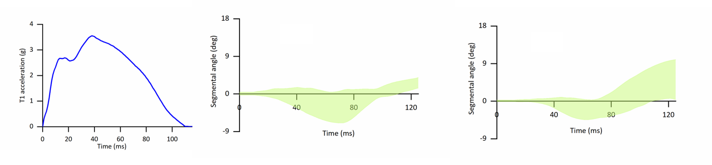
Figure 1: Left shows the acceleration pulse. Middle and right shows the corridors at the C2-C3 and C3-C4 levels.

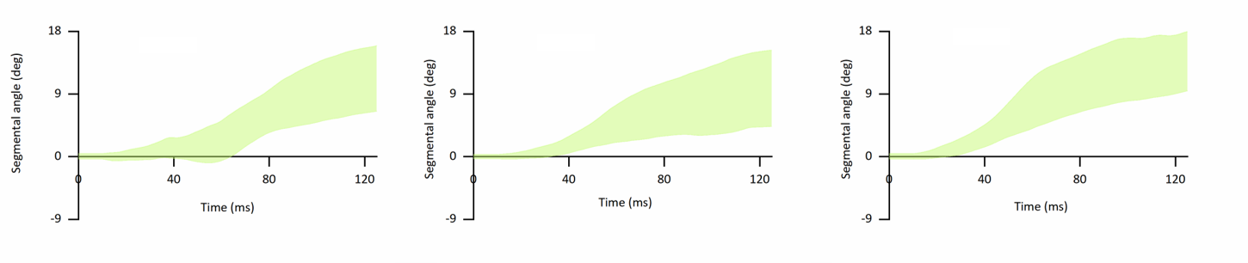
Figure 2: Corridors from left to right: C4-C5, C5-C6, and C6-C7 levels. Negative angulations denote flexion and positive angulations denote flexion.

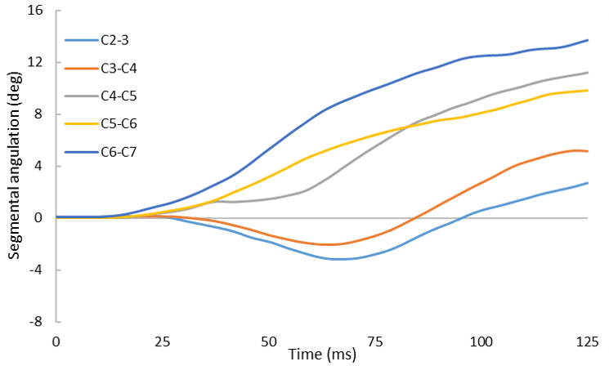
Figure 3: Mean responses for different segments of the cervical spine under rear impact loading. Negative angulations denote flexion and positive angulations denote flexion.

Wednesday, 10/20/21, 02:50 PM - 03:00 PM EST
Importance of Neural Foraminal Narrowing in Lumbar Spine Fractures of Low AIS Severity
Author: Dennis Maiman, dmaiman@mcw.edu
Co-Authors: Karthik Somasundaram, ksomasundaram@mcw.edu, Narayan Yoganandan, yoga@mcw.edu, Frank Pintar, fpintar@mcw.edu

ABSTRACT
Objective: In recent years, based on injuries predicted using machine learning, there have been efforts to reduce imaging performed on trauma patients. While useful, such efforts do not incorporate results from studies investigating the pathophysiology of traumatic events. The objective of this study was to identify potentially symptomatic vertebral foramen narrowing in the presence of minor to moderate (AIS ≤ 2 levels of severity) thoracolumbar fractures sustained in motor vehicle crashes (MVCs). Methods: Hospital records and images of patients admitted to a Level One trauma center between the years 2014 and 2018 with the diagnosis of thoracolumbar fracture were reviewed. Spinal injuries were scored using the AIS v2015. In addition, the geometry of the neural foramina, particularly the height of the foramina and intervertebral disc at the posterior region, were measured using reconstructed sagittal computed tomography (CT) images. The criteria for foraminal narrowing were associated with < 15 mm for the foraminal height and < 4 mm for the height of the posterior disc. Results: 24 patients with MVCs associated thoracolumbar fractures, who met both the clinical and imaging criteria for radiculopathy and foraminal narrowing without spinal cord injury, were considered for the present clinical study. 54% of the total lumbar fracture cases reported were rated as AIS 2 injuries. AIS ≥ 3 cases reported 50% narrowing of foramen, which was expected. However, it was surprising to note that the AIS 2 cases also sustained foraminal stenosis, narrowing ranging from 13% to 20%. Conclusions: Low severity (AIS ≤ 2) injuries were often found to be associated with foraminal narrowing leading to clinical complaints. While the present clinical study cannot determine if narrowing existed prior to the trauma, they were certainly asymptomatic prior to the trauma. The present findings emphasize the need for detailed imaging in all instances of thoracolumbar trauma, as clinically significant nerve compression may occur even with modest vertebral body injury.

INTRODUCTION
Traumatic loading of the dorsal column leading to lumbar spine injuries has been identified recently in automotive environments (Pintar et al., 2012; Kaufman et al., 2013). Injuries have been documented in restrained occupants in frontal impacts. It is also documented in underbody blast loading events (Loftis et al., 2019) and Falls (Cooper et al., 1996). One of the potential mechanisms of injuries is the axial loading along the caudal to rostral axis of the lumbosacral spinal column (Yoganandan et al., 2015; Somasundaram et al., 2021). Compressive fractures of lumbar vertebrae may expose the neural structures to long term consequences secondary to foraminal narrowing. Studies correlating the severity of injuries and foraminal narrowing are limited. Ina prior effort using isolated spines (Maiman et al., 2020), we observed that 30% of AIS II lumbar spine fracture associated with vertical loading demonstrated foraminal narrowing and hypothesized the possibility of clinical symptoms resulting from these otherwise benign-appearing fractures. This motivated us to conduct a retrospective analysis of symptomatic vertebral foramen narrowing in the presence of minor to moderate (AIS ≤ 2 levels of severity) thoracolumbar fractures sustained in MVCs.

METHODS
The study was conducted after obtaining the approval from the local Institutional Board of the academic medical center (not disclosed based on the instructions for the AAAM short communication format). Medical records and imaging of all patients admitted to the Level One trauma center between the years 2014 and 2018 with the diagnosis of thoracolumbar fracture(s) were reviewed by the clinical senior author. Cases with inadequate follow-up or imaging were excluded from the study. The selection criteria included patients with radicular complaints and/ or findings, and clinical outcomes were recorded. Lumbar spine injuries were classified using the AIS injury scale (AIS, 2015). In addition, the neural foraminal geometry, defined as the maximum height of the foramen and height of the intervertebral disc at the posterior region were measured using CT scans. The measurement procedure was referenced from our previous study (Maiman et al., 2020). The criteria for foraminal narrowing were associated with < 15 mm for the foraminal height, primarily and < 4 mm for the height of the posterior disc (Hasegawa et al., 1995).

RESULTS
There was a total of 950 patients in the database who sustained compression fractures of the lumbar spine. Of these, 725 injuries were identified to be from motor vehicle crashes. Twenty-eight patients had evidence of radiculopathy. In four of these patients, imaging or follow-up records were deemed incomplete. Twelve fractures were at the L1 level, six at the L2 level, four at the L3 level, and two at the L5 level (Table 1). In all cases, the narrowing was identified at the caudal foramen. Of the total, 54% fractures cases were rated as AIS 2 injuries. Foraminal compression ranged from 50% narrowing to complete occlusion in fractures with higher severity AIS ≥ 3. Notably, in AIS 2 severity cases the narrowing of the foramen ranged from 13% to 20%. This observation supports our experimental findings of AIS 2 associated foraminal stenosis. Most patients had radicular pain and paresthesias which were appropriate to the level of involvement. Eight evidenced motor weakness attributable to the involved root. Similar to our experimental observations, the foraminal narrowing in present clinical study was due to intrusion of fracture vertebral body into the foramen in all except two AIS 2 cases, where the pedicle fracture induced foraminal stenosis.

DISCUSSION
The management of thoracolumbar fractures has changed considerably over time, and the current clinical paradigm is to focus on earlier mobilization, prevention of deformity, and aggressive decompression for potential neurologic deficit (Rajasekaran et al., 2015). Conversely, concerns about the amount of imaging performed early in the trauma environment have been raised. For example, while the use of computed tomography in trauma cases has increased over the years, some have pointed out that rarely does management change from a more accurate depiction of the findings (Heller et al., 2014; Byrne et al., 2020). However, the management of thoracolumbar fractures were not the focus of these studies, as they included injuries to different body regions. A detailed study focused on the thoracolumbar spinal column with a larger database is needed to reinforce the initial findings from this investigation.

One such database is the Crash Injury Research and Engineering Network (CIREN), which provides detailed information on injuries and crash details that include vehicle, occupant kinematics, occupant position and restraint, and inference on potential injury loading vectors. This may help define the need for imaging in patients with minor to moderate lumbar spinal column injuries that belong to the AIS ≤ 2 severities (Schneider et al., 2011). Further, such studies may improve the granularity in the coding of the current AIS 2015 version and is already under consideration by the AIS subcommittee of AAAM. Avenues for laboratory research to reproduce minor to moderate injuries with appropriate automotive relevant load vectors (compression as a primary loading mode) are important, as retrospective studies do not unveil pre-impact geometrical relationships between the osseous and neural structures of the human spinal column. From these viewpoints, the present, focused, retrospective study from a single Level One Trauma Center may act as a catalyst to improve occupant safety and medically manage these injuries.

In this limited retrospective clinical review, minor to moderate severity (AIS ≤ 2) fractures were found to be associated with foraminal narrowing leading to clinical complaints. While the clinical study cannot determine if narrowing existed prior to the trauma, patients were asymptomatic prior to trauma. These clinical review findings emphasize the need for detailed imaging in all instances of thoracolumbar trauma, as clinically significant nerve compression may occur even with modest vertebral body injury. Detailed and early imaging of low severity (AIS ≤ 2) injuries remains warranted to better identify these injuries.

REFERENCES
- AIS (2015). The Abbreviated Injury Scale, 6th edition. In AAAM (ed) Association for the Advancement of Automotive Medicine, Arlington Heights, IL.
- Byrne, R., Parks, A., Hazelton, J.P., Kirchhoff, M. & Roberts, B.W. (2020). Incidence and significance of injuries on secondary CT imaging after initial selective imaging in blunt trauma patients. Am J Emerg Med, 38, 1588-1593.
- Cooper, C., Dunham, M. & Rodriguez, A. (1996). Falls and major injuries are risk factors for thoracolumbar fractures: cognitive impairment and multiple injuries impede the detection of back pain and tenderness. J Emerg Med, 2, 275-276.
- Hasegawa, T., An, H.S., Haughton, V.M. & Nowicki, B.H. (1995). Lumbar foraminal stenosis: critical heights of the intervertebral discs and foramina. A cryomicrotome study in cadavera. J Bone Joint Surg, 77, 32-38.
- Heller, M.T., Kanal, E., Almusa, O., Schwarz, S., Papachristou, M., Shah, R. & Ventrelli, S. (2014). Utility of additional CT examinations driven by completion of a standard trauma imaging protocol in patients transferred for minor trauma. Emerg Radiol, 21, 341-347.
- Kaufman, R.P., Ching, R.P., Willis, M.M., Mack, C.D., Gross, J.A. & Bulger, E.M. (2013). Burst fractures of the lumbar spine in frontal crashes. Accid Anal Prev, 59, 153-163.
- Loftis, K.L., Mazuchowski, E.L., Clouser, M.C. & Gillich, P.J. (2019). Prominent injury types in vehicle underbody blast. Mil Med, 184, 261-264.
- Maiman, D., Curry, W., Yoganandan, N. & Pintar, F. (2020). Intervertebral foramen narrowing during vertical dynamic loading. Traffic Inj Prev, 21, S163-S165.
- Pintar, F.A., Yoganandan, N., Maiman, D.J., Scarboro, M. & Rudd, R.W. (2012). Thoracolumbar spine fractures in frontal impact crashes. Vol. 56, Ann Adv Automot Med. Association for the Advancement of Automotive Medicine, City. p. 277.
- Rajasekaran, S., Kanna, R.M. & Shetty, A.P. (2015). Management of thoracolumbar spine trauma. Indian J Orthop, 49, 72-82.
- Schneider, L.W., Rupp, J.D., Scarboro, M., Pintar, F., Arbogast, K.B., Rudd, R.W., Sochor, M.R., Stitzel, J., Sherwood, C. & MacWilliams, J.B. (2011). BioTab—a new method for analyzing and documenting injury causation in motor-vehicle crashes. Traffic Inj Prev, 12, 256-265.
- Somasundaram, K., Sherman, D., Begeman, P., Ciarelli, T., McCarty, S.A., Kochkodan, J.J., Demetropoulos, C.K. & Cavanaugh, J.M. (2021). Mechanisms and timing of injury to the thoracic, lumbar and sacral spine in simulated underbody blast PMHS impact tests. J Mech Behav Biomed Mater, 116, 104271.
- Yoganandan, N., Stemper, B.D., Baisden, J.L., Pintar, F.A., Paskoff, G.R. & Shender, B.S. (2015). Effects of acceleration level on lumbar spine injuries in military populations. T Spine J, 15, 1318-1324.

Level | N | AIS grade |  | Mean Foramen height (mm) | Mean Post disc height (mm)
L1 | 12 | 8: AIS 2 | 4: AIS ≥3 | 14 | 3
L2 | 6 | 2: AIS 2 | 4: AIS ≥3 | 12 | 3
L3 | 4 | 2: AIS 2 | 2: AIS ≥3 | 12 | 2
L5 | 2 | 1: AIS 2 | 1: AIS ≥3 | 13 | 3
Table 1. Data summary

Wednesday, 10/20/21, 03:00 PM - 03:10 PM EST
Belt-induced Abdominal Injuries in Recent Frontal-impact CIREN Cases
Author: Dale Halloway, dhalloway@mcw.edu
Co-Authors: Hans Hauschild, hhauschild@mcw.edu, Frank Pintar, fpintar@mcw.edu, Narayan Yoganandan, yoga@mcw.edu

ABSTRACT
Objective: Report sex related variation in three-point belt related abdominal injuries in CIREN cases.
Methods: A query of CIREN cases was made for those with the highest ranked CDC to the front plane, a PDOF +/- 20 degrees from 0 degrees, and an AIS 2+ abdomen injuries attributed to the seatbelt. Patterns of injury were categorized as: Above the crest of the ilium, injuries below the crest of the ilium and injuries above and below the ilium. This was done in the context of Autonomous Vehicle Occupant Kinematics testing results. 12 5th and 95th three-point belt restrained post-mortem human subjects (PMHS) were subjects; test speeds and recline angles varied. Abdomen injuries were anticipated; none were observed.
Results: 35 occupants with belt related abdominal were identified. 17 case occupants sustained an injury only within the pelvic contents: five women and 12 men. Nine of the 17 were ≥ 81st percentile in height, 13 were between 62nd and 80th percentile in height and four were < 50th percentile in height.
Conclusions: The stature component of the BMI appears to be a plausible candidate for an independent variable that is a contributing factor explaining the incidence of pelvic contents injuries when a three-point restrained occupant is involved in a frontal-impact.

INTRODUCTION
The Crash Injury Research Engineering Network (CIREN) is one of the programs the National Highway Traffic Safety Administration (NHTSA) operates obtaining information on motor vehicle collisions. It collects data on the same set of variables as the Crash Injury Sampling System (CISS) which employs a weighted random sample of crashes. The data points collected define the space of all light passenger vehicle crashes on public roadways. Neither program provides the means to establish a causal relationship between factors viewed as independent of any injury occupants sustain.
CIREN is an observational study analogous to those performed in clinical research. The object is the reduction of the forensic evidence for a crash and the acute care record injury evidence into an injury causation scenario (ICS) for each injury. A CIREN ICS incorporates experienced judgement of physicians, engineers, crash investigators about the information and images used to document a case. This allows CIREN cases to be viewed as retroactive experiments¹. The analytical method for developing a set of ICSs is described by the rules governing the Bio-tab schema². A variation of the Bio-tab method has been adopted by the CISS program.
A review of recent CIREN case occupants with abdominal injuries linked to seat belts was done to provide information on the types of abdominal injuries that could be expected in PMHS subjected to sled tests. The tests simulated a light passenger vehicle sustaining a frontal-impact involving primarily obese, three-point belt restrained occupants. This short-communication reports on a potential emerging pattern of seat belt related injuries in frontal-impacts, with a sex related variation in current-round CIREN cases.

METHODS
A query for CIREN cases where the highest ranked CDC was assigned to the front plane of the vehicle, the principal direction of force (PDOF) was +/- 20 degrees from 0 degrees, the occupant’s body region injured (BRI) was the abdomen, the contacted involved physical component (IPC) was the seatbelt and an AIS 2+ severity injury code specified to the BRI. The query reported age, sex, stature, mass, BMI, seat position and a flag for the presence of event data recorder (EDR) data. After excluding occupants with only AIS 1 injury to the abdomen, 35 cases, 18 female and 17 males, were identified for review.
The documented abdominal injury patterns were placed in one of the following categories: Injuries above the crest of the ilium, injuries below the crest of the ilium and injuries above and below the ilium. The injury locations were determined by reviewing the radiology reports, radiology images and operative reports. The determined locations were indicated on anatomical diagrams. Referring to the radiology images/reports and the operative notes in the case the diagrams were reviewed for accuracy by a member of Association for the Advancement of Automotive Medicine’s teaching faculty.
The occupants were also classified by percentile height and weight and the comparative percentages of occupants ≤ 50th percentile, between the 51st and 80th percentile and above the 81st percentile are reported in figure 1. The percentile of the height and weight were calculated using the data reported in the 2015-2016 National Health and Nutrition Examination Survey (NHANES 2015-2016)³.

RESULTS
Five of the 18 females had abdominal injuries only above the iliac crest; eight had abdominal injuries above and below it. Five had abdominal injuries only below the iliac crest. All five occupants with injuries below-the-iliac-crest had lacerations of the bowel or mesentery deep in the pelvic contents.
One of the 17 males had abdominal injuries (liver laceration) only above the iliac crest. Four had abdominal injuries above and below it. 12 had abdominal injuries only below the iliac crest and all of these cases had lacerations of the bowel or the mesentery deep in the pelvic contents documented; mesentery injuries were the most common. Vessel injures (external iliac artery) were seen in this category.
It was noted 5/18 females and 12/17 males sustained abdominal injuries only below the iliac crest. It was speculated a facet of body habitus might account for this difference. The Body Mass Index (BMI) is a metric for assessing the presence of increased body fat in clinical situations and correlates well to adiposity. Using cut-off points BMI describes six weight categories: Underweight (<18.5), healthy weight (18.5-25), overweight (25.1-30) and three classes of obesity (30.1 to 35, 35.1 to 40 and 40+). These BMI cut points in adults are the same for men and women, regardless of their age.
It was hypothesized abdominal injuries occurring only below the iliac crest were due to submarining the lap belt associated with deformation of the seat-bottom and BMI might indicate when deformation of structure could be expected. The data for the 35 CIREN case occupants is summarized in table 1. These were sorted into the BMI categories shown in figure 2. The ‘only-below’ cases of five females and 12 males were compared.
Three of the five females had a BMI in the healthy range. All were right-front passengers; two were in seats with deformed seat-pan structure. All sustained AIS 3 abdominal injuries. There were two female drivers; one was the other in the Obese 2 category. Both sustained AIS 4 abdominal injuries, and their seat-pans were deformed.
Three of the 12 males had a BMI in the healthy range. All were drivers; one in a seat with seat-pan deformation. Five of the 12 males were overweight. Four of these were drivers and one was a right-front passenger. All five sustained AIS 4 abdominal injuries. Four were in seats with deformed seat-pans.
Two of the 12 males had a BMI placing them in the Obese 1 category. Both were drivers, both sustained AIS 3 abdominal injuries. Neither of their seats had deformed seat-pans. Two of the 12 males were in the Obese 2 category. Both were drivers, both sustained AIS 5 abdominal injuries and both of their seats had deformed seat-pans. One driver was in the Obese 3 category and sustained an AIS 2 mesentery contusion but its location relative to the iliac crest is unknown.
For the total cohort (figure 1), 64% of males were at or taller than the 81st percentile; 28% of females were in this range. 44% of the females were 50th percentile or shorter; 18% of males fell into this range. The apparent sex difference in the distribution of weight percentiles was less marked. 14% more males were at or heavier than the 81st percentile compared to women. 39% of the females were 50th percentile or less in weight or less; 29% of males fell into this range.
A total of 17 case occupants sustained an abdominal injury only within the pelvic contents: five women and 12 men. Nine of the 17 were 81st percentile in height or taller, 13 were 62nd percentile in height or taller and four were less than 50th percentile in height, ranging from the 7th to the 32nd percentile in height.
An EDR image was available for 11 of the 17 case occupants. With one exception the PDOFs ranged from 350 to 10 degrees. The longitudinal velocity changes ranged from -22.5 to 80.4 km/h (-14 to -50 MPH)

DISCUSSION
In the biomechanics literature, BMI can be used to imply adiposity’s role in external body morphology. Kent et al. (2010)⁴ tested a female BMI 40 (67th percentile in height, 91st in weight) and two males BMIs 34.7 and 45.6 (97th and 81st in height/93rd and 98th in weight) in a comparison of the motion and potential injury mechanisms of nonobese and obese cadavers in simulated frontal impact crashes. The focus of the comparison was occupant interaction with the belt restraint. The relevant findings are: 1) Obese subjects had greater maximum forward excursion before motion was arrested by the restraint, 2) the torso of obese cadavers tended to pitch much less forward. The comparison indicated BMI was not necessarily predictive of the likelihood of pelvic content injuries or a correlation between adipose fat and deformation of the seat-bottom structure.
While 20 of the 35 cases were associated with seat-pan deformation, it was not a necessary indicator of injury nor was the cumulative longitudinal ΔV. Two of the three females with injuries only below the iliac crest, had healthy BMI and were below 50th percentile in height and weight. The smallest female (7th in height and 3rd percentile in weight) observed the lowest EDR reported longitudinal ΔV of -22.5 km/h (-14 MPH). The injuries attributed to the lap belt were an iliac artery injury and a contusion overlaying the right hip. The second lowest longitudinal ΔV -25.7 km/h (-16 MPH) involved a male 90th percentile in height and 34th in weight. The injuries attributed to the lap belt were an iliac artery tear, a mesentery laceration at the terminal ileum, and lacerations of the sigmoid colon and its mesentery. Neither lean occupant was in a seat with deformed seat-bottom structure.
BMI does not directly assess body fat. Muscle and bone are denser than fat leading to taller individuals having a reported BMI that is high, compared to actual body fat levels. As 64% of the male were at or taller than the 81st percentile, it is not clear whether all the males with a BMI indicating they are overweight is due to disproportionate adipose fat or the additional muscle/bone proportionate to their stature.

CONCLUSION
The incidence of this injury pattern among females and males among individuals with healthy/overweight BMIs, and in the case of males, in the context of their height, suggests that a relevant component of body morphology indexed by BMI as the contributing factor affecting three-point belt interaction in these 35 three-point restrained occupants is stature.

LIMITATIONS
CIREN data is from a convenience sample. The report is not representative of abdominal injuries patterns in the United States. Only current round CIREN cases are included. This limits the number of cases available for review. Age an DV were not controlled for. Confirming findings in CISS data is problematic; abdominal injuries of the same type receive one line of code.

REFERENCES
1. Carlson W. and Kaplan, R. Case Studies Considered as Retroactive Experiments. Accident Analysis and Prevention. Vol 7. pp. 73-80, 1975
2. Schneider, L et al. BioTab-A New Method for Analyzing and Documenting Injury Causation in Motor-Vehicle Crashes. June 2011Traffic Injury Prevention 12(3):256-65 DOI: 10.1080/15389588.2011.560500
3. NHANES Questionnaires, Datasets, and Related Documentation (cdc.gov)
4. Kent, R., Forman, J and Bostrom, O. Is There Really a “Cushion Effect”?: A Biomechanical Investigation of Crash Injury Mechanisms in the Obese. Obesity (2010) 18, 749–753. doi:10.1038/oby.009.315

TABLES AND FIGURES
Figure 1. Percent of Case Occupants by Sex by Category of Height and Weight Percentile
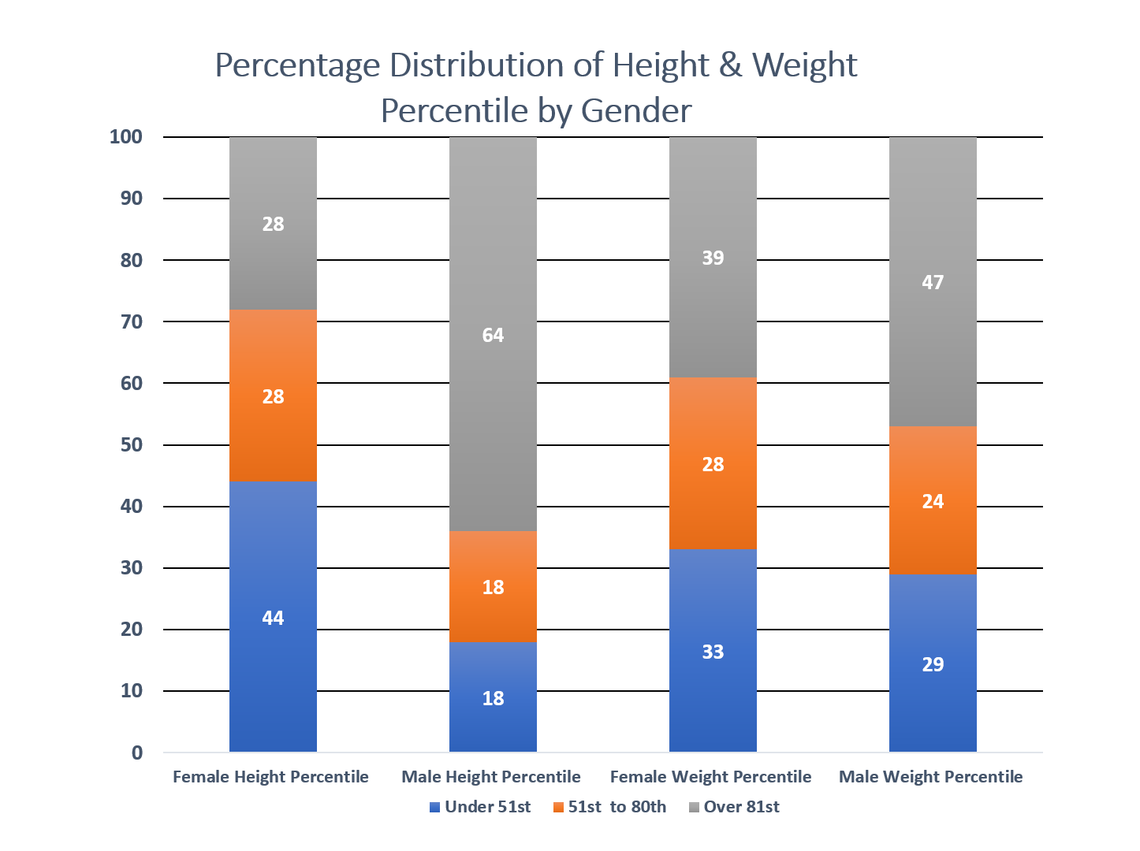
Figure 2. Number of Case Occupants by Sex per BMI Category
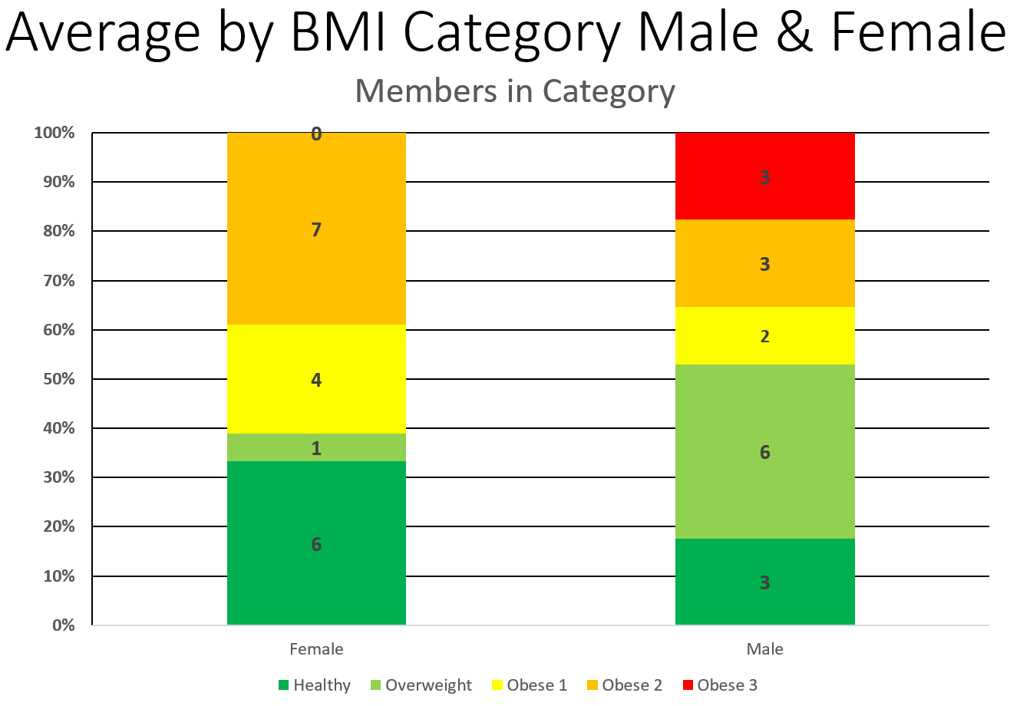

Table 1 Summary of Case Characteristics.
ID | Sex | Age | Long. DV (km/h) | Stature  (percentile) | Mass  (percentile) | BMI | Abd. Injury  (severity) | Category | Seat-pan Def.
409 | F | 68 | -48.3 | 175 (97th) | 99 (85th) | 32.1 | Abd. muscle rupture (2) | Above | No
537 | F | 53 | -53.9 | 163 (57th) | 89 (75th) | 33.5 | Abd. muscle rupture (2) | Above | No
415 | F | 68 | -41.8 | 157 (26th) | 51 (6th) | 20.7 | Duodenum perf. (3)  Small bowel lac. full thickness (3) | Above | No
85 | F | 71 | -60.8 | 168 (81st) | 113 (93rd) | 40 | Mesentery cont. (2) | Above | Unk.
115 | F | 22 | -44.2 | 157 (26th) | 91 (78th) | 36.9 | Liver lac. (4)  Mesentery lac. (4) | Above & below | Yes
568 | F | 31 | -59.5 | 167 (76th) | 73 (73rd) | 31.2 | Bladder lac. (3)  Spleen cont. (2) | Above & below | Yes
181 | F | 22 | -76.6 | 167 (76th) | 111 (92nd)  Note: 2nd trimester | 39.8 | Spleen lac. (4)  Uterus lac. (5)  & Diaphragm lac. | Above & below | Yes
585 | F | 60 | -65.9 | 150 (5th) | 55 (10) | 24.4 | Aorta intimal tear (4)  Small bowel lac. (4) | Above & below | Yes
110 | F | 22 | -52.7 | 157 (26th) | 68 (37th) | 27.6 | Liver lac. (2)  Iliac artery lac. (3) | Above & below | Yes
471 | F | 45 | -77.5 | 160 (40th) | 91 (78th) | 35.5 | Spleen lac. (4)  Mesentery cont. (2) | Above & below | Yes
290 | F | 23 | -62.4 | 165 (67th) | 85 (69th) | 31.2 | Mesentery contusion (4) | Below | Yes
188 | F | 74 | -22.5 | 151 (7th) | 49 (3rd) | 21.5 | Iliac artery laceration (3) | Below | No
354 | F | 22 | -56 | 157 (26th) | 53 (7th) | 21.5 | Small bowel lac. (3) | Below | No
15 | F | 35 | Bad EDR | 157 (26th) | 49 (3rd) | 19.9 | Liver lac. (4) | Above | No
306 | F | 50 | No EDR | 173 (95th) | 110 (92nd) | 36.8 | Mesenteric vein lac. (3) | Above & below | Unk.
314 | F | 57 | No EDR | 173 (95th) | 109 (91st) | 36.4 | Jejunum-Ileum lac. (4)  Descending colon lac (3) | Above & Below | Yes
81 | F | 81 | No EDR | 165 (67th) | 108 (91st) | 39.7 | Adrenal gland cont. (2)  Mesentery cont. (2) | Above & below | Yes
168 | F | 48 | No EDR | 168 (81st) | 60 (19th) | 21.3 | Small bowel lac. (2) | Below | Yes
546 | M | 57 | -48.2 | 191 (98th) | 108 (83rd) | 29.6 | Abd. muscle rupture (2) Mesentery lac. (4) | Above & below | Yes
524 | M | 63 | -35 | 183 (84th) | 136 (96th) |  | Liver lac. (5)  Bladder avulsion (4) | Above & below | No
384 | M | 49 | -72.4 | 188 (96th) | 103 (78th) | 29.1 | Spleen laceration (3)  Mesentery contusion (4) | Above & below | Yes
398 | M | 51 | -83 | 180 (72nd) | 93 (62nd) | 28.7 | Large bowel cont. (2) | Below | Yes
478 | M | 38 | -76.9 | 175 (45th) | 111 (86th) | 26.3 | Bladder lac. | Below | Yes
518 | M | 73 | -72.4 | 178 (62nd) | 115 (89th) | 36.3 | Iliac artery lac. (3) | Below | Yes
112 | M | 44 | -51.3 | 193 (99th) | 122 (92nd) | 32.8 | Mesentery lac. (3) | Below | No
187 | M | 74 | -25.7 | 185 (90th) | 79 (34th) | 23.1 | Iliac artery lac. (4) | Below | No
385 | M | 15 | -72.4 | 183 (84th) | 86 (50th) | 25.7 | Mesentery contusion (4) | Below | Yes
671 | M | 40 | -30.5 | 172 (32nd) | 109 (84th) | 36.8 | Mesentery lac. (5) | Below | Yes
650 | M | 37 | -80.6 | 180 (72nd) | 95 (66th) | 29.3 | Mesentery lac. (4) | Below | Yes
76 | M | 38 | -57.9 | 193 (99th) | 202 (99th) | 54.2 | Mesentery cont. (2) | Unknown | Yes
453 | M | 68 | No EDR | 180 (72nd) | 141 (97th) | 43.5 | Liver cont. (2) | Above | No
114 | M | 55 | No EDR | 183 (84th) | 82 (41st) | 24.5 | Spleen lac. (2)  Large bowel lac. (4) | Above & below | Unk.
449 | M | 54 | No EDR | 168 (16th) | 86 (50th) | 30.5 | Bladder lac. (2) | Below | No
50 | M | 53 | No EDR | 185 (90th) | 84 (45th) | 24.5 | Retroperitoneum hematoma (2) | Below | Yes
65 | M | 82 | No EDR | 188 (96th) | 98 (71st) | 27.7 | Mesentery cont. (2) | Below | No

Wednesday, 10/20/21, 03:10 PM - 03:20 PM EST
The Relationship of Body Mass Index, Belt Placement, and Abdominopelvic Injuries in Motor Vehicle Crashes: A Crash Injury Research and Engineering Network (CIREN) Study
Author: Sydney Schieffer, sschieff@wakehealth.edu
Co-Authors: Casey Costa, ccosta@wakehealth.edu, Thomas Hartka, Joel Stitzel, jstitzel@wakehealth.edu, R. Shayn Martin, romartin@wakehealth.edu, Bahram Kiani, bkiani@wakehealth.edu, Anna N. Miller, milleran@wustl.edu, Ashley A. Weaver, asweaver@wakehealth.edu

ABSTRACT
Objective: Obesity has important implications for motor vehicle safety due to altered crash injury responses from increased mass and improper seatbelt placement. Abdominal seatbelt signs (ASBS) above the anterior superior iliac spine (ASIS) in motor vehicle crashes (MVCs) often correlate with abdominopelvic trauma. We investigated the relationship of body mass index (BMI), lap belt placement, and the incidence of abdominopelvic injury using computed tomography (CT) evaluation for subcutaneous ASBS mark and its location relative to the ASIS.
Methods: A retrospective analysis of 235 Crash Injury Research and Engineering Network (CIREN) cases and their associated abdominal injuries was conducted. CT Scans were analyzed to visualize fat stranding. 150 positive ASBS were found and their ASBS mark location was classified as superior, on, or inferior to the ASIS.
Results: Obese occupants had a higher incidence rate of belt placement superior to the ASIS, and occupants with normal BMI had a higher incidence of proper belt placement (p<0.05). Trends of interest developed, notably that non-obese occupants with superior belt placement had increased incidence of internal abdominopelvic organ injury compared to those with proper belt placement (Normal BMI: 53.3% superior vs 39.4% On-ASIS, Overweight: 47.8% superior vs 34.7% On-ASIS).
Conclusions: Utilizing CT scans to confirm ASBS and lap belt placement relative to the ASIS, superior belt placement above the ASIS was associated with elevated BMI and a trend of increasing incidence of internal abdominopelvic organ injury.

INTRODUCTION
Abdominal seatbelt sign (ASBS) is used in medical trauma evaluation to visually assess for probable abdominal injury (Chandler et al., 1997) and can be correlated with computed tomography (CT) imaging as well (subcutaneous adipose belt marks) which has been proposed as a possibly more discerning measure for evaluating abdominal trauma (Hartka et al., 2014). Previous studies have shown that ASBS located above the anterior superior iliac spine (ASIS) sustained in motor vehicle crashes (MVCs) correlates with increased incidence of abdominopelvic trauma (Johnson et al., 2017). Obesity rates have risen globally, and research continues to investigate the role of obesity in MVC mechanisms of injury in relation to vehicle restraints and occupant biomechanics. Our primary objective was to investigate how occupant body mass index (BMI) and seatbelt placement influenced the incidence of abdominopelvic injuries in MVCs. We hypothesized higher occupant BMIs would be associated with placement of the lap belt superior to the ASIS, and that this improper placement would lead to increased incidence of internal abdominopelvic injury.

METHODS
Study Population
The study population was gathered from the Crash Injury Research and Engineering Network (CIREN) database of MVC cases enrolled from 2006-2015 (Wake Forest IRB: BG05-483). A total of 235 CIREN occupants met the inclusion criteria of this study: they were belted, over the age of 16 years with a BMI >18 (normal, overweight, or obese), and involved in a frontal/offset frontal collision (crashes with principal direction of force (PDOF) 300-360 or 0-60) with at least one abdominopelvic injury. The Abbreviated Injury Scale (AIS) 2008 and 2015 coding manuals were used to confirm exact injuries specified as outlined by the Association for the Advancement of Automotive Medicine (AAAM). Solid organ injures (hepatic, renal and splenic), mesenteric injuries and other system injuries (OSI) (bladder, etc) were the categorical internal organ injury groups studied, though any abdominopelvic injury (such as simple abdominal hematomas) allowed for inclusion. Lap belt causation for the injuries was determined by both the reported causation from the CIREN database and in-depth case review.

Determination of Positive ASBS and Location Relative to the ASIS Level
CT scans of cases that met inclusion criteria were rendered with open-source Slicer 3D software (http://www.slicer.org, Fedorov, et al, 2012) to visualize fat stranding on the CT (which appears yellow/bright green contrasted to blue/dark green non-contused fat). Positives were defined as only lap belt signs (Figure 1). With a positive ASBS, the ASIS level was measured by adjusting the transverse slice of the CT to the visualized ASIS level and then confirmed with the sagittal slice. The distance (in cm) from the ASIS level to the midpoint of the ASBS was determined via the Slicer 3D measurement tool. Using previous studies (Gayzik et al. 2012) that have confirmed that the ASIS level drops 2 cm in the seated versus standing position in normal weight occupants, we adjusted our measurements collected from the CIREN CT scans taken in the supine posture. We defined ASBS location as superior (greater than 1 cm above ASIS), proper belt placement on the ASIS (within 1 cm above to 3 cm below the ASIS), or inferior (greater than 3 cm below the ASIS).
Statistical analysis
All statistics were completed with JMP software (SAS, Inc, Cary, NC), with the significance level set at p<0.05. The number of injuries and total number of internal injuries per occupant sustained was used for each injury category. All variables were compared via Chi-square regression, and the Pearson p-value was calculated.

RESULTS
Obese occupants had a higher incidence of superior belt placement (16%) compared to normal (10%) and overweight occupants (15.3%), and normal BMI occupants had a higher incidence of proper belt placement (22%) compared to overweight (15.3%) and obese (8%) occupants (p=0.002). The remainder of the statistical analyses showed no statistical significance including occupant BMI vs incidence of abdominopelvic organ injury when grouped by ASBS location. Though the superior belt placement did not significantly increase the rates of intra-abdominopelvic organ injury as predicted, there were notable trends such as higher incidence of internal organ injury for non-obese occupants with superior belt placement vs their on-ASIS counterparts [Normal BMI: 53.3% (Superior) vs 39.4% (On-ASIS); Overweight: 47.8% (Superior) vs 34.7% (on-ASIS)] with notably only 25% of obese occupants with superior placement sustaining internal abdominopelvic organ injury (Table 1).

DISCUSSION
Obese occupants were found to be at an increased risk of improper belt placement when compared to occupants with lower BMI. The difficulty in proper lap belt positioning as BMI increases may be explained by the protrusion of the abdomen over the centerline of even a properly positioned lap belt, causing a higher riding midline point which directs forces onto the abdomen rather than the underlying bony pelvis as seen in studies of pregnant occupants (Klinich et al., 1998). Our findings differ from similar studies on obesity and belt placement in that the significance was achieved with a dichotomous study design compared to a linear regression and employed a different algorithm for stratifying belt placement (Hartka et al. 2018). This study opens further opportunities for quality improvement investigations for overall seatbelt design and proper usage education to continue to evolve as obesity rates climb nationally and worldwide. The lack of accepted location for superior/inferior ASIS level was a limitation as there is no standardized level that is adapted how different body mass individual’s abdominal fat pad moves from seated to supine (as seen from occupant driving to lying supine in the CT scanner). Standardizing the movement of the pelvic skeleton under abdominal body mass would allow more efficient trauma evaluation and targeted CT scan reading based on more accurate knowledge of direction of force applied to the abdomen and pelvis during MVCs.

ACKNOWLEDGEMENTS
The authors would like to thank the National Highway Traffic Safety Administration who provided funding under the Crash Injury Research and Engineering Network study (DTNH2217D00069) as well as Wayne and Gayle Meredith Student Research Support Fund for Wake Forest School of Medicine’s Medical Student Research Program (MSRP) 2019.

REFERENCES
Chandler CF, Lane JS, Waxman KS. Seatbelt sign following blunt trauma is associated with increased incidence of abdominal injury. Am Surg. 1997 Oct;63(10):885-8.
Fedorov A, Beichel R, Kalpathy-Cramer J, Finet J, Fillion-Robin JC, Pujol S, Bauer C, Jennings D, Fennessy F, Sonka M, Buatti J, Aylward S, Miller JV, Pieper S, Kikinis R. 3D Slicer as an image computing platform for the Quantitative Imaging Network. Magn Reson Imaging. 2012 Nov;30(9):1323-41.
Gayzik, F.S., Moreno, D.P., Danelson, K.A. et al. External Landmark, Body Surface, and Volume Data of a Mid-Sized Male in Seated and Standing Postures. Ann Biomed Eng 2012; 40: 2019
Hartka TR, Sochor MR, Hersi K, Booker A, Poplin G. Comparison of Visual and CT 3D Reconstructed Abdominal Seatbelt Sign Locations. Traffic Injury Prev. 2014; 15. S247-S249.
Hartka TR, Carr HM, Smith BR, Melmer M, Sochor MR. Does obesity affect the position of seat belt loading in occupants involved in real-world motor vehicle collisions? Traffic Inj Prev. 2018 Feb 28;19(sup1):S70-S75.
Johnson MC, Eastridge BJ. Redefining the abdominal seatbelt sign: Enhanced CT imaging metrics improve injury prediction. Am J Surg. 2017 Dec;214(6):1175-1179.
Klinich KD, Schneider LW, Moore JL, Pearlman MD. Injuries to Pregnant Occupants in Automotive Crashes. Annu Proc Assoc Adv Automot Med. 1998;42:57-91.

FIGURES AND TABLES
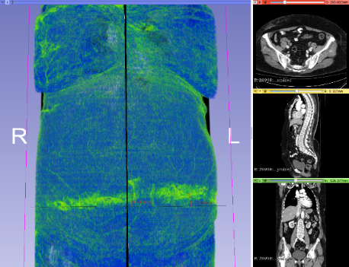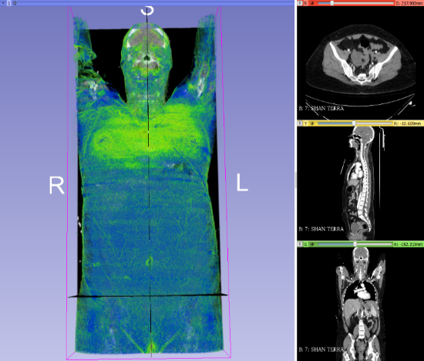 Figure 1: 1A: Positive Abdominal Seat Belt Sign (ASBS; Red Arrow), and 1B: Negative ASBS  1A  1B | Table 1: BMI vs Abdominopelvic Injury Percentages by ASBS Locations.
  Occupants Sustaining Internal Abdominopelvic Injuries, N (%) | Belt Superior to ASIS | Belt On-ASIS
  All | 25 (40.3%) | 29 (42.6%)
  Normal BMI | 8 (53.3%) | 13 (39.4%)
  Overweight BMI | 11 (47.8%) | 8 (34.7%)
  Obese BMI | 6 (25.0%) | 8 (66.7%)

Biomechanics: 03:50 PM - 05:10 PM EST

Wednesday, 10/20/21, 04:40 PM - 04:50 PM EST
Potential Effect of Pre-Activated Muscles Under a Far-Side Lateral Impact
Author: Maria Gonzalez-Garcia, maria.gonzalez.garcia@volkswagen.de
Co-Authors: Jens Weber, jens.weber@volkswagen.de, Steffen Peldschus, steffen.peldschus@med.lmu.de

ABSTRACT
Objective: The goal of this study is to evaluate the potential effect of muscle pre-activation under a lateral impact scenario, in this case focusing on a far-side impact, using an Active Human Body Model.
Methods: In total fourteen simulations were run, out of these, twelve were computed with an Active Human Body Model and two with a passive one. The models were subjected to a far-side impact scenario reaching up to 14 g’s. Two different pre-crash scenarios were analyzed with the Active Human Body Model: 1) constant velocity, and 2) braking deceleration. During the pre-crash phase a lambda control based on the muscle length computed the muscle activation. Since there is no available data concerning the neuromuscular strategy of the occupants subjected to high accelerations, six different control strategies were analyzed during the in-crash phase. Besides, rib fracture and brain injury risk were analyzed, since they are the two most relevant body regions in this simplified far-side crash scenario.
Results: The pre-activation of the muscles showed an effect on both the occupant kinematics and estimated injury risks. Depending on the considered muscle strategy, the head lateral excursion varied up to 75 mm, specifically for the scenario with constant velocity. Moreover, the rib fracture probability and the brain injury indicator revealed higher injury risks for the passive Human Body Model. When applying the constant velocity during pre-crash, the fracture probability for two or more ribs ranged from 9.91 to 46.06% for the Active Human Body Model, whereas it reached 84.3% for the passive model. The brain injury indicator was reduced by about 10% when using the active model compared to the passive one.
Conclusions: The numerical results show that the pre-activation of the muscles affects the kinematic and injury outcomes in car crashes. In this study, six muscular control strategies have been proposed. The two muscular controls that may be most realistic are: constant activation after the in-crash phase starts, by trying to hold the position prior to the crash, or no stimulation, by not responding to the upcoming in-crash event.

INTRODUCTION
Road accidents causing 1.35 million deaths each year (WHO, 2018) are motivating great efforts in the further enhancement of vehicle safety. Likewise, more biofidelic tools are being developed to further improve and assess occupant safety. Human Body Models (HBMs) are virtual tools that enable a deep insight into injury mechanisms. They are validated against experimental data of Post-Mortem Human Subject (PMHS), from tissue via body region to whole body level. However, the human-like behavior observed under low g pre-crash loading is not represented by passive HBMs, since they do not include active muscles and their soft tissues are modelled too stiff (Yigit 2018). To consider neuromuscular control and occupant reaction, Active HBMs have been developed during the past decade (Kato et al. 2017, Yigit 2018, Larsson et al. 2019, Devane et al. 2019). The active behavior of these models has been additionally validated against volunteer data under low g loading scenarios, with accelerations mainly up to 1g (Huber et al. 2015, Sandoz et al. 2019, González-García et al. 2020a, Ghaffari et. al 2018). Due to limited loads in volunteer tests and lacking muscular activity in PMHS tests, human neuromuscular control and their reactions have not yet been thoroughly investigated under high accelerations. Due to the short duration and the loading level of the in-crash phase almost no targeted voluntary movement is expected, however this question remains still open.
Noteworthy are the experiments conducted at the Naval Biodynamics Laboratory (NBDL), in which volunteers were subjected up to 15 g’s (Ewing et al. 1973). Afterwards these experiments were compared with PMHS data under the same conditions. The PMHS showed larger head rotations than the volunteers (Wismans et. al 1987). The main hypothesis for this difference was the lack of muscular activation for the PMHS.
Previous studies have numerically analyzed the potential influence of muscle pre-activation in frontal impact scenarios using Active Human Body Models (AHBMs) (González-García et al. 2020b, Devane et al. 2020). In these studies, it was observed that the occupant position prior to the crash affects the injury outcomes. Besides, muscle activation altered the strain distribution in the rib cage and reduced the head rotation (González-García et al. 2020b).
The aim of this study is to further evaluate the potential effect of muscle pre-activation under a side impact scenario. Specifically, a far side impact scenario was chosen due to its duration and lower acceleration level than in other side impacts. To consider and evaluate different muscle activation strategies during the in-crash phase, an AHBM was used with a modified muscle control algorithm.

METHODS
The THUMS TUC-VW AHBM and the THUMS TUC (VPS) HBM have been used in this study. The former model is an AHBM based on the passive THUMS TUC 2019 (THUMS User Community 2020). The THUMS TUC-VW AHBM has been previously validated against volunteer data under moderate frontal, lateral and oblique accelerations (Sugiyama et al. 2018, Davidsson et al. 2021). The AHBM has been used to evaluate the effect of pre-activated muscles under a lateral impact on the non-struck occupant side, whereas the passive one served as a baseline for the comparison.
The THUMS TUC-VW AHBM includes 600 curved muscles modelled with 1-D Hill-type elements. Besides, the original material properties of the THUMS TUC, especially the soft tissue materials, have been modified (Yigit 2018) according to available literature data (Nie et al. 2010, Song et al. 2007, Van Loocke et al. 2008, Mattucci et al. 2012). To consider the muscle activation, while keeping the computational time low, the muscles have been clustered into 66 muscle controllers depending on their functionality, e.g., flexors and extensors. Two software packages have been coupled to calculate the muscle activation, namely VPS and SimulationX. The former handles the finite element computation, whereas the latter controls the muscle activation. The muscle control strategy is a closed-loop feedback controller based on the length and the strain rate of the muscle at each time step. This algorithm represents the neuromuscular action of the muscle spindles, which are stretch receptors detecting changes in the length of the muscle. Besides, a parameter to account for the agonist-antagonist relationship has been included (Günther et al. 2003). Based on the dynamic activation reported in (Hatze et al. 1978), the muscle activation is computed and fed back into the muscle material to calculate the active muscle forces. Nonetheless, the muscle activation is not considered immediately by the contractile element but after the neural delay has been reached.

Activation in the In-Crash Phase
To the authors’ knowledge, there is no experimental information regarding the neuromuscular control followed by human beings under high acceleration impacts. Thus, very limited data are available to validate AHBMs under high g loading scenarios. In this study, the previously mentioned muscle control is used during the pre-crash phase. Thereafter, as the in-crash phase starts, different control strategies have been considered to analyze their influence on the kinematics and injury outcome: 1) muscle controller remains activated, 2) no muscle stimulation; no impulse is sent from the central nervous system (CNS) to the muscles, 3) muscle tone, the muscle activation is set to be 0.05, 4) last pre-crash activation level is kept constant, 5) no muscle activation and 6) full activation, representing a startled response.
Boundary Conditions
The HBMs were positioned and seated on a sled environment readily available at (THUMS User Community 2020). The seatbelt anchor points represent a driver position; however, no steering wheel was used, and the HBMs’ hands rested on their thighs.
The sled is based on the setup considered by Forman et al. (2013) for a far side PMHS experimental test series. Besides, in this study a rigid center console with generic dimensions was modelled – its height and horizontal distance to acetabulum were approximately 50 and 260 mm, respectively.
Two different loading conditions were considered for the pre-crash phase: 1) constant velocity during 500 ms without any deceleration pulse, and 2) an increasing braking pulse applied for 500 ms, with a maximum jerk of 2 m/s³ reaching 1 g at 500 ms. After the pre-crash phase, the high severity far-side deceleration pulse reported by Forman et al. (2013) was applied to the sled with an initial velocity of 65 km/h and a duration of 100ms. The impact direction was set to 90°.

RESULTS
A total of 14 simulations were run to evaluate the influence of the pre-activated muscles during a far-side crash scenario. Out of these simulations, twelve were computed using the THUMS TUC-VW AHBM using different muscular control strategies under two different pre-crash conditions – six simulations for each scenario. Additionally, two simulations were run with the passive THUMS TUC model; its position was the AHBM posture prior to the in-crash for each condition.
Depending on the muscular strategy used in the in-crash phase, the maximal head excursion varied, as it is shown in Figure 1. For the condition with constant velocity, the lateral excursion ranged from -738 mm to -813 mm (Figure 1.a). These extreme behaviors were obtained with the full activation and no activation strategies, respectively. Same trend is observed for the simulations to which the braking pulse was applied (Figure 1.b).
During the pre-crash phase the head flexed 5 degrees due to the AHBM settling; additionally, under the braking loading the neck flexion increased 25 degrees with respect to the constant velocity scenario. This allows larger extension of the upper body during the in-crash phase for the HBMs after braking (Figure 2.a). Moreover, in both pre-crash conditions the passive model showed less extension than the active ones (Figure 2).
Even if the setup used in this study is simple, the simulations were repeatable and the shoulder belt slipped-off in all the simulations, thus the boundary conditions and results are comparable.

Injury indicators
Two injury risk indicators have been computed to analyze the influence of the pre-activated muscles on the injury outcome. The probability of rib fracture of a 40 year old male for two or more ribs was calculated based on the method proposed by Forman et al. (2012). Additionally, as an indicator for brain injury risk the BrIC (Brain Injury Criterion) was evaluated (Takhounts et al. 2013). The risk is higher for the passive model and increased for the models subjected to braking (Table 1).

DISCUSSION
The pre-activation of the muscles and the control strategy used during the in-crash phase alter the lateral excursion as well as the backward movement of the head. Under both pre-crash conditions, constant velocity and braking, it was observed that the largest head displacement occurred without muscular activation during the in-crash phase, whereas the lowest was reached when the muscles were fully activated. These two muscular strategies are two extremes that are unlikely to occur in real accidents. Some residual muscular tone would be more realistic than no activation. Full activation might be a realistic response when the occupants are startled by the upcoming impact, with uncertainties in muscle synchronization and actual levels reached.
Furthermore, the initial position prior to the crash highly affects the response in both the AHBM and the passive HBM. The initial neck flexion, as a result of the pre-crash braking, causes larger lateral excursion as well as larger upper body extensions.
During both pre-crash conditions, the muscular activation was approximately the same level over the whole body since the control parameters were chosen to represent a moderately tensed state (Sugiyama et al. 2018). Nonetheless, the initial neck flexion during braking resulted in the neck musculature being more activated during the pre-crash phase due to the larger muscles elongation. It would be interesting to consider a lane change maneuver prior to the lateral impact, since the muscular activation would not be symmetrical, thus the head could be subjected to higher accelerations.
For both pre-crash conditions, the lateral excursion of the passive model was comparable with the AHBM with muscular control during the in-crash phase. However, the extension of the head was smaller for the former model. When comparing the spine curvature, it was observed that the pre-activation of the back muscles prevents flexion and extension of the spine, whereas the spine of the passive model flexes in the cervical region and extends in the lumbar one. Thus, the total height of the spine of the passive model is reduced due to its curvature. This is one reason why the lateral excursion for the passive model is smaller.
Additionally, the results show that the pre-activation of the muscles reduces the risk of brain injury, as well as of rib fractures. It is interesting to highlight that even if the lateral excursion was larger for the AHBM, the injury risks were lower. Currently, the only safety assessment variable for far-side focusses merely on the lateral head excursion.
In this study a simple sled setup was used. In addition to interaction with the center console, the seat structure has been stated to be one important parameter influencing the kinematics and the thoracic loading (Pérez-Rapela et al. 2019).
The THUMS TUC-VW AHBM has solely been validated under low g load cases. Thus, different muscular control strategies for the in-crash phase have been analyzed to evaluate its influence under far side impact. Nonetheless, due to lack of data under high acceleration scenarios, it cannot be yet stated which muscular control would better represent the actual response. However, this study shows that the pre-activation of the muscles plays an important role on both the kinematics and the injury outcome. The control strategies, no activation and full activation, show the extreme behaviors that are unlikely to occur. Constant activation and no stimulation are the two approaches that may better represent the reality, by either holding the position prior to the impact or not responding to the impact. These two control strategies show similar results.

REFERENCES
Davidsson J et al. Validated and computationally robust active HBMs. Deliverable D3.2, OSCCAR Project; Grant Agreement No768947; 2021.
Devane K, Koya B, Gayzik FS. Active Human Body Models and Associated Risk of Injury for Out-of-Position Occupants in Frontal Crash. Presented at: 8th International Symposium Human Modeling and Simulation in Automotive Engineering; November, 2020; Online.
Devane K, Kova B, Gayzik FS. Validation of a simplified human body model in relaxed and braced conditions in low-speed frontal sled tests. Traffic Inj Prev. 2019; 20(8):832-837. doi: 10.1080/15389588.2019.1655733
Ewing CL, Thomas DJ. Human Head and Neck Response to Impact Acceleration. NAMRL Monograph 21. Naval Aerospace Medical Research Laboratory, Pensacola, Florida; 1973.
Forman JL, Kent RW, Mroz K, Pipkorn B, Bostrom O, Seguí-Gómez M. Predicting rib fracture risk with whole-body finite element models: development and preliminary evaluation of a probabilistic analytical framework. Ann Adv Automot Med. 2012;56:109-24.
Forman JL, López-Valdés F, Lessley DJ, et al. Occupant Kinematics and Shoulder Belt Retention in Far-Side Lateral and Oblique Collisions: A Parametric Study. Stapp Car Crash J. 2013;57:343-385.
Ghaffari G, Brolin K, Brase D, et al. Passenger kinematics in Lane Change with Braking Manoeuvres using two belt configurations: standard and reversible pre-pretensioner. In Proceedings: IRCOBI Conference 2018.
González-García M, Weber J, Sugiyama T, Peldschus S, Sandoz B. Closing the Gap between Sled and In‐Vehicle Volunteer Tests under Moderate Lateral Accelerations. In Proceedings: IRCOBI Conference 2020.
González-García M, Weber J, Peldschus S. Numerical Study to Quantify the Potential Influence of Pre-Activated Muscles during the In-Crash Phase. Presented at: 8th International Symposium Human Modeling and Simulation in Automotive Engineering; November, 2020; Online.
Güther M, Runder H. Synthesis of two-dimensional human walking: a test of the λ-model. Biol Cybern. 2003;89:89-106.
Hatze H. A general myocybernetic control model of skeletal muscle. Biol Cybern.1978;28(3):143-157.
Huber P, Kirschbichler S, Prüggler A, Steidl T. Passenger kinematics in braking, lane change and oblique driving maneuver. In Proceedings: IRCOBI Conference 2015.
Kato D, Nakahira Y, Iwamoto M. A study of muscle control with two feedback controls for posture and reaction force for more accurate prediction of occupant kinematics in low-speed frontal impacts. In Proceedings: 25th ESV Conference; 2017; Detroit, USA.
Larsson E, Iraeus J, Fice J, et al. Active Human Body Model Predictions Compared to Volunteer Response in Experiments with Braking, Lane Change, and Combined Manouvres. In Proceedings: IRCOBI Conference 2019.
Mattucci S, Moulton J, Chandrasekhar N, Cronin D. Strain Rate Dependent Properties of Younger Human Cervical Spine Ligaments. J Mech Behav Biomed Mater. 2012;10:216-226. doi: https://doi.org/10.1016/j.jmbbm.2012.02.004
Nie X, Cheng J, Chen W, Weerasooriya T. Dynamic tensile response of porcine muscle. J Appl Mech. 2010;78(2):021009. doi: https://doi.org/10.1115/1.4002580
Pérez-Rapela D, Donlon J-P, Forman JL, et al. PMHS and WorldSID Kinematic and injury Response in Far-Side Events in a Vehicle-Based Test Environment. Stapp Car Crash J. 2019;63:83-126.
Sandoz B, Sugiyama T, Weber J. Upper Body In Vivo Kinematics during Moderate Lateral Accelerations – towards Active Finite Element Human Body Model Validation. In Proceeding: IRCOBI Conference 2019.
Sugiyama T, Weber J, Sandoz B, Bensler H-P. Validation of a Reactive Finite Element Human Body Model under Moderate Lateral Loading. Presented at: 7th International Symposium Human Modeling and Simulation in Automotive Engineering; November, 2018; Berlin, Germany.
Song B, Chen W, Ge Y, Weerasooriya T. Dynamic and quasi-static compressive response of porcine muscle. J Biomech. 2007;40(13).2999-3005. doi: https://doi.org/10.1016/j.jbiomech.2007.02.001
“TUC-Project – THUMS User Community”, THUMS User Community, https://tuc-project.org/. Accessed March, 2021.
Takhounts EG, Craig MJ, Moorhouse K, McFadden J, Hasija V. Development of brain injury criteria (BrIC). Stapp Car Crash J. 2013;57:243-66.
Van Loocke M, Lyons CG, Simms CK. Viscoelastic properties of passive skeletal muscle in compression: Stress-relaxation behavior and constitutive modelling. J Biomech. 2008;41(7):1555-156. doi: https://doi.org/10.1016/j.jbiomech.2008.02.007
Wismans J, Phippens M, van Oorschot E, Kallieris, Mattern R. Comparison of Human Volunteer and Cadaver Head-Neck Response in Frontal Flexion. SAE Transactions. 1987;96(3):1323-1335
World Health Organization. Global status report on road safety 2018. Geneve: World Health Organization; 2018.
Yigit E. Reaktives FE-Menschmodell im Insassenschutz. Wiesbaden, Germany: Springer Fachmedien Wiesbaden GmbH; 2018. doi: https://doi.org/10.1007/978-3-658-21226_1-1.

TABLES AND FIGURES
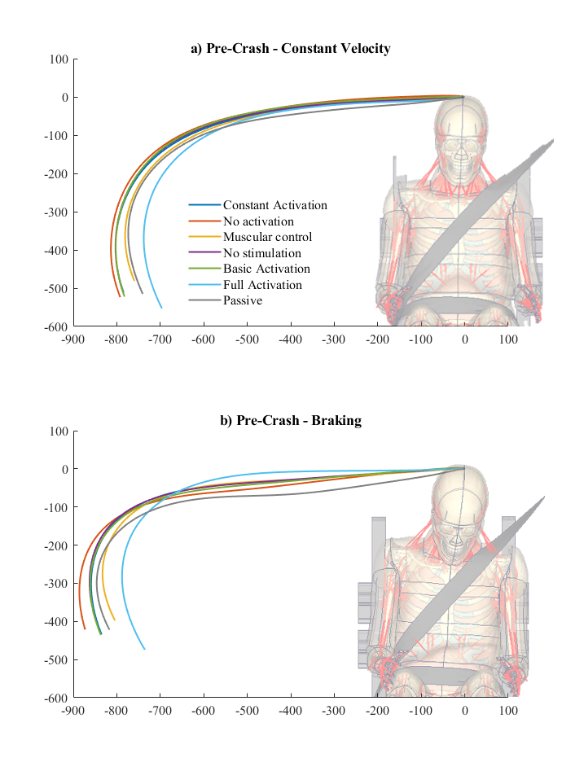
Figure 1. Head lateral excursions during in-crash phase after two pre-crash scenarios: a) constant velocity and b) braking.
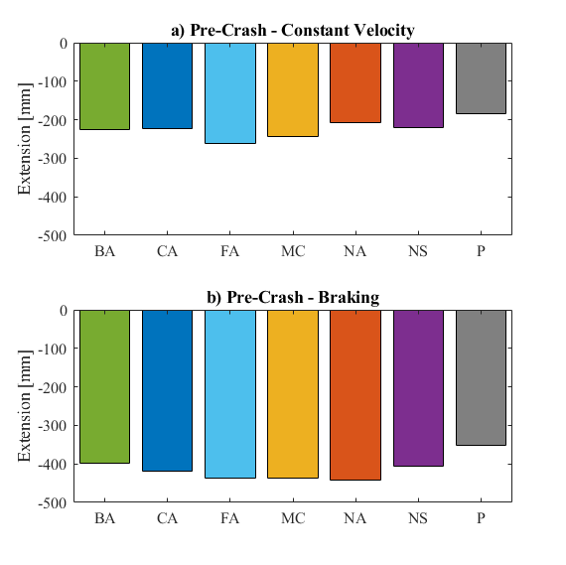
Figure 2. Extension of the head with respect to the initial head position after the two pre-crash scenarios: a) constant velocity and b) braking. MC: muscle control, NS: no stimulation, BA: basic activation, CA: constant activation, NA: no activation, FA: full activation (MC to FA correspond to muscle schemes 1 to 6, respectively) and P: passive model.

Table 1. Injury indicators of rib fracture and BrIC for the passive HBM and the AHBM for the different muscle strategies during the in-crash phase for the two pre-crash conditions: constant velocity (CV) and braking (B).
 |  | Passive | Constant Activation | No Activation | Muscular Control | No Stimulation | Basic Activation | Full Activation
2 or more rib fx probability (%) | CV | 84.307 | 9.91 | 46.06 | 22.28 | 12.67 | 11.41 | 14.73
2 or more rib fx probability (%) | B | 49.9 | 14.24 | 49.37 | 33.79 | 19.83 | 22.13 | 20.2
Brain Injury Indicator (%) | CV | 84.8 | 74.1 | 70.7 | 71.9 | 69.9 | 69.5 | 74.5
Brain Injury Indicator (%) | B | 95.1 | 86.9 | 86.2 | 89.5 | 88.4 | 86.2 | 88.0

Wednesday, 10/20/21, 04:50 PM - 05:00 PM EST
Complementing Femur Model Validation with a Variability-Focused Approach
Author: Sonja Schneider, sonja.schneider@med.uni-muenchen.de
Co-Authors: Jason Forman, jlfl3m@virginia.edu, Steffen Peldschus, steffen.peldschus@med.uni-muenchen.de

ABSTRACT
Objective: This short communication presents an approach as an objective means to validate that population variability is potentially incorporated into human body models in an accurate way, complementing existing validation techniques based on individual experiment-simulation comparison. This shall provide a further option for the assessment of the quality of large-number statistical simulations with human body models regarding their biofidelic behavior.
Methods: This population-based approach uses mathematical clustering methods to group similar curves of a combined population of numerical simulation results and experimental curves together. The resulting clusters can be used to assess the biofidelic behavior of numerical simulations, also with characteristics substantially differing from the experimental objects. This developed population-based approach was tested on a reference load case, the dynamic 3-point bending of the femur (Forman et al. 2012).
Results: The clustering approach rendered a distinction into 4 groups of response curves. For this small number, the grouping can be manually assessed as plausible. All experimental, and most numerical responses were grouped into one cluster. Three result curves constitute a cluster of their own, with their meta-data ranking on the margins of the population in at least one of the crucial biomechanical parameters. Such a result can be considered in accordance with the included experimental and anthropometric data.
Conclusions: The feasibility of using such a cluster analysis without individual comparisons is demonstrated on a small set of results. It is used to judge whether a finite element model including aspects of the variation in a population is in agreement with experimental and anthropometric data. For experiments as the femur bending addressed here, it is of high importance to firstly ensure a gross match of curve shapes between experiments and simulation, i.e., capturing the relevant biomechanical aspects.

INTRODUCTION
Understanding how population variability contributes to injury risk is one of the major potentials of using Finite Element human body models in vehicle safety assessments, as those models are easily modified by mesh morphing techniques or material parametrization. However, a human body model leaves the area in which it was validated and intended to be used if it gets modified. This leads to the questions how to assess the biofidelity of numerical models with characteristics differing to those of experimental test objects, and how to efficiently assess the numerous numerical results of a whole stochastic population. The presented approach is meant to be used in addition to existing validation approaches, like the individual experiment-simulation comparison (Park et al. 2017). Ultimately, an objective assessment of the population variability being incorporated into human body models in an accurate way would make the models indistinguishable from the actual population.
The term `numerical result’ refers to the record of the whole loading response of a specimen until fracture. A complementary clustering approach is presented based on mathematical clustering of curves of a combined dataset of numerical and experimental results.
A cluster analysis can be performed on a dataset to group similar objects of a dataset together. There are lots of different algorithms to cluster curves. Here, only hierarchical clustering methods were used (Aghabozorgi et al. 2015). After the cluster analysis a suitable amount of clusters has to be defined. In this context objective internal validity indices are used for determining a suitable amount of clusters (Charrad et al. 2014). The proposed approach was tested on a reference load case.

METHODS
Experimental data from the dynamic 3-point bending of the femur published by Forman et al. (2012) and Park et al. (2017), was combined with a small sample population of numerical femora. The experimental dynamic 3-point bending study impacted the test objects at the mid-shaft of the femur till their fracture with a velocity of 1.5 m/s. The impactor had a diameter of 13 mm. The ends of the femora were potted into roller blocks with a height of 152 mm, a width of 89 mm and a depth of 114 mm made out of 6.4 mm thick steel plates. The thickness of the bottom part of the rollers was 4.6 mm.
A sample population of FE-models of femora was derived independently from the characteristics of the experimental data, based on CT-scans of individual specimens. After having created 9 numerical models of femora, consisting of 4 different geometries and varying material characterizations, they were subjected to the 3-point bending test with the validated numerical setup shown in Figure 1. The numerical curves of the bending responses of the femora till their fracture points represent the numerical population. The experimental population consists of randomly selected curves, named Experiment 1 to 5 in Figure 2, from the experimental study of Forman et al. (2012) presented in Park et al. (2017). One combined dataset was established with the numerical and experimental curves.
A population-based validation approach was tested, potentially enabling the assessment of the quality of stochastic simulations with human body models regarding their biofidelic behavior, also with different characteristics than the experimental objects. This approach uses clustering methods to group similar curves of a combined dataset of numerical simulation curves and experimental curves together. The resulting clusters are in a next step analyzed in terms of agreement of the response curves as well as in terms of biomechanically relevant characteristics of the femora.
In order to allow manual analysis of plausibility of the clustering results, the approach is tested and demonstrated on a small number of results, 5 experimental ones and 9 simulation results. This combined dataset of curves was subjected to a clustering analysis with the Average-Linkage fusioning algorithm. The cluster validity ptbiseral-index was used to specify the amount of clusters.
Every single cluster is analyzed by itself and is compared to other clusters. Hereby, the validation approach not only considers the curves but also the corresponding metadata belonging to each curve and individual object in the population. With the term metadata, information about the test objects is summarized. In this context regarding the femora, the femur length, sectional properties as the moment of inertia or material properties are summarized as metadata. Each metadata variable can be analyzed, correspondingly to the analysis of the curves, independent for each cluster or in comparison to other clusters. This comparison of the metadata uses reference data depicting the distribution of the according data in a population. The reference database regarding the moment of inertia at the mid-shaft of the femur comprises the published data by Ivarsson et al. (2009), Funk et al. (2004), Kennedy (2004), and Kerrigan et al. (2004).

RESULTS
The combined dataset was divided by an internal cluster validity index into 4 clusters shown in Figure 2. All experimental, and most numerical responses were grouped into one cluster. Two simulations and one experimental result constitute a cluster of their own. Figure 3 shows the value ranges of the metadata variable `moment of inertia` for each cluster compared to a reference database. The same comparison was performed regarding the femur length. The FE models of the femora included in this study fall well into the distribution of the reference databases. All in all the used data can be evaluated as plausible.
In Figure 3 the metadata of the identified clusters is depicted regarding the moment of inertia at the mid-shaft section of the femur. Cluster 1 is represented by the range of the according values from experimental data and simulation models. The other clusters contain only single simulation models and are therefore represented by one line in the figure. It can be seen that cluster one represents the middle of the distribution of the reference database, whereas cluster 2 represents the left margin and the clusters 3 and 4 represent the right margin of the distribution of the reference database. This observation is in agreement with the response curves included in the clusters, with a high moment of inertia in cluster 3 and 4 leading to a high bending resistance of the bone leading itself to high fracture forces. In contrast, the low moment of inertia, as present in cluster 2, results in low fraction force representing a weak bone.

DISCUSSION
The feasibility of using a cluster analysis to judge, whether a finite element model including aspects of variation in the population is in agreement with experimental data, is demonstrated, without individual comparisons. With the help of clustering analysis, a complex dataset can be broken down to single clusters, which can be easily analyzed regarding characteristic features and compared to each other. In this context, experimental and numerical curves with slightly different metadata are grouped in one cluster, whereas they are grouped in different clusters if they differ significantly in their metadata.
The applied clustering algorithms lead to a dominance of failure values in the grouping of the curves. The approach would therefore be most appropriate for simple response curves, i.e. for experiments yielding monotone curves. For experiments as the femur bending addressed here, it is of high importance to firstly ensure a gross match of curve shapes between experiments and simulation, i.e. capturing the relevant biomechanical parameters. Larger differences between the shape of experimental curves and numerical ones, as for instance potentially caused by oscillations present in only one of these two groups, would prevent the approach from being successfully applied.
Within this study several combinations of hierarchical fusioning algorithms and internal cluster validity indices lead to the same clustering result. In future studies, further investigation regarding the most suitable combination of clustering algorithm, distance metric and internal validity index for this kind of validation approach is recommended. The biggest limitations of the presented study are that this approach was tested only with one validation load case and a small set of curves. This eases demonstration and biomechanical reflections, but it is essential to examine those potentially suitable combinations on further datasets with varying amount of curves or dataset structures. The clustering approach would fail with a completely homogenously structured dataset.
Finally, further effort is recommended to be put into the automation of the whole approach including the clustering procedure to enable the analysis of bigger datasets. With guidance based on small-scale studies as the one presented here, it is seen as a promising option to apply algorithm-based decision-making processes or machine-learning approaches to complex population-focused model validation.

REFERENCES
Aghabozorgi, Saeed; Shirkhorshidi, Ali Seyed; Wah, Teh Ying (2015): Time-series clustering‐A decade review. In Information Systems 53, pp. 16–38.
Charrad, Malika; Ghazzali, Nadia; Boiteau, Veronique; Niknafs, Azam (2014): NbClust. An R Package for Determining the Relevant Number of Clusters in a Data Set. Journal of Statistical Software.
Forman, Jason L.; Dios, E. de; Symeonidis, Ioannis; Duart, Julio; Kerrigan, Jason R.; Salzar, Robert S. et al. (2012): Fracture tolerance related to skeletal development and aging throughout life:3-point bending of human femurs. In : IRCOBI Conference Proceedings, Dublin, Ireland, pp. 529–539.
Funk, James R.; Kerrigan, Jason R.; Crandall, Jeffrey Richard (2004): Dynamic bending tolerance and elastic-plastic material properties of the human femur. In : Annual Proceedings/Association for the Advancement of Automotive Medicine, vol. 48. Association for the Advancement of Automotive Medicine, p. 215.
Ivarsson, B. Johan; Genovese, Daniel; Crandall, Jeff R.; Bolton, James R.; Untaroiu, Costin D.; Bose, Dipan (2009): The tolerance of the femoral shaft in combined axial compression and bending loading. SAE Technical Paper.
Kennedy, Eric Allen (2004): Lateral and posterior dynamic bending of the mid-shaft femur. Fracture risk curves for the adult population. Virginia Tech.
Kerrigan, J. R.; Drinkwater, D. C.; Kam, C. Y.; Murphy, D. B.; Ivarsson, B. J.; Crandall, J. R.; Patrie, J. (2004): Tolerance of the human leg and thigh in dynamic latero-medial bending. In International Journal of Crashworthiness 9 (6), pp. 607–623. DOI: 10.1533/ijcr.2004.0315.
Park, Gwansik; Kim, Taewung; Forman, Jason; Panzer, Matthew B.; Crandall, Jeff R. (2017): Prediction of the structural response of the femoral shaft under dynamic loading using subject-specific finite element models. In Computer methods in biomechanics and biomedical engineering 20 (11), pp. 1151–1166.

TABLES AND FIGURES

Figure 1. FE model of the simulation setup of Forman et al. (2012)
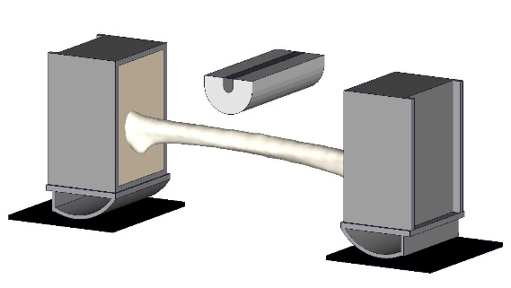

Figure 2. Combined dataset and result of cluster analysis.
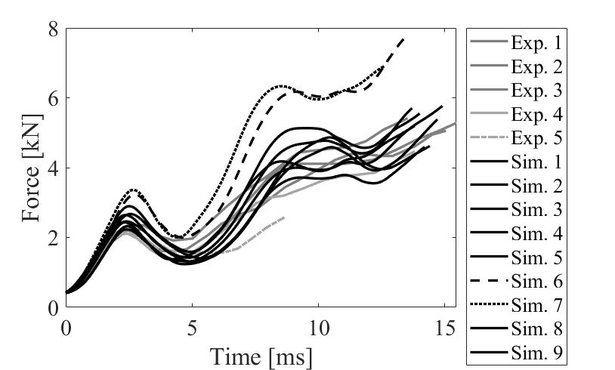
Cluster 1
Cluster 2
Cluster 3
Cluster 4

Figure 3. Comparison of value ranges between clusters and reference database.
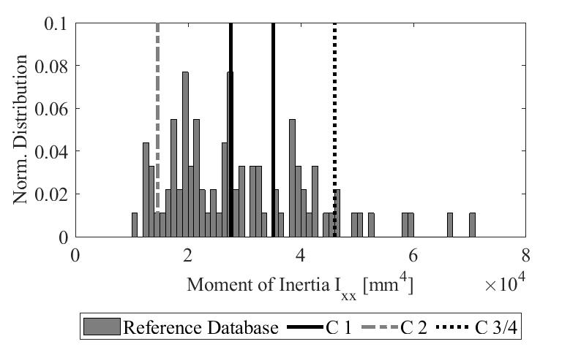

Wednesday, 10/20/21, 05:00 PM - 05:10 PM EST
Sagittal Plane Moment Responses of the THOR-05F Anthropomorphic Test Device
Author: John Humm, jhumm@mcw.edu,
Co-Author: Narayan Yoganandan, yoga@mcw.edu

ABSTRACT
Objective: Anthropomorphic test devices (ATD) are used in crashworthiness studies to advance safety in automotive, military, aviation, and other environments. The Test Device for Human Occupant Restraint (THOR) is an advancement over the widely used Hybrid III ATD. The female version THOR-05F is different from the male as it is not a scaled-down version of the male, and it is based on the recognition that the cervical spines (necks) of females have a different response than males. The objective of this study is to evaluate its response at dynamic rates of loading and compare it with previous postmortem human surrogate (PMHS) responses under sagittal plane bending.
Methods: The head/neck assembly was separated from the thorax, and a custom lower neck plate was attached to the head/neck assembly to mount the preparation to the frame of the electro-hydraulic testing device. A custom upper neck interface plate was attached to a novel angular displacement test device that converted the linear motion of the vertical electrohydraulic piston to moment loading at the occipital condyle joint. The neck was preconditioned by applying a sinusoidal 10-degree flexion-extension cycle for 90 seconds and then three repeat dynamic tests at a target rate of 90 Nm/s. Flexion and extension tests were performed with and without the front and rear neck cables of the THOR-05F neck. Targets were fixed to the upper neck adapter plate, occipital condyle joint, mid-spine aluminum puck, and lower neck adapter plate. The targets' three-dimensional positions were measured using a seven-camera optical motion capture system. Upper neck load cell and occipital condyle potentiometer data were sampled at 20 kHz, and loading rates were determined by calculating the sagittal moment slope between 15% and 85% of the signal. Results: The mean occipital condyle angle versus sagittal moment response from the 12 tests (three tests each with and without cables and under flexion and extension) are given in the body of the manuscript. With and without cables, the loading rates for flexion tests were 89.3 ± 0.5 Nm/s and 86.3 ± 0.4 Nm/s, and for extension tests they were 90.8 ±
1.2 Nm/s and 88.0 ± 1.5 Nm/s. The average peak sagittal moments were 34.2 ± 0.3 Nm and 30.3 ± 0.2 Nm for flexion and 50.6 ± 0.3 Nm and 47.0 ± 0.3 Nm for extension tests. The mean peak occipital condyle angles were 23.5 ± 0.2 deg and 25.3 ± 0.1 deg for flexion and 22.7 ± 0.2 deg and 25.8 ± 0.1 deg for extension.
Conclusion: Using the angular motion as a basis and comparing it with the previously conducted PMHS tests, the THOR-05F neck has approximately twice the stiffness of the human under sagittal plane bending.

INTRODUCTION
A recent analysis of NASS-CDS data reported that females have a greater risk for AIS 2+ and 3+ injuries in frontal crashes when controlled for age, height, and delta-V and nearly twice the risk of cervical spine injuries1. In crashes with a delta-V of 25-65 km/h, it has been shown that belted females have a one-and-a-half times greater risk for MAIS 3+ injuries than belted males and nearly two times the risk for serious spine injuries 2. For extension, in matched-pair rear impacts, women have been shown to have just over three times the risk as males for medical impairment3. Occipital condyle moment tolerances in flexion and extension have been measured using isolated female postmortem human surrogate (PMHS) segments4. Male-female differences in spinal geometry from volunteers and kinematics from tests have been demonstrated5-7, while others have examined the effect of the female spine's physiologic differences on local cervical spine kinematics using a finite element model8-10. These studies have highlighted the differences between males and females, clearly showing that females are not scaled-down versions of males and need further research to reduce injuries in the automotive environment for female occupants11.
The National Highway Traffic Safety Administration (NHTSA) has supported the development of female- specific human surrogates to protect the female population. The upgraded New Car Assessment Program (NCAP) includes a 5th percentile female anthropomorphic test device (ATD) in front- and side-impact tests. Work continues to expand the population of ATDs, which are more biofidelic and have enhanced injury assessment capabilities. The Test Device for Human Occupant Restraint 5th percentile female (THOR-05F) ATD is under consideration for frontal impacts. This surrogate will supply researchers and automobile manufacturers with other tools to help reduce injuries to females in the automotive environment and promulgate improved standards.
The purpose of the current study is to conduct THOR-05F head/neck tests at dynamic loading rates, replicating previous PMHS tests to characterize the sagittal plane bending modes (flexion and extension). These data can be used to determine the scaling ratios between PMHS and ATD and assess the biofidelity of the upper cervical spine (occipital condyle joint).

METHODS
ATD Preparation: The skull cap and skin were removed from the head, and the head/neck assembly was separated from the thorax. A schematic of the isolated THOR-05F neck is shown in Figure 1. Next, the primary and redundant head linear accelerometers, head angular velocity transducers, head tilt sensor, and the head sensor mounting plate were removed. A custom upper neck interface plate was attached to the head/neck platform assembly's top surface using the ATD screws. Holes were made through the plate to accommodate clearance for the anterior and posterior compression springs attached to the cables. The primary accelerometers, angular velocity transducers, and head tilt sensor were attached to the interface plate's top surface. The upper neck interface plate has holes on the lateral edges to connect the ATD to the loading device described below. A lower neck interface plate was similarly attached to the bottom of the neck to mount the neck to the test frame.
Test Apparatus: Testing was conducted using an Angular Displacement Test Device (ADTD), which converted the linear motion of a vertically oriented electro-hydraulic piston to a torque about the occipital condyle (OC) joint of the ATD. The ADTD acted as a modified slider-crank mechanism wherein the piston (slider) rotated a transmission shaft joined to the upper neck interface plate by a rotating disc. See Figure 2 for a schematic of the test setup. The piston [a] was connected to a follower arm [b] and crank arm [c] via revolute joints. A transmission shaft [d] was fixed to a disc [e] on one end and coupled to the crank arm [c] on the other end. The center of the disk [e] was aligned with the OC joint. The disc [e] was connected to the upper surface of the THOR-05F neck via the upper neck interface plate [g]. As the piston [a] moved downward, the crank arm [c] turned the disc [e] which rotated the upper neck interface plate [d] about the OC joint in either flexion or extension.
Test Procedure: The lower spine interface plate [e] was fixed to an angled plate such that the head platform was parallel to the ground. Next, the spine height and anterior-posterior (A/P) direction was adjusted to position the medial-lateral (flexion/extension) axis of the OC joint in line with the center of rotation of the ADTD disc [e]. The upper neck interface plate [g] was then attached to the ADTD. Before the first test in the series, the neck was preconditioned by applying a sinusoidal 10-degree flexion-extension cycle for 90 seconds. Three repeat dynamic tests were then conducted, targeting a rate of 90 Nm/s, and were determined by calculating the slope of the sagittal moment trace 15 and 85% of the peak moment. The loading rate was selected to match previously collected OC-C2 PMHS tests4. The neck was relaxed for 30 minutes in between tests. Flexion and extension tests were performed with and without the front and rear neck cables attached to the spine's inferior end. Retroreflective targets were fixed to the upper neck adapter plate (representing the head), OC joint, the mid-spine aluminum puck, and the lower neck adapter plate (representing T1). The three-dimensional targets were measured using a seven-camera optical motion capture system (Vicon LTD, Oxford, UK). Upper neck load cell and occipital condyle potentiometer data were sampled at 20 kHz. The upper neck interface plate was rotated until contact was observed between the inferior edge of the ATD head platform and the superior surface of the load cell. The dual fixed end condition of the test setup produced combined sagittal plane moment and axial compression at the upper neck load cell.

RESULTS
A total of 12 tests were conducted. The OC angle versus sagittal moment response for each test is shown in Figure 3. Flexion of the OC (chin to chest) yields a positive moment with a negative displacement, whereas extension gives a negative moment and a positive displacement. Average loading rates for the flexion tests with and without the cables attached were 89.3 ± 0.5 and 86.3 ± 0.4 Nm/s. For the extension tests they were -90.8 ± 1.2 and -88.0 ± 1.5 Nm/s.
Similarly, average peak sagittal (My) bending moments were 34.2 ± 0.3, 30.3 ± 0.2, -50.6 ± 0.3, and -47.0 ± 0.3 Nm.
The average peak OC angles were -23.5 ± 0.2, -25.3 ± 0.1, 22.7 ± 0.2, and 25.8 ± 0.1 degrees.

DISCUSSION
The current study's goal was to apply a dynamic moment centered at the occipital condyle joint of the THOR-05F neck at rates matching isolated upper cervical spine PMHS tests4. Three repeat tests were conducted in flexion and extension to approximately 25 degrees in each direction as measured at the OC joint. Tests were run with and without the front and rear cables attached to the lower spine. Loading was delivered using a dynamic angular displacement test device, which applied torque about the OC joint. The off-axis moments were typically less than 5%, and the translation of the OC joint was less than 3 mm indicating the applied torque was centered about the OC joint. The coefficient of variation was typically less than 1% for the primary moment. Peak moment magnitudes were significantly higher in extension than flexion (p < 0.05), with an average of 50.6 Nm and 34.2 Nm with the cables attached and 47.0 and 30.3 Nm with the cables disconnected.
The THOR-05F neck is not a scaled-down version of the THOR-50M, as the two have different geometries. Unlike THOR-50M's straight spine, the THOR-05F neck has a lordotic curve and resembles the anthropometry of the human cervical spine12. The anterior and posterior cables were designed to simulate the loads through the external musculature of the human neck13. In contrast, the loads through internal musculature and ligaments were represented by the molded neck and nodding block of ATD. Therefore, it is appropriate to conduct tests without the cables when comparing results to PMHS tests of osteoligamentous columns or segments where the internal musculature and other soft tissues have been removed for matched-pair test conditions. The THOR-05F neck consists of four elliptical rubber pucks with offset geometry or "stairway" design13. The lower two pucks are shorter in height in the front than the back (wedge-shaped design), resulting in higher bending stiffness in extension than flexion. It was reported that the specially designed cam at the top of the load cell below the head/neck platform assembly controlled the OC joint motion replicating the OC to C2 bending response12. Data from the current study demonstrated a 1.5 increase in the extension moment compared to the flexion response at the peak angulation as determined by estimating the stiffness from the peak of the moment-angle curve.
Load application site and rate were selected to match previously conducted female PMHS cervical spine experiments. In the previous study, isolated OC-C2 segments were potted and inverted such that the moment was applied to the proximal (C2) segment at 90 Nm/s to failure in flexion and extension. Isolated segment PMHS are difficult to replicate with ATD under matched-pair conditions for the following reasons: (a) there is not a 1 to 1 correspondence in the number of functional units of the ATD spine to human, (b) it is impractical to isolate the ATD neck identically to the PMHS tests, and (c) it is not acceptable to run the ATD neck to failure. Despite these challenges, data from the PMHS tests provide valuable estimates of the tolerance of human injury flexion and extension bending modes and can be used to determine human-ATD scaling ratios. While bending is usually about the lower neck joint in frontal and rear impacts, the current study applied the moment centered at the OC joint to replicate the loading condition of the isolated PMHS tests while acknowledging the above limitations. The average peak failure moment and angle in flexion were 23.7 Nm and 56.2 degrees and 43.4 Nm and 50.2 degrees in extension for the PMHS. The most appropriate comparison to these osteoligamentous spine segment loads is the tests conducted with the anterior and posterior cables detached from the lower spine. This detached cable test model simulates an ATD neck without the external musculature load path. The average THOR-05F flexion angle at 23.7 Nm was 22.4 degrees, while in extension at 43.4 Nm, the angle was 25.5 degrees. Therefore, the ATD neck has approximately twice the stiffness of the human under sagittal plane bending as determined by estimating the response at the mean PMHS values.

ACKNOWLEDGEMENTS
This work was supported by NHTSA DTNH2215D00016/693JJ919F000185 and DoD W81XWH-16-1-0010. This material is also supported with resources and facilities at the Zablocki VA Medical Center, Milwaukee, Wisconsin and the Department of Neurosurgery at the Medical College of Wisconsin. The views expressed are these of the authors and do not represent the views of the sponsor organizations.

REFERENCES
- Forman J, Poplin GS, Shaw CG, et al. Automobile injury trends in the contemporary fleet: Belted occupants in frontal collisions. Traffic Injury Prevention. 2019;20(6):607-612.
- Parenteau C, Zuby D, Brolin K, Svensson M, Palmertz C, Wang S. Restrained male and female occupants in frontal crashes: are we different? IRCOBI; Sept. 11-13, 2013, 2013; Gotehenburg.
- Jonsson B, Tingvall C, Krafft M, Bjornstig U. The risk of whiplash-induced medical impairment in rear-end impacts for males and females in driver seat compared to front passenger seat. IATSS Research. 2013;37(1):8- 11.
- Nightingale RW, Winkelstein BA, Knaub KE, Richardson WJ, Luck JF, Myers BS. Comparative strengths and structural properties of the upper and lower cervical spine in flexion and extension. Journal of Biomechanics. 2002;35(6):725-732.
- Stemper BD, Yoganandan N, Pintar FA. Gender dependent cervical spine segmental kinematics during whiplash. J Biomech. 2003;36(9):1281-1289.
- Stemper BD, Yoganandan N, Pintar FA. Gender- and region-dependent local facet joint kinematics in rear impact: implications in whiplash injury. Spine (Phila Pa 1976). 2004;29(16):1764-1771.
- Stemper BD, Yoganandan N, Pintar FA, et al. Anatomical gender differences in cervical vertebrae of size- matched volunteers. Spine (Phila Pa 1976). 2008;33(2):E44-49.
- John JD, Saravana Kumar G, Yoganandan N. Cervical spine morphology and ligament property variations: A finite element study of their influence on sagittal bending characteristics. J Biomech. 2019;85:18-26.
- John JD, Saravana Kumar G, Yoganandan N. Rear-impact neck whiplash: Role of head inertial properties and spine morphological variations on segmental rotations. J Biomech Eng. 2019.
- John JD, Yoganandan N, Arun MWJ, Saravana Kumar G. Influence of morphological variations on cervical spine segmental responses from inertial loading. Traffic Injury Prevention. 2018;19(sup1):S29-S36.
- Yoganandan N, Bass CR, Voo L, Pintar FA. Male and Female Cervical Spine Biomechanics and Anatomy: Implication for Scaling Injury Criteria. J Biomech Eng. 2017;139(5).
- Martin P, Craig MD, Ridella S, Rigby P, Chan P. OOP air bag tests with the fifth percentile female THOR and Hybrid III dummies. Paper presented at: Enhanced Safety of Vehicles2009; Stuttgart, Germany.
- Wang Z, McInnis J, Benfant L, Feng Z, Lee E. THOR 5th Percentile Female ATD Design. Paper presented at: Enhanced Safety of Vehicles2017; Detroit, MI.

TABLES AND FIGURES

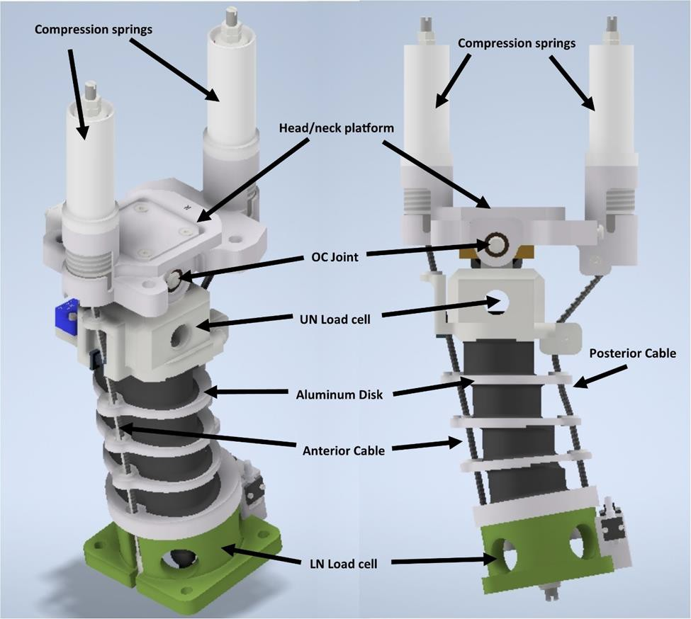
Figure 1: Oblique (left) and sagittal (right) schematic of the THOR-05F neck showing key components such as the posterior and anterior neck cables, upper neck (UN), and lower neck (LN) load cells (structural replacement shown for LN load cell), compression springs, and head/neck platform.

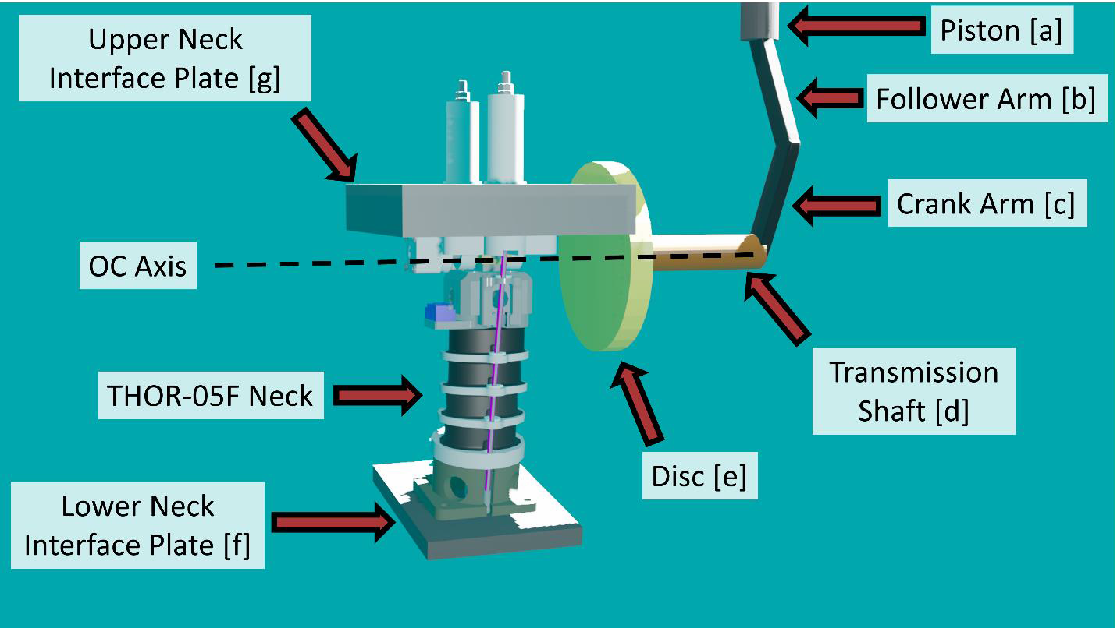
Figure 2: Schematic of the THOR-05F and mechanical components of the Angular Displacement Test Device (ADTD). The letters next to the labels correspond to the description in the methods section.

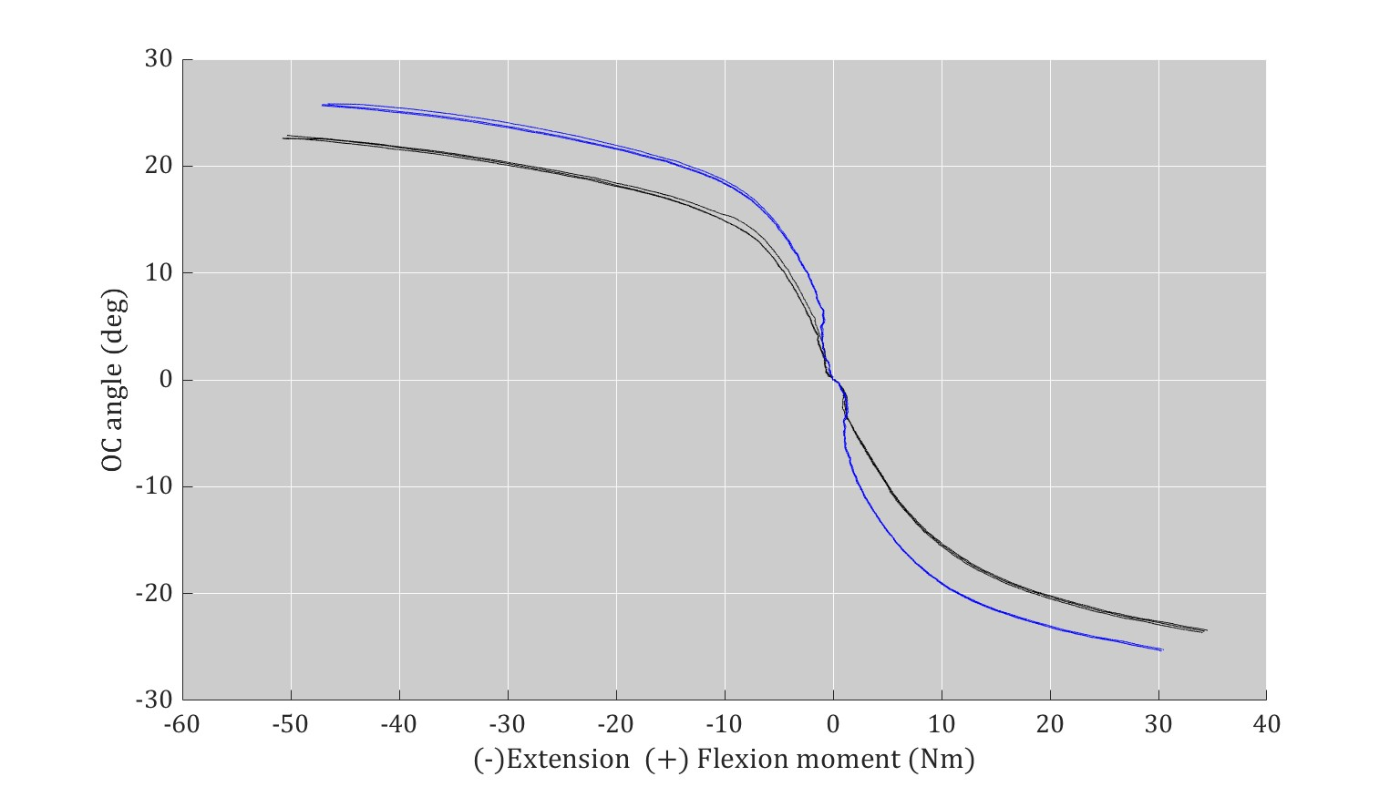
Figure 3: Occipital condyle angle vs. upper neck moment response for the three flexion tests with cables (black and lower right), three flexion tests without cables attached (blue and lower right), three extension tests with cables (black and upper left), and three extension tests with the cab.

Thursday, October 21, 2021
Pre-/Post-Crash Research: 08:30 AM - 10:00 AM EST

Thursday, 10/21/21, 09:10 AM - 09:20 AM EST
The Effect of Prior Night Sleep on Simulated Driving Performance in Medical Residents
Author: Benjamin McManus, bmcmanus@uab.edu
Co-Author: Despina Stavrinos, dstavrin@uab.edu

ABSTRACT
Objective: Indications of driving performance negatively affected by poor sleep often occur early in simulated driving experiments and are measured to progress over relatively large epochs of time. How driving performance changes over smaller increments of time as a function of not only sleep quantity but also sleep quality is largely unknown. The overall objective of this work-in-progress is to examine the trajectory of driving performance in medical residents as a function of the prior night’s sleep quality using a high-fidelity driving simulator.
Method: Thirty-two medical residents were enrolled and wore sleep tracking devices over up to a two-week period. The residents drove a 16- minute scenario in a high-fidelity driving simulator. A mixed effects model will estimate baseline intercept and slope of simulated driving performance over the course of the drive. The slope of driving performance over the drive, Actigraphy estimated sleep variables from the prior 24 hours will serve as predictors.
Results: Preliminary descriptive findings indicate a wide range of sleep quality metrics in the sample.
Conclusions: This study will be among the first to focus on the trajectory of driving performance over small continuous epochs of time when simulated driving performance may first begin to degrade. Further, objective estimates of sleep using actigraphy as predictors of the next day’s driving will enhance our understanding of the potential “dose-response” between low sleep quality and crash risk in the following 24 hours

INTRODUCTION
The odds of at-fault crash risk increase when achieving under 7 hours of sleep in the preceding 24 hours (Tefft, 2018). Sleep deprivation negatively affects lane maintenance in both driving simulation and on-road experiments (Philip, Sagaspe, Taillard, Valtat, Moore, Akerstedt, Charles and Bioulac, 2005). When sleep prior to driving has been restricted, lane positioning is more varied, and subjective sleepiness may be predictive of lane maintenance (Horne and Baulk, 2004). The majority driving simulator studies impose experimental sleep deprivation conditions focusing on quantity of sleep prior to the simulated drive and feature experimental sessions 30 minutes or much longer (Soares, Ferreira and Couto, 2020) with time-on-task effects measured between epochs of time (e.g., every 10 minutes). However, both subjective sleepiness and variation in lane positioning increase soon after beginning a drive in a driving simulator (Ingre, Akerstedt, Peters, Anund and Kecklund, 2006), and thus the trajectories of driving performance metrics over smaller increments (e.g., every 30 seconds, every minute) are largely unknown. Further, driving performance metrics in a driving simulator as a function of specific sleep quality measurements require attention in addition to sleep quantity. For instance, when demonstrating no significant differences in sleep quantity, drivers with untreated and undiagnosed sleep apnea displayed greater lane variability over the course of a driving simulator task compared to healthy controls (May, Porter and Ware, 2016). Medical residents provide an ideal population to examine the impact of sleep quality among other relevant fatigue factors on driving performance due to their wide variety of schedules (Lockley, Barger, Ayas, Rothschild, Czeisler and Landrigan, 2007) and decrease in sleep quality (Zebrowski, Pulliam, Denninger and Berkowitz, 2018) which does not appear to improve across residency (McManus, Galbraith, Heaton, Mrug, Ponce, Porterfield, Schall and Stavrinos, 2020). The overall objective of this work in progress is to examine the trajectory of driving performance in medical residents as a function of the prior night’s sleep quality using a high-fidelity driving simulator.

METHOD
Thirty-two medical residents (M_{age} = 28.56 years, SD = 2.18) wore actigraphy watches continuously over several days (M = 8.47 days, SD = 3.04) that provided objective estimates of sleep duration and sleep quality. The actigraphy watches were calibrated to each participant’s age, gender, height, and weight and contained a 3-axis accelerometer to estimate movement and sleep continuously. The medical residents completed a driving simulator appointment before beginning their shift to mimic driving after a typical 24-hour period of sleep that was not experimentally manipulated. At the appointment, medical residents provided self-reported assessments of fatigue and subjective sleep propensity, a salivary cortisol sample as a biomarker of stress measurement and drove in a state-of-the-art driving simulator. The simulated driving scenario was a nighttime, 16-minute drive with scenario resembling the local region. The primary analysis will utilize a mixed effects model to estimate baseline intercept and slope of driving performance over the course of the drive. The slope of driving performance over the drive, Actigraphy estimated sleep variables from the prior 24 hours will serve as predictors.

RESULTS
Data collection is complete for the sample. Descriptive statistics for the driving simulator variables, subjective fatigue and sleep variables, salivary cortisol, and actigraphy estimated sleep variables for the 24 hours prior to the appointment are displayed in Table 2. Preliminary analyses indicated the odds of obtaining fewer than the recommended 7-9 hours of sleep was 325% higher in the night preceding the simulated drive of interested compared to an off-duty day (χ²(1) = 4.73, p = 0.03, Odds ratio = 4.25, 95% CI: 1.15 – 15.65). Preliminary analyses also indicated an association between braking reaction time and sleep quality averaged over the multiple days of actigraphy wear. Ranges indicated a wide variety of sleep quality metrics in the sample.

DISCUSSION
The final data analysis will be complete in summer, 2021. This study will be among the first to focus on the trajectory of driving performance over small epochs of time when simulated driving performance may first begin to degrade. Further, objective estimates of sleep using actigraphy as predictors of the next day’s driving will enhance our understanding of the potential “dose-response” between low sleep quality and crash risk in the following 24 hours. Further, medical residents display high levels of stress and poor sleep outcomes throughout medical residency and may often be at high risk for drowsy driving as a result. Although these data do not include a control group or control period of sleep for comparison purposes, future studies should consider including such comparisons. These findings may further develop policies, recognition, and recommendations of when crash risk may be high as a result of poor sleep outcomes.

ACKNOWLEDGMENTS
This work was supported by Grant# 2T420H008436 and Grant# K01OH011943 from The National Institute for Occupational Safety and Health (NIOSH). Its contents are solely the responsibility of the authors and do not necessarily represent the official views of NIOSH. Special thanks to the Translational Research for Injury Prevention (TRIP) Laboratory for providing use of the driving simulator facility.

REFERENCES
Horne JA and Baulk SD. Awareness of sleepiness when driving. Psychophysiology. Jan 2004;41(1):161-5.
Ingre M, Akerstedt T, Peters B, Anund A and Kecklund G. Subjective sleepiness, simulated driving performance and blink duration: examining individual differences. J Sleep Res. Mar 2006;15(1):47-53.
Lockley SW, Barger LK, Ayas NT, Rothschild JM, Czeisler CA and Landrigan CP. Effects of health care provider work hours and sleep deprivation on safety and performance. Joint Commission Journal on Quality and Patient Safety. Nov 2007;33(11 Suppl):7-18.
May JF, Porter BE and Ware JC. The deterioration of driving performance over time in drivers with untreated sleep apnea. Accident Analysis & Prevention. Apr 2016;89:95-102.
McManus B, Galbraith JW, Heaton K, et al. Sleep and stress before and after duty across residency years under 2017 ACGME hours. American journal of surgery. 2020;220(1):83-89.
Philip P, Sagaspe P, Taillard J, et al. Fatigue, sleepiness, and performance in simulated versus real driving conditions. Sleep. Dec 2005;28(12):1511-6.
Soares S, Ferreira S and Couto A. Driving simulator experiments to study drowsiness: A systematic review. Traffic Inj Prev. 2020;21(1):29-37.
Tefft BC. Acute sleep deprivation and culpable motor vehicle crash involvement. Sleep. Oct 1 2018;41(10).
Zebrowski JP, Pulliam SJ, Denninger JW and Berkowitz LR. So Tired: Predictive Utility of Baseline Sleep Screening in a Longitudinal Observational Survey Cohort of First-Year Residents. Journal of General Internal Medicine. Feb 20 2018.

Table 1
Simulated Driving Performance and Sleep Quality Prior to Simulated Driving Task
Variable | Mean (SD) | Range
Driving
Average Speed (MPH) | 51.38 (4.38) | 41.61 – 58.23
Speed Variability (MPH) | 23.21 (2.55) | 18.77 – 31.03
SD Lane Position (feet) | 1.21 (0.19) | 0.90 – 1.87
Subjective Sleep , Fatigue, and Stress
Sleep Propensity | 9.28 (5.43) | 0.00 – 19.00
Chronic Fatigue | 42.50 (17.42) | 16.67 – 80.00
Acute Fatigue | 65.73 (19.79) | 26.67 – 96.67
Persistent Fatigue | 36.04 (19.17) | 10.00 – 83.33
Salivary Cortisol | 0.38 (0.23) | 0.07 – 1.17
Actigraphy Measured Sleep Prior
Duration (hours) | 7.30 (2.79) | 2.57 - 13.20
Efficiency (%) | 92.33 (3.80) | 79.38 – 98.39
Wake After Sleep Onset (minutes) | 34.13 (17.66) | 9.00 - 91.00
Sleep Fragmentation Index (%) | 20.50 (11.92) | 2.73 – 52.70
Note. SD = standard deviation

Thursday, 10/21/21, 09:20 AM - 09:30 AM EST
A Methodology for Assessing Driver Perception-Response Time during Unanticipated Cross-Centerline Events
Author: Luke Riexinger, riexinger@vt.edu
Co-Author: Dave Fortenbaugh, dmfortenbaugh@engsys.com

ABSTRACT
Objective: The purpose of this study was to present a methodology that utilizes naturalistic driving data to measure the driver response to an unanticipated driving scenario, a cross-centerline event.
Methods: Forward-facing video from naturalistic driving was used to determine when the cross-centerline event occurred. Then, the recorded acceleration and yaw rate data were used to identify the start of braking and steering evasive actions, respectively. A deceleration threshold of -0.1 g was defined as the braking onset, and a yaw rate of 2 deg/s was defined as the steering onset. Perception-response times (PRTs) were derived using these inputs.
Results: 17 cross-centerline events were identified from the naturalistic driving database. The drivers in all analyzed events applied the brakes, and 11 of the 17 drivers performed a steering maneuver. However, the average steering PRT (0.39 s) was faster than the average braking PRT (0.84 s).
Conclusions: Based naturalistic data from cross-centerline encroachment scenarios, the average driver steering PRT was faster than the average driver braking PRT. Both the driver’s median braking and steering PRT was faster in these real-world scenarios than in similar test track or simulator studies. Future analyses should investigate which action is attempted first and the effect of time to contact on driver response.

INTRODUCTION
In many crash modes, one of the most important factors that could prevent the impact is the response of the driver. In recent years, vehicles have been equipped with advanced driver assistance systems (ADAS). ADAS attempt to augment the actions of a driver or act on behalf of the driver to prevent or mitigate a potential crash. These systems are carefully optimized to minimize their activation frequency while also maximizing the time for drivers to react and avoid the crash. Current ADAS, such as forward collision warning and lane departure warning, are particularly sensitive to the activation time to contact (TTC), that is, the time from initial detection of a hazard to the theoretical time of impact with no intervention (Kusano & Gabler, 2015; Luke E. Riexinger et al., 2019a; Luke E. Riexinger et al., 2018). Systems that deliver the warning at a greater TTC and give the driver more time to respond have a considerable increase in their potential crash benefit. However, delivering a warning too early can result in many unwanted activations, which may result in the driver disabling the system. In 2016, Flannagan found that lane departure warning was disabled for more than half of the time the vehicle was in operation (Flannagan et al., 2016). To optimize ADAS for the many crash configurations, the perception-response time (PRT) and driver response type must be understood.
Previous studies have used multiple methods for estimating driver PRT, including vehicle simulator scenarios, controlled test scenarios, and naturalistic driving scenarios. Previous simulator studies have found the driver PRT for a potential impact with a stationary object to be approximately 1.3 s (Broen & Chiang, 1996) and for a potential impact with a pedestrian to be approximately 0.9 s (D’Addario & Donmez, 2019). Simulator studies allow for the exact driving scenarios to be controlled between participants, but a simulator cannot perfectly reflect real driving scenarios. Studies performed at test sites can control many factors to ensure the safety of the participants. Previous PRT studies on test tracks found a driver PRT of 1.1 s to 1.5 s to objects in the road (Lerner, 1993; Olson & Sivak, 1986). Unlike simulator and test track scenarios which cannot pose any real threat to the subject, studies based on naturalistic driving data capture the driver response to real potential crash scenarios. In real-world car following events, the driver PRT was approximately 1.6 s (Gao & Davis, 2017). However, each of these studies focused on measuring the driver’s PRT when the driver was responding to a stationary object, a pedestrian, or a slowed/stopped vehicle. These scenarios are well-aligned frontal crash scenarios that the driver may anticipate and often result in the driver performing a braking evasive maneuver. However, there are many crashes, such as cross-centerline crashes, that are completely unanticipated and in which the driver may use a steering evasive action instead of or before a braking action (Luke E Riexinger et al., 2019b). The purpose of this study was to present a methodology that utilizes naturalistic driving data to measure the driver PRT in an unanticipated driving scenario, namely a cross-centerline event.

METHODS
This study utilized a sample of 17 cross-centerline events from the second Strategic Highway Research Program (SHRP 2), the largest naturalistic driving study in the world (Dingus et al., 2015). The detailed data captured in this study include multiple vehicle-mounted videos, vehicle acceleration, vehicle yaw rate, global positioning system (GPS) measurements, and vehicle network data such as brake activation. Cross-centerline scenarios were selected because of their unexpected and potentially dangerous nature, which cannot be perfectly matched in controlled test environments or simulator environments. There were just 42 cases initially labeled as a cross-centerline scenario in the SHRP 2 dataset, but ultimately only 17 cases were able to be analyzed by the researchers, as the other 25 cases had factors that limited the video analysis (e.g., poor centerline visibility, reduced video quality due to inclement weather). The distribution of age and sex were similar to the overall SHRP 2 participant population that oversampled younger and older drivers.
For driver PRT studies, the time is measured starting from the precipitating event, in this case the crossing of the centerline by an oncoming vehicle. In the current study, the moment of the encroachment was determined by using the front-facing video, which was recorded at 15 Hz. In reveal cases, where the oncoming vehicle crossed the centerline before becoming visible, the time when the oncoming vehicle was visibly in the wrong lane was used as the moment of encroachment.
The driver PRT was measured separately for braking and steering evasive actions from the acceleration and yaw rate time-series data, respectively. The acceleration and yaw rate 300 ms prior to the precipitating event was subtracted from the respective signal to account for scenarios occurring on a grade or turn. Braking onset was assumed to be when the first acceleration sample was below -0.1 g. The beginning of an evasive steering action was assumed to be when the yaw rate exceeded 2 deg/s and the yaw rate of the entire maneuver exhibited an N-shape (Dingus et al., 2006).

RESULTS
For the 17 drivers that performed a braking maneuver, the average braking PRT was 0.84 s (Figure 1). The average steering PRT was 0.39 s for the 11 drivers who performed a steering maneuver. The difference was statistically significant based on a two-sample t-test (p=0.03).

DISCUSSION
This study presented a method for utilizing naturalistic driving data to estimate driver PRT during unanticipated cross-centerline events. This is one of the first studies to measure the difference in braking and steering evasive actions in real-world unanticipated potential crash scenarios, and the first known study to do so for cross-centerline events. The primary finding was that steering PRT was faster than braking PRT. Similar to previous studies, many drivers performed both a steering maneuver and a braking maneuver during the event (Lerner, 1993) and the steering maneuver preceded the braking maneuver (D’Addario & Donmez, 2019). Ergonomically, a slower braking PRT may be due to the extra time needed to move the foot from the accelerator to the brake pedal. Intuitively, steering is a quicker, more automatic reaction to an urgent scenario, and the hands are typically already engaged with the steering wheel (Green, 2000; Hankey, 1997).
Additionally, the measured PRT in this study tended to be faster than the PRT measured in previous simulator and controlled test site scenarios. One possible explanation is the difference in the scenario environment. In studies that use simulator or controlled test sites, it is impossible to completely replicate the threat to the driver and eliminate any anticipation from the driver. Naturalistic driving data, like that found in the SHRP 2 database, allow researchers to observe drivers in real crash scenarios that pose an actual threat to the driver and could not be anticipated. One challenge to utilizing naturalistic data that is not present in other study designs is that each subject is not exposed to the same event or even event timing. Previous work has shown that urgent scenarios may elicit an automatic response that is much faster than a planned response (Green, 2000; Markkula et al., 2016). Future work should estimate the TTC of the event to control for the different scenario urgencies experienced by each driver.
This work also suggests that ADAS, which tune the activation to the driver reaction time, could alter the activation depending on the desired driver response. If the system intends to elicit a driver braking maneuver, it could deliver the warning earlier than when eliciting a driver steering maneuver. However, determining the desired driver maneuver requires future research in understanding the type of attempted driver evasive actions in different scenarios and which evasive actions minimize the injury severity of a potential impact.

ACKNOWLEDGEMENTS
The authors would like to thank Mitch Garber and Clay Gabler for their insights and advice for this study.

REFERENCES
Broen, N. L., & Chiang, D. P. (1996). Braking response times for 100 drivers in the avoidance of an unexpected obstacle as measured in a driving simulator. Paper presented at the Proceedings of the Human Factors and Ergonomics Society Annual Meeting.
D’Addario, P., & Donmez, B. (2019). The effect of cognitive distraction on perception-response time to unexpected abrupt and gradually onset roadway hazards. Accident Analysis & Prevention, 127, 177-185.
Dingus, T. A., Hankey, J. M., Antin, J. F., Lee, S. E., Eichelberger, L., Stulce, K. E., . . . Stowe, L. (2015). Naturalistic driving study: Technical coordination and quality control.
Dingus, T. A., Klauer, S. G., Neale, V. L., Petersen, A., Lee, S. E., Sudweeks, J., . . . Gupta, S. (2006). The 100-car naturalistic driving study, Phase II-results of the 100-car field experiment. Retrieved from
Flannagan, C., LeBlanc, D., Bogard, S., Nobukawa, K., Narayanaswamy, P., Leslie, A., . . . Lobes, K. (2016). Large-scale field test of forward collision alert and lane departure warning systems. Retrieved from
Gao, J., & Davis, G. A. (2017). Using naturalistic driving study data to investigate the impact of driver distraction on driver's brake reaction time in freeway rear-end events in car-following situation. Journal of Safety Research, 63, 195-204.
Green, M. (2000). " How long does it take to stop?" Methodological analysis of driver perception-brake times. Transportation human factors, 2(3), 195-216.
Hankey, J. M. (1997). Unalerted emergency avoidance at an intersection and possible implications for ABS implementation.
Kusano, K. D., & Gabler, H. C. (2015). Comparison of expected crash and injury reduction from production forward collision and lane departure warning systems. Traffic injury prevention, 16(sup2), S109-S114.
Lerner, N. D. (1993). Brake perception-reaction times of older and younger drivers. Paper presented at the Proceedings of the human factors and ergonomics society annual meeting.
Markkula, G., Engström, J., Lodin, J., Bärgman, J., & Victor, T. (2016). A farewell to brake reaction times? Kinematics-dependent brake response in naturalistic rear-end emergencies. Accident Analysis & Prevention, 95, 209-226.
Olson, P. L., & Sivak, M. (1986). Perception-response time to unexpected roadway hazards. Human factors, 28(1), 91-96.
Riexinger, L. E., Sherony, R., & Gabler, H. (2019a). Residual Road Departure Crashes After Full Deployment of LDW and LDP Systems. Traffic injury prevention.
Riexinger, L. E., Sherony, R., & Gabler, H. C. (2018, April 2018). Methodology for Estimating the Benefits of Lane Departure Warnings Using Event Data Recorders. Paper presented at the SAE World Congress Experience, Detroit, USA.
Riexinger, L. E., Sherony, R., & Gabler, H. C. (2019b). A Preliminary Characterisation of Driver Evasive Manoeuvres in Cross-Centreline Vehicle-to-Vehicle Collisions. Paper presented at the International Research Consortium on the Biomechanics of Injury Florence, Italy.

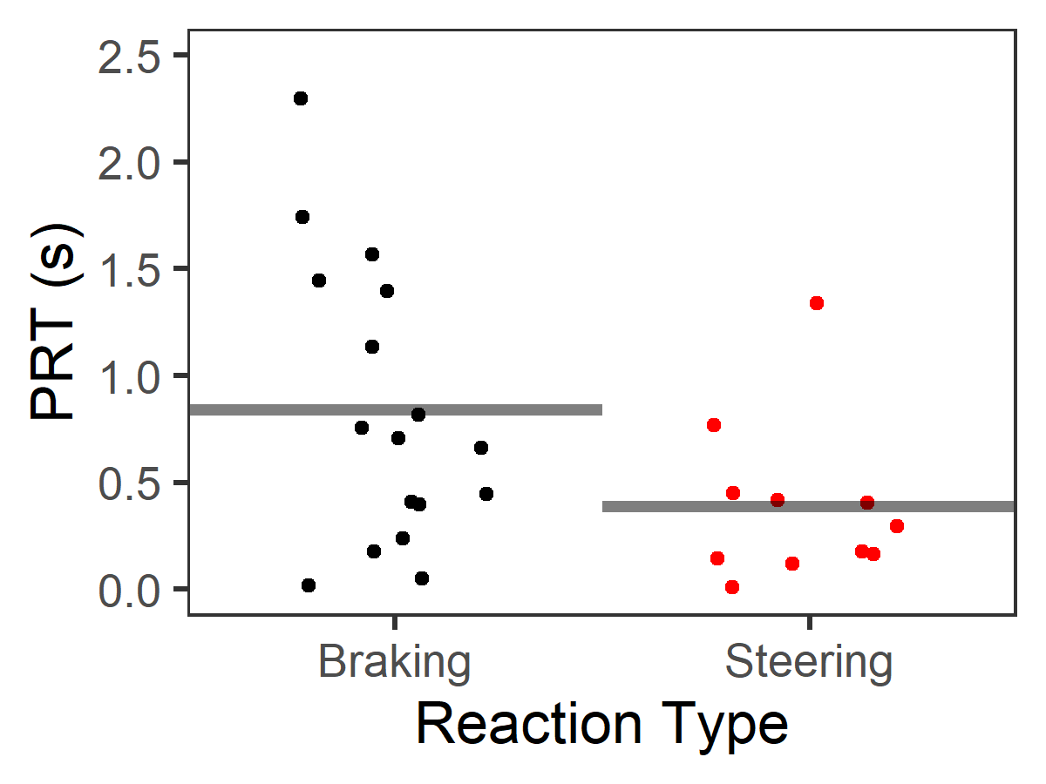
Figure 1. Reaction times for braking and steering according to the TTC of the scenario.

Thursday, 10/21/21, 09:30 AM - 09:40 AM EST
Developmental Trajectories of Driving Attention in Adolescents: Preliminary Findings from REACT
Author: Despina Stavrinos, dstavrin@uab.edu
Co-Authors: Benjamin McManus, bmcmanus@uab.edu, Sylvie Mrug, smrug@uab.edu, Andrea Underhill, moonpie@uab.edu, Thomas Anthony, tanthony@uab.edu, Kristina Visscher, kmv@uab.edu, M. Grace Albright, mgalbrig@uab.edu, Austin Svancara, asvan@uab.edu, Piyush Pawar, pawar@uab.edu

ABSTRACT
Objective: To characterize the trajectory of driving attention as a function of age and driving experience. Hypotheses. The rate of change in driving attention will be greater for 16- compared to 18-year-olds and those acquiring driving experience (vs. non-drivers). Age and driving experience will interact, with the effect of driving experience being stronger among 16- compared to 18-year-olds
Methods: In this longitudinal study, 190 adolescents were enrolled into 4 groups: (1) 16-year-olds and (2) 18-year-olds recruited within 2 weeks of obtaining a full driver’s license; (3) 16-year-olds and (4) 18-year-olds with no driving experience (no permit/license, no intention to obtain either over study period). At seven time points over 18 months, participants drove in a high-fidelity driving simulator integrated with eye tracking. Participants completed three experimental drives with three safety critical events and varying cognitive load conditions. Driving attention was measured by vertical and horizontal eye movements, number of glances, and glance length. A multilevel model using SAS PROC MIXED (SAS 9.4) will estimate the baseline intercept and slope of driving attention over time, with baseline age, driving experience, and their interaction serving as predictors of intercept and slope.
Results: Preliminary analyses suggest driving attention changes over time as a function of age, driving experience, and across cognitive load conditions.
Conclusions: Inattention is the primary contributor to motor vehicle crashes. It is critical to gain a clear understanding of how driving attention changes during adolescence, the riskiest developmental period for drivers. Results will reveal how driving impacts attention development through practice, providing a target for intervention.

INTRODUCTION
Age and experience are important factors for motor vehicle crash (MVC) risk. Most studies considering young age as a risk factor confound age with experience, because young drivers are also the most inexperienced. A combination of age- and experience-related factors may impact development of attention in the driving context, but empirical evidence characterizing the trajectories of change in driving attention and the direct impact of this change on occurrences of MVCs is lacking. The primary contributor to MVCs among adolescents is driver inattention manifesting as vulnerability to distraction (Gershon et al., 2019). Our research gives particular attention to text-messaging because it involves three domains of distraction (visual, manual, and cognitive) and is an exceptionally risky behavior. Tasks that take drivers’ eyes off the forward roadway (Stavrinos et al., 2016), reduce visual scanning (Recarte et al., 2003), and increase cognitive load (Strayer et al., 2004) are among the most dangerous distractions.
Aims and Hypotheses
Aim 1: Characterize the trajectory of driving attention development as a function of age and driving experience. Hypotheses: The rate of change in driving attention will be greater for 16- as compared to 18- year-olds and for those acquiring driving experience (vs. non-drivers). Age and driving experience will interact, with the effect of driving experience being stronger among 16- compared to 18-year-olds. Aim 2: Characterize the roles of age and driving experience in driving attention under varying levels of distraction. Hypothesis: Younger age, no driving experience, and their interaction will more strongly impair driving attention under more demanding distractions.

METHODS
Participants
Participants were enrolled into four groups: (1) Younger teens (16-year-olds) and (2) Older teens (18-year-olds) with driving experience: Recruited within 2 weeks of obtaining a full driver’s license; (3) Younger teens (16-year-olds) and (4) Older teens (18-year-olds) without driving experience: No driving experience (no permit/license, no intention to obtain either over the 18-month study). Adolescents were recruited from local high schools and via flyers on social media and in the community to complete 7 appointments, 3 months apart, over 18-months.
Measures and Procedure
At each appointment, participants completed three drives in a high-fidelity driving simulator. Integrated with the vehicle is a Smart Eye Pro system designed for head and gaze tracking. During the simulated drives a cognitive load condition was randomly presented (no distraction, cell phone conversation, texting interaction). Each drive required navigation through a freeway, residential, and urban section, each containing one randomized safety critical event (SCE). SCEs represented either a pedestrian walking, a moving vehicle, or an animal. Data were sampled around the onset of each SCE until participant either responded or passed the SCE. Driving attention was measured by horizontal and vertical eye movements (in X and Y direction, respectively), number of glances (number of times participants glance at SCEs) and average glance length (the sum of the time a participant glances at SCEs divided by total time the SCE is presented. A glance is defined as ≥ 0.75 seconds) (Decker et al., 2015).
Descriptive statistics distributions will be examined and inspected for kurtosis/skewness. Non-normal distributions will be transformed. Bivariate relationships among variables will be examined. Demographics and other factors will be used as covariates. Missing data will be handled with Full Information Maximum Likelihood. The primary analysis will utilize a multilevel model using SAS PROC MIXED to estimate the baseline intercept and slope of driving attention over time, with baseline age, driving experience, and their interaction serving as predictors. Aim 2 will be tested by adding cell phone and texting distractions and their interactions with age and driving experience. If attention development shows non-linear growth, a quadratic term will be added or driving attention will be transformed.

RESULTS
Participants (n=190) included 101 girls (53%) and 138 black adolescents (72.3%). We conducted preliminary analyses to examine eye movement during the presentation of SCEs in the simulated drives.
Aim 1: Preliminary analyses showed that horizontal eye movements increased over time among 16-year-olds (β = .07, p < .05), but decreased over time among 18-year-olds (β = -.15, p < .05). Vertical eye movements increased over time among youth who were not licensed (β = .09, p < .05), but decreased among licensed youth (β = -.14, p < .01). In these two models, 56% and 32% of variability in gaze metrics were explained by age, driving experience, and passage of time.
Aim 2: Preliminary analyses showed both cell phone use and text messaging exhibited robust effects on gaze direction and variability, suggesting impaired driving attention. These effects were further modified by age and licensure status. Text messaging increased vertical gaze among non-licensed youth (β = .27, p < .05), but not those who were licensed (β = -.32, p < .05), and this effect may vary further by age (β = .50, p = .08). In this model, 38% of variability in gaze was explained by distractions, age, licensure, and passage of time.

DISCUSSION
Changes in eye movements over time were congruent with scanning patterns of experienced drivers observed in prior work. Increases in horizontal eye movements and decreases in vertical eye movements were indicative of more efficient visual attention processes, such that over time, drivers eliminated irrelevant scanning vertically and scanned more area horizontally where safety-relevant information was distributed (Aim 1). Similarly, licensed drivers more efficiently allocated their gaze during text messaging, as indicated by less vertical eye movements over time during load conditions.

Potential Implications
This study is the first longitudinal study of attention in the driving context. Findings are preliminary as data collection is ongoing, but there are important implications for adolescent development and traffic injury prevention researchers. Findings will facilitate development of interventions to accelerate adolescent attention development and driver learning and will improve adolescent driving safety through translational work informing critically needed science-based interventions to reduce adolescent MVCs. The study will offer insights into the development of attention as adolescents develop both chronologically and in their skill at the complex task of operating a vehicle. The results will reveal how driving impacts attention development through repeated practice or training, providing an additional target for intervention. Public policy implications are at stake, including: Are 16-year-olds developmentally too young to handle the attentional and cognitive demands of driving, or does driving simply require a longer period of experience?

SELECTED REFERENCES
1. Gershon P, Sita KR, Zhu C, et al. Distracted Driving, Visual Inattention, and Crash Risk Among Teenage Drivers. Am J Prev Med. 2019;56(4):494-500. doi:10.1016/j.amepre.2018.11.024
2. Decker JS, Stannard SJ, McManus B, Wittig SM, Sisiopiku VP, Stavrinos D. The impact of billboards on driver visual behavior: a systematic literature review. Traffic Inj Prev. 2015;16:234-239. doi:10.1080/15389588.2014.936407
3. Recarte MA, Nunes LM. Mental workload while driving: effects on visual search, discrimination, and decision making. J Exp Psychol Appl. 2003;9(2):119-137. doi:10.1037/1076-898x.9.2.119
4. Stavrinos D, Mosley PR, Wittig SM, et al. Visual Behavior Differences in Drivers Across the Lifespan: A Digital Billboard Simulator Study. Transp Res Part F Traffic Psychol Behav. 2016;41(A):19-28. doi:10.1016/j.trf.2016.06.001
5. Strayer DL, Drews FA. Profiles in driver distraction: effects of cell phone conversations on younger and older drivers. Hum Factors. 2004;46(4):640-649. doi:10.1518/hfes.46.4.640.56806

ACKNOWLEDGEMENT
Research reported in this publication was supported by the Eunice Kennedy Shriver National Institute of Child Health & Human Development of the National Institutes of Health under Award Number R01HD089998. The content is solely the responsibility of the authors and does not necessarily represent the official views of the NIH.

Thursday, 10/21/21, 09:40 AM - 09:50 AM EST
Delta-V Slope as an Indicator of Injury
Author: Hans Hauschild, hhauschild@mcw.edu
Co-Author: Dale Halloway, DHallloway@mcw.edu, Frank Pintar, fpintar@mcw.edu

ABSTRACT
Objective: This study’s objective was to examine a crash severity characteristic and the relationship as an indicator of abdominal injury causation.
Methods: Data was analyzed from 23 CIREN case vehicles involved in a frontal type collision, had an AIS 2+ abdominal injury, and contained an electronic data recorder (EDR) download. Data was downloaded from the NHTSA and IIHS crash test databases for comparison. Data was run through a MATLAB algorithm calculating the maximum velocity-time profile slope. This data was compared to the available crash tests.
Results: The CIREN vehicle EDR velocity-time slopes ranged from 233 m/s² to 434 m/s² for crashes with a delta-v range of 42 km/h to 77 km/h. NHTSA NCAP comparable data was available for all cases, and the slopes ranged from 263 m/s² to 405 m/s² calculated from the collected accelerometer. Three comparable tests were available from the IIHS database and the calculated slopes ranged from 252 m/s² to 298 m/s². Four test vehicles had EDR data, two each from NHTSA and IIHS and slopes ranged from 245 m/s² to 281 m/s². The crash test EDRs slope calculations were lower than the accelerometer data. Nine of the 12 case vehicles had slope values lower than the comparable NCAP accelerometer velocity-time slopes.
Conclusions: Vehicle velocity-time profile can be beneficial to examine the characteristics of crash severity and potential injury. This small sample of field crashes did not indicate a clear relationship of abdominal injury related to crash severity measured by the EDR delta-v slope. EDR results can be considered when determining crash severity, but the limitations need to be understood.

INTRODUCTION
Vehicle crash severity has often been determined by examining the delta-v calculated from crush. Crush is associated with the direct damage to sheet metal classified using the collision deformation classification (CDC) coding scheme in SAE J224 (SAE 2017). Crash reconstruction has used the crush profiles and delta-v calculations or electronic data recorder (EDR) (aka: black box) data for classifying crash severity and potential injury. Crush based delta-v may not be good representation of the crash severity and injury relationship (Brumbelow, 2019). Current vehicles EDR have data which can be analyzed and used for crash reconstruction and severity, typically delta-v. EDRs supply a velocity-time profile or delta-v at a minimum 10 millisecond (ms) intervals, some supply smaller intervals. Although more is collected, this large time interval output by the EDR may not fully represent the actual vehicle deceleration in a crash (Chidester et.al. 2001; Gabler et al. 2004).
The most severe time during a crash is at the highest rate of change in velocity, which can be determined by calculating the velocity-time profile’s largest or steepest slope. Crash characteristics are not just related to the delta-v and crush, but also the item and direction impacted, which influences the deceleration profile. Maximum delta-v slope calculation during its most linear phase can be utilized to determine the highest severity period of the collision and possibly determine injury relationship.
This study examined the velocity-time slope as a basis to define relative crash severity and the phases of severity. The velocity-time profiles were utilized as the acceleration traces are not always part of an EDR download. Field data was compared to available crash test data and the crash test EDR data when available for comparable vehicle models. The study was part of an abdominal injury investigation of CIREN cases as they relate to lap belt submarining. Part of this study was investigating the crash severity characteristics which might be indicators of abdominal injuries. A review was conducted to compare the time-velocity slope values for the CIREN cases and standard crash tests.

METHODS
The data collection criteria included vehicle model years 2010 or newer, crash PDOF +/- 20 degrees from full frontal with at least one AIS 2+ abdominal injury. This resulted in 23 CIREN cases. Reported longitudinal delta-v ranged from 23 km/h to 83 km/h. This study was a subset of data downloaded to examine abdominal injuries. The longitudinal velocity-time profiles from the downloaded EDRs were used for analysis.
Crash test data for the same make and model to the case vehicles, with the model year within 1 – 5 years of the case vehicle, were downloaded for the NHTSA NCAP and IIHS 40% offset tests (Table 1). When available the EDR was downloaded in a .pdf format and the velocity data transcribed into a spreadsheet. Eleven vehicle crash tests of the CIREN field data vehicles were available from the NHTSA and IIHS databases. One crash test vehicle (2013 Accord) was used for two cases (2014 and 2015 Accord). Table 1 presents the case vehicles and crash test vehicles used for comparison. Comparable NHTSA NCAP tests were available for 12 case vehicles and 2 with EDR data. Only 3 comparable tests of the IIHS 40% offset were available with 2 having EDR data.
The EDR delta-v data was run through a MATLAB algorithm to calculate the velocity-time profile maximum slope and time period. The CIREN field EDR data was input in the time step interval available from each model vehicle. The EDR data was typically at 10 ms intervals. Maximum slope was determined using a minimum of a 30-millisecond (ms) time period, and a linear regression R² greater than 0.98 or best fit when the slope was not equal to or greater than 0.98.
Velocity-time profile data from the crash tests were run through the MATLAB algorithm. The crash test accelerometer data was reduced to 1 ms intervals for the analysis. The crash test vehicle’s EDR data was also input. Slope values were calculated using meters per second over seconds (m/s²). The 12 CIREN case vehicles’ delta-v ranged from 42 km/h to 77 km/h. The nominal delta-v from NCAP testing is 56 km/h and 64 km/h for the IIHS offset tests but it typically slightly higher due to vehicle dynamics and crush characteristics. The resulting data was analyzed to determine how comparable the crash tests data is to the EDR and if the CIREN cases similar characteristics to the crash test data.

RESULTS
Results of the 12 case vehicles are presented in table 1 and figure 1. The steepest calculated velocity-time slope ranged from 233 m/s² to 434 m/s². The highest calculated slope was 434 m/s² for a 50 km/h crash. The steepest slope was not necessarily calculated from the highest delta-v crashes, 2015 Toyota Camry, 77 km/h, slope = 323 m/s², and 2013 Toyota Prius, 77 km/h, slope = 334 m/s². The flattest slope, 233 m/s², corresponded to the lowest delta-v, 42 km/h, in the group.
The NCAP accelerometer data of similar model vehicles was integrated to obtain a velocity-time profiles. During NCAP tests the vehicle is pulled into the flat barrier at 56 km/h. The slope calculated from the NCAP delta-v’s of 11 vehicles ranged from 263 m/s² to 405 m/s² from accelerometer data. For the two NCAP vehicles with EDR data, 2012 Toyota Camry and 2012 Chevrolet Camaro calculated highest slope was 264 m/s² and 250 m/s². respectively but were less than the accelerometer data, 342 m/s² and 290 m/s². The CIREN case vehicles had delta-v of 72 km/h for the 2015 Chevrolet Camaro, slope = 242 m/s², and 77 km/h for the 2015 Toyota Camry slope = 323 m/s².
Velocity data was downloaded from the IIHS database 40% offset crash tests in which 40% of the vehicle front is pulled into a deformable barrier at 64 km/h. Three comparable vehicles were available for calculating the delta-v slope; 2012 Toyota Prius, slope = 298 m/s²; 2016 Chevrolet Camaro, 279 m/s²; and 2011 Ford Mustang, 252 m/s². EDR data was available for the crash tested Camaro and Mustang, slope = 281 m/s² and 245 m/s² respectively. Delta-v for each of the comparable case vehicles was 77 km/h, 72 km/h and 62 km/h for the 2013 Toyota Prius, slope = 334 m/s²; 2015 Chevrolet Camaro, slope = 242 m/s²; and 2011 Ford Mustang slope = 361 m/s² respectively.

DISCUSSION
Research related to injury relationships to crash severity due to delta-v has been shown by many authors (Gabauer & Gabler, 2007; Jurewicz, et al., 2016; Nance et al., 2006, Gabler et al. 2004; Shelby, 2011). Examination of EDR data is a source of the velocity change and rate. Crash research has indicated that vehicles need “ride down” time, longer deceleration time, to protect an occupant during the crash. Vehicles have several items to help the occupants “ride down” the crash including crush zones, load limited seat belts, and airbags for example. Those studies that implicate the delta-v was related to the potential injuries only examined the whole known delta-v reported from an EDR or calculation by a crash reconstructionist. The relationship has been established as an indicator through many studies. The time period that the change occurred is not taken into consideration. A low value or shallow slope would be indicative of more ride down time while a high value or steeper slope would be indicative of less ride down time.
This research took a novel approach to analyzing a characteristic of the delta-v and its potential relationship to injury. This study broke down the available EDR data from crashes involving injuries examining if there is a relationship to the velocity-time profile shape and injury type. This pilot study examined CIREN field crash delta-v characteristics which may be indicators of higher risk for submarining and subsequent abdominal injuries. Previous testing of four different acceleration sled pulses found that the pulse with an acceleration which dropped in a short time period produced the highest lumbar forces compared to the other three pulses, and that timing was a factor (Hauschild et al. 2016).
The crash test data from both the NHTSA NCAP and IIHS 40% offset demonstrated that the EDR profiles are lower than the values calculated from the longitudinal accelerometer secured on the vehicle. This was likely due to the larger time steps, 10 ms, the EDRs output, compared to the acceleration analysis in 1 ms intervals.
Similar time intervals were found for the highest slope for both the EDR and accelerometer data of comparable test vehicles. This likely indicates the field EDR data may be useful when determining the injury timing. Future studies related the slope timing and its relationship to injury causation need to be completed. The family of ATDs used for the NCAP and IIHS testing reviewed for this paper did not include ASIS force and abdominal pressures to determine submarining and injury potential due to the lap belt.
Nine of the 12 CIREN case vehicles EDR velocity-time profiles have a lower slope value than the comparable NHTSA NCAP crash test vehicles. The average calculated velocity-time slope of the CIREN EDRs (309 m/s²) was lower than the average calculated accelerometer data from the NHTSA NCAP tests (325 m/s²) of comparable vehicles. The vehicle crash test data set of noncomparable vehicle EDR and accelerometer values presented the EDR slope values were typically lower than the accelerometer.
The EDR slope calculations from the four comparable vehicles were lower than the average of the CIREN case vehicles. The Chevrolet Camaro data was available for both the NHTSA NCAP and IIHS 40% offset, slope calculations were 250 m/s² and 281 m/s² respectively, while the case vehicle was calculated at 242 m/s², lower than the two crash tests accelerometer & EDR data (figure 2). This agrees with the discussion in the Chidester et al. (2001) paper analyzing EDR output. This indicates that the EDR data does not output complete velocity-time data traces and actual field-crash slopes may likely be greater. There was not a clear correlation between the velocity-time slope and abdominal injury in these CIREN cases based on the EDR data of this small sample.
Limitations of this study include small case numbers and comparable test vehicles. Another limitation is the lack of available crash test data related to abdominal injuries. Future research should include a larger number of cases and comparison to other injury types and crash test data including EDRs. This study only examined the highest calculated slopes, other characteristics may have relationships to an injury.
More research is needed to parse out the specific vehicle crash characteristics which may contribute to a group of injuries. Field researchers will have to account for EDR output values limitations as compared to crash test data. One such characteristic may be breaking down the velocity-time curves to determine the crash severity, injury causation and injury timing. This data type may be beneficial for crash pulse simulation development for sled testing or modelling.
ACKNOWLEDGEMENTS - Funding
The statements made are those of the authors and not necessarily those of the funding agencies. This research was supported in part by USDOT NHTSA contract number DTNH2217D00071 and the Department of Veterans Affairs Medical Research.
Table 1. Vehicle data and velocity-time slope calculations
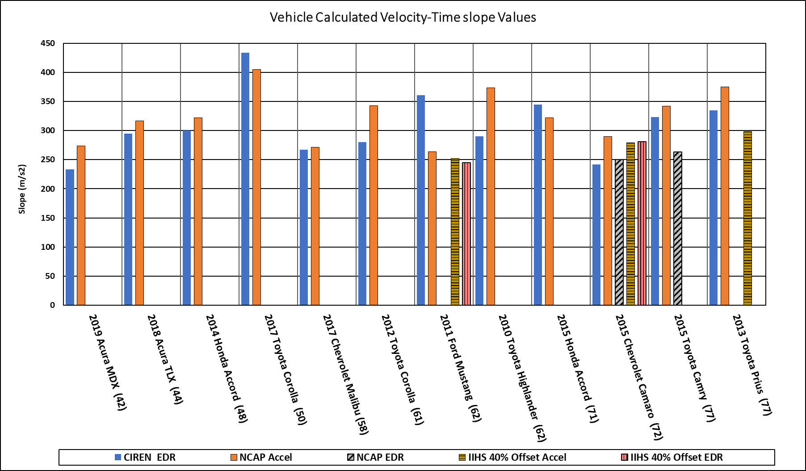
Figure 1. Vehicle data and velocity-time slope results sorted from lowest to highest delta-v (case vehicle and case delta-v used for sorting on x-axis, see table 1 for crash test vehicle model year comparison)

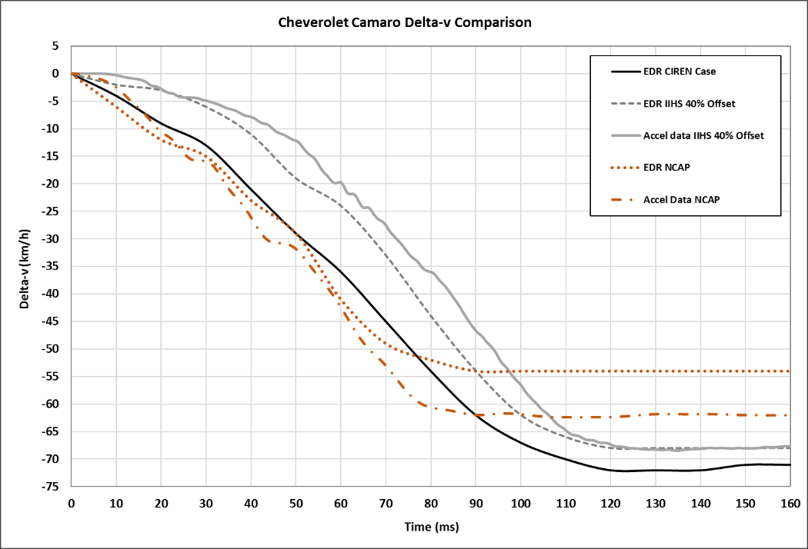
Figure 2 – Graph demonstrating different delta-v shapes for one vehicle; a CIREN field case, IIHS 40% offset test and NHTSA NCAP test.
REFERENCES
Brumbelow, M. L. (2019). Front crash injury risks for restrained drivers in good-rated vehicles by age, impact configuration, and EDR-based delta V. In Proceedings of IRCOBI Conference.
Chidester, A. C. D., Hinch, J., & Roston, T. A. (2001, May). Real world experience with event data recorders. In Proceedings of the Seventeenth International Technical Conference on the Enhanced Safety of Vehicles, Amsterdam, Netherlands (June 2001).
Chidester, A., Hinch, J., Mercer, T. C., & Schultz, K. S. (2001). Recording automotive crash event data.
Gabauer, D. J., & Gabler, H. C. (2008). Comparison of roadside crash injury metrics using event data recorders. Accident Analysis & Prevention, 40(2), 548-558.
Gabler, H. C., Hampton, C. E., & Hinch, J. (2004). Crash severity: a comparison of event data recorder measurements with accident reconstruction estimates (No. 2004-01-1194). SAE Technical Paper.
Hauschild HW, Halloway D, Pintar FA. (2015) ATD Spine Response as a Function of Crash Pulse Input. Traffic Injury Prevention, AAAM special Issue. Short Communication. 2015. 237- 240.
Jurewicz, C., Sobhani, A., Woolley, J., Dutschke, J., & Corben, B. (2016). Exploration of vehicle impact speed–injury severity relationships for application in safer road design. Transportation research procedia, 14, 4247-4256.
Nance, M. L., Elliott, M. R., Arbogast, K. B., Winston, F. K., & Durbin, D. R. (2006). Delta V as a predictor of significant injury for children involved in frontal motor vehicle crashes. Annals of surgery, 243(1), 121.
Shelby, S. G. (2011, January). Delta-V as a measure of traffic conflict severity. In 3rd International Conference on Road Safety and Simulati. September (pp. 14-16).
Society of Aumotive Engineers. SAE J211-1 (2017) Instrumentation for Impact test, Surface vehicle recommended practice. Warrendale PA SAE International: 2017.

Thursday, 10/21/21, 09:50 AM - 10:00 AM EST
Finding and Understanding Pedal Misapplication Crashes Using a Deep Learning Natural Language Model
Author: Max Bareiss, bareiss@vt.edu
Co-Author: Colin Smith, colinsmith@vt.edu, Hampton Gabler, gabler@vt.edu

ABSTRACT
Objective: The objective of this study was to develop a system which used the BERT natural language understanding model to identify pedal misapplication (PM) crashes from their crash narratives and validate the accuracy of the system.
Methods: The training dataset used for this study was 11 cases from the NMVCCS study and 952 cases from the North Carolina state crash database. Cases for this study were selected from their respective full datasets using a keyword search algorithm containing terms indicative of a pedal-related mistake. A BERT language model was used to classify each case narrative as either no pedal misapplication, PM by vehicle 1, PM by vehicle 2, or PM by vehicle 3. After training, the language model was used to determine the incidence of pedal misapplication in a test dataset of 8,668 North Carolina and NMVCCS cases and these results were compared to a manual review of the dataset. After manual review, 2,969 cases were pedal misapplications.
Results: The model’s AUC ROC performance at detecting PM was quantified on the entire testing dataset to evaluate the power of the system to generalize to case narratives unseen at training time. The AUC ROC value was 0.9835, indicating strong generalization to all crash narratives. By choosing the optimal threshold using the ROC curve, the system correctly identified PM in 95.7% of crash narratives. When pedal misapplication was correctly identified, the correct vehicle was identified in 95.9% of cases. A total of 3,062 pedal misapplications were identified. The model labeled cases 353 times faster than a researcher.
Conclusions: The strong performance of the model suggests that the automated interpretation of case narratives can be used for future research studies without any manual review. This would save time and enable the use of datasets where manual review would be infeasible. The automated extraction of information from crash narratives using deep learning natural language models has not been demonstrated previously in the literature, to the best of the authors’ knowledge. This technique can be applied to large, infrequently used datasets of crash narratives and extended to extract useful vehicle, occupant, or environment information to make these datasets amenable to traditional statistical analyses.

introduction
Pedal misapplication crashes occur when one or more drivers in a crash inadvertently press the accelerator pedal instead of the brake pedal, causing unintended acceleration into an object, person, or vehicle. The frequency of pedal misapplication crashes has been estimated as 0.2% of all serious crashes where EMS was called based on an analysis of crash data from the National Motor Vehicle Crash Causation Survey (NMVCCS), although the limitations of this study suggest that the true frequency of pedal misapplication crashes is likely higher (Lococo et al., 2012).
One challenge associated with the study of pedal misapplication crashes is identification. All nationally representative databases produced by the National Highway Traffic Safety Administration (NHTSA) in the United States do not identify pedal misapplication as a crash type, instead labeling these crashes as other crash types such as rear ends or roadside departures. NMVCCS, which includes detailed crash information collected within hours of the crash including driver and bystander interviews, does not include information about pedal misapplication in the critical pre-crash factors for each case. State databases, which contain a greater number of cases than those produced by NHTSA, contain less information for each case, and to our knowledge no state database explicitly labels pedal misapplication crashes. However, state databases and all federal databases contain short case narratives. In state databases, the National Automotive Sampling System Crashworthiness Data System (NASS/CDS), and the Crash Investigation Sampling System (CISS), the case narrative is derived from the police accident report (PAR). In NMVCCS, the case narrative is developed by the case investigator including information from the PAR, interviews, and their judgement of crash causation in each case. This case narrative can contain language which indicates a pedal misapplication occurred.
Recent advances in Natural Language Processing (NLP) techniques which use Transformer-based models have achieved significant gains to near-human-level performance in a number of standard NLP tasks (Devlin et al., 2018; Vaswani et al., 2017). The BERT (Devlin et al., 2018) deep neural network model is pre-trained on a large corpus of normal text from the Internet by imputing missing words in normal prose. The input to the model was a sequence of word segments called tokens, and the output of the model was a feature vector for each token. A logistic classifier was trained on the feature vector to predict a specific token. A special non-word token was used to represent the idea of a missing token. The training objective was to select the correct token, thereby understanding sentence context. The features developed as a part of this training procedure contain rich semantic information about the text and context both before and after each word. Additional special non-word tokens in the input sequence are not imputed at training time but are used to divide up passages of text or perform sentence classification using a logistic classifier on the feature values for those tokens. The BERT model outperforms humans on the reading comprehension benchmark SQuAD 1.1 (Rajpurkar et al., 2016), suggesting the model is capable of “reading” prose and “answering” interpretive questions about the text.
The objective of this study was to use the BERT natural language understanding model to identify pedal misapplication crashes from their crash narratives and validate the accuracy of the system.

METHODS
The dataset used for this study was 110 cases from the NMVCCS study and 9,521 cases from the North Carolina state crash database. The NMVCCS cases occurred from 2005 to 2007 and the North Carolina cases occurred from January 2014 to May 2020. The occurrence of pedal misapplication was determined through manual review. Cases for this study were selected from their respective full datasets using a keyword search algorithm containing terms indicative of a pedal-related mistake (Lococo et al., 2012). Pedal misapplication was defined to occur if the narrative indicated the driver may have inadvertently pressed one pedal while intending to press another. A training dataset was constructed by randomly selecting 10% of the NMVCCS and North Carolina cases. A validation dataset consisting of 20% of the training cases was used during algorithm development.
The BERT model used in this study was implemented using the Transformers library maintained by 🤗 (Hugging Face) (Wolf et al., 2020). The specific model used was the ‘bert-large-uncased-whole-word-masking’ model (Hugging Face, 2021) in the Sequence Classification configuration. The model fine-tuning objective was to classify each narrative in to one of four categories: no pedal misapplication, pedal misapplication by the driver of vehicle 1, pedal misapplication by the driver of vehicle 2, or pedal misapplication by the driver of vehicle 3. The categories represent the occurrence of pedal misapplication by each driver as separate classification categories, including a category to represent the absence of pedal misapplication. The source dataset contained no cases where drivers of higher numbered vehicles performed pedal misapplication, nor were there any cases where multiple drivers performed pedal misapplication. The input to the model was the case narrative, tokenized using the standard procedure for the Hugging Face BERT model. No other information was used as an input to the model.
Fine-tuning used a learning rate of ${10}^{-6}$, a batch size of two narratives, ten warm-up steps, a weight decay of 0.01, and 15 training epochs. The duration of fine-tuning was approximately 50 minutes using one NVIDIA GeForce 1080 Ti GPU.
The fine-tuned model was used to determine pedal misapplication in the test dataset of 8,668 North Carolina and NMVCCS cases which were not used during training. Among these, 2,969 cases were pedal misapplications.

RESULTS
The performance of the system was evaluated on the training dataset using a ROC curve. Because an ROC curve can only evaluate binary decisions, all pedal misapplications, regardless of vehicle number, were considered the positive category and the absence of pedal misapplication was considered the negative category. The ROC curve is shown in Figure 2 and the AUC ROC value was 0.9992, indicating a high-performance system or overfitting. By choosing the optimal threshold using the ROC curve, the system correctly labeled 99.5% of crash narratives in the training dataset. When pedal misapplication was correctly identified, the correct vehicle was identified in 99.1% of cases.

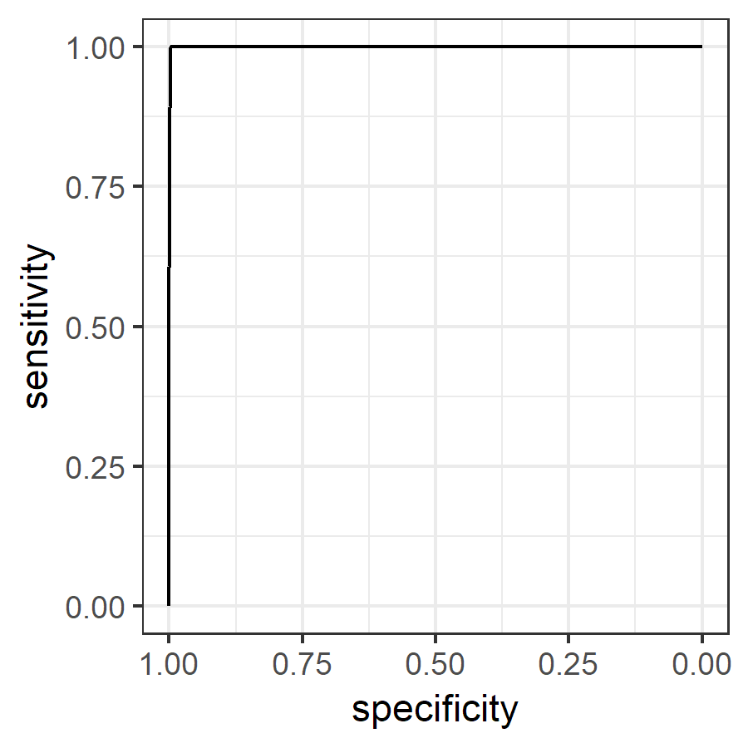
Figure 2. Receiver Operating Characteristic (ROC) curve describing the pedal misapplication model on the training dataset.

The model’s ROC performance was quantified on the entire testing dataset to evaluate the power of the system to generalize to case narratives unseen at training time. The ROC curve is shown in Figure 3 and the AUC ROC value was 0.9835, indicating strong generalization to all crash narratives. By choosing the optimal threshold using the ROC curve, the system correctly labeled 95.7% of crash narratives. When pedal misapplication was correctly identified, the correct vehicle was identified in 95.9% of cases. A total of 3,062 pedal misapplications were identified.

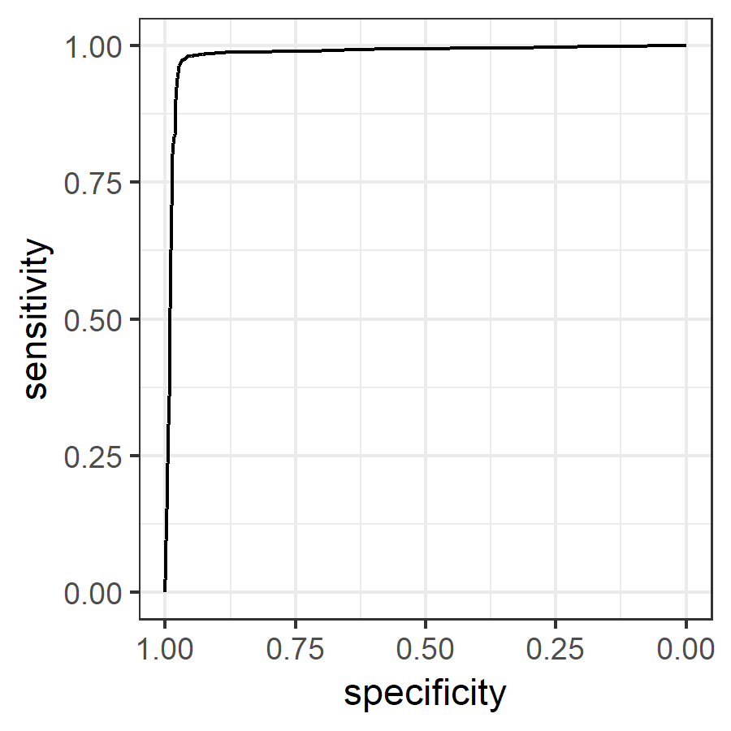
Figure 3. ROC curve describing the performance of the pedal misapplication model on the test set of 8,668 narratives.

DISCUSSION
Analysis of crash narratives using machine learning allows large datasets to be analyzed quickly, consistently, and at low cost. The model in this work evaluated 53 case narratives per second using one NVIDIA GeForce 1080 Ti GPU, released in 2017. Cases were manually reviewed at a rate of 0.15 per second. Newer GPUs and advanced technologies, developed with natural language models like BERT in mind, can evaluate cases more quickly. Performance scales linearly with the number of GPUs dedicated to the task, allowing for most crash narrative datasets to be analyzed in their entirety in a reasonable amount of time. Large experiments with manual labeling often involve multiple workers and the resulting potential for inconsistency. By labeling a small portion of the dataset by one person and training a machine learning model on those results, the potential for mis-labeling and bias between labelers is reduced. The reduced cost associated with university GPU systems and labeling effort could potentially enable new types of future studies. Future work could automatically determine crash configuration, injury, and other crash factors for unlabeled datasets such as state databases, insurance documents, and medical records. This could enable rich statistical analyses of text datasets which are otherwise challenging to parse with traditional methods. Among the cases found using the keyword search, 35% were pedal misapplication cases. Selecting cases using the BERT model instead of the keyword search would have yielded significantly fewer false positives, and a shorter manual review time, if manual review were deemed necessary.

CONCLUSION
The objective of this study was to use the BERT natural language model to identify pedal misapplication cases from crash narratives. The system correctly labeled 99.5% of crash narratives from the training dataset and 95.7% of crash narratives from a test dataset unseen at training time. When pedal misapplication was correctly identified in the test dataset, the correct vehicle was identified in 95.9% of cases. The BERT model labeled cases 353 times faster than a researcher. The strong performance of the model suggests that the automated interpretation of case narratives can be used for future research studies without any manual review. This would save time and enable the use of datasets where manual review would be infeasible.

NOVELTY/Traffic safeTy implications
The automated extraction of information from crash narratives using deep learning natural language models has not been demonstrated previously in the literature, to the best of the authors’ knowledge. This technique can be applied to large, infrequently used datasets of crash narratives to extract useful vehicle, occupant, or environment information to make these datasets amenable to traditional statistical analyses.

ACKNOWLEDGEMENTS
The authors acknowledge the Collaborative Safety Research Center (CSRC) and Toyota Motor Corporation for funding this study.
The authors would like to thank Alexandra Haynes and Jordan Moon at Virginia Tech for their help labeling the training and validation datasets.

REFERENCES
Devlin, J., Chang, M.-W., Lee, K., Toutanova, K., 2018. BERT: Pre-training of Deep Bidirectional Transformers for Language Understanding. arXiv:1810.04805 [cs].
Hugging Face, 2021. bert-large-uncased-whole-word-masking · Hugging Face [WWW Document]. URL https://huggingface.co/bert-large-uncased-whole-word-masking (accessed 3.22.21).
Lococo, K.H., Staplin, L., Martell, C.A., Sifrit, K.J., 2012. Pedal Application Errors (No. DOT HS 811 597).
Rajpurkar, P., Zhang, J., Lopyrev, K., Liang, P., 2016. SQuAD: 100,000+ Questions for Machine Comprehension of Text. arXiv:1606.05250 [cs].
Vaswani, A., Shazeer, N., Parmar, N., Uszkoreit, J., Jones, L., Gomez, A.N., Kaiser, Ł., Polosukhin, I., 2017. Attention is All you Need, in: 31st Conference on Neural Information Processing Systems (NIPS 2017). Presented at the 31st Conference on Neural Information Processing Systems (NIPS 2017), Long Beach, CA, p. 11.
Wolf, T., Debut, L., Sanh, V., Chaumond, J., Delangue, C., Moi, A., Cistac, P., Rault, T., Louf, R., Funtowicz, M., Davison, J., Shleifer, S., von Platen, P., Ma, C., Jernite, Y., Plu, J., Xu, C., Le Scao, T., Gugger, S., Drame, M., Lhoest, Q., Rush, A., 2020. Transformers: State-of-the-Art Natural Language Processing, in: Proceedings of the 2020 Conference on Empirical Methods in Natural Language Processing: System Demonstrations. Association for Computational Linguistics, Online, pp. 38–45. doi:10.18653/v1/2020.emnlp-demos.6

Thursday, October 21, 2021
Vulnerable Populations: 02:00 PM - 03:40 PM EST

Thursday, 10/21/21, 03:30 PM - 03:40 PM EST
Simulated and Self-Reported Driving Among Young Adults with and without Prenatal Cocaine Exposure
Author: Deepa R. Camenga, deepa.camenga@yale.edu
Co-Authors: Barbara Banz, barbara.banz@yale.edu, Michael Crowley, michael.crowley@yale.edu Linda Mayes, linda.mayes@yale.edu, Timothy L. Brown, timothy-l-brown@uiowa.edu, Kaigang Li, Kaigang.Li@colostate.edu, Federico E. Vaca, federico.vaca@yale.edu

ABSTRACT
Objective: This exploratory study aimed to examine associations between executive function and simulated and self- reported driving behavior among young adults with and without a history of prenatal cocaine exposure (PCE).
Methods: Young adult drivers with PCE (n=38) and with no drug exposure (NDE; n=25) were recruited from an ongoing longitudinal birth cohort study assessing effects of PCE on development (Mean age=23.7; 60.3% male; 61.9% with a valid U.S. driver’s license, 38.1% report independent driving without a license). Participants completed executive function tasks (i.e., the Stop Signal Task and Groton Maze Learning Task) and self-reported driving measures (i.e., Checkpoints Risky Driving Scale (C-RDS)) outside the cab. Average stop signal reaction time(s) measured inhibitory control, number of exploratory errors measured visuo-spatial working memory, and the total C- RDS score measured self-reported risky driving. Participants completed a high-fidelity driving simulation scenario in a miniSim™ ½ cab National Advanced Driving Simulator (NADS) that yielded indicators of driving performance shown in previous research to correlate with inhibitory control (e.g., average speed, standard deviation lane position (SDLP)) and working memory (minimum headway time, lane departures). Multivariate linear regression models tested whether PCE status, licensure status and executive function measures were associated with simulated driving measures or C-RDS, controlling for sex.
Results: Multivariate regression models demonstrated inhibitory control, working memory and PCE group status was not significantly associated with driving outcomes. Licensure was significantly associated with total lane departures (β=-0.66, SE=0.19; p<0.001) and C-RDS (β=5.86, SE=1.4; p<0.001).
Conclusions: This exploratory study suggests that young adults with PCE have similar neurocognitive performance and driving behaviors as their non-drug exposed (NDE) peers. These findings add to the growing literature demonstrating that the effect of PCE on cognitive functions in childhood may not persist to young adulthood. Further research with similar groups of young drivers in a naturalistic driving context (i.e., instrumented vehicles) is needed to more definitively translate and confirm our findings.
Keywords: Driving Prenatal Cocaine Exposure, Working Memory, Inhibitory Control

INTRODUCTION
Cocaine is an illicit prenatal drug exposure experienced by young adults in the United States. During the 1980s and early 1990s cocaine epidemic, it was estimated that ~1% of pregnant women used cocaine (Shiono, 1996). Research suggests that prenatal cocaine exposure (PCE) impacts executive functions that might increase the likelihood of risky driving. PCE has been shown to alter inhibitory control (Banz, Wu, Crowley, Potenza, & Mayes, 2016), a neurocognitive process shown to be correlated with driving speed and variability of lane position (Jongen, Brijs, Komlos, Brijs, & Wets, 2011; Ross et al., 2015; Ross, Jongen, Brijs, Brijs, & Wets, 2016). Similarly, poorer working memory has been related to lane departures and greater headway distance, which has been hypothesized to be due to a greater need to use compensatory strategies to safely execute the driving task (e.g., maintain longer following distances) (Ross et al., 2015). Neuroimaging evidence also demonstrates a long-term effect of PCE on the arousal regulation system with implications for the regulation of inhibitory control and working memory (Robey, Buckingham-Howes, Salmeron, Black, & Riggins, 2014). However, independent cocaine effects appear to subside (i.e., undergo some remission) with age (Lambert et al., 2013), suggesting that during older adolescence and young adulthood, other socio-environmental factors may account for a substantial variance in vehicle control and motor vehicle crash risk. It is unknown whether PCE impacts young adult driving behaviors (Morie, Crowley, Mayes, & Potenza, 2019)– one of the most common health-risking behaviors among young adults
This exploratory study examined associations between executive function and simulated and self-reported driving behavior among young adults with and without a history of PCE. To examine the independent effects of PCE, we studied PCE and non-drug exposed (NDE) populations recruited from an ongoing longitudinal/lifespan birth cohort study of children with similar socio-environmental stress and vulnerability (Bridgett & Mayes, 2011). Since motor vehicle crashes are the leading cause of death and injuries for youth, documenting associations between PCE and driving behaviors will help inform our understanding of the long-term impacts of prenatal drug exposure.

METHODS
Participants and Protocol
Young adults were recruited from an ongoing longitudinal birth cohort study assessing effects of PCE on physical, cognitive, social, and emotional development (Bridgett & Mayes, 2011). Pregnant women residing in the same low-income, urban neighborhoods in New Haven, CT were recruited into the cohort between 1991 and 1996 and their children have been followed biannually since birth. Women were approached for study participation when they presented for prenatal care or, in the case of no prenatal care, when they were admitted to the postpartum ward at a large urban hospital. Newborns were defined as having PCE if their mothers reported cocaine use during pregnancy, had a cocaine positive urine during pregnancy or delivery, or if the newborn had a cocaine-positive meconium at birth. Women not reporting cocaine use and not having a positive urine toxicology were eligible for recruitment into the two comparison groups defined by “no drug-use prenatally” and an “other-drug-use prenatally” group (i.e., alcohol, tobacco or marijuana use but no cocaine). In the current study, young adults from the no drug-use prenatally group were included in the NDE group.
Inclusion criteria were: 1) Member of the birth cohort; 2) English-speaking; 3) able to provide written consent; 4) self-reported experience with independent driving; and 5) screen negative on the driving simulation sickness questionnaire (Kennedy, Lane, Berbaum, & Lilienthal, 1993). Participants did not need a valid driver’s license to participate in this study, as previous research has shown that youth from lower-income urban neighborhoods drive regularly without a license (Elliott, Ginsburg, & Winston, 2008; Vaca, Trevino, Riera, Meyer, & Anderson, 2012). Exclusion criteria included: 1) current incarceration; 2) current diagnosis of seizure disorder; or 3) current alcohol intoxication (blood alcohol concentration (BAC) >0.02% at the time of the laboratory assessment).
Eligible participants provided written consent for study participation and all procedures were approved by the Yale Institutional Review Board. Participants completed demographic and driving questionnaires, computer-based tasks measuring executive function, and drove in a high-fidelity driving simulator. Seventy participants were enrolled between October 2018 and March 2020 (n=42 PCE, n=28 NDE (of which 2 were tobacco exposed). The analytic sample included 63 participants with complete data on study measures (n=38 PCE, n=25 NDE (0 tobacco exposed)); mean age=23.7, SD=1.9, range 18-27 years). Prior to the simulator drive, sobriety was confirmed by a BACtrack S80 Pro Alcohol Breathalyzer (BAC ≤0.02%; KHN Solutions Inc., San Francisco, CA).

Executive Function Tasks and Measures
Inhibitory control: Participants completed the Stop Signal Task (SST) outside of the cab using EPrime (Psychology Software Tools, Sharpsburg, PA) with a Chronos Response Pad®. During the task, white arrows were presented on a black screen. Participants were asked to press the button which represented the direction the arrow was pointed (left or right) and to withhold response if a red box appeared around the arrow. Average stop signal reaction time(s) measured inhibitory control (Logan, Schachar, & Tannock, 1997).
Working memory: The computer based Cogstate Groton Maze Learning Test (GMLT) measured spatial working memory and error monitoring (Cogstate, 2020; Pietrzak, Cohen, & Snyder, 2007; Pietrzak et al., 2008). Participants were asked to find and remember a hidden 28-step pathway on a 10x10 grid of tiles by choosing blocks one step at a time. Per Cogstate protocols, the 7-minute task was first administered as a practice trial and then as a “Delayed Recall” trial roughly 40 minutes later. The current design also included a “Delayed Reverse Recall” wherein participants navigated the pathway in reverse. The sum of errors made while navigating the “Delayed Recall” and “Delayed Reverse Recall” hidden mazes over five trials was calculated as a summary measure of visual and spatial executive function, respectively.

Self-Reported Driving
Participants self-reported risky driving through the Checkpoints Risky Driving Scale (C-RDS), which measures driving risk over the past month (Simons-Morton et al., 2013). Participants were also asked whether they had a “License allowing independent, unsupervised driving” (yes/no).

Simulated Driving Tasks and Outcomes
All procedures occurred in the Yale Developmental Neurocognitive Driving Simulation Research Center with a miniSim™ (National Advanced Driving Simulator, University of Iowa) high-fidelity driving simulator with NADSDyna™ software. The simulator was instrumented to a sedan half-cab on the driver and passenger side from front bumper to behind the front seats. The display system included a smooth, floor to ceiling cylindrical screen and four high resolution rear projectors. Prior work supports the validity of using driving simulation to assess driving behavior (Mayhew et al., 2011).
Practice drive: After the computerized tests, participants completed a 5-minute highway practice drive to become familiar with maintaining a 2-second following distance from a lead car.
Task drive: Before the start of the 20-minute task drive, participants were instructed to drive as they normally would and to follow all road signs and driving directions to their final destination--a department store. Road pad triggers cued timepoints for data extraction events, the presentation of driving directions on the simulated driving screens, and instructions to follow other cars at a 2-second following distance. The task drive included rural and highway driving conditions wherein participants maintained a 2-second following distance for a predefined distance. Participants were instructed to be aware of the posted speed limit of 65 mph (104.6 km/hr.) on the highway. The drive ended in a city environment at the department store. Drivers could interact with surrounding vehicles (e.g., pass other drivers) as they would in a real-world driving setting. Data acquisition was continuous throughout the entire drive at a 60Hz frequency. The driving task yielded indicators of driving performance shown in previous research to correlate with inhibitory control (percentage speed over highway speed limit, average city speed, standard deviation lane position (SDLP), C-
RDS; (Jongen et al., 2011; Ross et al., 2015; Ross et al., 2016) and working memory (minimum headway time, total number of lane departures during 16 driving events (Mäntylä, Karlsson, & Marklund, 2009; Ross et al., 2015).

Covariates
Sex (male vs. female) was included as a covariate.

Analysis
Data were analyzed using SAS v 9.4 and p < 0.05 was considered statistically significant. Student’s t-tests were used to compare continuous outcomes according to PCE group status. Multivariate linear regression models tested whether speed, SDLP or self-reported driving measures (C-RDS) were associated with PCE status, inhibitory control, or licensure. In all analyses, C-RDS scores were only analyzed for participants who reported driving in the past month (n=51). Multivariate regression models also tested whether log-transformed minimum headway time or lane departures were associated with PCE status, working memory or licensure. To assure adequate control of confounding, sex was included as a covariate in all models. Effect size was reported for significant associations with partial omega squared (ω²p), and 0.13 ≤ ω² p < 0.26 was defined as a medium effect size per Cohen (1992, 2013).

RESULTS
Overall, the analytic sample (n=63) was 60.3% male and 61.9% had a U.S. driver’s license. The PCE and NDE groups did not differ by sex (p=0.6) or licensure status (p=0.2). Driving outcomes and executive function measures did not differ between the PCE and NDE groups (Table 1). Multivariate regression models demonstrate that inhibitory control (as measured by stop-signal reaction time) was not significantly associated with speed, SDLP, or C-RDS scores (Table 2). Working memory was not associated with headway or lane departures. However, licensure status was strongly related to C-RDS scores in multivariate models (β=5.86, SE=1.4, p<0.001, ω2 = 0.21 (90% Confidence Interval [0.07, 0.37]). Licensure was also related to 0.6 less total lane departures in models including visual (β=-0.68, SE=0.20;
p
p

p<0.01, ω2
p
= 0.15 (90% Confidence Interval [0.05, 0.29]) and spatial (β=-0.66, SE=0.19; p<0.01, ω2
= 0.14 (90%

Confidence Interval [0.05, 0.30]) working memory. Group status was not associated with simulated or self-reported driving outcomes.

DISCUSSION
This exploratory study is one of the first to explore neurocognitive correlates of risky driving among young adults with and without PCE. In our study, young adults with PCE had similar executive function and driving performance as their NDE peers. These findings add to the growing literature supporting the observation that the cognitive effect of PCE may subside with age, and suggests that other socio-environmental experiences, such as licensure, may better explain variance in driving behaviors (Willford, Singhabahu, Herat, & Richardson, 2018). Although previous research has shown that driving without a license is associated with fatal crashes among young drivers (Hanna, Hasselberg, & Laflamme, 2014), medium effect sizes were seen with licensure status as it related to self-reported risky driving and lane departures. Specifically, having a license was associated with greater self-reported risky driving, which most likely represents more driving exposure and opportunities to take risk among young adults with a license. On the other
hand, licensure also resulted in fewer lane departures, demonstrating that driving experience is an important predictor of lateral vehicle control.
This study has several limitations. First, the small sample size limited power to detect meaningful differences, test additional confounders or examine gender effects. Further research with larger samples is needed to confirm our findings. Second, the simulated driving conditions may not have posed enough of a challenge to detect differences in driving performance where higher cognitive workload is observed such as dense traffic, nighttime driving, driving while performing secondary tasks (Banz et al., 2020), and detection and avoidance of roadway hazards. However, driving simulation is overall a valid measure of driving performance for research purposes (Mayhew et al., 2011).
In summary, the current study provides novel and important evidence that young adults with PCE have similar simulated and self-reported driving behaviors as those without PCE. Lack of group differences in inhibitory control or working memory may be evidence of neuromaturational changes that compensate for the PCE-related executive functioning differences earlier in life. It is therefore possible that group differences in driving may be more likely to emerge during younger ages (adolescence) or during the earliest stages of driving (e.g., learning to drive) when driving is a highly novel cognitive and mechanical task. More research is needed to better understand which aspects of executive function relate to driving behavior in young adulthood and to determine whether other socio- environmental factors, such as prenatal drug exposure, trauma, or economic stress, explain differences in driving and crash risk among young adults.

ACKNOWLEDGEMENTS
We thank Cody Bartz and Kathy Armstrong for their assistance with data collection This publication was made possible by CTSA Grant Number UL1 TR001863 from the National Center for Advancing Translational Science (NCATS), a component of the National Institutes of Health (NIH). This publication was also supported, in part, by the National Institute on Alcohol Abuse and Alcoholism (NIAAA) Grant Number R01AA026313. The content is solely the responsibility of the authors and does not necessarily represent the official views of the NIH. The funders had no role in the collection, analysis, and interpretation of data; in the writing of the abstract; or in the decision to submit the study for publication.

Table 1: Driving Outcomes and Executive Function for Young Adults with PCE and NDE

PCE NDE p-value Mean [SD] Mean [SD]

Simulation Driving Outcomes

% of Highway Speed over 104.6 km/hr.* | 20.47 | [12.81] | 17.95 | [11.02] | 0.4
Average city speed (km/hr) | 102.98 | [12.03] | 99.81 | [13.90] | 0.3
SDLP, highway (m) | 0.31 | [0.09] | 0.29 | [0.09] | 0.4
SDLP, city (m) | 0.29 | [0.08] | 0.26 | [0.09] | 0.1
Minimum Headway time, highway (s) | 1.48 | [0.79] | 1.45 | [0.78] | 0.9
Minimum Headway time, rural (s) | 6.64 | [5.54] | 6.43 | [4.43] | 0.9
Lane Departures (total number) | 6.84 | [6.03] | 4.32 | [4.89] | 0.1
Self-Reported Driving Outcomes**
C-RDS Score | 7.38 | [4.96] | 8.91 | [4.64] | 0.3
Inhibitory Control
Stop Signal Reaction Time (s) | 189.48 | [31.78] | 182.67 | [54.12] | 0.6
Working Memory
Visual WM: Delayed Recall (# errors) | 7.62 | [6.11] | 6.68 | [5.30] | 0.5
Spatial WM: Delayed Reverse Recall (# errors) | 9.37 | [4.30] | 8.40 | [5.19] | 0.4

PCE= prenatal cocaine exposure; NDE= non-drug exposed; SD= standard deviation; SDLP=standard deviation lane position; C-RDS= Checkpoints for Risky Driving Scale; WM=working memory. * 65 miles/hour
**C-RDS was measured among 51 participants who reported driving in the past month.

Table 2: Multivariable Regression Predicting Simulated and Self-Reported Driving Behaviors

Outcome Predictor | β | [SE] | 95% CI
Simulated Driving Behaviors Speed (km/hr.)  % of Highway Speed Licensure (yes vs. no)  over 104.6 km/hr.* Group (PCE vs. NDE)  Stop Signal Reaction Time | 3.98  1.50  0.04 | [2.97]  [3.05]  [0.04] | -9.81  -4.48  -0.03 | 1.84  7.49  0.11
Average city speed Licensure (yes vs. no) | 0.44 | [3.14] | -5.71 | 6.58
Group (PCE vs. NDE) | 2.58 | [3.13] | -3.56 | 8.72
Stop Signal Reaction Time | 0.02 | [0.04] | -0.06 | 0.09
SDLP (m)  Highway Licensure (yes vs. no) Group (PCE vs. NDE) Stop Signal Reaction Time | 0.01  0.01  0.00003 | [0.02]  [0.02]  [0.00] | -0.04  -0.04  0.00 | 0.05  0.05  0.00
Highway Licensure (yes vs. no) | -0.02 | [0.02] | -0.06 | 0.02
Group (PCE vs. NDE) | 0.02 | [0.02] | -0.02 | 0.06
Stop Signal Reaction Time | 0.0002 | [0.00] | 0.00 | 0.00
Log-transformed Minimum Headway Time (s)  Highway Licensure (yes vs. no) Group (PCE vs. NDE) Visual WM: Delayed Recall | -0.03  -0.01  0.01 | [0.04]  [0.04]  [0.00] | -0.11  -0.09  0.00 | 0.06  0.07  0.01
Highway Licensure (yes vs. no) | -0.02 | [0.04] | -0.11 | 0.06
Group (PCE vs. NDE) | -0.01 | [0.04] | -0.09 | 0.08
Spatial WM: Delayed Reverse
Recall | 0.003 | [0.00] | -0.01 | 0.01
Rural Licensure (yes vs. no) | -0.06 | [0.15] | -0.36 | 0.24
Group (PCE vs. NDE) | -0.05 | [0.15] | -0.35 | 0.24
Visual WM: Delayed Recall | 0.01 | [0.01] | -0.01 | 0.04
Rural Licensure (yes vs. no) | -0.05 | [0.15] | -0.34 | 0.25
Group (PCE vs. NDE) | -0.03 | [0.15] | -0.32 | 0.26
Spatial WM: Delayed Reverse
Recall | -0.001 | [0.02] | -0.03 | 0.03
Log-Transformed Lane Departures  Total # Lane Licensure (yes vs. no)**  Departures Group (PCE vs. NDE) Visual WM: Delayed Recall | -0.68  0.28  0.01 | [0.20]  [0.19]  [0.02] | -1.06  -0.10  -0.02 | -0.29  0.66  0.05
Total # Lane Licensure (yes vs. no)** | -0.66 | [0.19] | -1.03 | -0.28
Departures Group (PCE vs. NDE) | 0.27 | [0.19] | -0.10 | 0.64
Spatial WM: Delayed Reverse
Recall | 0.03 | [0.02] | -0.01 | 0.07
Self-reported Driving Behavior  C-RDS Score Licensure (yes vs. no)*** Group (PCE vs. NDE) Stop Signal Reaction Time | 5.86  -0.57  0.02 | [1.40]  [1.20]  [0.02] | 3.11  -2.91  -0.01 | 8.61  1.78  0.05
Controlling for sex.
PCE= prenatal cocaine exposure; NDE= non-drug exposed; SD= standard deviation; CI=Confidence Interval; SDLP=standard deviation lane position; C-RDS= Checkpoints for Risky Driving Scale.
* Speed limit of 65 miles/hour; ** p < 0.01; *** = p ≤ 0.001

REFERENCES
Banz, B. C., Wu, J., Camenga, D. R., Mayes, L. C., Crowley, M. J., & Vaca, F. E. (2020). Brain-based limitations in attention and secondary task engagement during high-fidelity driving simulation among young adults. Neuroreport, 31(8), 619-623. doi: 10.1097/wnr.0000000000001451
Banz, B. C., Wu, J., Crowley, M. J., Potenza, M. N., & Mayes, L. C. (2016). Gender-related differences in inhibitory control and sustained attention among adolescents with prenatal cocaine exposure. Yale Journal of Biology and Medicine, 89(2), 143-151.
Bridgett, D. J., & Mayes, L. C. (2011). Development of inhibitory control among prenatally cocaine exposed and non- cocaine exposed youths from late childhood to early adolescence: The effects of gender and risk and subsequent aggressive behavior. Neurotoxicology and Teratology, 33(1), 47-60. doi: 10.1016/j.ntt.2010.08.002
Cogstate. (2020). Groton Maze Learning Test. Retrieved August 25, 2020, from https://www.cogstate.com/clinical- trials/computerized-cognitive-assessment/
Cohen, J. (1992). A power primer. Psychol Bull, 112(1), 155-159. doi: 10.1037//0033-2909.112.1.155 Cohen, J. (2013). Statistical power analysis for the behavioral sciences: Academic press.
Elliott, M. R., Ginsburg, K. R., & Winston, F. K. (2008). Unlicensed teenaged drivers: who are they, and how do they behave when they are behind the wheel? Pediatrics, 122(5), e994-1000. doi: 10.1542/peds.2008-1257
Hanna, C. L., Hasselberg, M., & Laflamme, L. (2014). Young unlicensed drivers and fatal road traffic crashes in the USA in the past decade. A neglected public health issue. Inj Prev, 20(1), 54-56. doi: 10.1136/injuryprev- 2013-040809
Jongen, E. M. M., Brijs, K., Komlos, M., Brijs, T., & Wets, G. (2011). Inhibitory control and reward predict risky driving in young novice drivers - A simulator study. Paper presented at the Procedia - Social and Behavioral Sciences.
Kennedy, R. S., Lane, N. E., Berbaum, K. S., & Lilienthal, M. G. (1993). Simulator Sickness Questionnaire: An Enhanced Method for Quantifying Simulator Sickness. The International Journal of Aviation Psychology, 3(3), 203-220. doi: 10.1207/s15327108ijap0303_3
Lambert, B. L., Bann, C. M., Bauer, C. R., Shankaran, S., Bada, H. S., Lester, B. M., . . . Higgins, R. D.
(2013). Risk- taking behavior among adolescents with prenatal drug exposure and extrauterine environmental adversity. Journal of Developmental and Behavioral Pediatrics, 34(9), 669-679. doi: 10.1097/01.DBP.0000437726.16588.e2
Logan, G. D., Schachar, R. J., & Tannock, R. (1997). Impulsivity and inhibitory control. Psychological Science, .8(1), pp. doi: 10.1111/j.1467-9280.1997.tb00545.x
Mäntylä, T., Karlsson, M. J., & Marklund, M. (2009). Executive control functions in simulated driving. Applied Neuropsychology, 16(1), 11-18. doi: 10.1080/09084280802644086
Mayhew, D., Simpson, H. M., Wood, K. M., Lonero, L., Clinton, K. M., & Johnson, A. G. (2011). On-road and simulated driving: Concurrent and discriminant validation. Journal of Safety Research, 42(4), 267-275. doi: https://doi.org/10.1016/j.jsr.2011.06.004
Morie, K. P., Crowley, M. J., Mayes, L. C., & Potenza, M. N. (2019). Prenatal drug exposure from infancy through emerging adulthood: Results from neuroimaging. Drug and Alcohol Dependence, 198, 39-53. doi: https://doi.org/10.1016/j.drugalcdep.2019.01.032
Pietrzak, R. H., Cohen, H., & Snyder, P. J. (2007). Spatial learning efficiency and error monitoring in normal aging: an investigation using a novel hidden maze learning test. Arch Clin Neuropsychol, 22(2), 235-245. doi: 10.1016/j.acn.2007.01.018
Pietrzak, R. H., Maruff, P., Mayes, L. C., Roman, S. A., Sosa, J. A., & Snyder, P. J. (2008). An examination of the construct validity and factor structure of the Groton Maze Learning Test, a new measure of spatial working memory, learning efficiency, and error monitoring. Arch Clin Neuropsychol, 23(4), 433-445. doi: 10.1016/j.acn.2008.03.002
Robey, A., Buckingham-Howes, S., Salmeron, B. J., Black, M. M., & Riggins, T. (2014). Relations among prospective memory, cognitive abilities, and brain structure in adolescents who vary in prenatal drug exposure. J Exp Child Psychol, 127, 144-162. doi: 10.1016/j.jecp.2014.01.008
Ross, V., Jongen, E., Brijs, T., Ruiter, R., Brijs, K., & Wets, G. (2015). The relation between cognitive control and risky driving in young novice drivers. Applied Neuropsychology:Adult, 22(1), 61-72. doi: 10.1080/23279095.2013.838958
Ross, V., Jongen, E. M. M., Brijs, K., Brijs, T., & Wets, G. (2016). Investigating risky, distracting, and protective peer passenger effects in a dual process framework. Accident Analysis and Prevention, 93, 217-225. doi: 10.1016/j.aap.2016.05.007
Shiono, P. H. (1996). Prevalence of Drug-Exposed Infants. The Future of Children, 6(2), 159-163. doi: 10.2307/1602425
Simons-Morton, B. G., Li, K., Brooks-Russell, A., Ehsani, J., Pradhan, A., Ouimet, M. C., & Klauer, S. (2013). Validity of the C-RDS self-reported risky driving measure.
Vaca, F. E., Trevino, S., Riera, A., Meyer, E., & Anderson, C. L. (2012). Contextualizing exposures and experiences of behaviors that influence the risk of crash injury in latino adolescent males. Ann Adv Automot Med, 56, 79- 86.
Willford, J. A., Singhabahu, D., Herat, A., & Richardson, G. A. (2018). An examination of the association between prenatal cocaine exposure and brain activation measures of arousal and attention in young adults: An fMRI study using the Attention Network Task. Neurotoxicol Teratol, 69, 1-10. doi: 10.1016/j.ntt.2018.06.004

Friday, October 22, 2021
Automated Systems/AV Seating/Biomechanics: 10:15 AM - 11:55 AM EST

Friday, 10/22/21, 11:35 AM - 11:45 AM EST
Application of Complex Neck Loads to Human Spine at the Occipital Condyle Joint: Implications for Non-Standard Postures for Automated Vehicles
Author: John Humm, jhumm@mcw.edu
Co-Author: Narayan Yoganandan, yoga@mcw.edu, Frank Meyer, frmeyer@unistra.fr, Remy Willinger, remy.willinger@unistra.fr

ABSTRACT
Objective: The automotive industry's shift towards automated vehicles allows the occupants to assume postures different from the standard upright seated position. Injury criteria assessments are needed under these non-standard postures to advance safety. The objective of this study is to develop a new device that can position the human cadaver head-neck structures in different non-standard pre-postures using custom devices and apply external loading anticipated in modern and future automotive and military scenarios.
Methods: An isolated head to T1 human cadaver specimen was attached to a load cell at T1. The load cell was fixed to the top of a six-degree-of-freedom custom spinal positioning device to orient the specimen such that the occipital condyle joint was in line with the torque axis of a custom angular displacement test device. The angular device converted the linear motion of a vertically oriented electro-hydraulic piston to a torque about the occipital condyle joint of the specimen. The head was pre-rotated in the axial plane, approximately 20 degrees to the left while maintaining the coronal alignment of the lower cervical spine. Targets were secured at the head and spine (details in the body of the manuscript), and their three-dimensional positions were measured using a seven-camera optical motion capture system. Right and then left lateral bending tests were conducted. Occipital condyle joint loads were determined from the superior load cell, and the stiffness difference between the left and right lateral bending was determined.
Results: The peak coronal bending moments were 27.1 Nm and 47.6 Nm for the right and left lateral bending tests. At the time of the peak x-moment, the y moments were 1.6 and 9.1 Nm, and the z moments were 3.1 and 4.8 Nm. The head angle with respect to T1 at the time of peak x-moments was 28.1 and 27.7 deg about x, 11.0 and 11.7 deg about y, and 33.9 and 21.8 deg about z axes for the right and lateral bending tests. C1 left lateral mass fractured following the left lateral bending test.
Conclusions: The stiffness of the spine increased by approximately three times due to the asymmetry in posture and loading. The present system of custom spinal positioning and angular displacement test devices and loading methodologies can be used in conjunction with conventional piston testing apparatus to conduct additional experiments to delineate the injury patterns and mechanisms and develop injury criteria applicable to modern and future vehicle environments.

INTRODUCTION
Human cadaver studies are pivotal to developing injury criteria for advancing automotive safety and have been used in current US regulations, including the frontal impact federal motor vehicle safety standards, FMVSS-208 (FMVSS- 208, 2001). This approach has successfully advanced safety standards, modern vehicle designs, and increase public awareness and improve safety. In recent years, technological improvements have shifted towards automated vehicles that may allow different seating configurations and occupant postures. However, current human injury criteria and standards are only based on standard postures, head-neck in the normal seated posture without initial head rotation,
for example. For improved safety, injury criteria assessments are needed under the non-standard postures. The objective of this study is to develop new devices that can position the human cadaver head-neck structures in different non-standard pre-postures and apply external loading expected in modern and future automotive and military scenarios.

METHODS
PMHS Preparation: An isolated head to T1 specimen was procured and screened for blood-borne pathogens. The specimen's inferior end was potted in polymethyl-methacrylate (PMMA) such that the C7/T1 disc was unconstrained and the top of the PMMA was parallel to the transverse T1 plane. The distal cranium was sectioned just above and parallel to the Frankfurt plane and removed along with the internal contents. A 102x102x6 mm aluminum interface plate was fixed to the top of the skull and centered rostral to the foramen magnum. The soft tissues on the anterior neck were removed and sets of three noncolinear retroreflective targets were fixed to the vertebral bodies at C2, C4, and C6, and on zygomatic bone and T1 PMMA. CT scans were obtained, and select anatomic points were digitized along with the centers of the markers. After the scans, a 65 mm diameter 190 g six-axis load cell (Sunrise Instruments, Nanning, China) was attached to the interface plate. A second six-axis load cell (mg-sensor, Rheinmuenster, Germany) was attached to the inferior side of the T1 PMMA. Three linear accelerometers and angular velocity transducers were attached to the interface plate anterior to the cranium.
Test Apparatus: Load was applied using an angular displacement test device, which converted the linear motion of a vertically oriented electro-hydraulic piston to a torque about the occipital condyle joint of the specimen. The device acted as a modified slider-crank mechanism wherein the piston (slider) rotated a transmission shaft joined to a rigid aluminum disc. See Figure 1 for a schematic of the test setup. The piston [a] was connected to a follower arm [b] and crank arm [c] via revolute joints. A transmission shaft [d] was fixed to a disc [e] on one end and coupled to the crank arm [c] on the other end. The center of the disk [e] was aligned with the OC joint and was connected to the upper surface of the PMHS skull via a load transfer plate [k]. Inferior to the load transfer plate [k] was the upper load cell [j] and cranium plate [i]. The axial position of the base of the skull [h] relative to the load transfer plate [k] was set using a bolt that fixed the load transfer plate [k] to the top of the upper load cell [j]. The upper load cell and the base of the skull were rotated about the Frankfurt plane's vertical axis such that the torque from the center of the disk was aligned through the occipital condyle joint at an oblique angle to the anterior-posterior axis. The piston's vertical motion rotated the disc and transmitted the torque to the top of the head about the occipital condyle joint at an oblique angle to the antero-posterior axis of the head and parallel to the coronal plane of the lower cervical spine.
Posture Device: The inferior end of the T1 load cell was fixed to the top of a six-degree-of-freedom spinal positioning device to orient the posture of the specimen such that the occipital condyle joint was in line with the torque axis of the angular displacement test device. The spinal positioning device was made up of separate translation and rotation fixtures. From bottom to top, it consisted of the following elements: (1) an x-y table to adjust the fore/aft and lateral position of the spine (translation), (2) a vertical lift platform to adjust the height of the spine (translation), and (3) a triaxial rotational device consisting of two vertically stacked rotational platforms with orthogonally mounted shafts and pillow blocks to rotate the lower spine in the coronal and sagittal planes (rotation). The rotational platforms can be adjusted as a unit about the vertical axes to change the specimen's position in the transverse plane.
Test Procedure: The specimen was positioned on the spinal positioning device with the coronal plane perpendicular to the torque axis of the transmission arm. The height of the spine was adjusted along the superior-inferior and medial- lateral axes to align the occipital condyle joint to the center of rotation of the angular displacement test device disc. The cranium interface plate was then attached to the angular displacement test device. Next, the T1 sagittal angle was set to 20 degrees with respect to the horizontal to simulate a standard driving posture. The superior-inferior height of the T1 fixation was adjusted to remove axial preloads (as measured by the upper and lower load cells). The neck was preconditioned by applying a sinusoidal lateral bending cyclic load to the left and right for a total of ten degrees for 90 seconds. Next, the head was rotated in the axial plane approximately 20 degrees to the left while maintaining the coronal alignment of the lower cervical spine to the angular displacement test device disc. Two tests were conducted on the specimen. The first test was right lateral bending (opposite the axial rotation of the head), and the second was left lateral bending (towards the axial rotation of the head). The three-dimensional of the targets were measured using a seven-camera optical motion capture system (Vicon LTD, Oxford, UK) at 1 kHz. Sensor data were sampled at 20 kHz. In between the first and second tests, x-rays were obtained, and a clinician assessed the status of the specimen's integrity. After the second test, CT scans were obtained, and a gross dissection was conducted to document injuries. Three-dimensional anatomical kinematics were calculated for the head, C2, C4, C6, and T1 using the anatomic fiducials obtained from the instrumented CT scans combined with the marker motions measured from the motion capture system. Occipital condyle joint loads were determined from the superior load cell and anatomic offsets from the CT scans.

RESULTS
Two lateral bending tests (one to the right and one to the left) were conducted with the head initially rotated axially 20 degrees to the left, i.e., left axial head rotation. The peak coronal bending moments (about the x-axis) were 27.1 Nm and 47.6 Nm for the right and left lateral bending tests, respectively. At the time of the peak x-moment, the y (sagittal) moments were 1.6 and 9.1 Nm, and the z (axial) moments were 3.1 and 4.8 Nm, respectively. The head angle with respect to T1 at the time of peak x-moments was 28.1 and 27.7 deg about the x (coronal), 11.0 and 11.7 deg about the y (sagittal), and 33.9 and 21.8 deg about the z axes (axial) for the right and lateral bending tests. Figures 2 and 3 show the coronal moment time-history and x angle responses. Following the second (left) lateral bending test, a fracture occurred at the inferior C1 left lateral mass following the second (left) lateral bending test.

DISCUSSION
As stated in the introduction, modern and future automotive and military environments allow the occupant in non- standard positions, and current injury criteria are based on normal or nominal posture. The human tolerance to injury and injury mechanisms are posture specific. Pure sagittal oriented postures of the cervical spine with no pre-rotation of the head loads the head and cervical spine in a symmetric mode. A head rotated position for the neck, however, induces asymmetric loading. The experimental model should include such postural changes to develop injury criteria and investigate potential injury mechanisms for modern environments. The present study developed an angular displacement test device to attach to an electro-hydraulic piston and a spinal positioning device attached to the former apparatus to accomplish this goal. This novel approach was used to subject a specimen to right- and left-lateral bending loads with an initial head axial rotation to the left. The former loading was a nonfailure test, while the latter was an injury-producing test. The left lateral loading scenario resulted in an asymmetric fracture of the C1 lateral mass on the left side. The asymmetric injury was attributed to a combination of the coronal moment and axial force on the left lateral mass (Mead et al., 2016). The first evidence of the fracture initiation was determined by the change in moment slope that occurred at 38.8 Nm and 20.7 degrees, with a linear stiffness of 1.9 Nm/deg. The equivalent stiffness for the right lateral bending test was 0.6 Nm/deg. These data indicate that the stiffness of the spine increases by approximately three times due to the asymmetry in posture and loading, in contrast to the expected equality in stiffness between right and left lateral bending modes associated with the nominal posture. The presently developed system of devices and loading methodologies can be used in conjunction with conventional/widely used piston testing apparatus to conduct additional experiments to delineate the injury patterns and mechanisms and develop injury criteria applicable to modern and future vehicle environments.

ACKNOWLEDGEMENTS
This study was supported by W81XWH-16-1-0010 and the Department of Veterans Affairs

REFERENCES
FMVSS-208. 2001. 49 Code of Federal Regulations: Washington, DC: US Government Printing Office.
Mead LB, 2nd, Millhouse PW, Krystal J, Vaccaro AR. 2016. C1 fractures: a review of diagnoses, management options, and outcomes. Curr Rev Musculoskelet Med 9:255-262.
Yoganandan N, Stemper BD, Pintar FA, Maiman DJ. 2011. Use of postmortem human subjects to describe injury responses and tolerances. Clin Anat 24:282-293.

TABLES AND FIGURES
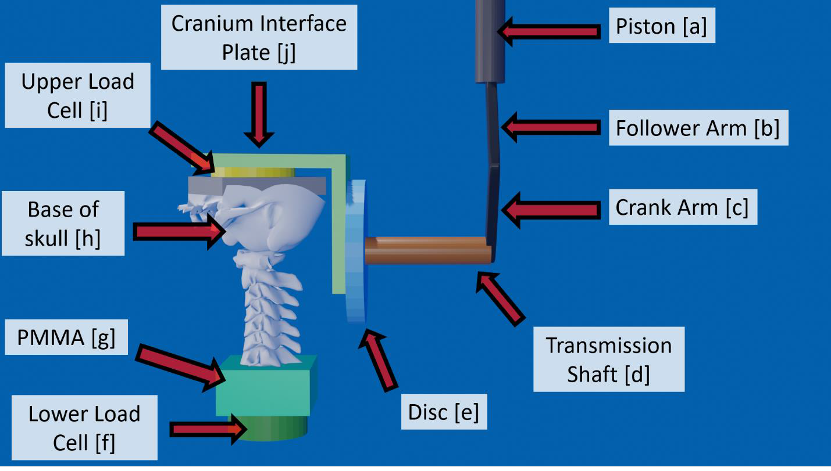
Figure 1: Schematic of isolated PMHS test setup.

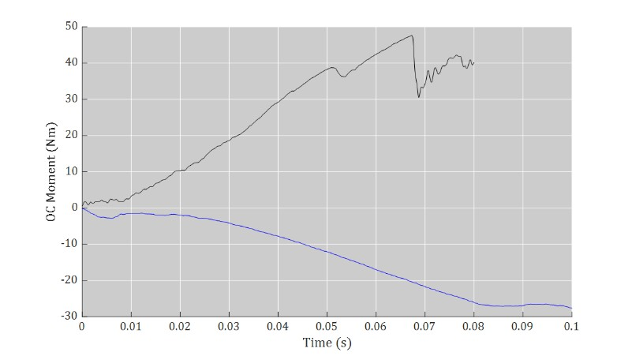
Figure 2: Occipital condyle moment for the left lateral bending (black) and right lateral (blue) bending tests.

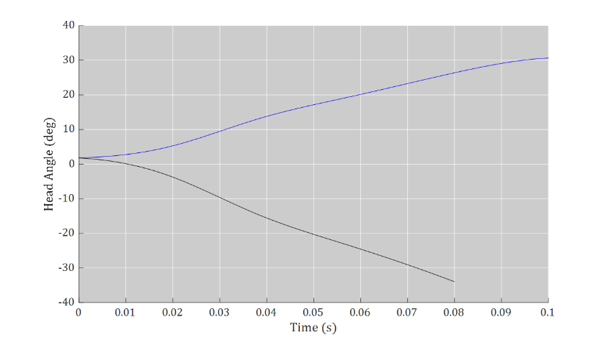

Figure 3: Head angulations for the left lateral bending (black) and right lateral (blue) bending tests.
Friday, 10/22/21, 11:45 AM - 11:55 AM EST
Subcutaneous Adipose Tissue Thickness Around the ASIS Area for Human Body Models in Reclined Positions
Author: Sylvia Schick, sylvia.schick@med.uni-muenchen.de
Co-Authors: Julia Muehlbauer, julia.muehlbauer@med.uni-muenchen.de, Anja Wagner, anja.wagner@med.uni-muenchen.de, Florian Fischer, florian.fischer@med.uni-muenchen.de, Miriam Puschnig, miriam.puschnig@med.uni-muenchen.de, Nikolas Pfeiffer, nikolas.pfeiffer@outlook.com, Steffen Peldschus, steffen.peldschus@med.uni-muenchen.de

ABSTRACT
Objective: Subcutaneous adipose tissue (SAT) thickness above the anterior superior iliac spine (ASIS) influences belt fit of a vehicle occupant. For the improvement of Finite Element (FE) Human body models (HBMs) and their application assessing future seating positions in cars, a need for more detailed data is given.
Methods: Anthropometric input data are used to statistically model a lower limit of the SAT thickness in the area around the ASIS (at the ASIS or in the groin) extracted from 102 postmortem Computed Tomography (pmCT) datasets (56 males and 46 females). Additionally, two pmCT scans of one male individual in both supine and sitting condition are used for estimating change in SAT thickness by position.
Results: Distributions and locations of minimum values for SAT thickness were derived for males and females. Sex, age, and Body Mass Index (BMI) remained in a linear regression model for the minimum SAT thickness in the ASIS area. 37 % of the variance in the SAT distribution of the sample can be explained by these input variables. The individual with data in supine and sitting position showed SAT thickness value above the ASIS six times higher in sitting than supine position.
Conclusions: Individual factors influence SAT thickness around the ASIS in addition to BMI, sex, and age. The presented values need to be regarded as a lower limit of SAT thickness, as in 63% the minimum was found in the groin area and the measurements were performed in supine position. The increase of SAT thickness in a sitting position compared to supine seen in the case example shows the need for further data acquisition to establish a transfer function interpolating between both positions. The SAT thickness minimum values in the ASIS area shown in this study can be a valuable input for soft tissue modelling in HBMs with the aim to analyze seatbelt fit and to assess computationally lap belt and occupant interaction sensitivity to SAT tissue thickness under load. This might be crucial in reclined sitting positions in automated driving.

INTRODUCTION
Soft tissue structure and distribution at the anterior iliac bone - especially around the ASIS (anterior superior iliac spine) - is expected to play a crucial role in the interaction between seatbelt and occupant (Hartka et al. 2018). As this interaction may also be important considering alternative seating positions in automated driving, it is important to evaluate the thickness and distribution of subcutaneous adipose tissue (SAT) within the driving population. The aim is to assess the pelvic region of FE models where lap belt interaction could depend on the amount of soft tissue coverage to offer new data for FE model enhancement. Anthropometric and sociodemographic characteristics might influence SAT thickness; therefore, a predictive statistical model is developed. As the SAT thickness is believed to be thinner in supine position compared to sitting, in addition a single case with available soft tissue thickness in supine and sitting position is presented in this work.

METHODS
Material
A subset of 114 individuals of both sexes was selected out of the in-house postmortem CT (pmCT) database. Selection criteria were high scan quality (0.625mm spatial resolution or higher) without image artefacts, no pelvic injuries or other medical conditions that affect pelvis geometry, a wide variation of age (18 – 92 years, Median 50y), body height (150 – 192 cm, Median 168.5cm) and weight (50 – 136 kg, Median 71.5kg), and no signs of decay. PmCT scans were performed on the same or next day after death or find date in 70%, in 8% a maximum of 4 days was documented. Table 1 documents BMI data for age groups by sex.
In order to standardize the view of the objects and allow interactive alignment, every dataset was resliced according to pre-defined planes. The pelvic bone and the SAT in the pelvic area, roughly a square area from pubic symphysis to navel and between both iliac wings, were 3D reconstructed from the pmCT scans using commercial image processing software (Mimics and 3-matic, Materialise). Automated minimum wall thickness analysis of SAT was performed using the same software package, providing the shortest distance in mm between inner and outer layer for right and left body side, respectively. The localization of the minimum was documented manually on the right side and attributed to areas “ASIS”, “groin” or “belly”. Figure 1 shows the result of the wall-thickness analysis of SAT of one individual that displays SAT minimum values in the ASIS region. Only the minimum values on the right side are then used for further steps.
Data preparation and case selection
Plausibility checks are performed by identifying obstructions of the measurement site (clothes, hands), positioning influence (pelvis tilted to left or right side and legs flexed or ad-/abducted), not detected areas (holes in CT reconstruction of SAT), other artefacts and an unexpected minimum value found in the belly area. 102 cases with minimum SAT thickness in the ASIS region (n=38) and in the groin (n=64) remain.
Statistical analysis
IBM ® SPSS © Version 25 is used for data analysis. First, SAT minimum values each are plotted against possible influencing variables (scatterplot for continuous (age, BMI, body size, body weight), and boxplots for categorical variables (sex, age group, BMI weight class)) to identify the type of relation between variables. The same is done with transformations for minimum SAT thickness (squareroot, log), however, no improvements in potential correlations are gained and both are not pictured here. Spearman correlation coefficients are calculated and non-parametric tests (Mann Whitney U-test) for independent samples are performed to check for bivariate associations. Further, multicollinearity is checked for the anthropometric parameters. From the data preparation and bivariate analysis, it is decided to model a linear regression with backward selection and input variables sex, BMI and age.
Single Case Analysis
In addition, the SAT thickness above the ASIS was obtained from two pmCT scans depicting the same individual, in both supine and upright sitting. The subject was close to the 50th percentile male, 67 years old, 1.80 m tall and weighed 78 kg (BMI=24). It was not part of the pmCT cohort initially described. Seat angle was close to 0° and back rest angle was close to 10°. Scan resolution was 10⁻⁶ m (flat panel detector) and reconstruction was performed with a resolution of 0.625 mm. SAT thickness above the ASIS (shortest distance ASIS to inner boundary of skin, mean of right and left body side) was measured manually for both body positions and is compared descriptively.

RESULTS
The median value of the minimum SAT thickness is 3.1 mm for 56 males (range 1.0 mm to 13.2 mm) and 4.4 mm for 46 females (range 1.0 mm to 12.1 mm), with significant different distributions (p=0.014), see Figure 2.
The spearman rank correlation coefficients show moderate but significant correlations for minimum SAT thickness with BMI (0.513, p=0.000) and weak association with age (0.375, p=0.000). Body size (- 0.281, p=0.004) and body weight (0.265, p=0.007) correlate significantly with minimum SAT thickness, however, not as well as BMI. Due to correlations between BMI and weight (0.830, p=0.000) and age and size (-0.352, p=0.000), size and weight are not further regarded.
By linear regression with backward elimination, all variables remain in the model. The coefficients result in the following Eq. (1) for minimum SAT thickness value calculation (minimumSATpred) (in mm).

minimumSATpred = -6.600 + 0.285 * BMI + 0.029 * age + 1.415 * sex (1)

with age in years, BMI in kg/m² and sex (male=1, female=2). The coefficient of determination giving the share of explained variance by the model is R²= 0.392, (R²_{adjusted} = 0.374).
Supine to upright sitting transfer data resulted in a SAT thickness of 1.96 mm when lying supine and 11.94 mm when seated upright. Thus, a transfer factor of roughly six can be assumed for SAT thickness increase above the ASIS when shifting from supine to sitting upright for this subject. Regarding the supine SAT thickness, the subject lies within the second quartile of the male pmCT sample distribution (see Figure 2).

DISCUSSION
By statistically modelling the minimum SAT thickness in the area around the ASIS based on BMI, age, and sex nearly 40% of the variance of SAT distribution in the sample can be explained. Other studies showed age and BMI to correlate with belt fit (Reed et al. 2013, Reed et al. 2012). Even if age remained in the model, this might be just valid for this data sample, as other studies never found age to have an effect on SAT thickness in general (Kuk et al, 2009), or in the groin area (Hanson-Viana et al. 2021). Further individual factors and statistical approaches as well as higher case numbers might be necessary to better predict SAT thickness. For the improvement of Human Body Models regarding soft tissue around the ASIS it needs to be remembered, that next to the SAT at least skin will be an additional layer. The muscles and ligaments originating from the ASIS add to the soft tissue in the area around the ASIS. Even if at the ASIS there is no muscle tissue, that doesn’t mean that the SAT has its minimum value exactly at the ASIS. In our supine pmCT population, only 37% show the minimum SAT values at the ASIS. The presented values can be interpreted as a lower limit in the range of SAT distribution on the ASIS, as in 63% of the sample the SAT thickness at the ASIS was higher than the minimum found in this study.
Scanning postmortem, some limitations have to be taken into account. First, the amount of tissue thickness change for the regarded SAT around the ASIS during the postmortal phase is unknown. Thus, minor differences to a living occupant cannot be ruled out entirely. Second, scanning supine, the body position may at times not be aligned manually to being symmetrical, leading to a skew position in some scans. Data sets were excluded from further analyses if body posture was suspected to influence SAT thickness considerably. Third, body posture of the single subject scanned in upright position is not identical to a driving body posture but globally slightly rotated forward and locally less upright. Thus, there may be deviations of the reported SAT thickness in the upright posture to those of a standard driving posture.
The transfer factor obtained from two pmCT scans of the same individual may be used to approximate SAT thickness of the supine pmCT database in an upright posture and in reclined positions between those two. The authors want to stress that this data should be interpreted and used carefully, as it depicts only one male individual at two-time instances after death. The transfer factor may vary to yet unknown extent between people of different BMI, age, or sex.
To the authors’ best knowledge, this is the first presentation of subcutaneous adipose tissue thickness around the ASIS for modeling between supine and upright sitting. More transfer data is needed to understand soft tissue distribution under different gravity load vectors.

ACKNOWLEDGEMENTS
Of the presented work, supine pmCT data processing and the use for statistical modeling was funded by the EU Horizon 2020 research and innovation program under grant agreement No. 768947 “OSCCAR”. This document reflects only the authors’ view, the Innovation and Networks Executive Agency (INEA) is not responsible for any use that may be made of the information it contains.

REFERENCES
Hartka TR, Carr HM, Smith BR, Melmer M, Sochor MR. Does obesity affect the position of seat belt loading in occupants involved in real-world motor vehicle collisions?. Traffic Inj Prev. 2018 Feb 28;19(sup1):70-75.
Reed MP, Ebert-Hamilton SM, Rupp JD. Effects of obesity on seat belt fit. Traffic Inj Prev. 2012;13(4):364-72.
Reed MP, Ebert SM, Hallman JJ. Effects of driver characteristics on seat belt fit. Stapp Car Crash J. 2013 Nov;57:43-57.
Kuk JL, Saunders TJ, Davidson LE, Ross R, Age-related changes in total and regional fat distribution. Ageing Research Reviews 2009;8:339–348
Hanson-Viana E, Rojas-Ortiz J, Rendón-Medina MA, Pacheco-López RC, Ríos-Lara López LR, Palacios-Juárez J, Influence of BMI, Age, and Gender on the Thickness of Most Common Thinned Flaps. Plast Reconstr Surg Glob Open 2021;9:e3409

TABLES AND FIGURES
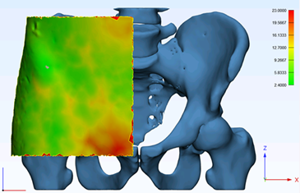
Figure 1: Skeleton (blue) and 3D reconstructed subcutaneous adipose tissue (green, yellow, red for increasing thickness) around the ASIS on right side of pmCT data

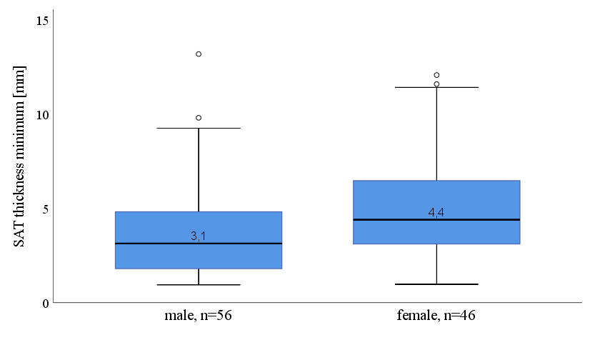
Figure 2: SAT minimum thickness distributions (mm) around the ASIS for males (n=56) and females (n=46)

Table 1: Range and Median of BMI values in age groups by sex in pmCT sample
Age group n Minimum BMI Median BMI Maximum BMI
male <40 years 23 18.5 22.6 41.2
40 to <60 years 19 19.9 27.9 47.6
60+ years 14 19.2 23.7 42.7
female <40 years 12 19.8 22.6 30.9
40 to <60 years 14 21.4 26.5 34.8
60+ years 20 18.5 23.7 31.3

