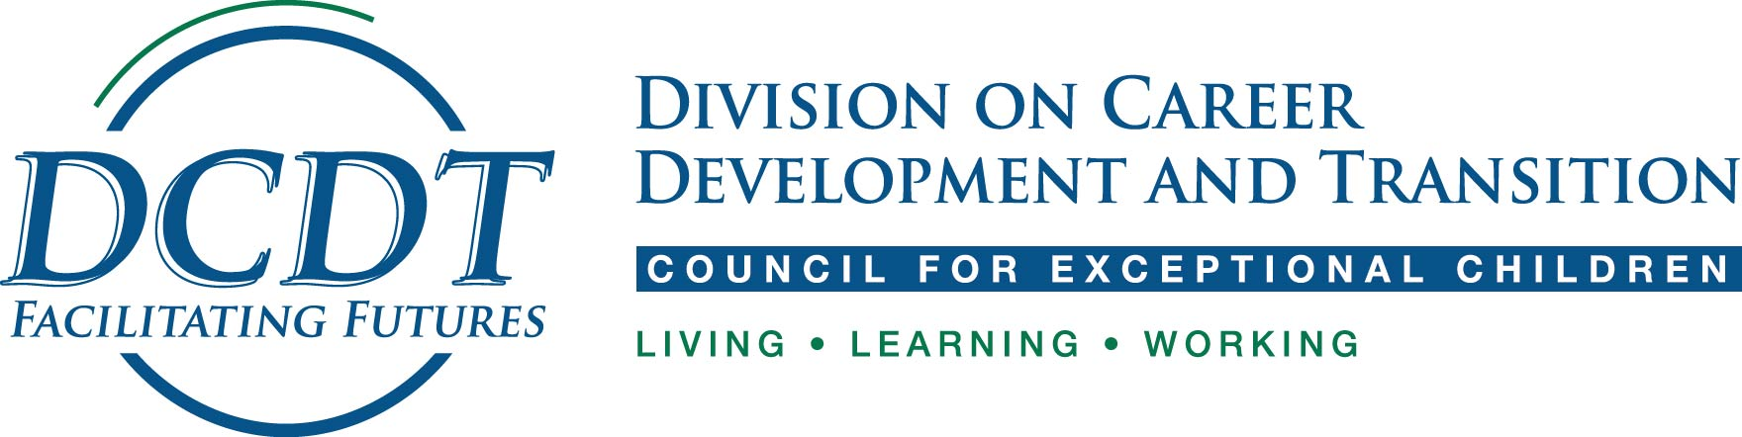
State Chapter Mini-Grant

This DCDT request for proposals is to support active DCDT state chapters in developing innovative ways to put research into practice and elicit new DCDT members. Examples of projects may be professional development modules, training tools, or materials that build the capacity of educators to put research into practice. To be considered for the mini-grant, your state chapter must be an active DCDT state chapter. DCDT will fund up to five mini-grants for a total of $15,000 through this competitive grant competition. Therefore, each active chapter may submit a proposal that does not exceed $3,000. The call for proposals will be disseminated through our DCDT e-Blast on July 12. The deadline for submitting proposals is August 31. Notification for five funded proposals will be September 30. To apply for the mini-grant, state chapters should complete the proposal form below and return it to your DCDT Regional Representative.
If you have specific questions about your proposed ideas or activity, please contact your regional DCDT Regional Representative.
If you are not sure whether your state has a chapter, or are interested in starting a state chapter, please contact your DCDT Regional Representative (emails below and found at http://community.cec.sped.org/dcdt/subdividions/dcdt-state-subdivisions).
Northwest (Alaska, Idaho, Iowa, Kansas, Minnesota, Missouri, Montana, Nebraska, North Dakota, Oregon, South Dakota, Washington, Wyoming): Dawn Rowe, drowe3@uoregon.edu
Southwest (Arizona, Arkansas, California, Colorado, Hawaii, Louisiana, Nevada, New Mexico, Oklahoma, Texas, Utah, Guam, Mexico): Kendra Williams-Diehm, klwd@ou.edu
Southeast (Alabama, Delaware, District of Columbia, Florida, Georgia, Kentucky, Maryland, Mississippi, North Carolina, South Carolina, Tennessee, Virginia, West Virginia, Puerto Rico): Joy Ivester, Joy.Ivester@uscmed.sc.edu
Northeast (Connecticut, Illinois, Indiana, Maine, Massachusetts, Michigan, New Hampshire, New York, Ohio, Pennsylvania, Rhode Island, Vermont, Wisconsin): Clare Papay, clarepapay@gmail.com

State Chapter:

Name(s) and Title with State Chapter (e.g., President, Vice President):

Date:

Mini-Grant Proposal Title:

What is the purpose of this mini grant request, including how you are currently addressing research to practice in secondary transition?
Proposed timeline for project:
Project Activities | Timeline
 | Sum | Fall | Win | Spr

Requested budget: Please include a brief budget justification (2-3 sentences) in addition to a line item budget (budget should be itemized and not exceed a total of $3000.00):

Line item | $ Requested
Personnel
Materials
Travel
Indirect/overhead
Other (please specify):
Total

Budget Justification:

List of transition evidenced-based, research-based, or promising practices that will be addressed through this proposal if funded (see http://transitionta.org/effectivepractices):

Identify the intended outcomes of your project, how success will be measured, and how this project will benefit practitioners:

Follow-up Report Submitted by September 30, 2018: Awardees should submit a short summary of project and examples of materials produced through this mini-grant, such as training materials, pictures or video’s that capture related to grant activities.

This state chapter (indicate state chapter ) agrees to submit a follow-up report of project activities completed no later than September 30, 2018.

Process for Submitting:
Save this document under a new file name and then e-mail this request to your Regional Representative (listed below) for review and processing. If you have questions about your ideas or activity, please contact your regional DCDT representative.
Northwest: Dawn Rowe, drowe3@uoregon.edu
Southwest: Kendra Williams-Diehm, klwd@ou.edu
Southeast: Joy Ivester, Joy.Ivester@uscmed.sc.edu
Northeast: Clare Papay, clarepapay@gmail.com
- After your Regional Representative reviews this request, she/he may seek clarification. You may be asked to update this request. After everything on the request is agreed upon, it will then be sent to the DCDT Executive Board for review.
- After final review, you will be contacted about the status of your mini grant proposal

- Should your mini grant be accepted, you will be asked to submit a follow up report by September 30, 2018. Awaredees should submit a short summary of project and examples of materials produced through this mini-grant, such as training materials, pictures or video’s that capture related to grant activities to your Regional Representative. This short write-up of the project will be included in the DCDT Newsletter and e-Blast to highlight the work supported through the mini-grant from DCDT. We also encourage you to submit the project and outcomes of your project as a poster at our annual DCDT International conference. We also encourage you to submit a manuscript reflecting your project to the Transition in Practice section of Career Development and Transition for Exceptional Individuals (CDTEI; if interested contact Valerie Mazzotti, Associate Editor for Transition in Practice section of CDTEI) initial
- Date of Follow Up Report: September 30, 2018 initial

- As a part of this mini grant, we ask that any advertisement specifically acknowledges the financial support of DCDT. We can supply the DCDT logos if you need them. initial

Date:

Approved by Regional Representative: Date:

Approval by Membership Committee: Date:

Approval by DCDT Executive Board: Date:

Date funds were released to state chapter:

