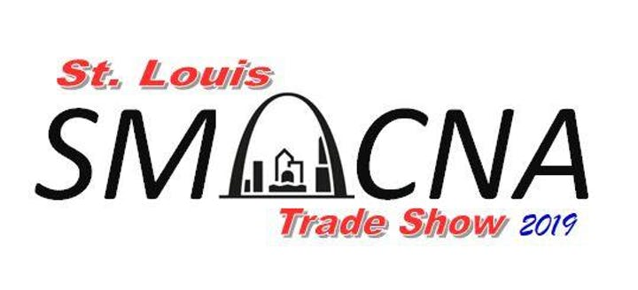
Hundreds of local, regional, and national attendees will descend on the SMACNA St. Louis Trade Show this year. A new location will allow for higher attendance and greater participation. As the largest local SMACNA trade show in the nation, you won’t want to miss this opportunity to show your products and business off!

Invited Attendees

- Sheet Metal Contractors
- Mechanical Contractors
- City Building Officials
- County Building Officials
- Region Officials
- Public Officials
- Region Engineers
- General Contractors
- Trade School Officials
10.And So Many More!

Register by July 15th and receive $50 off your registration! (Online Promocode: EarlyBird19)

New Location
Greensfelder Recreation Center
Queeny Park 550 Weidman Rd.
Ballwin, MO 63011

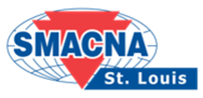
See complete registration form on the reverse side.

Application For Booth Space – Products Trade Show 2019

Please enter my reservation for SMACNA’s 2019 Products Trade Show:

Date: Wednesday, September 4, 2019
Place: Queeny Park: 550 Weidman Rd. Ballwin, MO 63011
Time: 1:30 p.m. – 8:00 p.m.

Cost: $900 for the first booth (includes two attendants) *
$700 each for additional booths from the same firm
(All booths include food & open bar admission for each attendant)
- $50 for each additional 8’ table
- $50 for each additional booth attendant up to 3 per booth
- Application deadline is August 15, 2019

* Booths will have a company name plate, one 8’ skirted table and, if requested, two side chairs and/or a standard 110 voltage electrical outlet. Extra tables and chairs are available at an additional charge.

Single booth fees include the cost of two attendants; additional booths include three attendants per booth. For additional attendants, the cost is $50 per person with a maximum of three per booth (1 booth – 3 additional; 2 – 6, etc.) except for early bird registrants (see details above).

All booth spaces will be allocated as they are received. Please return the completed application along with a check for the appropriate amount made payable to:

SMACNA – St. Louis
10405 Liberty Avenue
St. Louis, MO 63132
------------------------------------------------------------------------------------------------------------------------
Enclosed please find a check in the amount of $_______________________ securing ___________ booths ($900 1st booth; $700 each additional booth from the same firm).

PLEASE PRINT THE FOLLOWING INFORMATION:
# of Booths:______ # of Attendees: ______ (2 per booth- $50 each additional)
(Mark one)Invoice: ______ Credit Card (We will contact you for processing) ____
Name:
Company
City, State, Zip:
Phone: |  |  |  |  | Fax: |  | E-mail:
Signature:

