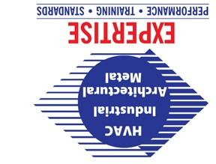

You are cordially invited to attend the
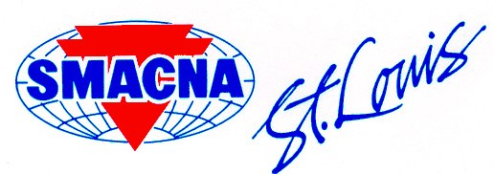
Products
Trade Show & Industry Seminar September 4, 2019

PRODUCTS TRADE SHOW GENERAL INFORMATION: September 4, 2019

Queeny Park

550 Weidman Rd. Ballwin, MO 63011

Seminar: 2:30 – 4:00 p.m.
Product Viewing 1:30 - 7:00 p.m.
Drinks & Hors d’oeuvres: 4:00 - 7:00 p.m.

As a special guest of SMACNA-St. Louis and our product exhibitors, you will be able to view existing and new product lines available to architects, engineers, sheet metal and HVAC contractors.
SEMINAR INFORMATION FOR ARCHITECTS & MECHANICAL ENGINEERS:
SMACNA’s Executive Director of Technical Services, Eli Howard will present two seminars.
- 2019 SMACNA Fire, Smoke Damper Manual
- 2019 SMACNA Kitchen Grease Duct Fabrication Tables
Attendees will earn State of Missouri Professional Development Hours.
Mini-Seminars will be provided by exhibitors. Please contact SMACNA St. Louis for more information.
Reserve your space now by filling out the registration form below and returning
or at our website smacnastlouis.org.

REGISTRATION FORM: | Please return this card by August 15th, 2019 to:
Company_________________________________________ | SMACNA-St. Louis
Address__________________________________________ | 10405 Liberty
City___________________ State_____ Zip_____________ | St. Louis, MO 63132
Phone#__________________ Fax#___________________ | FAX: (314) 427-8330
E-mail___________________________________________
Please fill out the following information for each person attending from your firm (if necessary, please make additional copies).
Name: ____________________________________________ Attending: ____ Seminar & Trade Show
____Trade Show only
SEMINAR ATTENDEES:

If applicable, please provide your state license number.
PDH Certificate State License #_____________________________________________

