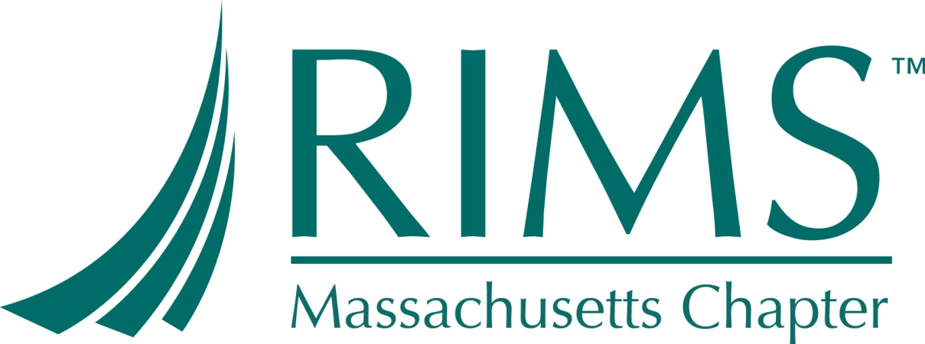

48th Fall Educational Conference
“#Property #CAT Losses# Resiliencies”
Friday, September 28th, 2018
9:00AM-6:00PM
Vertex Pharmaceuticals, Inc.
50 Northern Avenue
Boston, MA 02210

Contact
Please e-mail Anja Rittling at arittling@oceanspray.com

TOPICS & TIMELINE
Time | Min | Topic | Speakers
9:00 – 10:00AM | 60 min | BREAKFAST AND REGISTRATION | -----------------------------
10:00 – 11:10AM | 70 min | Climate Change and Extreme Events | Ellen Marie Douglas, PE, PhD Professor, Hydrology School for the Environment University of Massachusetts, Boston
11:10 – 11:20AM | 10 min | BREAK | -----------------------------
11:20 – 12:20AM | 60 min | Take Control of Your Resiliency in the Face of Changing Natural Hazards | Katherine D. Klosowski, P.E., VP Special Projects, FM Global
12:20 – 1:30PM | 70 min | LUNCH | -----------------------------
1:30 – 2:30PM | 60 min | FACS involvement Pre- Loss and Post-Loss / BI Development & BI Claims Support | Kerri Owens (, SVP, Marsh Risk Consulting’s Forensic Accounting and Claims Services); Dennis Manning (SVP, Marsh Property Claims Advocate); John Petito (VP, WR Grace Manufacturing and Capital Management)
2:30 – 3:40PM | 70 min | Quantifying Cyber Risk to Take Strategic Actions | Tracy Martin, President at PivotPoint Risk Analytics; Brando Soto, RM at Vertex;
3:40 –3:50PM | 10 min | BREAK | -----------------------------
3:50 – 5:00PM | 70 min | Insurability and Resilience Finance, Opportunities at the Intersection of Science, Capital & Law | SAMANTHA A. MEDLOCK, J.D., CFM, Senior Vice President, Head of North America Capital, Science & Policy, Willis Towers Watson
5:00PM – 6:00PM | 60 min | RECEPTION AND NETWORKING optional | ---------------------------

