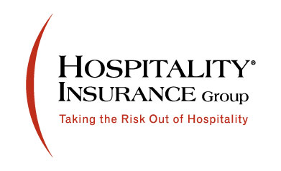

Job Description
Commercial Lines Underwriter
Hospitality Insurance company located in Southborough, MA is seeking an experienced property and casualty commercial lines underwriter to join the team. You will be a great fit for this job if you are an experienced underwriter and have experience doing business in Pennsylvania. This position can be remote.
This position is responsible for the Commercial Lines underwriting activities, agency relationship management, product pricing, and applying sound underwriting judgment within assigned territory in line with corporate market direction, profit and production objectives.
Commercial Lines Underwriter Responsibilities
- Analyzes commercial lines accounts to make decisions based on individual risk characteristics, exposure analysis, hazard recognition and control.
- Prices business according to Company underwriting and pricing guidelines.
- Providing top notch customer service and maintain positive relationships agents.
- Trains and educates agency staff on Company products, services, processes, and underwriting philosophy.
- Promotes the Company's products and services
Job Requirements
- 3 to 5 years commercial lines underwriting experience within the commercial insurance industry.
- Experience in the hospitality industry, restaurants and bars preferred.
- Liquor liability experience preferred
- Ability to manage agency relationships and production.
- Ability to gather, report and act on appropriate market information.
- Strong oral and written communication skills.
- Strong organizational skills
- Proficient with Microsoft Office applications specifically Word, Excel and Outlook
- College degree required
Submit resumes - Shaley@hmic.com

