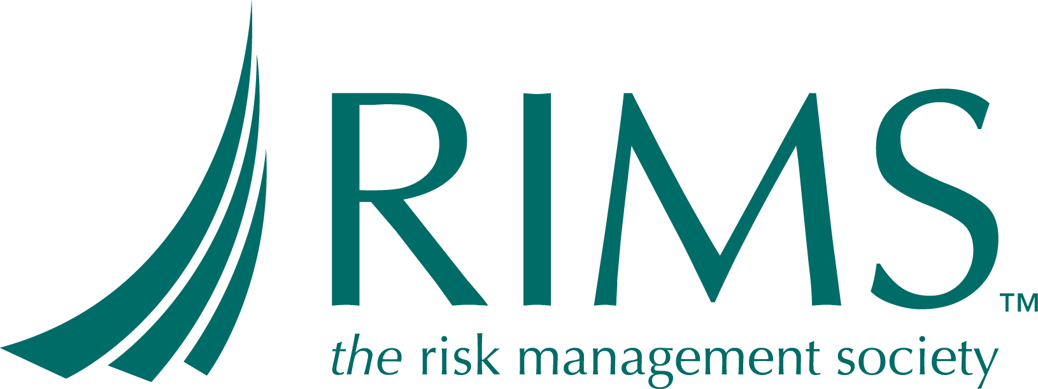
MARIMS REGISTRATION FORM

Manitoba Chapter of the Risk and Insurance Management Society (RIMS)

Enterprise-Wide Risk Management:

Developing and Implementing

MONDAY THRU WEDNESDAY, MARCH 12-14, 2012 8:00 AM – 4:30 PM

RICHARDSON CONFERENCE CENTRE

ONE LOMBARD PLACE, WINNIPEG

NAME ____________________________________________

ADDRESS_________________________________________

COMPANY ________________________________________

TELEPHONE__________________ E MAIL __________________________

REGISTRATION FEE:

$ 600 RIMS MEMBER _____ $800 MARIMS MEMBERS ______
(includes continental breakfast, lunch & coffee)

(Join MARIMS for $50 .. or $100 for company)

SEND REGISTRATION TO: Annette.ethier@gov.mb.ca Phone 945-1917

Please make cheque payable to MaRIMS and send to:

MARIMS
c/o Insurance and Risk Management Branch
Manitoba Finance
908 – 401 York Ave
Winnipeg, MB, R3C 0P8

** Register early as seating will be limited **

Note: Obtaining the textbook is the responsibility of the Registrant.
Link is: http://www.rims.org/resources/RIMStore/Pages/AssociateinRiskManagement-RM.aspx
Only the textbook is required. Order soon to ensure you have it for the course.

