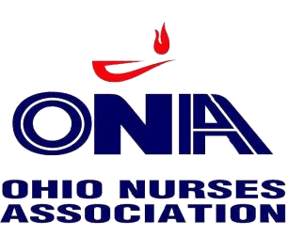
CALL FOR NOMINATIONS

The Ohio State University Nurses Organization (OSUNO) is inviting you to submit your name as a candidate for one of the following leadership positions, which are currently vacant, for your local bargaining unit. The terms of office for both Secretary and Board of Directors positions are for one (1) year beginning with appointment and ending December 31, 2018. Applications with a short nursing biography must be submitted to Jessie Frymyer, OSUNO President, no later than 5:00 p.m. on January 17, 2018. You can contact Jessie by e-mail, jessieosu@hotmail.com. Appointments will be made by the Board of Directors according to provisions in the OSUNO Bylaws via conference call on January 18, 2018.

Open 2018 Officer Positions Open 2018 Board of Director Positions
Secretary | ED/CDU (formerly held by Rick Lucas- now 1st VP)  Off-Site/Clinics (formerly held by Paula Anderson- now retired)

I would like to be considered a candidate for the following position:
____________________________
I am willing to accept appointment to any open Board of Director position
YES ________ NO____________

(All of the following information is required)
Name: ____________________________________________________
Address: __________________________________________________
__________________________________________________
Home Phone: __________________ Cell Phone:_________________
Home E -mail: ______________________________________
Unit where I work: __________________________________
# of years in the bargaining unit: ____________

Signature ________________________________ Date_____________________

