Sigma Theta Tau International

Gamma Xi Gazette
October 16, 2017

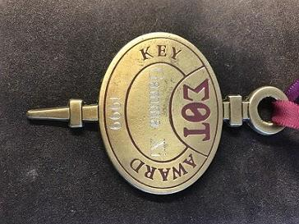
Gamma Xi Receives International Awards
The Chapter Key Award, established in 1991, honors STTI chapters that excel in chapter-related activities. This award is presented each biennium at STTI’s Biennium Convention. Nicole Ward will accept the award on behalf of the chapter at the convention in Indianapolis on October 30th. Gamma Xi last received this honor in 1999.
In addition to the 2017 Chapter Key award, the Gamma Xi chapter is being recognized for excellence in activities for the Presidential Call to Action in Philanthropy, Advocacy, and Policy.
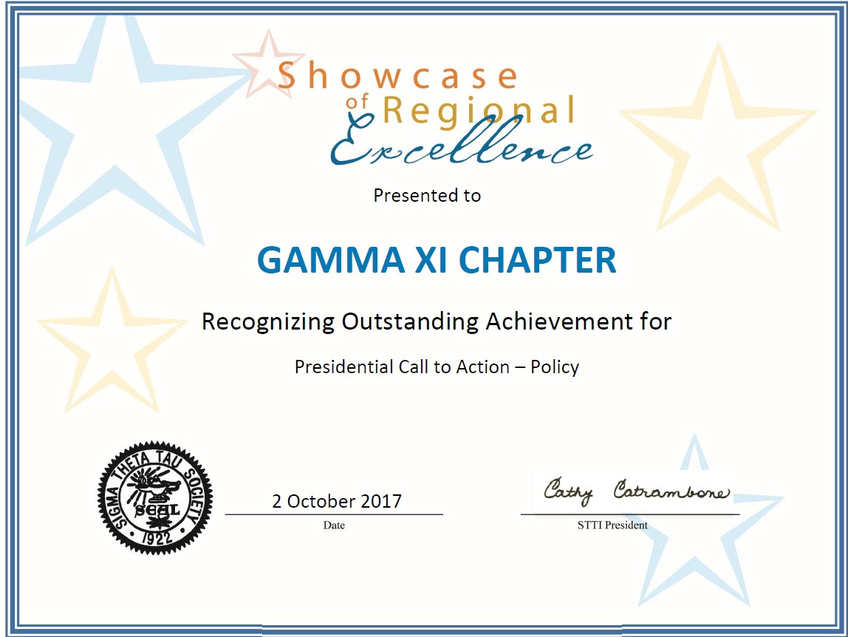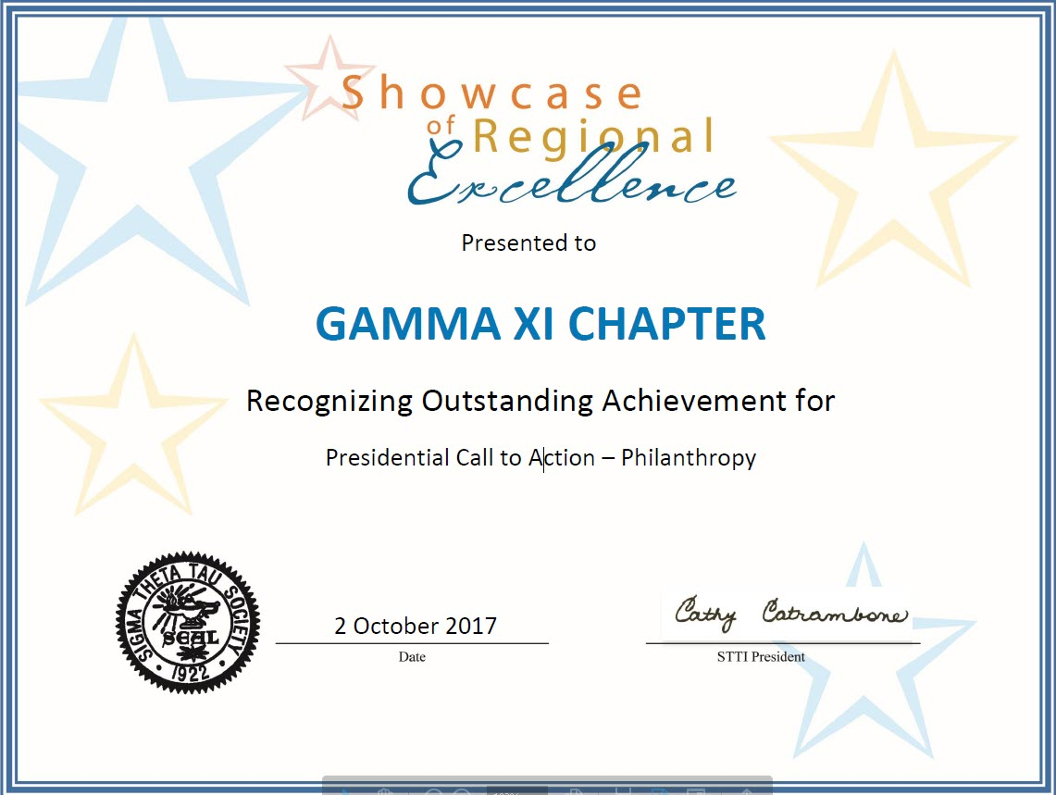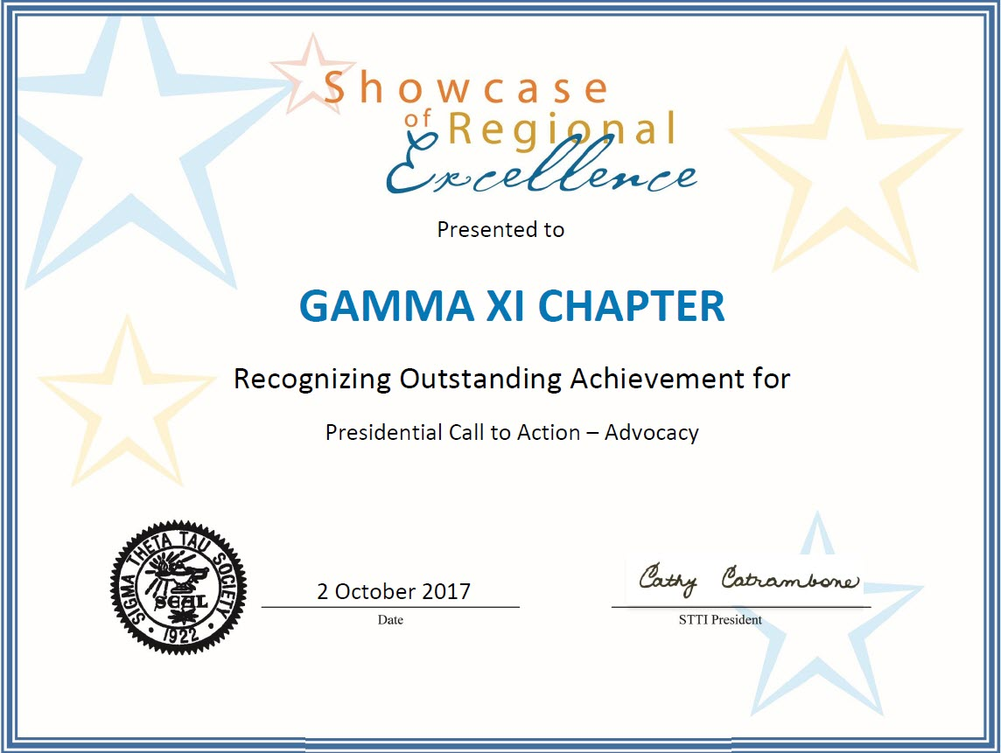

Welcome UAPB to the Gamma Xi Chapter
The Gamma Xi chapter would like to welcome our newest partner school – the University of Arkansas at Pine Bluff. Five UAPB students were inducted into the chapter at the October 8th ceremony. We are excited to welcome them.
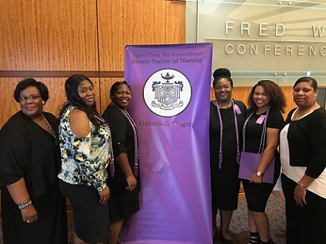

Read more on our website

Induction Ceremony

The Gamma Xi annual induction ceremony was held on Sunday, October 8th. This year 139 students and 2 nurse leaders were inducted into the chapter. Congratulations to all of our new inductees! We would also like to congratulate the seven students who were awarded scholarships from the Dr. Cheryl Schmidt STTI Gamma Xi membership scholarship fund.

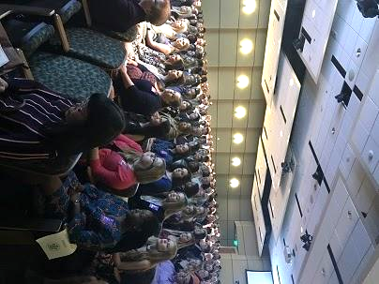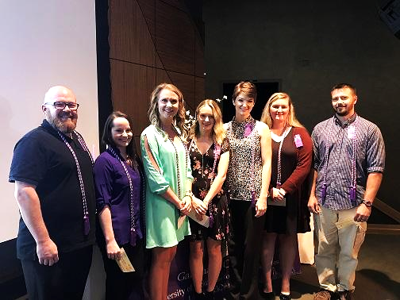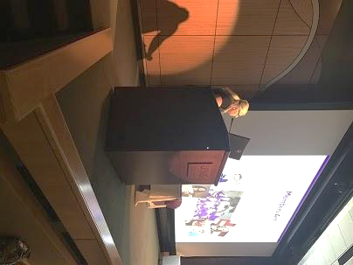

Ireland International Conference
Several Gamma Xi chapter members attended and presented at the 28th annual STTI International Research Congress in July. The conference was held in Dublin, Ireland. The chapter sponsored registration fees for Dr. Kelly Betts, chapter Vice-President, and UAMS College of Nursing student and chapter member, Christi Turnage.
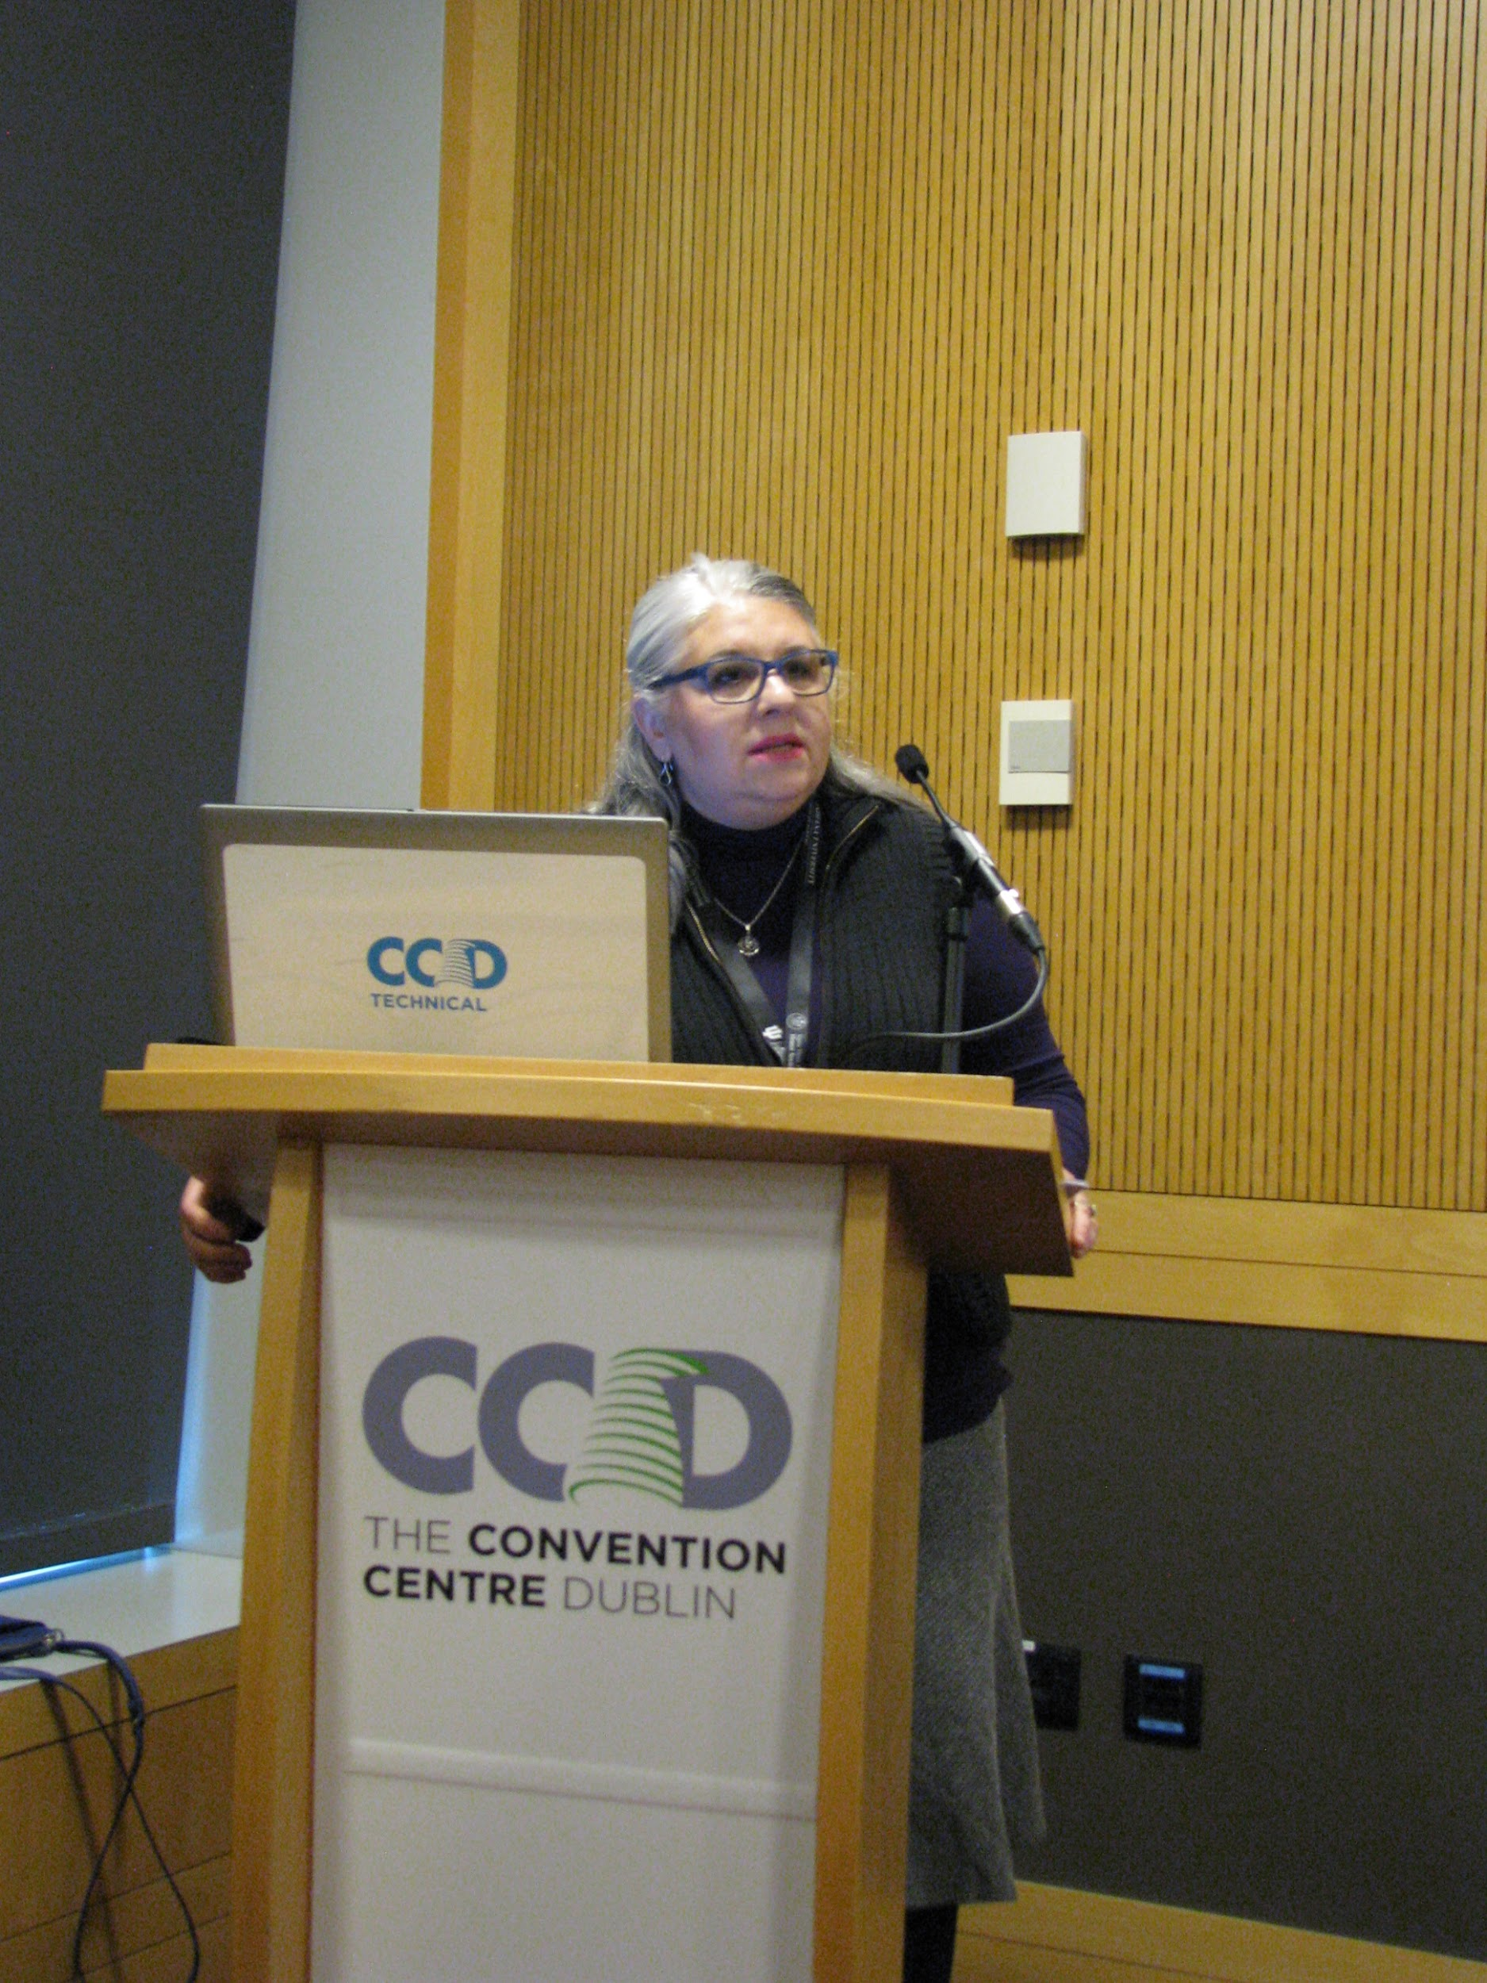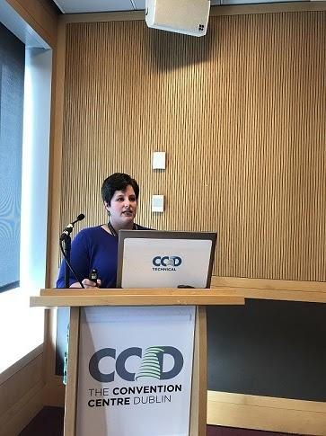

December Meeting
Save the date for our fall meeting. It will be held Friday December 1st from 12-1 pm at UAMS. We will have a speaker presenting about how nurses can recognize and respond to human trafficking. Food and CE will be provided. More details will be sent out in November.

Interested in getting involved? Consider being a committee member.
We are looking for members to join the Service, Fundraising, and Membership committees
Service – This committee focuses on community outreach and plans 2-3 projects per year. Contact Laura Mayfield – LHMayfield@uams.edu or Erin Bush EBush@uams.edu for more information.
Fundraising – This committee will coordinate merchandise sales at chapter events and plan at least 1 additional fundraiser per year. Contact Kimberly Stickley KStickley@uams.edu for more information
Membership – This committee helps involve members, promote chapter activities and recruit members at their schools or work sites. Contact Tamisha Henderson THenderson@uams.edu for more information.
Follow us on Facebook!

Interested in Gamma Xi Merchandise?
An online ordering platform will be released soon! T-shirts, lanyards, cozies, and cups are available.

President | Nicole Ward
Vice-President | Kelly Betts
Treasurer | Seonkgum Heo
Secretary | Traci Motes
Governance Chair | Joan Tackett
Publicity Chair | Jennifer Gernat
Service Co-Chairs | Laura Mayfield, Erin Bush
Fundraising Chair | Kimberly Stickley
Membership Chair | Tamisha Henderson
Awards Chair | Jay White
Research Chair | Patricia Wright
Leadership Succession Chair | Keneshia Bryant
Leadership Succession Members | Leah Richardson, Tammy Webb
Counseling Chair | Sherri Ward
UAMS Counselors | Sherri Ward, Joan Tackett, Judy LaBonte
UALR Counselor | Elizabeth Riley
HSU Counselor | Barbara Landrum
SAU Counselor | Janet Deeds
UAM Counselor | Heidi Hogue
UAPB Counselor | Shawna Hughey, Carolyn Hood
2017-2018 Gamma Xi Board of Directors

