“Nursing in the Digital Age: Implications for Education, Service, Administration & Research”
Saturday, November 10, 2018 at the Del Mar Hilton
HILTON SAN DIEGO/DEL MAR
15575 Jimmy Durante Blvd
Del Mar, CA 92014
8:30am – 3:30pm
Join us we explore emerging technologies and linkages to clinical applications, education, administration, and research. Network with clinical practitioners, students, faculty, researchers, and administrators.
Double Platinum Sponsor: University of Phoenix
Silver Sponsor: Nurse.com
Registration: Register online at http://www.omicrondelta.net/conference-registration.html
Conference Fee (Includes AM refreshments, lunch, conference materials and CE certificate)
$125 General Admission
$100 Attended Odyssey
$75 Omicron Delta Member
$50 Student or Retired
Continuing education provided by Omicron Delta. Provider approved by the CA BRN (Provider # 16709) for 6 contact hours. Cancellation Policy: No refunds after 11/1/18.
For hotel reservations, call 858.792.5200 to book, modify, or cancel a reservation. Group Convention Promo Code is OSC. You may also book your reservation online. Below is the link to the group’s personalized web page, which you can use exclusively to make reservations. There is no code needed for this option, you just need to click on the link below to book directly with the block of rooms for the event.
Hilton Link is: http://www.hilton.com/en/hi/groups/personalized/S/SANDMHF-OSC-20181107/index.jhtml?WT.mc_id=POG
The group rate is $189 + tax for 2 queens or a king bed. You have until OCTOBER 15, 2018 or until the block is full to make your reservations at the group rate. If the room block is sold out contact marlenesruiz@yahoo.com to investigate increasing the size of the room block. Parking fees: self-parking is $12 per night and valet parking is $20 per night.

Learning Objectives: At the end of this session, participants will be able to:
- Understand their personalized informatics environment.
- Orchestrate their own best technology practices.
- Change their perspectives on living in the digital age.
- Set intentions for their own journey with healthcare technology
8:30 – 9:00 Registration, Refreshments, Posters and Exhibits
9:00 - 9:15 Opening Remarks and Introductions
9:15 – 10:15 The Digital Age: “You Are Here” – Terri Nichols
How Information Has Brought Us to 2018
10:15 – 10:30 BREAK
10:30 – 11:30 Break Out Sessions: Informatics Today
Group A: Practicing Nurses
- How technology provides our framework for practice
- How technology supports quality of care, patient safety and evidence-based practice
- What knowledge and skills do nurses need?
Group B: Faculty/Students
  - Learning characteristics of today’s students
- What knowledge and skills should faculty possess to bridge the academic gap?
- Best practices for teaching informatics
11:30-12:00 Regroup & debrief from breakouts
Roundtable discussions to be shared with the other track
12:00-1:30 Lunch, Posters, Exhibits
1:30 – 2:30 Storytelling: Making Change Personal – Lee Ann Shearing
2:30 – 2:45 BREAK
2:45 – 3:20 Techno Think Tank
The Power of Groupthink Using Technology
3:20-3:30 Summary and Goodbyes

Featured speakers include:
Terri Nichols is the Principal of TRN Consulting, which provides strategic consulting services in information technology to healthcare organizations. She is currently engaged at the University of California, Davis Center for Health and Technology providing assistance with the development of an organizational digital health strategy and a portfolio for connecting to patients in their homes and communities. She has also contributed to the State of California, Department of State Hospitals in assessment of options for electronic health records for their five behavioral health hospitals.

Terri previously worked as the Director of IT Application Support and subsequently the Assistant Vice President for Physician Strategy at Adventist Health. Her prior role was as the Manager of Clinical Transformation at the University of California, Davis. In this capacity she led the implementation and optimization of the ambulatory electronic medical record across more than 40 clinics, 1200 providers, and 4000 staff members. Terri has 35 years experience in the healthcare industry across a variety of settings and organizations. She is a licensed Registered Nurse with a BSN from the University of Texas, El Paso, an MSN from California State University, Los Angeles, and a Masters in Healthcare Administration from the University of Southern California.

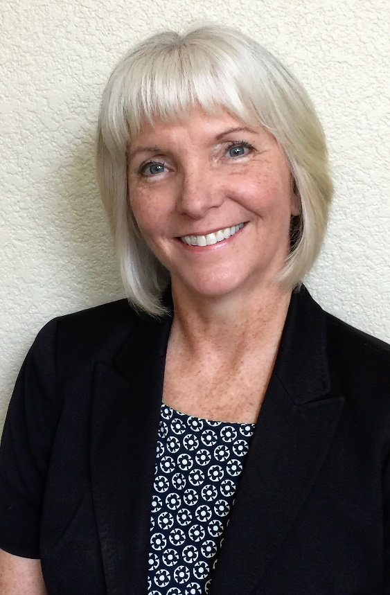 | Lee Ann Shearing is the Associate Vice President of Change Management at Adventist Health. In this role, she provides leadership to the integration of change associated with strategic initiatives, requiring directed stakeholder management, creative communications, education and change success measurements. Most recently, she led the change management team in implementing the Oracle Human Capital Management system and migrating Finance, Supply Chain and Human Resource departments to a shared service environment.  Lee Ann is the former Chief Nursing Information Officer and Assistant Vice President of Clinical Operations of Adventist Health. She has provided executive leadership in guiding system wide clinical, financial and operational software selection, implementations and optimization efforts. Lee Ann has also provided oversight for system hospital accreditation, Infection Prevention, Quality and Performance Improvement functions.  Lee Ann’s 25 year background in health care and informatics leadership includes roles as Vice President of Enterprise Hospital Systems at the University of Pittsburgh Medical Center as well as Director with First Consulting Group and Clinical Architect with Cerner corporation. Lee Ann is a licensed Registered Nurse and holds a BScN from McMaster University, a BA from the University of Western Ontario and a Masters in Public Administration from Queens University in Ontario, Canada.

