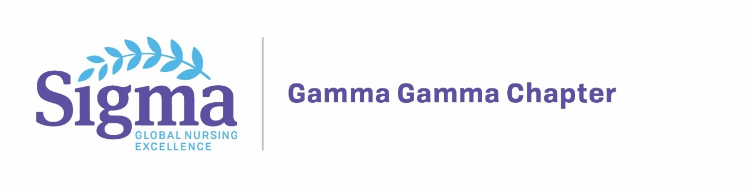
Understanding the Transgender Patient
Population and Community
Presented by Trans Family Support Services

Monday, February 11, 2019
San Diego State University
Location Pending
6:00pm – 8:00pm
*Registration begins at 5:30pm

CEU’s & Food Provided
Training Objectives:
• Build Stronger, Sensitive Work Environment
• Understand Issues Faced by Transgender Individuals
• Understand the Importance of Using Inclusive Language
• Ensure Equal Treatment for All, Free From Harassment and Discrimination
• Provide Your Team with Best Practices for Inclusive Climate
• Change Negative Behaviors, Not Values or Beliefs
• Utilize EMR to Reflect Preferred Name and Gender Identification

Registration: $10.00 students and $20.00 non-students
Register online at: Gammagamma.nursingsociety.org
or
Pre-register by sending a check payable to: “Gamma Gamma”
Mail to: Dawn Harrell
884 Alveda Avenue
El Cajon, CA 92019

