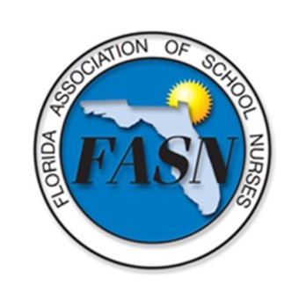 | FASN 24th Annual Conference  Scholarship Application
In a continuing effort to serve the School Nurses of Florida we are offering 5 early bird registration fee scholarships ($130 member/$140 non-member) to attend the 24th Annual FASN Conference on February 7-8, 2020.

The Conference will be held at The Florida Hotel, Orlando where special accommodation rates are available for attendees. FASN membership is not required, but applicants must be school nurses, educators, or administrators.

If you wish to apply, please complete this application and email it to: Nancy Mooney at nancy.mooney06@gmail.com to arrive no later than 8pm October 22, 2019. Drawing will be completed within 48 hours of deadline. Alternates will be notified if original recipients are unable to commit.

If you have been a FASN scholarship recipient within the past two years you are not eligible to apply. As a professional courtesy please give others the opportunity this year.

Applicant Information
Full Name:
 | Last | First | M.I.

Address:
 | Street Address | Apartment/Unit #

 | City | State | ZIP Code

Member? | O Yes O No
County:
Home Phone: |  | Alternate Phone:

Email
Winners will be notified by email - and are required to respond within 72 hours of receipt. Alternate scholarship winner will be drawn in the case a winner is unable to attend.
Employer:

Applicant Agreement
All scholarship winners are required to attend the conference in its entirety (Friday and Saturday), the FASN Annual Business Meeting and will be assigned a duty to assist the Conference Committee. Registration fees will be reimbursed at the close of the conference on Saturday. Failure to fulfil these criteria will prohibit you from future scholarships.

I understand and agree to the above Applicant Agreement.
Signature:

