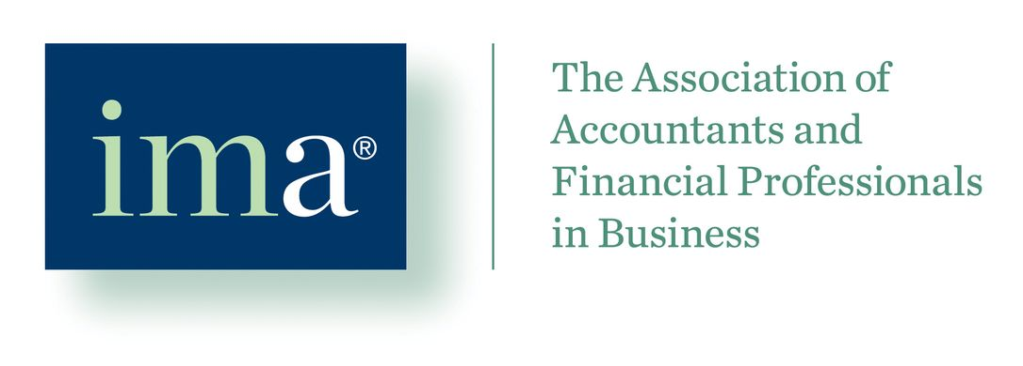
IMA Heartland Regional Council 2020 Student Leadership Conference Proposal Guidelines

Proposals should include the following:
- Event location – it is recommended that the location have at least one room with a capacity of 100 people plus additional rooms with a minimum capacity of 50 people to allow for concurrent activities
- Event agenda – The proposal should include a list of proposed topics to be presented by professional and faculty speakers during the event. Suggested topics include the following:
- Topics that are included on the CMA exam or included in the IMA’s management accounting framework
- Other topics relevant to students pursuing careers in management accounting. This would include accounting, finance, economics, marketing, and data analytics. Topics related to career development and planning, networking, social media, leadership, and resume preparation are also encouraged.
Adequate time should be allowed for student networking activities.
Proposals may also include proposed speakers and/or companies.
Proposals may also include any other items the student chapter deems necessary to make their proposal attractive to the Heartland Regional Council board and other student chapter members.
Please note that lunch is expected to be provided for the students and other attendees upon arrival at noon on the day of the event.
Attachments from the March 30th conference at Missouri State are attached for your convenience.
For those of you receiving this who have student chapters in your local chapter area, please be sure to share this information with the appropriate faculty members at your schools.
Deadline for application is Friday, May 10th. Please submit applications to:
Bob Swisher – rswisher7@gmail.com
Ralph Rogers – ralph@kcsausage.com

