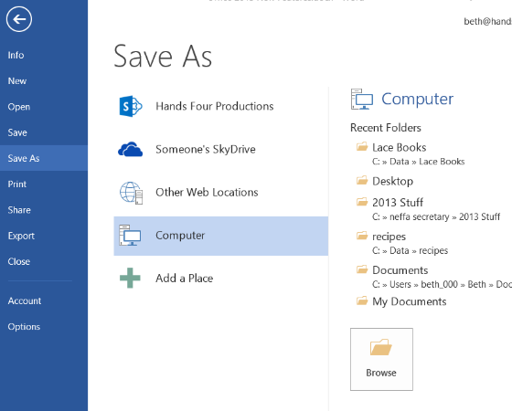
New Features across Office 2013

New Office 2013 Ribbon
The Ribbon in all Office application has a cleaner look. The ribbon now has three view position: Auto-hide which hides the ribbon, Show Tabs which displays only tabs and Show Tabs and Commands.
Single sign-on account information is displayed at the top right and credentials are passed to other services such as OneDrive and SharePoint.
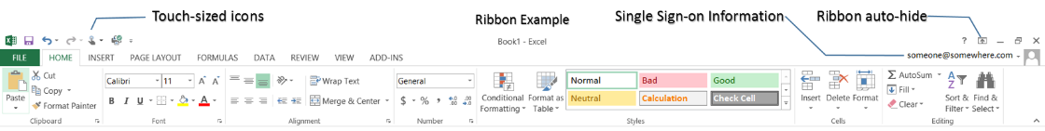

Optimize Display for Touch
The ribbon can be viewed with larger icons for working with touch. To access this option:
- Click drop down arrow at end of Quick Access Toolba (QAT).
- Select Touch/Mouse Mode from the list.
- The touch icon will appear in your QAT:
- Click the icon to toggle between touch mode and standard mode.

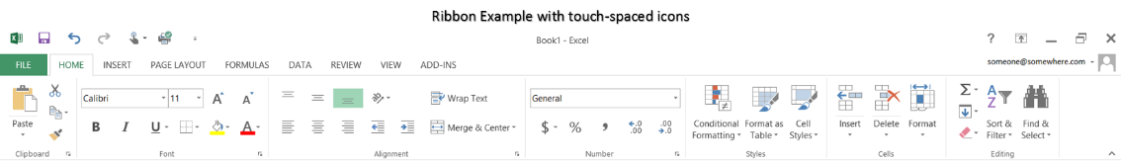

The Backstage View
Backstage view no longer displays the other tabs of the ribbon. To return to editing view, click
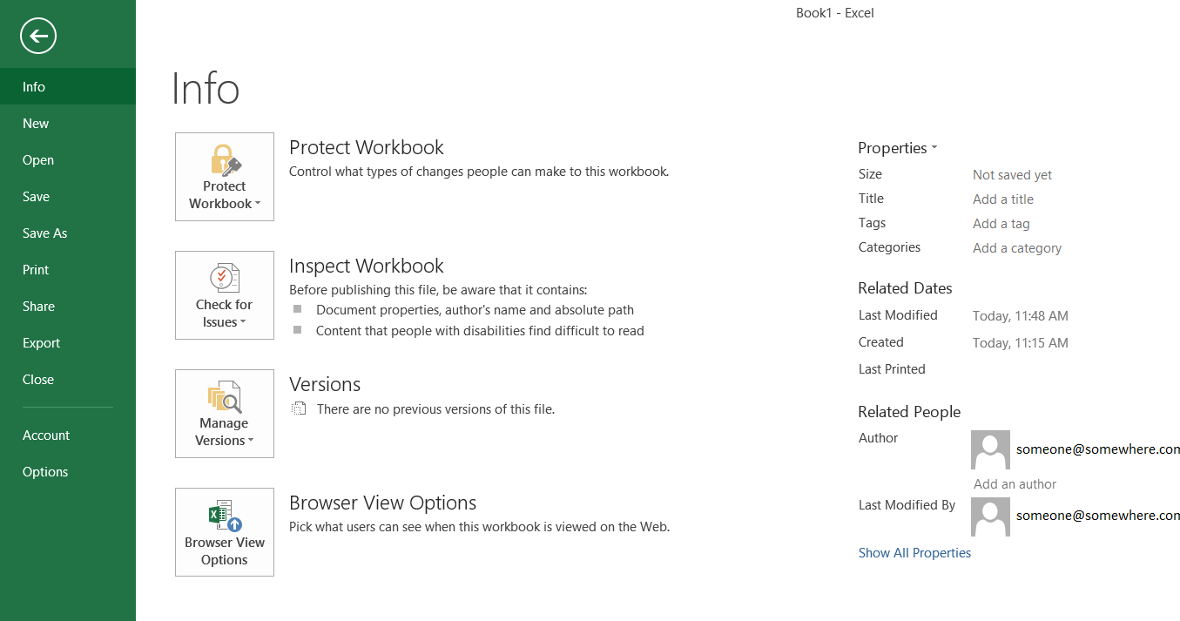

File Open & Save As
Open and Save As ask for a location first and offer on-line options. This allows you to choose a location on your computer, OneDrive, SharePoint site or other web locations. Recent folders are shown as well as the current folder if the document has been previously saved.

To select a recent folder, click on the folder name. To locate another folder on your computer using the traditional Save As dialog box, click Computer and then click Browse.
When saving or opening, you can pin your most recently used folders on your so they will remain visible each time you open or save.

Insert Online Pictures and Videos
The commands for adding pictures and videos from online storage locations such as YouTube, SharePoint and Facebook have their own icons on the Insert tab. When you use the Bing Image Search, by default the initial search results will only return images licenses under Creative Commons.
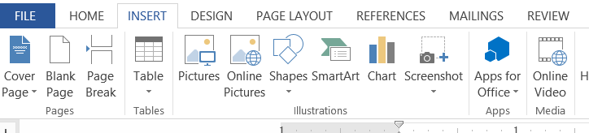

Apps
You have had apps for your smart phone, but now developers can publish and you can download apps from the Office Store to expand the capabiliites of Microsoft Office. Look for the Apps section on the Insert tab in your Office applications. Once you download an app, you can access it from the My Apps drop down.
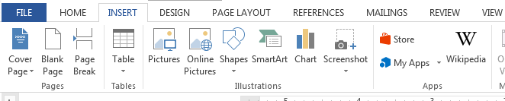

Changing the Office Theme
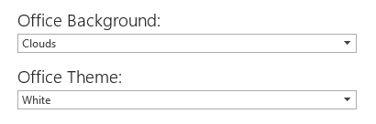
You can change the color and the design them seen in the title bar of your applications.
- Click the File tab.
- Click Account.
- Choose your desired Office Background and Office Theme from the available drop down lists.
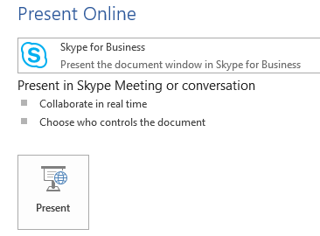

Present Online
You can share your files on-line via Skype for Business or through Microsoft’s Office Presentation Service, which allows you to display your files to other users’s via a browser.
- Click the File tab.
- Select Share.
- Choose Present Online.
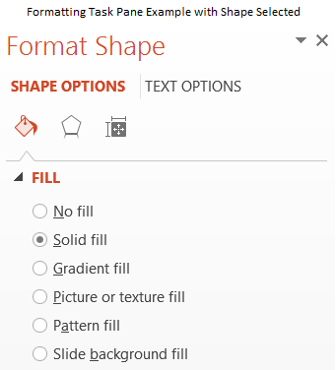
- Select from the drop down either Skype for Business or Office Presentation Service.

Formatting Task Pane
When working on inserted items, you can turn on the Formatting Task Pane. This will display formatting commands for whatever object you have selected. As in previous versions of Office, this task pane will appear anchored on the right side of your application window. There is no need to turn it off when moving from object to object, simply click on the next object and it will display the settings for that object. In Word it even displays text effects.

The People Card
Most often seen in Outlook, the People Card is the new contact card in Outlook, but it also appears across the rest of office when collaborating, accessing Skpe for Business and more. Hover on someone’s name or presence indicator and a truncated card will appear:
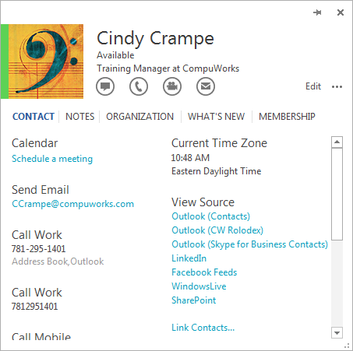
The circlar buttons at the bottom respresent actions you can take with the contact: Message, Call, Video Call, Email.
Click the down arrow to extend the contact card. A full card will appear allowing you to access links to other sources for the contact or scroll to view all the info you have on this contact: phone numbers, addresses, notes, and more.

The Start Screen
When you open an Office application, you will now be presented with the start screen, which shows recently used files along with available templates.
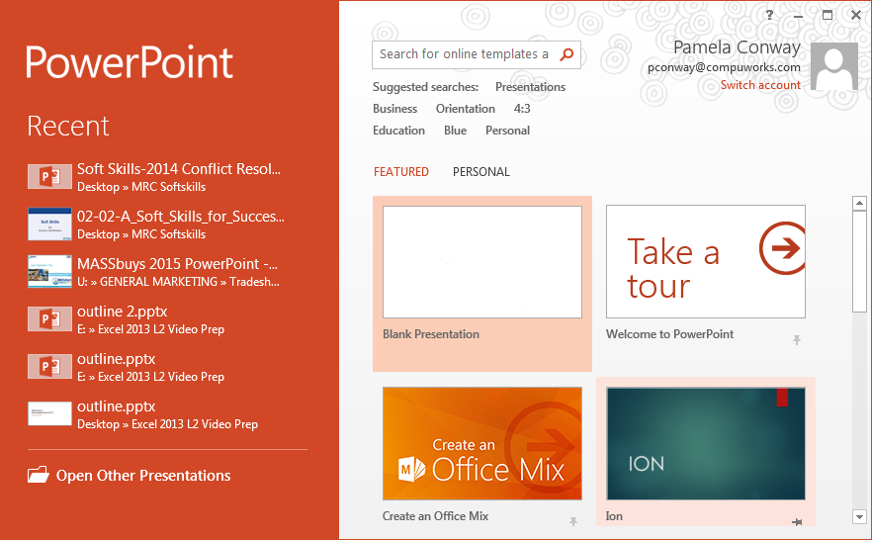
To access a simple open file dialogue box, you must click the link the bottom left corner:
If you do not prefer this new screen, it can be disabled:
- Click the File tab.
- Select Options.
- On the left, select General.
- Remove the check mark before

Word 2013

Collapse/Expand Headings
When using the built in Heading paragraph styles, you can now collapse content under the heading text making larger documents more manageable.
- Hover mouse over heading text.
- Click the triangle next to the heading to collapse or click again to expand.

Resume Reading
When opening a document again, Word will remember where in the document you were when it last was open and a call out box on the scroll bar will appear. Click it to jump to that point in the document.

Read Mode
Available on the View tab, Read Mode will convert the display into an e-reader friendly format. This makes it easier on tablets or for view long documents on a monitor.

Table Changes
To add rows or columns quickly:
- Move your mouse to the top of the table or left edge of the table.
- Click the + that appears.

Comment on a Comment
You can now comment on a comment. Click the icon in the upper right corner of the comment to add to it.
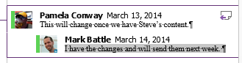

Locking Track Changes
You can lock track changes so others cannot disable it.
- On the Review tab, click Track Changes.
- Select Lock Tracking.
- Enter a password twice.
- Click OK.

Edit PDFs
You now can open, edit, save back to a PDF format. PDFs will now be visible in folders when you are looking for files to open. Word will convert the PDF so depending on the complexity of the file, the converstion may not be perfect.

Excel 2013

Save Workspace
If you used the Save As Workspace feature in previous versions of Excel, this feature is no longer available.

Quick Analysis
When you select a range of cells, a Quick Analysis icon will appear in the lower right corner of the selection. Click on it to access a list of analysis options. Excel will make recommendations of each based on the data selected.
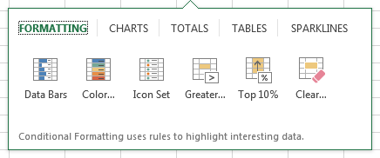

Chart and PivotTable Recommendations
Located on the Insert tab, the two buttons below access dialogue boxes of samples appropriate based on the data selected.
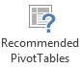

Flash Fill
Previous versions of Excel used Text functions to clean up data. Flash Fill makes the process easier and less technical.
- Select cell adajcent to the data to be formatted.
- Type data in corrected format.
- Repeat in next cell down.
- Excel should seen the example. Press Enter to fill the remainder.
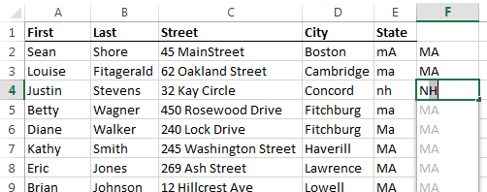

Chart Formatting
Chart formatting is simplified with call out buttons visible directly off the right edge of a selected chart. Click the buttons to add chart elements, format chart styles, filter chart contents. This works in PowerPoint too.

Outlook 2013

Interface Changes
Contacts are now referred to as People. When you hover over the different views available on the Navigation bar, a “peek” of each view appears. In the example here, you see the date navigator and upcoming appointments. There is a peek for each component of Outlook.

Attachment Reminders
Outlook scans message contents for words such as “attachements,” “enclosed,” “sending you,” and so on to determine if an attachment should have been added. If there is none, Outlook will pop up an attachment reminder when you hit send.

Folder List
In pervious versions of Outlook, the folder list was sorted alphabetically and could not be altered. In 2013 you can drag and drop your folders into any order you like!

Finding and Filtering
The great improvements in searching added in 2010 remain but have been augmented.
- A scope drop down list is available at the end of the search bar. This allows you to refine quickly where you are searching.
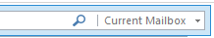
- A Filter Email drop down list of common searches is available at the end of the Home tab.

Weather Bar
The calendar now has a weather bar located at the top right. It shows three days and you can add up to five locations. To customize this.
- Click the drop down arrow next to the city name.
- Click Add Location.
- Type location name and hit enter.
- Click the x next to a location to remove it or to add a different location if you currnetly have five locations set.

Inline Replies in the Reading Pane
When the Reading Pane is active, you can reply and forward messages directly in the pane.
- Click appropriate reply button from those available at the top of the reading pane:
- Click the Pop Out button if you want to move from inline to a separate window.

PowerPoint 2013

New Themes
PowerPoint now has theme variations. Variants have alternate color schemes, backgrounds, and fonts.
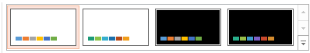
- Select the Design tab.
- A gallery of Variants will appear next to the themes.
- Click the drop down arrow to further customize a variant based on color scheme, fonts, effects, and background styles.

Eyedropper
The new Eyedropper tool allows you to match colors from a theme or even an inserted image.
- Select the shape to which the color will be applied.
- Select the Format tab.
- Click Shape Fill.
- Select Eyedropper. A dropper will appear next to your mouse pointer.
- Point to the color you wish to sample, a preview window will appear and will show the RGB number.
- Click to apply the color.

Merge Shapes
You can customize shapes you draw by mergning them in a variety of ways.
- Select the multiple shapes you want to merge.
- Select the Format tab.
- Click Merge Shapes.
- Select the merge choice from the list: Union, Combine, Fragment, Intersect, Subtract

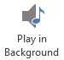
Audio Improvements
You can now play an audio file across slides.
- Insert the audio file.
- Click the Play in Background button.

Saving as Video File
In previous versions of PowerPoint your only option was to save as a .WMV file. Now you can save your presentations as .MP4 files as well.

Motion Path Improvements
When applying a motion path, in addition to the dotted line showing the motion path, a second, transparent version of the shape appears at the end of the path.

Collaboration
PowerPoint offeres the same collaboration enhancements as Word: you can comment on comments here too. Additionally, the comment indicator is now a small speech bubble with comments appearing in a comment task pane when the bubble is clicked.
If the presentation is saved in your OneDrive, multiple users can edit the file simultaneously.

Presenter View
Perhaps the greatest improvement in PowerPoint 2013, the presenter view is available when you are in slide show mode and have more than one monitor avaialable or are connected to a projection device. One display will show the presentation to the audience while the other will display a view for the presenter that includes the image seen by the audience, the upcoming slide, and speaker notes for the current slide.
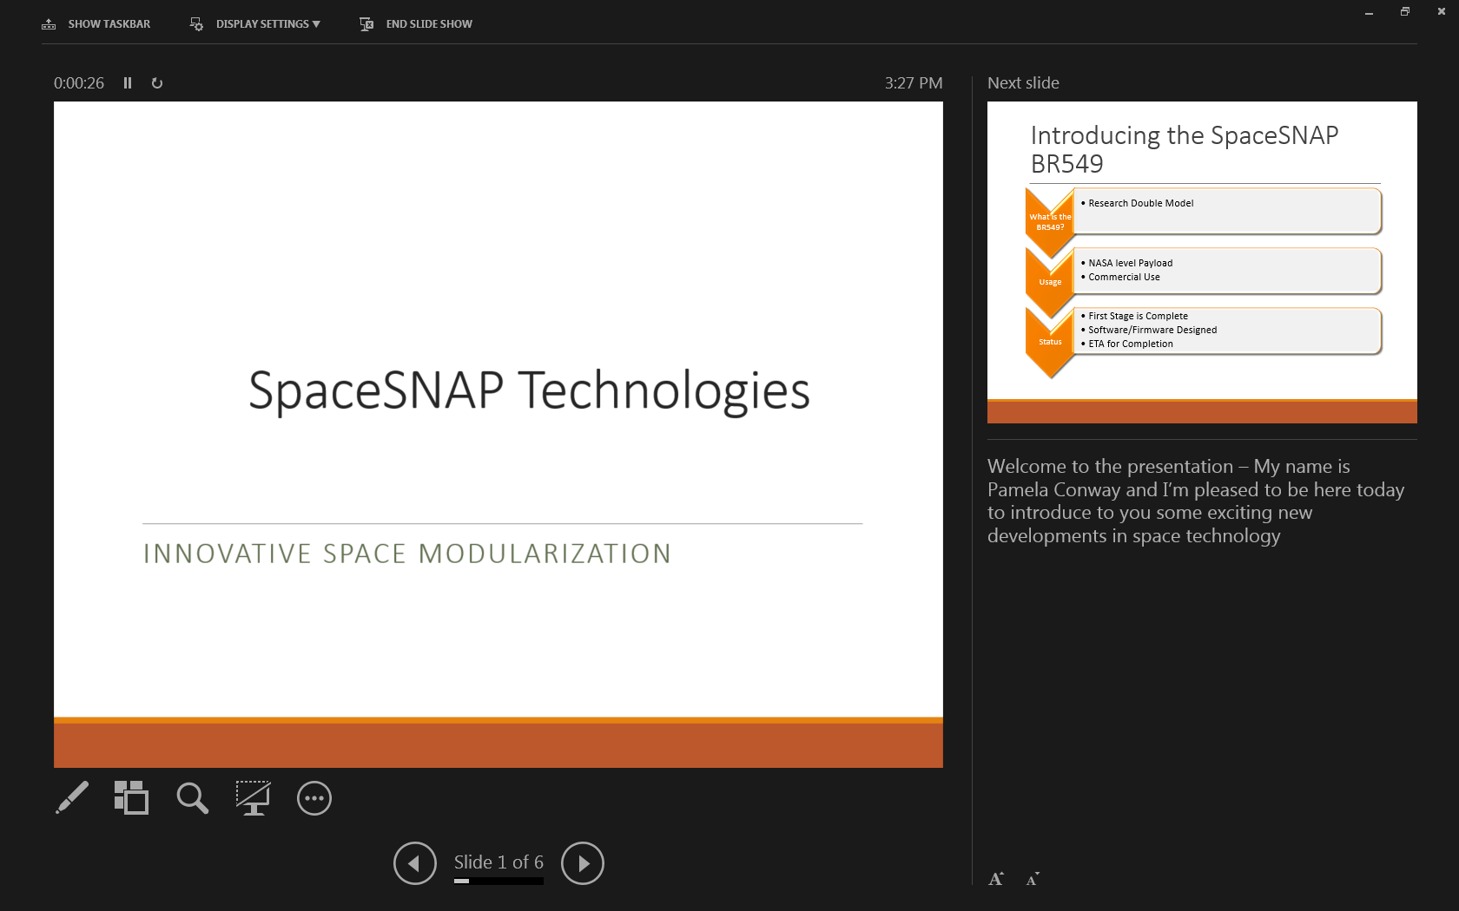
The icons below the currently displayed image allow the presenter to:

- Access a laser point, a pen, a highlighter, and other arrow options for the mouse
- Switch to a thumbnail view of the slides. You can click on a thumbnail to jump to displaying that image to the audience.
- Zoom in on a part of the currently displayed slide. This is an excellent tool for dense images or large charts.
- Toggle between a black screen and the displayed image.
- The last icon is a menu of additional options such as end show, pause, hide presenter view and more
Above the currently displayed image is a counter showing elapsed time spent on the current slide. You can pause the counter or reset it using the two buttons next to the counter.

The buttons in the upper right corner of the presenter window will allow the taskbar, suppressed by default, to be visible in the Presenter View. Display Settings lets you swap the monitors or duplicate the image on both screens if you prefer.

