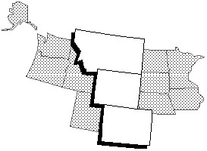Colorado-Wyoming-Montana Division
Resume of Qualifications

Please fill out and return this form, along with your letter of interest and endorsement letter from your Chapter President to the Nominating Committee Chairman no later than April 30, 2012.
Name: | Phone:
Address:

Chapter: | Membership Date:
Employer: | Title:
Experience:

Strengths:

Organizations and Positions Held:

Personal History – family, hobbies, interests, etc. (optional)

Your 2011/2012 Nominating Committee:

Deanna Anthony CAP/OM, Chairperson
Rimrock Chapter
P O Box 20261
Billings MT 59104
W-406-248-7444
H-406-656-4142
C-406-208-3411

