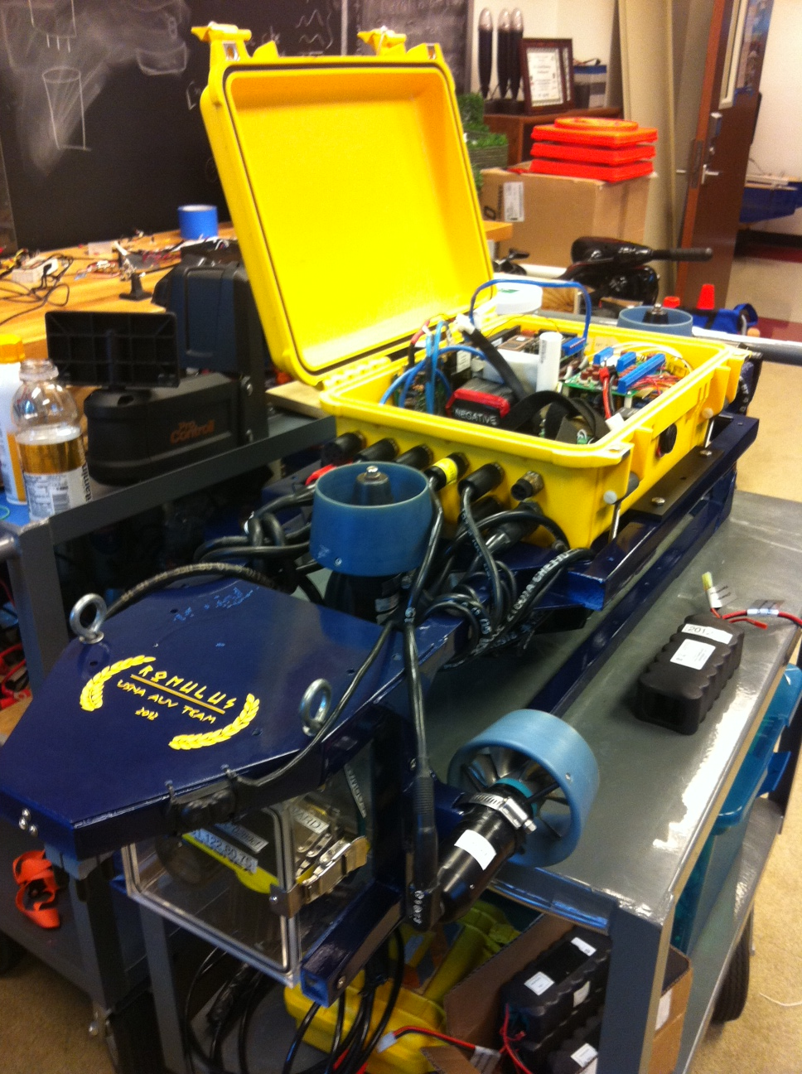 **United States Naval Academy**

**Autonomous Underwater Vehicle**

***Abstract***

**The purpose of the 2012 United States Naval Academy (USNA) Autonomous Underwater Vehicle (AUV), named *Romulus*, is to compete in the 15th AUVSI/ONR International AUV Competition in San Diego, California. Being the sixth incarnation of USNA’s vehicle, *Romulus* is a combination of the tried and true methods of the past and the bright new ideas for the future. The principal goals for this year’s team were to design a new frame, successfully utilize camera navigation, implement passive sonar, and improve position control with the addition of two horizontal thrusters.**

**This year’s developments focus on improving current reliability while designing with future teams in mind. A new frame was created to accommodate a more logical layout of the present end effectors and provide room for the addition of new end effectors on future designs. In past years, camera vision has proven to be unreliable in the arena, but with improved knowledge of the software used by the Cognex 5400-C cameras, *Romulus* will enter the water this year with more robust vision capabilities able to score points on a more consistent basis. We have also made progress this year in integrating passive sonar, which has never been successfully used by previous USNA teams. Lastly, to work in conjunction with the improved cameras and sonar, *Romulus* will be utilizing two horizontal thrusters to enable lateral movement. This will result in more accurate position control for all components of the obstacle course.**

***Introduction***

While competing, *Romulus* will attempt to complete a complex obstacle course completely autonomously. These tasks include:

- Passing through an underwater gate along a straight path

- Following orange path segments on the pool bottom

- Striking two of three underwater buoys

- Passing through a pair of ‘L’ shapes suspended in the water

- Dropping markers on designated underwater targets

- Firing projectiles through underwater circular cutouts

- Removing small cylinders from underwater pegs

- Homing in on an acoustic pinger

- Picking up a large ‘wreath’ from the bottom

- Surfacing within a designated surfacing octagon

One of the most fundamental and crucial elements of the vehicle’s success is a reliable control system that maintains the vehicle’s position and attitude (depth, pitch and heading) simultaneously. The control system is the foundation of more complex vehicle behaviors, such as navigating a series of waypoints, using cameras to find, identify, and locate objects using sonar to detect and locate a pinger, and ultimately positioning the vehicle to achieve each objective.

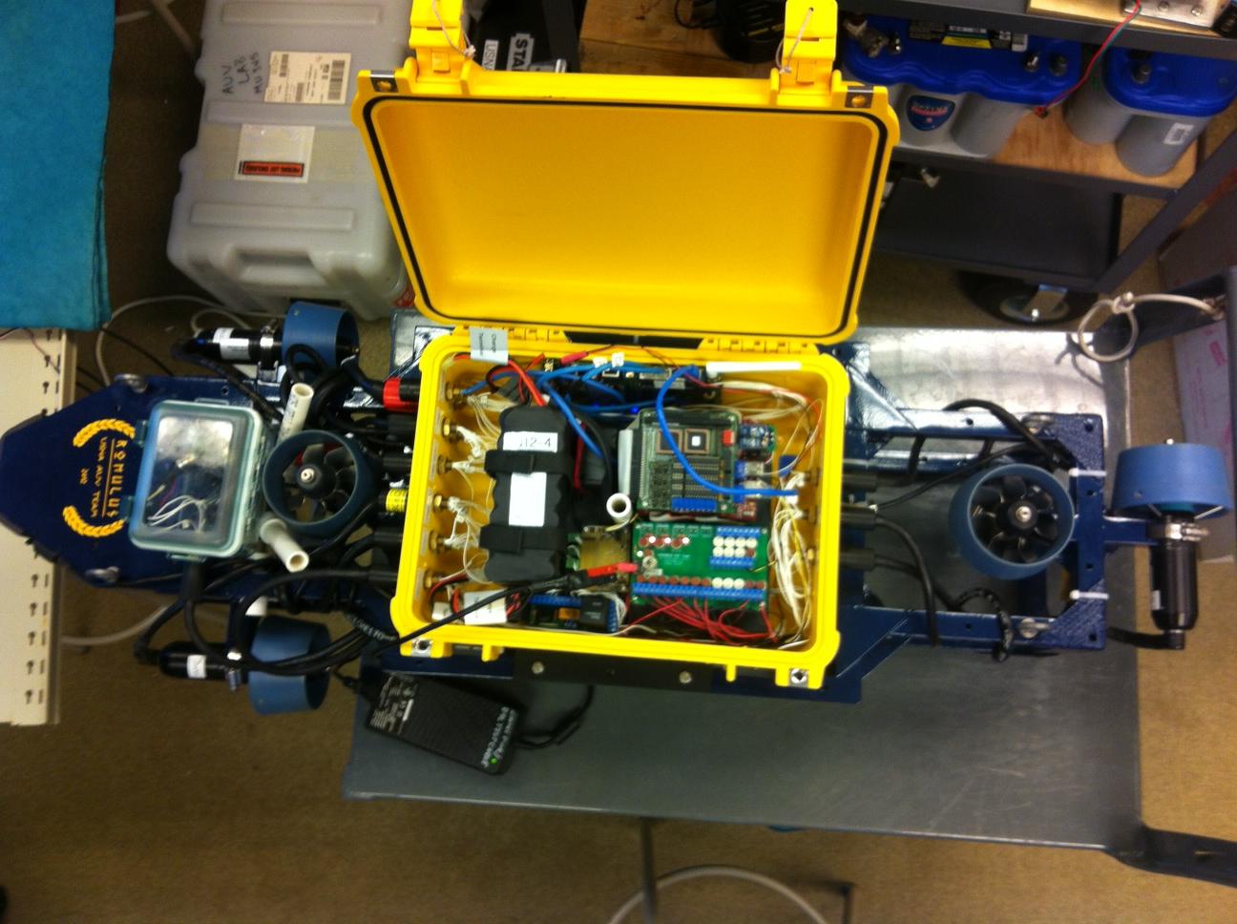

***Mechanical Design***

*Frame*

The vehicle’s chassis was fabricated from one inch pultruded fiberglass square tubing to reduce the weight, eliminate any possibility of rust, and is prismatic vice flat. This year’s new frame is 45” long and 14.5” wide and is prismatic vice flat, creating a much larger profile compared to the 2011 vehicle.

The edges of the frame were bonded with fiberglass, epoxy, and triangular supports to ensure that the edges would be able to sustain the same forces as the rest of the chassis. The frame is light, yet extremely strong and can withstand the normal stresses of operation as well as overloads due to accidents and mishaps.

Figure 1 Top view of vehicle. All but the forward lateral thruster can be observed.

*Main Housing*

The main housing consists of a model 1450 Pelican case where the computer, two batteries, and electrical components are placed. The case is larger this year which added buoyancy to help offset the weight added by the larger frame to correct the lack of buoyancy of the 2011 vehicle. Watertight electrical penetrations in and out of the main housing utilized thirteen SeaCon connectors to connect all of the vehicle components to the case. All but three of the SeaCon connectors were placed densely on the forward side of the box in order to reduce the internal volume lost to these connections. Internal wiring is kept orderly by carefully routing most wires underneath the bedplate of the box internals. The external box mounting devices used to connect the main housing to the frame were constructed out of adjustable bolts connected to cross beams of fiberglass that run under the main housing.

*Thrusters*

Two Tecnadyne model 300 thrusters are placed on the port and starboard sides of the vehicle to provide propulsion and heading control. Two other Tecnadyne 300 thrusters are mounted fore and aft as vertical thrusters to provide pitch and depth control. The last two Tecnadyne 300 thrusters were placed fore and aft, at right angles to the depth control thrusters to provide lateral movement for more precise positioning capabilities.

The Tecnadyne 300 thrusters were selected because they are compact, completely watertight, powerful and easily interfaced with the computer through a digital to analog converter. They are also in counter-rotating pairs, minimizing the effects of torque on vehicle attitude. The separate power and control circuits in the thrusters are advantageous compared to simple DC motors, which would require a completely separate power control circuit to regulate the speed of the motors.

The thruster power circuit features a 12,000 uF capacitor bank to prevent back EMF and voltage spikes from damaging electronics in the thrusters. This addition was in response to thruster MOSFET failures that occurred in two previous vehicles.

The thrusters are mounted by connections to small sections of pultruded fiberglass that are directly connected to the chassis. They contain a slight concave cut identical in radius to the thrusters and have slits in the sides in order to accommodate the hose clamps that securely fasten the thrusters to the frame while they are in use. When mounting the thrusters, black tape was used to coat the casing of the thruster which might encounter the hose clamp to prevent any damage to the thruster. The hose clamp is covered with heat shrink to increase the friction of the hose clamp to the thruster in addition to protecting it.

*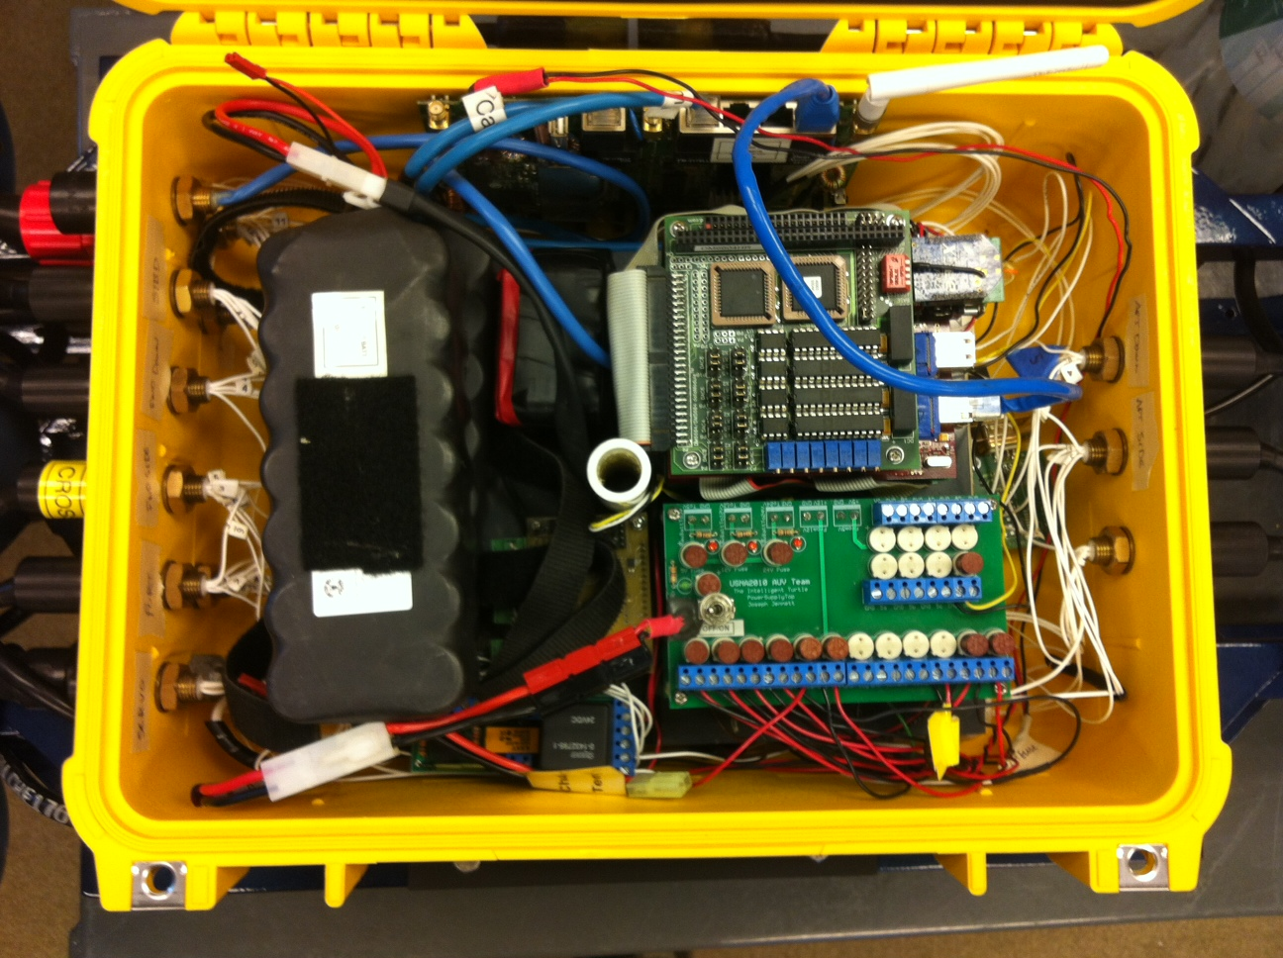Camera Box*

The camera box was built by the USNA machine shop. It is constructed from 1/2’ plexiglass on all six sides. It is situated so the lid is facing forward to accommodate easy access to the components housed inside. The bottom and front (lid) surfaces of the box are used by the cameras. Communication between the cameras and the main computer is done through a SeaCon connector placed in the rear of the Camera Box. The box is attached to the frame securely. There are four screws, two on each side, that hold the box between the inner sides of the frame so that it cannot separate. These prevent the box from moving from its original position, even slightly. This is important because we do not want the cameras jostled, and the camera box is the ideal location for a back-up compass. The stability of the box eliminates a large source of potential error of navigation equipment.

Figure 2 Inside the main housing.

***Electrical Design***

*Power*

Two batteries are used to provide power to the vehicle. One, designated the thruster battery, is provided for powering high-current loads to the six Tecnadyne 300 thrusters. The other, designated the instrument battery, powers the sensors, computer, kill switch, servo motors, and router. The use of two batteries isolates the electrical noise of the high-current loads from the power for the sensors, which require clean, stable, and regulated voltages. The batteries were selected based on compatibility between load voltages and to remain below the Navy shipboard electrical safety standard of 30V. Both instrument and thruster batteries are nickel-metal-hydride, rated for 24 Volts and 4.5 amp-hours.

*Switching and Regulation*

The kill switch is a waterproof switch that is in compliance with the RoboSub competition safety rules. The thrusters are the only devices powered through the kill switch, which enables propulsion to be disabled while operating the computer and instruments. The switch is downstream of two relays. The first is a relay which the switch turns on and off to directly control the power to the thrusters. The second relay will remain on when the kill switch is in the on position but requires a magnet to be swiped past a reed switch before it will reactivate the switch after the switch has been turned off, preventing an inadvertent thruster restart.

Electrical loads are listed in Table (1). Regulation is provided by a custom-built power supply board located in the vehicle’s main housing. Four power switching voltage regulators and associated circuitry reduce and regulate instrumentation battery bus voltage to meet component input voltage specifications levels. Fuses are also installed on this board for short-circuit protection.

**Table 1 – Electrical Loads**

|  |  |
| --- | --- |
| **Component** | **Input Voltage (VDC)** |
| Doppler Velocity Log | 24V unregulated |
| Depth Cell | 24V unregulated |
| TS7200 Computer | 5V regulated |
| In Sight 5400-C Cameras | 24V regulated |
| Sonar | 12V regulated |
| Tecnadyne Thrusters(6x) | Main: 24V Inst: 12V reg. |
| Servo Motors | 5V regulated |

*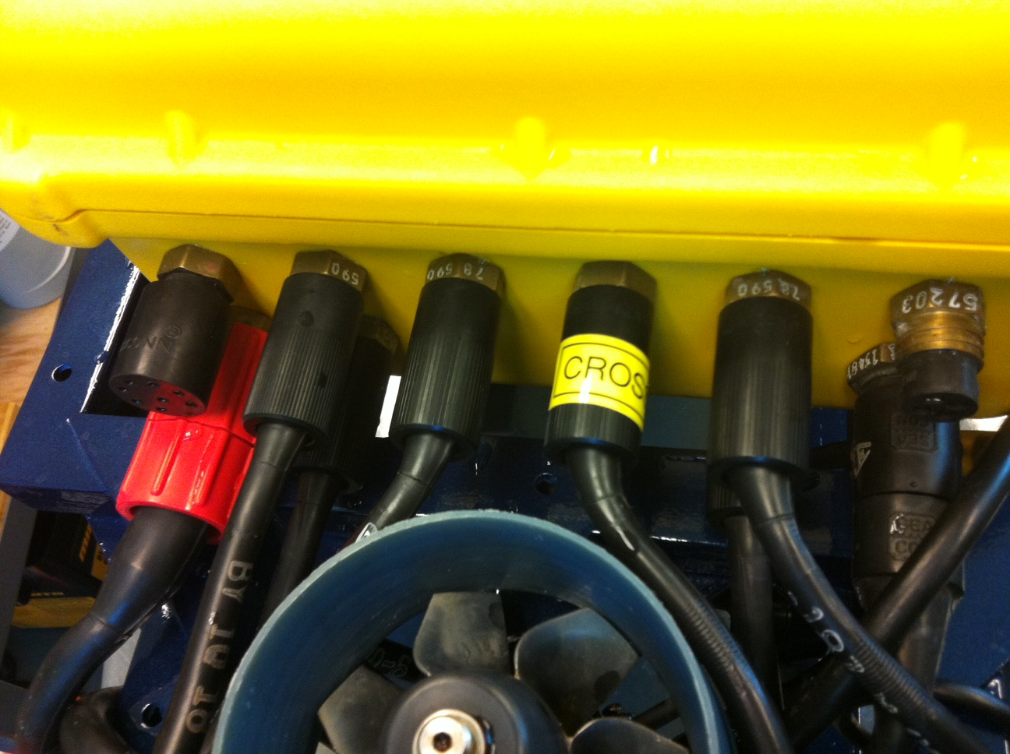SeaCon Connectors*

SeaCon connectors were selected for ease of installation and customization. The SeaCons were used for all connections between thrusters, sensors, mission devices, main Pelican case, and camera case.

Figure 3 Computer stack with breakout board below.

***Computer***

*Hardware*

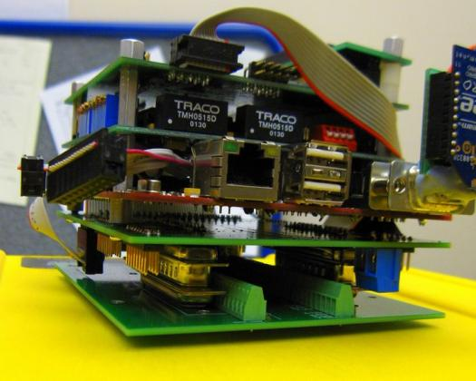The computer stack is based on the Technologic TS-72000 single board computer. This was selected due to its small size, low power requirement, extensive features, and expandability. The mother board houses a 200 MHz ARM-9 processor, 32 MB of SDRAM, two RS-232 serial ports, two USB 2.0 ports, Ethernet port, an 8 channel 12-bit analog to digital converter, 20 digital input-output pins, and other various features. In place of a disk drive, the motherboard uses a 2 GB compact flash (CF) card for file storage; significantly reducing the size of the computer and its power requirements. Additionally, the CF card can be quickly duplicated, providing a simple means of backing up the vehicle’s file system. In the event of a computer hardware causality, the computer can be quickly restored by securing the computer power, installing the spare computer stack and a duplicate CF card, and then restoring power. The computer stack draws approximately five watts. The motherboard also includes an 8-bit 64-pin PC-104 header, allowing installation of daughter boards to complete the computer stack.

Figure 4 SeaCon connectors.

The computer stack contains a total of 6 serial ports: 2 on the motherboard (COM 1 and COM 2) and 4 on the Technologic TS-SER4 card installed on the PC104 header (COM A, COM B, COM C, and COM D). Two of the ports are allocated to sensors: Doppler velocity log (DVL), sonar, and two are currently unused. The sixth port is used for serial terminal connection to the computer when Ethernet is not used, either by serial cable in the lab or by Maxstream XBee wireless communications once the hull is sealed. Table (2) summarizes communication protocols in the vehicle.

The computer stack is installed in the vehicle as a module. It is mounted on a custom-designed circuit board with three 25-pin connectors on the bottom that mate with a similar board mounted on the electronics box base plate. This design is beneficial for software development away from the complete vehicle.

**Table 2 - Communication Protocols**

The vehicle’s thrusters require an analog speed command between -5 and +5 VDC, which is provided by a Real Time Devices DM6604 D/A card. The card is connected to the motherboard via the PC-104 bus, and 6 of its 8 channels are set to -5 to +5 VDC operation and used to command the 6 thrusters.

*Software Architecture*

The software architecture utilizes a modular design. By having an increased number of programs with clearly defines purposes, making changes to enhance mission capability is much more simple. Our program suite consists of concurrent processes that write to and read from a shared memory structure that can be accessed by any program. All the code is written in GNU and is run on a Debian Linux distribution. The programs break down into three basic types: control, user interface, and sensors.

*Control Code*

|  |  |  |
| --- | --- | --- |
| **Component** | **Protocol** | **Port** |
| Thruster Speed Command | Analog | D/A Channels 0-5, -5V to +5V |
| Depth Cell | Analog | A/D Channel 0, 0V to +10V |
| XBee | RS-232, 115200 baud, 8n1 | COM-1 (TS-7200) ttyAM0 |
| DVL | RS-232, 9600 baud, 8n1 | COM-B (TS-SER4) ttyS1 |
| SONAR | RS-232, 9600 baud, 8n1 | COM-C (TS-SER4) ttyS2 |
| Marker Dropper | Command String | SV203 Servo control board |
| Forward (downward) Cognex Cameras | TCP/IP | 131.122.80.85 (75) |

*Romulus* utilizes three primary control levels: behavior, operation, and mission. The behavior level contains two programs. One is the device controller that controls the position of mission devices, and a program called maneuver that contains attitude controllers that maintain desired headings, pitches, depths and speeds.

The depth control is a PID controller, with the depth derivative obtained from an observer on the depth signal. The depth controller has different gain and saturation values for the forward and aft thrusters to account for hydrodynamic and buoyancy forces, allowing more controlled descent. The pitch control uses a PI controller. The heading control is also a PI controller based on heading error. We set a constant speed for the vehicle, which the controller then adds or subtracts from that constant on each forward thruster to provide steering. The integral portion of the controller overcomes any consistent error such as always drifting to the left or right.

This year, with the addition of the two lateral thrusters, we have implemented a position controller. Simply put, if the vehicle is left of its target, it will slide to the right, or if the target is still in front, the vehicle will move forward. Once the target is sighted, the heading is held constant. All adjustments are then controlled by the position controller and, the speed is controlled by a proportional gain. The advantages of this are prevalent for all obstacles where aiming and moving are involved.

The operation level contains one program for each objective in the competition. This allows us to easily change strategies for individual competition tasks. Each of the programs reads a corresponding text file that contains information for that task, such as the correct order of the buoys, or the correct bin to target. Using text files for this information allows us to make changes without recompiling the software. These programs do not run concurrently, but are initiated by the highest level of control, the mission level.

The mission level contains one program, the sequential controller. This program reads a text file that contains a list of the tasks the vehicle is to attempt, and the order at which to attempt them. The program then uses a system call to run the correct operation level program. After the task is complete, or is deemed a failure, the sequential controller moves to the next task in the mission sequence.

*User Interface*

There have been no significant changes in the user interface from last year’s vehicle. We have a user interface program that allows the user to navigate menus on the vehicle and decide various modes of operating the vehicle including remote control and autonomous modes. Finally, our data logging program is active only while the vehicle is running a mission, so we can store more data that is useful, and our plots are not disrupted by irrelevant data points.

***Sensors***

*Vision Systems*

Two Cognex In-Sight 5400-C Cameras are carried on the vehicle inside the forward mounted camera box. They run off of the vehicles instrument power batteries. They are supplied by a dedicated 24V regulator. The cameras are both very capable of detecting colors and shapes. The downward looking camera is used on the ‘Gladiator Ring’ task and the forward looking camera will assist on all the tasks that involve driving through or bumping a target such as the ‘Training’ task.

The cameras do all processing themselves. Before vehicle launch the images that they are looking for (including shapes, colors, orientation and sizes) are programmed into them. The software that the cameras use calls these preprogrammed tasks ‘jobs’. Using the jobs and the cameras internal computer the image is processed. The Cognex 5400-C cameras then send specific image information, like centroid location, color, or major axis angle to the computer.

Information is sent to the main computer via Ethernet cable. Each camera uses four pins in the 8 pin Ethernet connection. This allows the information to be easily transmitted and collected from both using only one bulkhead penetrator in the camera box, and the computer box.

*Doppler Velocity Log*

A Teledyne self-contained Workhorse Navigator DVL is used as *Romulus’* navigation sensor. The sensor has an on board compass that it uses to determine its heading and to convert body-fixed velocities to global velocities. Data is sent to the computer via serial communications at a rate of 2 Hz.

*Depth Cell*

The Depth Cell used on *Romulus* is a Keller America Levelgage. This cell was chosen because it enabled us to avoid an additional hull penetration required for an internally-mounted cell. This cell (designed as a level detector for liquid storage tanks) is mounted to the frame and can be completely immersed. Therefore, it was connected to the computer via a SeaCon connector through the pressure hull. Additionally, the depth cell has a 13-28 VDC input voltage range and therefore can be powered directly from the battery bus, but due to excessive draw from other instruments this too has its voltage regulated to 12 volts. Lastly, the depth cell can be purchased custom calibrated, which allows us to set an output of 0 VDC at 0 PSIG (atmospheric pressure) and 10 VDC at 13 PSIG, which corresponds to a depth of 30 feet in fresh water. This output is read by channel 0 of the vehicle computer's A/D converter.

*Sonar*

The USNA AUV passive SONAR system is comprised of hybrid analog and digital control circuitry configured to locate an underwater signal source by azimuth and elevation. The system consumes little physical space and draws little electrical power, yet it has many user configurable parameters in both hardware and software providing overall operational flexibility. The transmitted signal is acquired using four Reson omni-directional hydrophones precisely spaced from each other. Each signal is then amplified using a dual, low noise, single supply variable gain amplifier. The signal then enters a multiple feedback active band-pass filter and then splits to both a voltage divider and a variable threshold comparator with hysteresis. Each signal from the voltage divider enters the simultaneous sampling analog to digital converter of a C-programmable dsPIC33FJ128MC802 microcontroller. The dsPIC33 controls parameters of the analog circuitry by a MAX5741 quad 10-bit digital to analog converter (DAC) through an SPI communication bus. Once triggered on a user selected analog threshold voltage, samples are collected and stored in a serial memory. The signals from the band-pass that enter the threshold comparator become saturated digital pulses that enter the PIC33’s external interrupt sources (only 3 external interrupt sources are available). A cross-correlation algorithm is performed on binned signal return samples to find a phase difference between hydrophones. This phase deviation is used to triangulate the position of the transmitted signal. The PIC accepts ASCII commands through a serial RS232 UART and transmits a NEMA comma separated ASCII string of data parameters to the connected computer. The interface allows the user or a remote computer to control various parameters of the analog circuitry as well as several operating modes and data collection for post analysis. The dsPIC33 microcontroller also can be interfaced to an external color Nokia 6100 LCD display for data plotting and quick parameter configuration and control circuitry calibration. The SONAR system on the vehicle does not require the LCD. This SONAR system configuration provides a flexible hardware and software platform for obtaining and analyzing an underwater transmitted periodic signals location within a selected frequency range*.*

Figure 5 A Reson Hydrophone, the analog processor board (on left) and the bottom of the digital processor board and power supply.

*Communications Code*

All sensor processes perform similar functions. They essentially open a connection to the device (serial for DVL, and SONAR; TCP/IP socket for the cameras; and an analog-to-digital port for the depth cell), parse or calculate the data, and write the information to shared memory.

The socket connection for the cameras deserves special attention because of the complex nature of TCP/IP protocol and the chances of lost packets in the network. The program is robust enough to close and reopen the connection in the case of bad data and to attempt to connect multiple times if a connection attempt fails.

***Mission Devices***

Following the 2011 USNA Robosub team’s example, our goal at the beginning of the project was to focus on one mission objective at a time. This would give us the best chance of earning maximum points for the objectives we chose, rather than little or no points in all the objectives. While we did brainstorm and work on prototypes of multiple mission devices at the same time, our focus was mainly on the dropper system and grabber for the wreath.

*Dropper*

The dropping system underwent a large redesign this year. Rather than using balloons and rubber coating to waterproof the servos used, we used a watertight box with a bulkhead penetrator for the wires needed. The two servo motors and the driver board easily fit in the box, which also provides buoyant force to the vehicle. The servos operate two paddles (or gates) that cover the downward opening to two PVC tunnels (port and starboard) that house the projectiles to be dropped. These gates are connected to the servos by thin metal rods that pass through the watertight box by way of plastic bearings containing rubber rings, coated with silicone grease.

*Grabber*

Our grabber for the wreath utilizes a one-way-gate. PVC attachments for the bottom of the vehicle have downward extensions with flexible fingers coming off at an upward 45 degree angle. As *Romulus* descends onto the wreath, these fingers allow the frame of the wreath to pass other them, but once the ascent starts, the wreath is caught in the upward 45 degree angle.

*Conclusion*

Perhaps our biggest goal this year was to build a frame with lasting quality as a competition piece that would develop and grow over multiple generations of vehicles. Future teams will not have to spend precious time on frame design, but instead they will focus on mission capabilities, and new inventive coding to carry out those missions. We have also made significant strides toward camera navigation that have not been seen in the past. We plan to arrive in San Diego with the first successful camera-navigated USNA vehicle.

*Acknowledgements*

Thanks to the USNA machine shop for helping to build the new frame, DVL mount, and for the great looking paint job.

We would like to thank Joe Bradshaw and Norm Tyson for helping to come up with a solution to almost any problem we could think of and Keith Groch for being our "ace in the hole" who could get us anything that we needed to order.

Most importantly, the entire team wouldn’t be here today without the endless hours of patient, knowledgeable instruction that Captain Jack Nicholson has given to the team every year and every student that comes into his office asking for help.

***- Competition Travel Team 2011 -***

*Chase Hansen (Team Captain)*

*Jace Fincher*

*Marianne Topp*

*Robert Bruss*

*Captain Jack Nicholson, USN (Faculty Advisor)*