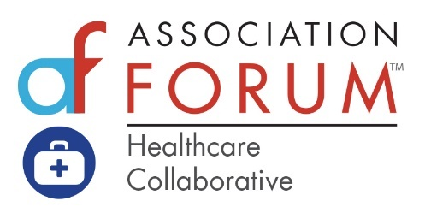

What is the Association Forum Healthcare Collaborative?
An interdisciplinary community of healthcare associations and stakeholders convened to identify pressing issues to address in common, opposed to individually.
Healthcare Collaborative Background
- The Healthcare Collaborative was approved by the Association Forum Board of Directors in March 2017.
- The inaugural co-chairs, Paul Pomerantz, CEO, American Society of Anesthesiologists and Kathy O’Loughlin, DMD, Executive Director, American Dental Association. Honorable mention to Lynne Thomas-Gordon, Executive Director, American Academy of Orthodontists.
- First Healthcare Collaborative convened at the Four Seasons Hotel Chicago, July 11, 2017.
- Founding Sponsors: Visit Dallas, Visit Phoenix, and Visit Seattle
- Association Sponsors: American Society of Anesthesiologists (2019 and 2020) and Society of Actuaries (2019)
- Healthcare Collaborative convened bi-annually (Winter and Summer) in Chicago.
- As of October 2020, more than 120 healthcare and medical associations engaged
- As of October 2020, nearly 700 individuals engaged
- Average attendance per meeting:
  - Winter Collaborative: 100 (in-person)
  - Summer Collaborative: 60 – 70 (in-person)
  - Virtual – 70 – 100
- Number of Collaboratives convened:
  - Five sessions in Chicago
  - Two in-market Cyber-Med Summits at the University of Arizona Biomedical Campus in Phoenix (sponsor Visit Phoenix)
  - One Innovation Summit at the Brain Performance Institute in Dallas, TX (sponsor Visit Dallas)
- Healthcare Collaborative topics:
  - July 11, 2017: Inaugural Meeting: Disruption in Healthcare
  - January 25, 2018: Navigating the World of Digitized Medicine and Healthcare Data Revolution
  - July 24, 2018: The Many Facets of the Opioid Crisis
  - January 29, 2019: The Social Determinants of Health
  - July 15, 2019: Redesigning the Healthcare System for the Empowered Patient
  - January 28, 2020: The Business of Quality in Healthcare Associations
  - July 22, 2020: Addressing the Triple Pandemic Threat: Racism, Economy, and COVID-19
  - September 22, 2020: Pre-Election What ifs?: The Impact of the Presidential Election on Healthcare Design and Economics
- Healthcare Collaborative In-Markets (held in sponsor destination or collaboration with partner)
  - Cyber Med Summit at Phoenix Biomedical Campus – Phoenix, AZ
    - March 4-6, 2020 (sponsor Visit Phoenix)
  - Innovation Summit at the Center for Brain Health – Dallas, TX
    - February 19-21, 2020 (sponsor Visit Dallas)
  - Healthcare Collaborative Roundtable – IMEX Americas, Las, Vegas
    - September 9, 2019: Trends and Disruptors Impacting Healthcare and Medical Meeting (sponsor Visit Phoenix)
  - 3 Part-Webinar Series – Sponsored by Destination Cleveland
    - October 22, 2020: Creating a Culture of Empathy and Patient Care in Post COVID-19 World
    - October 27, 2020: Social Determinants of Health
    - November 6, 2020: Future of Medical Tourism as an Export Industry in the Post COVID Era
- Healthcare Collaborative leadership transition from Paul Pomerantz and Kathy O’Loughlin on July 22, 2020. New leadership: Randy Moore, CEO, American Association of Nurse Anesthetists and Laurie McGraw, Senior Vice President, Health Solutions, American Medical Association.
- Future of the Healthcare Collaborative Strategic Planning Meeting – October 13, 2020

For more information about the Healthcare Collaborative, please email executiveoffice@associationforum.org

