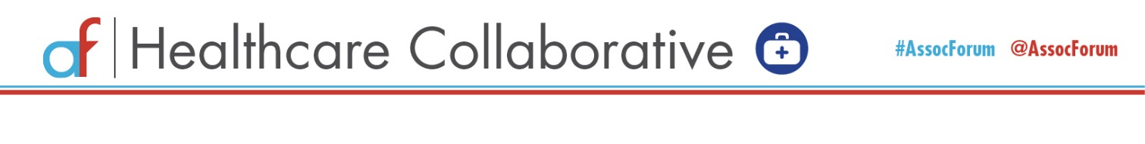
Association Forum Healthcare Collaborative
September 22, 2020
9:00am – 10:00am CT

Pre-Election What Ifs?: The Impact of the Presidential Election on Healthcare Design and Economics

9:00 – 9:10 a.m. Welcome and Setting the Stage:
Laurie McGraw, Senior Vice President, American Medical Association

9:10 – 9:45 a.m. Panel Discussion

Moderator: Scott Becker, Partner, Healthcare Department, McGuireWoods

Panelists:
- Katie Keith, JD, MPH, Research Professor, Georgetown University’s Center on Health Insurance Reforms
- Cybil Roehrenbeck, Shareholder, Polsinelli PC

9:45 – 10:00 a.m. Closing Summary and Next Healthcare Collaborative
Randy Moore, CEO, American Association of Nurse Anesthetists

Virtual Winter Healthcare Collaborative: January 24, 2021 – 9:00am – 11:00am CT

Post-Election Healthcare Politics: The Future Role for Healthcare and Medical Associations

