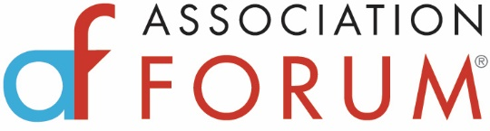

Summer 2020 Healthcare Collaborative
Addressing the Triple Pandemic Threat: Racism, Economy and COVID-19

A Virtual Healthcare Collaborative
July 27, 2020
9 – 11:00 a.m. (CT)
9:00 a.m. Welcome Remarks and Context
Healthcare Collaborative Co-Chair, Paul Pomerantz, FASAE, CAE- Chief Executive Officer, American Society of Anesthesiologists
9:05 – 9:07
Keynote Introduction – Visit Dallas

9:07 – 9:40
Impact
The Impact of Racism on Public Health
Keynote Speaker: Aletha Maybank, MD, MPH, Chief Health Equity and Group Vice President, American Medical Association

Moderated questions and answers
Moderated by Laurie McGraw, Senior Vice President, American Medical Association
9:40 – 9:42
Keynote Introduction – Visit Seattle
9:42 – 10:05
Recovery
Health and Wellness of the Healthcare Workforce
Keynote Speaker: Amy Vinson, MD, FAAP
Associate in Perioperative Anesthesia; Waltham Hospital, Department of Anesthesiology, Critical Care and Pain Medicine, Assistant Professor of Anaesthesia, Harvard Medical School

Moderated questions and answers
Moderator, Paul Pomerantz, FASAE, CAE- Chief Executive Officer, American Society of Anesthesiologists
10:05 – 10:06
Keynote Introduction – Visit Phoenix

10:06 – 10:25
Facilitated Discussion – The Looming Second Wave of COVID-19
Facilitator, Randy Moore, DNP, MBA, CRNA, CEO, American Association of Nurse Anesthetists
Panelist, David Martin, CEO and EVP, Society of Critical Care Medicine

10:25 a.m. – 10:50 a.m.
Panel Discussion:
The Ultimate Paradigm Shift: New Approaches and the Role of Associations
Facilitated by Healthcare Collaborative Co-chair, Dr. Kathy O’Loughlin, Executive Director, American Dental Association
Panelists: Laurie McGraw, Senior Vice President, American Medical Association and Randy Moore, DNP, MBA, CRNA, CEO, American Association of Nurse Anesthetists

Questions from audience
Closing remarks and transition:
Paul Pomerantz and Kathy O’Loughlin will pass the leadership gavel to new co-chairs, Laurie McGraw and Randy Moore.

