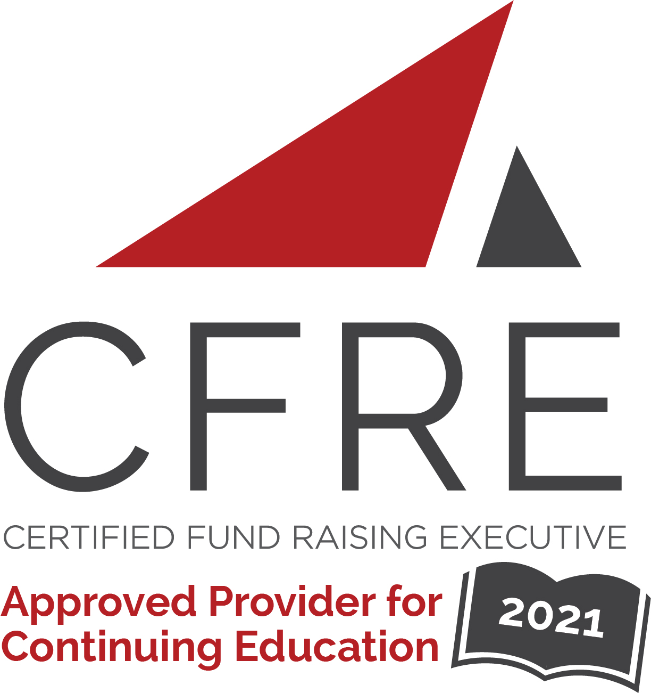  CFRE International has developed this form as a way for you to quickly track (and keep in your files!) the continuing education sessions you have attended. Simply check the boxes next to the sessions you attended. At the end of the conference, add up the total number of hours. Keep this sheet and you will be ready to complete your application form. All of the session slots listed are eligible for continuing education points on your CFRE application for initial certification and/or recertification. Sessions not listed here are not eligible for points. |  | CONTINUING EDUCATION POINTS TRACKER

Activity Organizer: - AFP Western PA Chapter
Title of Activity: - Emerging Philanthropy Conference
Names of Presenter(s): - Various
Dates and Location: - November 10 – 17. 2021 (Online)

Date: Wednesday, November 10, 2021
Keynote: 9:00 [am] – 10:15 [am] (1.25 pts)
- [Why Cash Is Not King In Fundraising: Results From 1 Million Nonprofit Tax Returns]

Date: Wednesday, November 10, 2021
Plenary: 10:30 [am] – 11:30 [am] (1 pt)
- [Lasting Lessons: Fundraising Trends That Will Continue Post Covid]

Date: Wednesday, November 10, 2021
Session 1: 12:30 [am/pm] – 1:30 [am/pm] (1 pt)
- [The Vibrant Index: Measuring What Matters and Promising Practices]
- [Responsive Fundraising: Build Lasting Donor Relationships & Increase Donor Loyalty In Today’s Distraction-filled World]
- [Navigating Special Events In A Post Pandemic World]

Date: Wednesday, November 10, 2021
Session 2: 1:45 [pm] – 2:45 [pm] (1 pt)
- [Cryptocurrency, NFTs, and New Forms of Giving]
- [Engaging Next Gen Donors]
- [Attributes and Skills of Effective Leaders]

Date: Wednesday, November 17, 2021
Keynote: 9:00 [am] – 10:15 [am] (1.25 pts)
- [Ikigai (Japanese philosophy about life's purpose); Gratitude]

Date: Wednesday, November 17, 2021
Plenary: 10:30 [am] – 11:30 [am] (1 pt)
- [“Past, Present, Future: What the history of philanthropy in Pittsburgh can teach us about fundraising today]

Date: Wednesday, November 17, 2021
Session 1: 12:30 [pm] – 1:30 [pm] (1 pt)
- [Deep Dive in to Ikigai ]
- [Major Gift Fundraising 102: Incorporating Blended and Planned Gifts into Everyday Asks]
- [Engaging Your Board In Fundraising]

Date: Wednesday, November 17, 2021
Session 2: 1:45 [pm] – 2:45 [pm] (1 pt)
- [Diversity]
- [How Marketing Automation Helps Nonprofits Do More With Less]
- [Engaging Your Board In Fundraising]

Total number of points attained: __________

